GSK SCCM INFRA Runbook

**Document information**

|  |  |
| --- | --- |
| Create Date | 08/07/2021 |
| Submitted By | Sagar saxena |
| Reviewed By |  |
| Document Name | SCCM Infra RUNBOOK |
| Version number | 1.4 |

*The data contained in this document shall not be disclosed and shall not be duplicated, used, or disclosed in whole or in part for any purpose. If a contract is awarded to chosen parties as a result of or in connection with the submission of this data, the client or prospective client shall have the right to duplicate, use, or disclose this data to the extent provided in the contract. This restriction does not limit the client’s or prospective client’s right to use the information contained in the data if it is obtained from another source without restriction. The data subject to this restriction is contained in all marked sheets.*

***Version Control***

*All information given under this version overrides all and any kind of offers, assumptions, deliverables, and contracts given under any previous version. All previous versions of the subject Proposal stand null and void.*

**Document History**

|  |  |  |  |
| --- | --- | --- | --- |
| **Version** | **Date** | **Author / Reviewer** | **Change Description** |
| 1.0 | 11/17/20 | Dilip Raju | * Draft based on Knowledge Absorption |
| 1.1 | 11/20/20 | Dilip Raju | * Power BI Reporting Topics * Minor changes with Product Owner / Product Name & Reactivation of Application |
| 1.2 | 12/17/20 | Dilip Raju | * Updated In Scope activities for SCCM Engineering Team * Updated Daily maintenance Task * Updated SLA & Assignment groups in Service Now * RACI Matrix for Windows Server Patching and SCCM Infra |
| 1.3 | 07/08/2021 | Sagar Saxena | * Updated Distribution Point List * Updated Boundaries Info * Updated Boundary Groups Info * Updated Distribution Points info * Updated Distribution Point Groups info * Updated RACI Matrix for SCCM Infra. |
| 1.4 | 27/12/2021 | Sagar Saxena | * Updated Distribution Point List * Updated Vendor Management Details * Minor changes with Product Owner * Updated Boundaries Info * Updated Boundary Groups Info * Updated Distribution Points info * Updated Distribution Point Groups info * Updated Primary and secondary Site Version * Updated Client Push details |

**Glossary**

|  |  |
| --- | --- |
| **Abbreviation** | **Description** |
| MP | Management Point |
| DP | Distribution Point |
| SUP | Software Update Point |
| SCUP | System Center Update Publisher |
| SCEP | System Center Endpoint Protection |
| HTTPS | Hyper Text Transfer Protocol Secure |

**table OF contents**

1. Business Overview 8

1.1. Business Services 8

1.2. Vital Business Processes 9

1.3. Document Objective 10

1.4. Audience 10

2. Scope 10

2.1. Scope of services 10

2.1.1. In Scope Services 10

3. SCCM Architecture Overview 11

4. SCCM Environment Details 11

4.1. Teams Supporting SCCM and Access on SCCM Admin console 15

4.2. AD OU Structure for SCCM Servers 15

4.3. SCCM Security Roles/Scopes/Administrative Users and Accounts 15

4.4. Site Server and System Settings 17

4.5. Discovery Methods 20

4.6. Boundary and Boundary Groups 27

4.7. Distribution Point Groups. 29

4.8. Client Settings 29

4.9. Site Maintenance Task Configuration 34

4.10. Software Metering 36

4.11. Backup Management 37

4.12. Daily Maintenance Task 38

4.13. Firewall_Ports-SCCM_Infrastructure 38

4.14. Custom Reports 39

4.15. Support Documents 40

5. Primary & Secondary Site Server Configuration 40

6. Client Installation Methods 47

7. Client Agents Settings 48

8. Monitoring Tools (if any) 63

9.VAMT Management 63

10 License Management (if applicable) 64

11 ITSM Processes 64

12 Vendor Management (if applicable) 65

13 Support Levels 65

13.1. SLA 65

13.2. On-Call Rotations 65

14 Approval Flow Process (if applicable) 66

15 Service Desk Contacts Details 66

16 GSK Key Contacts & Roles 66

17 RACI Matrix 67

# Business Overview

## Business Services

**About GSK**



**GSK History**

Origin of the company started in early 17th century starting with a small-time drug store in London, since then the company has always focused on innovations. From a selection of individual entrepreneurs to a global company of around 100k+ employees, developed a variety of medicines and healthcare products that form the foundations of today’s GSK.

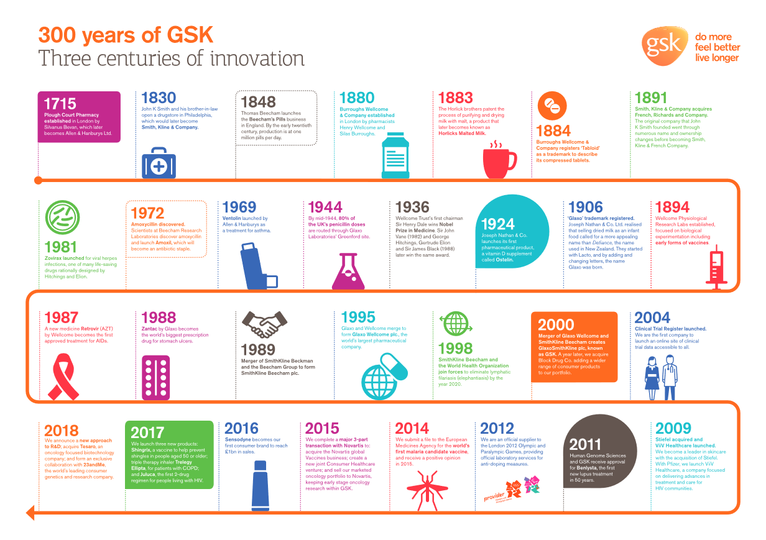

GSK has 3 global businesses that research, develop and manufacture innovative **pharmaceutical medicines, vaccines, and consumer healthcare products.**

**Our goal** is to be one of the world’s most innovative, best performing, and trusted healthcare companies.

**Our values and expectations**are at the heart of everything we do and help define our culture - so that together we can deliver extraordinary things for our patients and consumers and make GSK a brilliant place to work.

## Vital Business Processes

Following are 3 core business areas for GSK.

[Consumer Healthcare (CH)](https://myconnect.gsk.com/sites/Cx/Pages/default.aspx)

[Pharmaceuticals](https://myconnect.gsk.com/sites/pharmaceuticals/Pages/Home.aspx)

* Pharmaceuticals (Includes ViiV Healthcare - dedicated company for HIV medicines)

[Vaccines](https://myconnect.gsk.com/sites/biologicals/Pages/Default.aspx)

## Document Objective

The objective of this document is to give an overview of GSK infrastructure, identify and record the procedures or steps which need to be followed in SCCM administration. Most of the technical details given in this document are based on HCL & GSK Knowledge Transfer as agreed. This document contains technical details and other contact information. It was assumed that the reader has proficiency in SCCM administration and operations. This document also captures all the assumptions, considerations and risks involved. After reading this document the reader should be able to understand about the architecture and workflow of GSK SCCM track activities.

## Audience

This document has been prepared for the HCL BAU teams responsible for providing BAU support for the SCCM environment used by GSK. The document describes the SCCM infrastructure and SOP’s used to support the SCCM environment and business users.

Additional audiences for this document may include GSK IT Services Team, other stakeholders and application teams for reference purposes.

# Scope

This document will help HCL – GSK BAU to know the complete architecture of the System Center Configuration Manager (SCCM) in GSK environment. This document is covering the SCCM infrastructure details for global regions in GSK.



## Scope of services

## In Scope Services

* Patching (win10/win7/special), VAMT (Volume Access Management Tool – For License)
* CI/CB for PC (processes)
* Software Release/Push (including Content distribution troubleshooting and issue resolution) for both Workstations and Servers
* Client Management - Monitor client coverage (objects discovered versus clients installed)
* Client setting polices for PC
* Software Center issues support.
* Scripts/queries repository
* Global Releases planning
* PowerBi
* M365 testing & planning & deployment coordination
* Custom SCCM reports
* Support configuration for Microsoft PFE (Automatic SCCM Client Remediation)
* SCCM Application upgrade (SCCM version)
* Adding Site Systems (DP/MP/SUP). Most common scenario is adding distribution point
* Import SCCM Server Applications\Packages.

# SCCM Architecture Overview

Microsoft System  Center Configuration Manager (SCCM) is a systems management software product developed by Microsoft for managing large groups of computers running Windows NT, Windows Embedded,  macOS (OS X), Linux or UNIX, as well as Windows Phone, Symbian,  iOS and Android mobile operating systems.

Configuration Manager provides remote control, patch management, software distribution, operating system deployment, network access protection and hardware and software inventory.

The entire SCCM infrastructure runs as Virtual Machines. It uses MS SQL as the database backend, MS SQL Reporting Services for reporting purposes, Active Directory for authentication and authorization.

Servers composing SCCM infrastructure are distributed in ~208 locations (sites) across the world with core components located in the US and UK Data Centres. Site systems located in remote sites are used as Distribution Points serving content for managed devices (applications, patches). Additionally, SCCM utilizes Azure cloud components for the Cloud Management Gateway and Cloud Distribution Point to manage roaming workstations with Internet only connection.

GSK does not intend to use SCCM to manage devices with OS different than Microsoft Windows.

# SCCM Environment Details

SCCM is a software suite from Microsoft fully relying on a Microsoft technology. The GSK implementation of SCCM is built on top of the Windows Server 2016 and Windows Server 2012R2 (part of the Distribution Points), uses MS SQL Server 2016 for database backend and reporting services, Active Directory for authentication. All servers are installed as VMware vSphere Virtual Machines and run on different set of ESXi hosts/clusters depending on their location (Core DC vs. Remote Sites) but it is beyond the scope of this document and is irrelevant for the SCCM infrastructure as such.

The high-level GSK SCCM design is following:

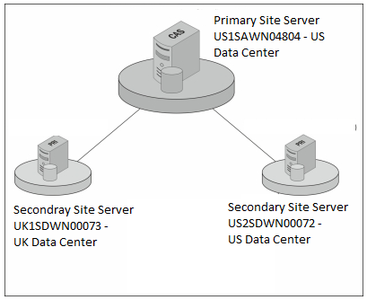

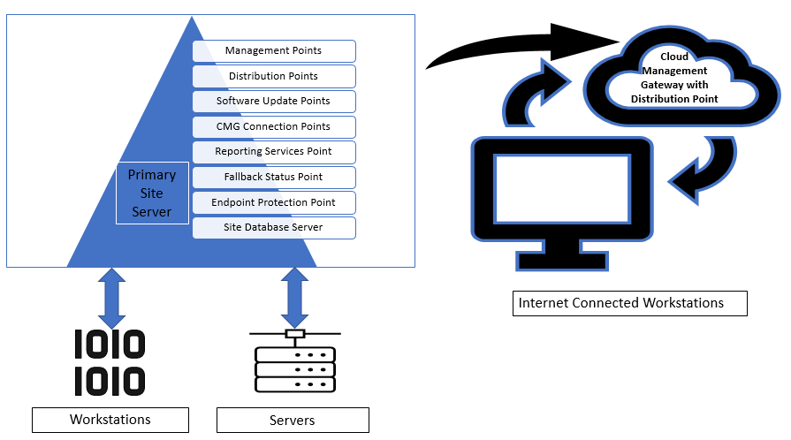

|  |  |  |  |  |
| --- | --- | --- | --- | --- |
| **Component** | **Server Name** | **Description** | **Type** | **Location and Number of Instances** |
| Site server | US1SAWN04804 | The main site system role that hosts the Configuration Manager components and services | Windows Server VM | US DC: 1 |
| Site database server | US1SDWN00084 | A site system role that runs Microsoft SQL Server and hosts the Configuration Manager site database. | Windows Server VM | US DC: 1 |
| Management point | US1SAWN04789 US1SAWN04790 US1SAWN04792 US1SAWN04796 US1SAWN04799 US1SAWN04800 US1SAWN05489 US1SXWN09559 | A site system role that replies to Configuration Manager client requests and accepts management data from Configuration Manager clients. | Windows Server VM | US DC: 8 |
| Distribution point |  | A Configuration Manager server role that stages packages for distribution to clients. | Windows Server VM | Worldwide: 200+ |
| Software update Point | UK1SAWN03271 UK1SAWN03272 UK1SAWN03273 US1SAWN04791 US1SAWN04793 US1SAWN04794 | A site system role that runs Microsoft Windows Server Update Services (WSUS) and allows Configuration Manager to use the WSUS catalogue to scan Configuration Manager clients for software updates. | Windows Server VM | US DC: 3 UK DC: 3 |
| Fallback status point | US1SAWN04789 | A site system role that receives messages from SCCM clients that cannot communicate with their management point | Windows Server VM | US DC: 1 |
| Endpoint Protection Point | US1SAWN04801 | A site system role that serves as an Endpoint Protection point. | Windows Server VM | US DC: 1 |
| Cloud Management Gateway with Distribution Point | GSKCMG1.GSK.COM  GSKCMG1.GSK.COM | A service component running in Azure used to manage clients connected over the Internet. It can serve as a Distribution Point for those devices. | Azure service | Azure: 1 *) |
| Cloud management gateway connection point | US1SAWN04792 US1SAWN04796 US1SAWN04799 US1SAWN04800 | A site system role that serves as a cloud management gateway connection point connecting SCCM infrastructure with the CMG service in Azure. | Windows Server VM | US DC: 2 **) |
| Reporting services Point | US1SXWNSQL0116 | A site system role that provides integration with SQL Server Reporting Services to create and manage reports for Configuration Manager. | Windows Server VM | US DC: 1 |
|  |  |  |  |  |
| Development SCCM Server |  | US1SAWN04447 | Windows Server VM | US DC: 1 |

**Notes:**

*) This is a service running in the Azure Public Cloud. There are multiple resources

serving it (VMs; their number configurable from the SCCM perspective) but it acts as a

single service with single connection point from the Internet.

Also the gsksccmroaming.cloudapp.net has been renamed to GSKCMG1.GSK.COM & GSKCMG2.GSK.COM

**) These 2 machines act also as Management Points for CMG traffic.



## Teams Supporting SCCM and Access on SCCM Admin console

**Release & Integration (R&I): Infrastructure**

Responsible for product enhancements and design of new functionalities, working closely with the Vendor, Configuration Management and the operational support teams. The team will be responsible for a day to day administration and maintenance of the existing SCCM infrastructure and will be managing escalations from the operational support teams (e.g. Server and PC Release).

**PC Release Patching**

Responsible for a day to day operational usage and support of the product for PC Operations i.e. workstations release activities.

## AD OU Structure for SCCM Servers

## SCCM Security Roles/Scopes/Administrative Users and Accounts

The System Access Plan will be reviewed annually.

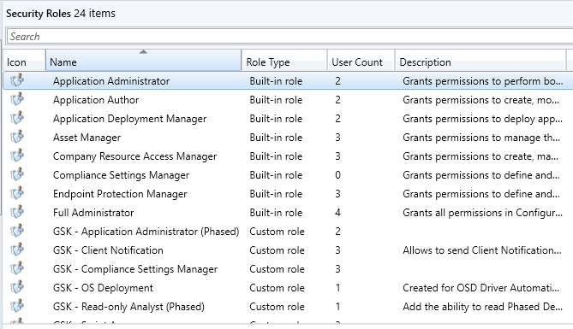

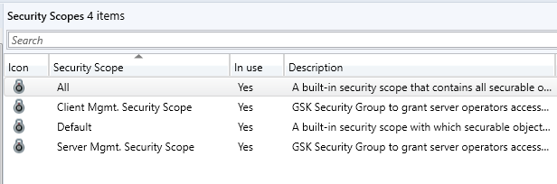

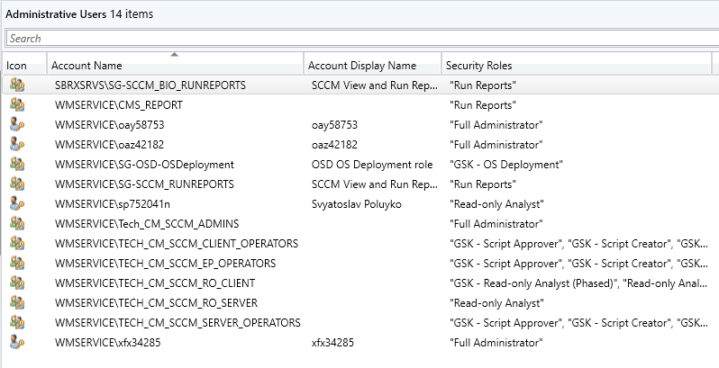

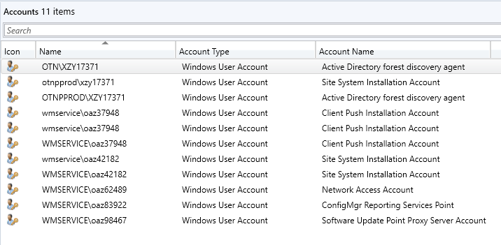

## Site Server and System Settings

A parent site is a primary site that has two Secondary site attached below it in the hierarchy. GSK has single primary site located in US Datacenter.

**Primary site server roles below -** US1SAWN04804

* Component server
* Service Connection Point
* Site server
* Site system
* SMS Provider

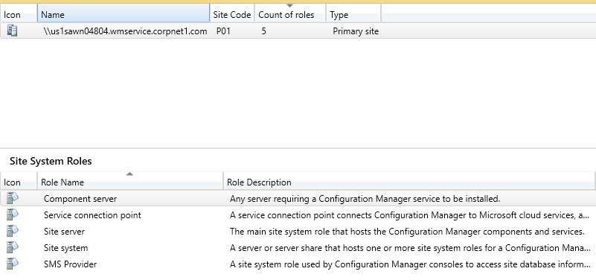

**Secondary site server roles below –** UK1SDWN00073

* Component server
* Distribution Point
* Management Point
* Site Database Server
* Site server
* Site system
* Software Update Point

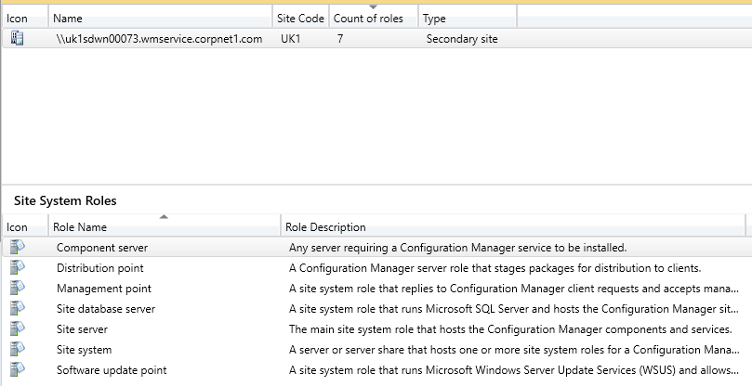

**Secondary site server roles below –** US2SDWN00072

* Component server
* Distribution Point
* Management Point
* Site Database Server
* Site server
* Site system
* Software Update Point

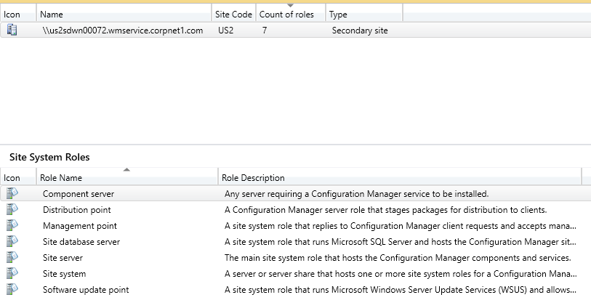

## Discovery Methods

System Center Configuration Manager discovery identifies computer and user resources that you can manage by using Configuration Manager. It can also discover the network infrastructure in the environment. Discovery creates a discovery data record (DDR) for each discovered object and stores this information in the Configuration Manager database.

1. AD Forest Discovery

* Discovers forests, domains, AD sites, and IP subnets.
* AD Forest Discovery :Enabled
* Polling Schedule: Once in a week

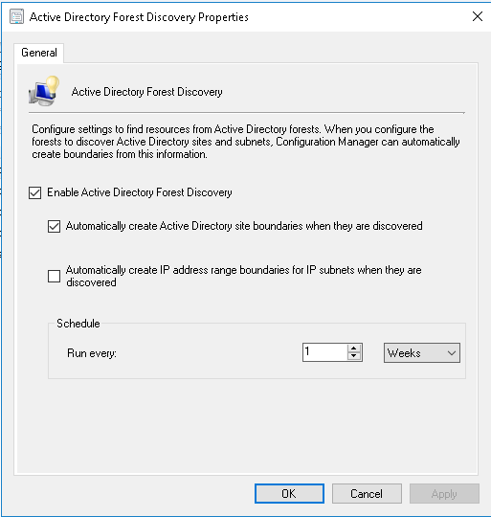

1. Heartbeat Discovery

* Heartbeat Discovery does not discover new resources and send an updated data discovery record (DDR) to the management point.
* Heartbeat Discovery :Enabled
* Heartbeat Schedule: Once in 3 Days

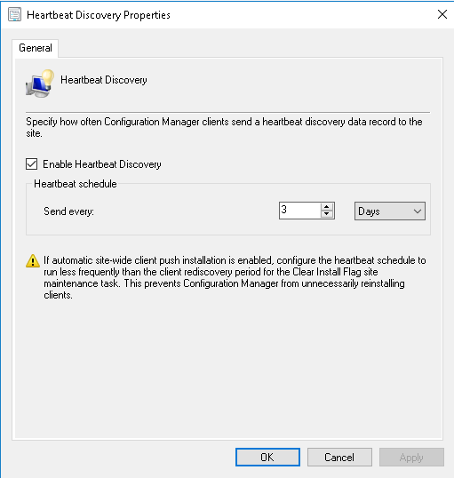

1. AD User Discovery

* Discover User Objects from Active Directory
* AD User Discovery :Enabled
* Polling Schedule: Once in a week Full Discovery and Delta is 5 Min.

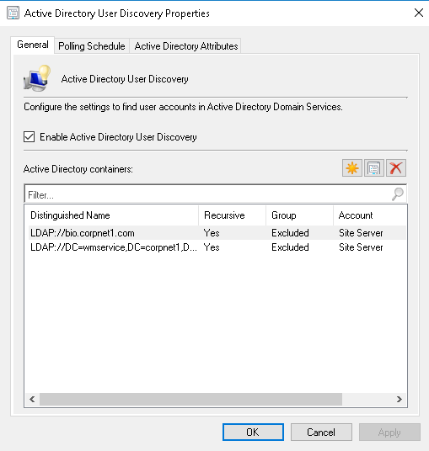 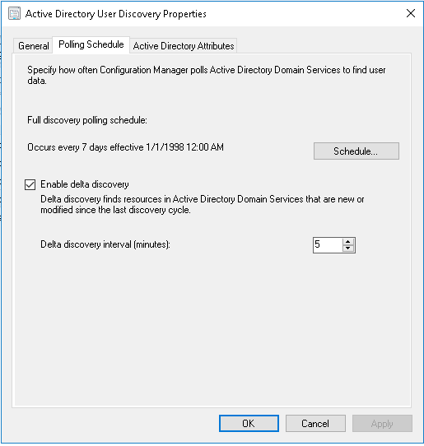

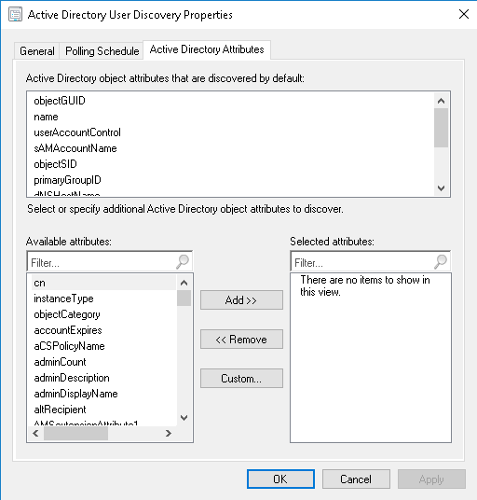

1. AD Group Discovery

* Discovers AD groups and group membership
* AD Group Discovery :Enabled
* Polling Schedule: Once in a Day Full Discovery and Delta is 5 Min.

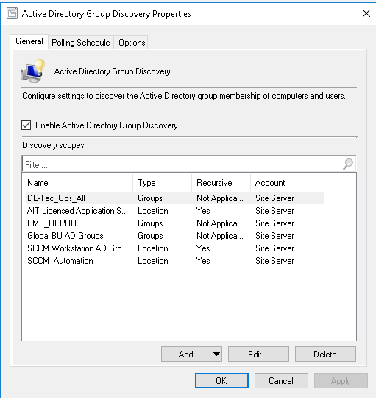 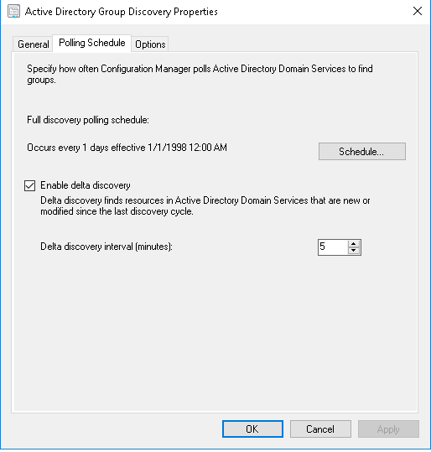

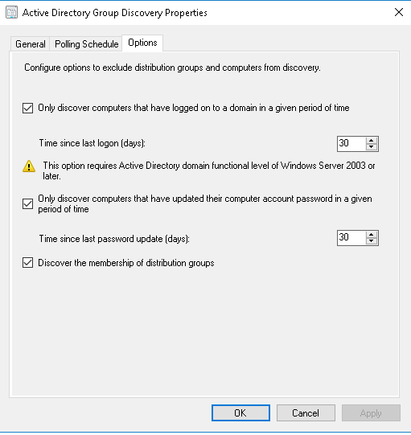

1. AD System Discovery

* AD System Discovery searches the specified Active Directory location for computer resources.
* AD System Discovery :Enabled
* Polling Schedule: Once in a week Full Discovery and Delta is 60 Min.

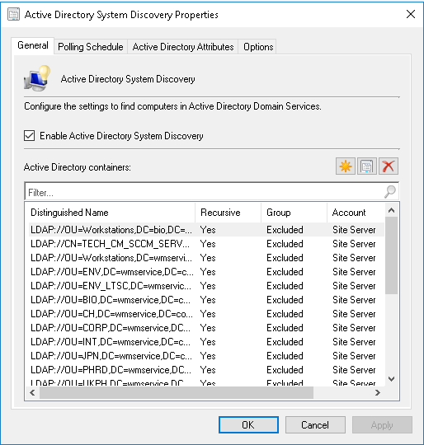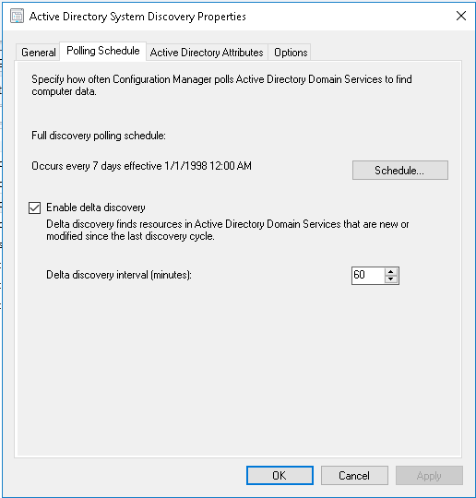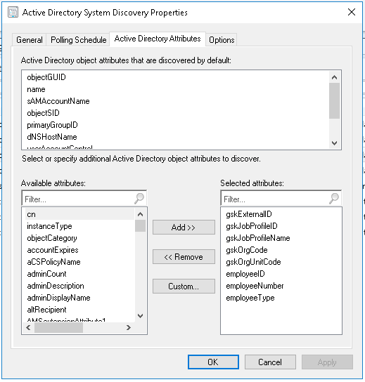 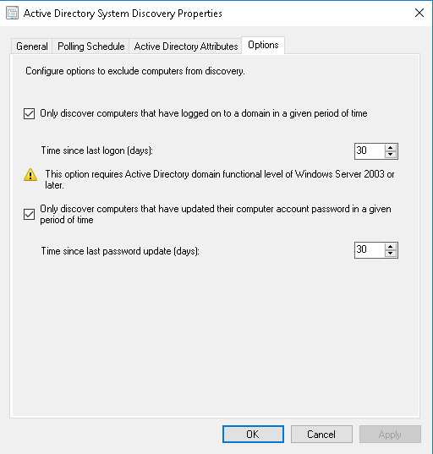

1. Network Discovery

* Allows you to go directly to the network to find new objects, such as computers, printers and network devices
* Network Discovery :Disabled

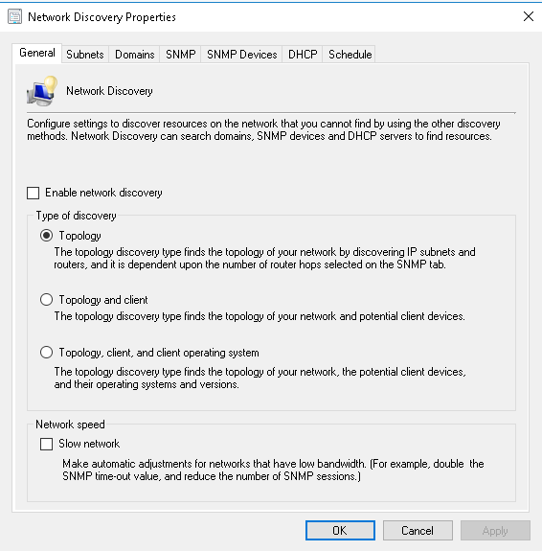

## Boundary and Boundary Groups

1. **Boundaries**

Boundary represents a network location in System Center Configuration Manager and it is available from every site in the hierarchy. A boundary does not enable to manage clients at the network location. To manage a client, the boundary must be a member of a boundary group. In GSK Site Boundary configured based on AD Site



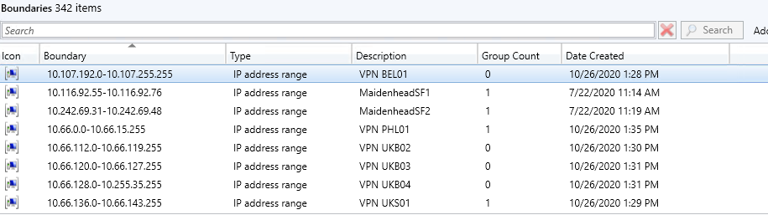

1. **Boundary Groups**

We need to Use boundary groups to manage the network locations. Boundaries are assigned to boundary groups before you can use the boundary group. Configure each boundary group with an assigned site for clients. Clients join the assigned site of a boundary group that contains the client’s current network location. In GSK adding the IP address or Subnet to the AD site is the responsibility to AD Team. GSK Environment having AD Sites and Boundary Groups are 279.



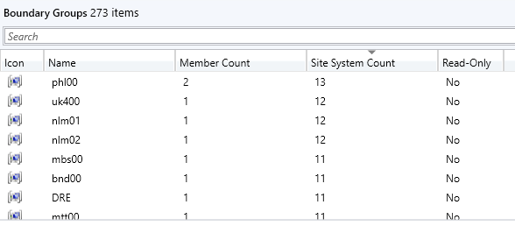

## Distribution Point Groups.

|  |  |  |
| --- | --- | --- |
| Distribution Point Group Name | Member Count | Description |
| All On-Prem Distribution Points | 183 | All On-Prem Distribution Points |
| All On-Prem Pull Distribution Point Group | 182 | Contains All On-Prem Distribution Points with sufficient disk space for distributing applications |
| Cloud Distribution Point Group | 2 | Cloud Distribution Point Group |
| Core Distribution Point Group | 6 | For UAT purposes and for rarely installed software. Should contain all Primary and Secondary DPs |
| Global Dual Role DP's - Altiris/SCCM | 0 | Global Dual Role DP's - Altiris/SCCM |
| Japanese App Distribution Point Group | 1 | Distribution Point for Japanese Language Applications |
| No Servers Distribution Point Group | 0 | This Distribution Point Group will not contain any DPs in it. Do not add servers to it. |
| RTP Modern Workplace | 2 |  |
| Server Core Distribution Points | 8 | Server Core Distribution Points |
| UK Core Distribution Point Group | 5 | Distribution Points located in the UK1 Core Datacentre |
| US Core Distribution Point Group | 3 | Distribution Points located in the US1 Core Datacentre |
| Vaccines Distribution Point Group | 9 | Distribution Points for Vaccines |

## Client Settings

Below are the Client Settings configured with respect to Server

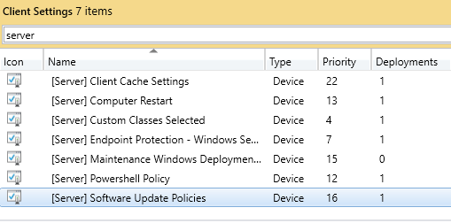

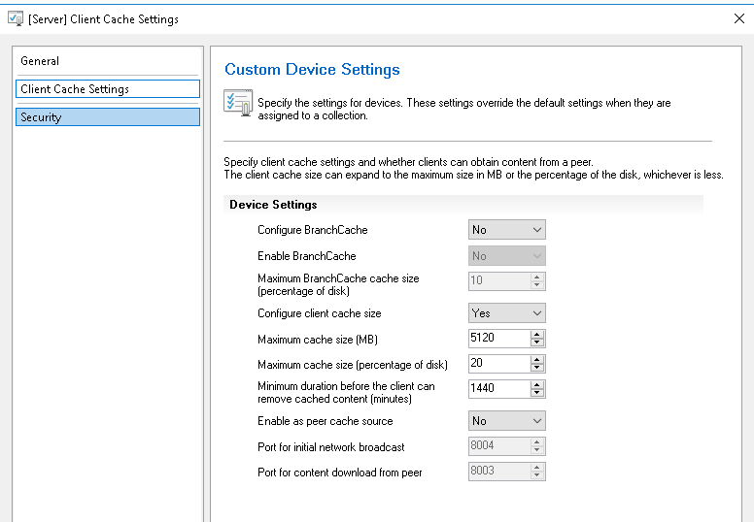

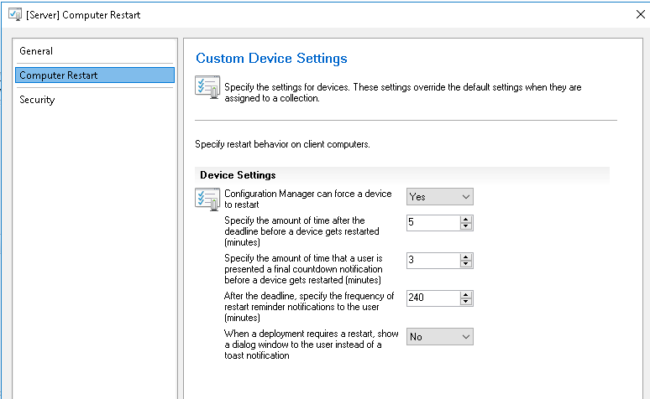

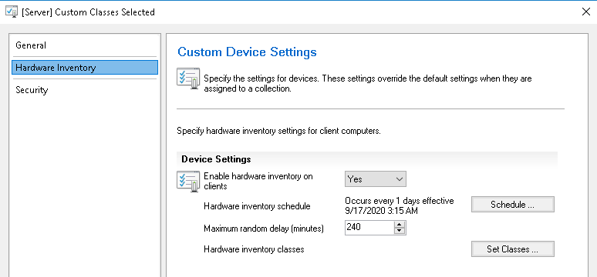

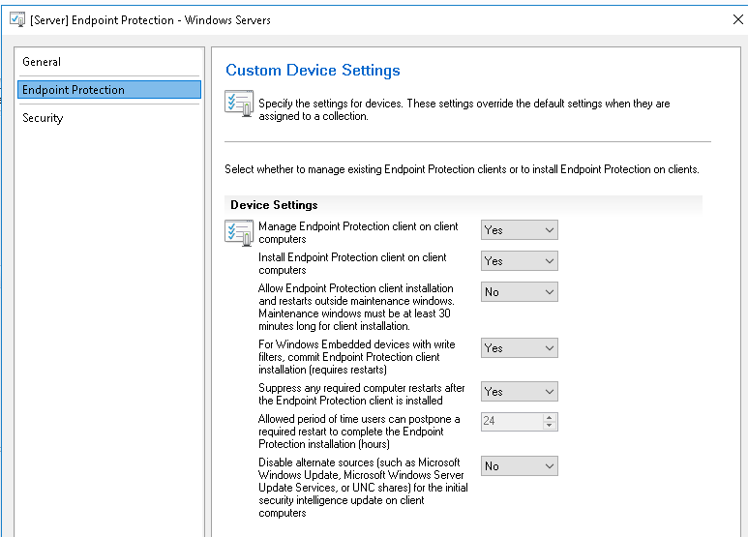

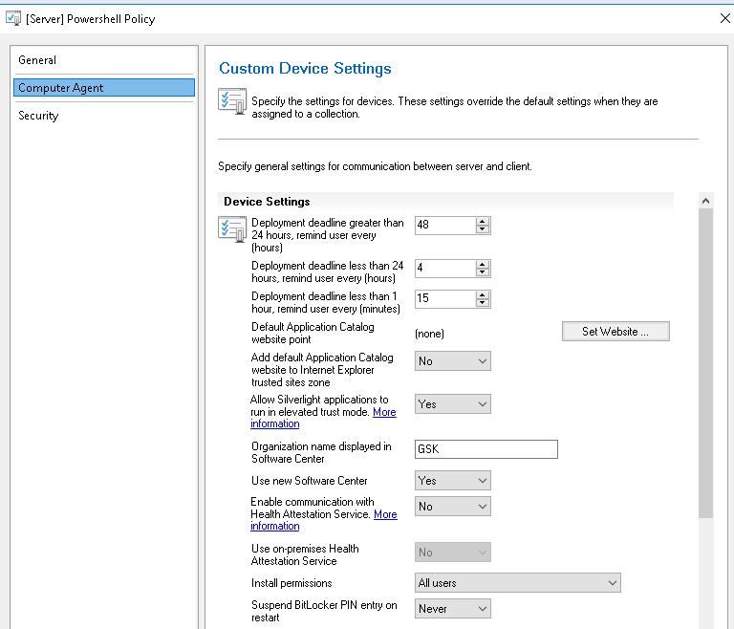

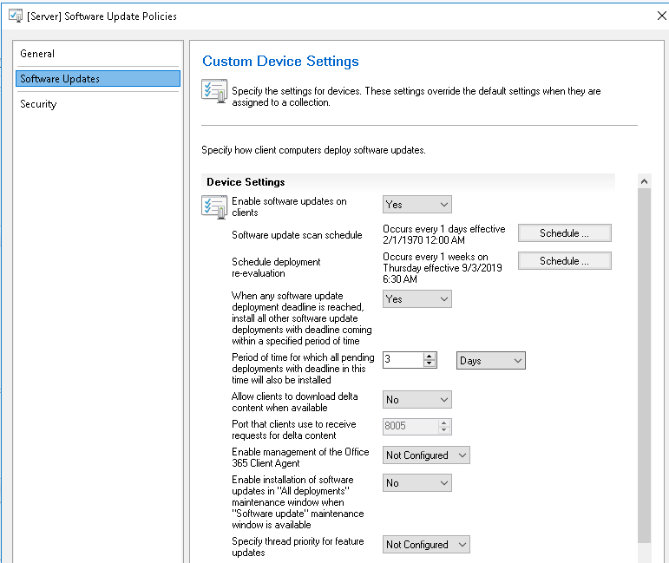

## Site Maintenance Task Configuration

System Center Configuration Manager sites and hierarchies require regular maintenance and monitoring to provide services effectively and continuously. Regular maintenance ensures that the hardware, software, and the Configuration Manager database continue to function correctly and efficiently.

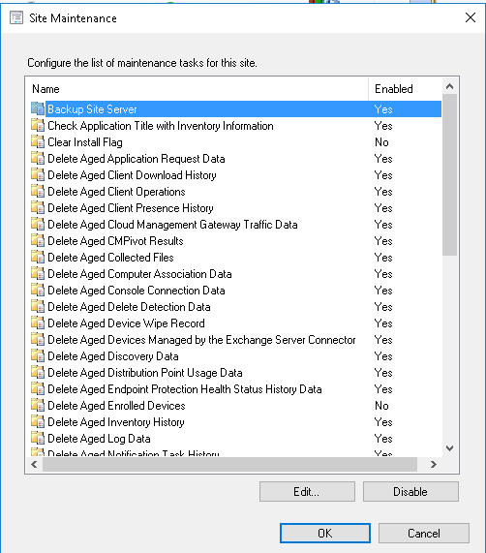



## Software Metering

Software metering in Configuration Manager allows you to monitor and collect software usage data on Configuration Manager Clients. The collection of this usage data is based on software metering rules that can be configured by the administrator in the Configuration Manager console, or by the automatic generation of rules based on usage data collected by Configuration Manager Inventory. These rules are evaluated by the software metering client agent on Configuration Manager Client computers, which collects metering data and reports this back to the site database. The software metering client agent continues to collect usage data when there is no connection to the Configuration Manager site and will report this back when the connection is re-established. Software metering data held on the site database is summarized on a specified schedule and propagated up through the site hierarchy to any parent site.

GSK has enabled the software metering on SCCM infrastructure.

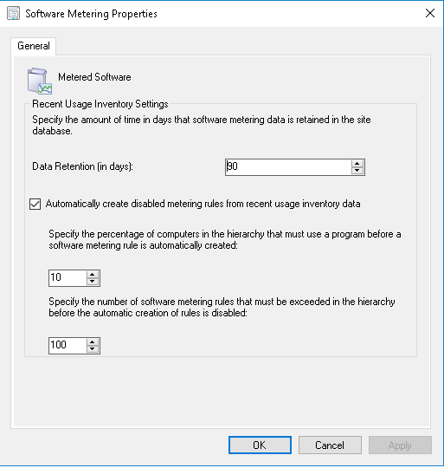

## Backup Management

A Configuration Manager site contains a large amount of data, which is mostly stored in the site database. To ensure that the site backup, GSK has scheduled the Backup Site Server maintenance task for the Primary Site Server all the 7 days in a week, which will be running after 7:00 PM and Latest Start time will be 11:00 PM which will be stored in the below server path US1SAWN04804\F$\Backup. The Backup Site Server maintenance task will create a complete backup snapshot of the site and contains all the data necessary to perform recovery operations.

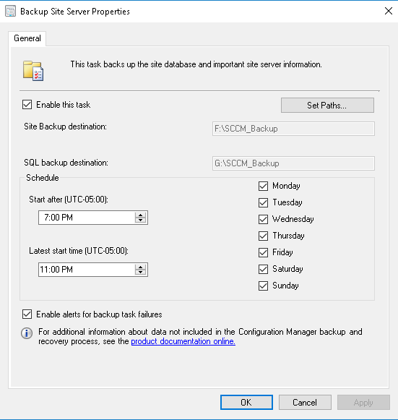

To verify that the Backup Site Server maintenance task is completed successfully

* Review the timestamp on the files in the backup destination folder that the Backup Site Server maintenance task created. Verify that the timestamp has been updated with a time that coincides with the time when the Backup Site Server maintenance task was last scheduled to run.
* In the Component Status node in the Monitoring workspace, review the status messages for SMS_SITE_BACKUP. When site backup is completed successfully, you see message ID 5035, which indicates that the site backup was completed without any errors.
* When the Backup Site Server maintenance task is configured to create an alert if backup fails, you can check the Alerts node in the Monitoring workspace for backup failures.

## Daily Maintenance Task

Team need to perform the below maintenance tasks on daily basis by SCCM Infrastructure Team.

* Check Primary Site Server Services
* Check for SQL Server Services
* Component Status
* Client Status @ All Physical WorkStation
* Distribution Point Package Status
* Software Update Point Status
* All Site System Health Status with respect to Availability and Disk Space
* Need to monitor the Remedy/Service Now incidents raised by Operation Team
* Monitor PFE messages backlog and SCCM Inboxes backlog.
* Monitor client upgrade. Analyze issues preventing clients to upgrade\install. Push upgrade\install to outstanding clients.
* Monitor SCCM daily Backup.

## Firewall_Ports-SCCM_Infrastructure

Attached is the list of the ports that are configured for SCCM Infrastructure.



## Custom Reports

Custom reports are available on SCCM SSRS reporting and it can be used to monitor and manage the devices.

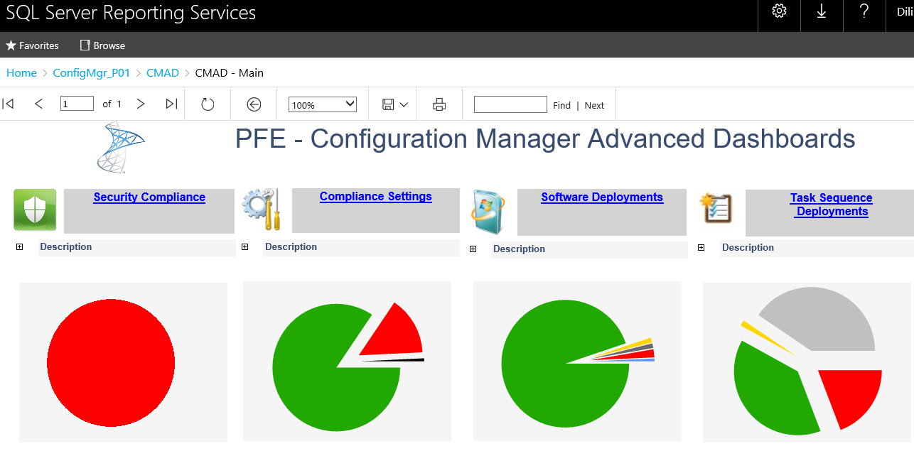

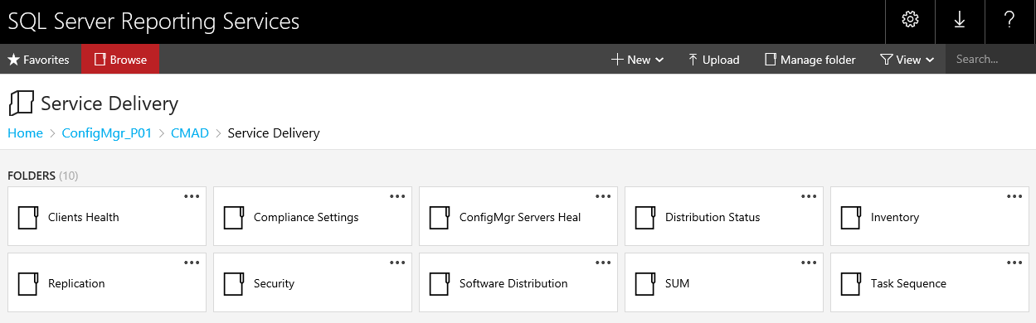

## Support Documents

Below are the Support documents are available in the CDMS

1. SCCM Application Upgrade: Draft document (go live in Jan 2021): **INS_00000841901**
2. Compliance Requirements Summary for Microsoft System Center Configuration : **RPT_00000710735 (0.1)**
3. System Access Plan for System Center Configuration Manager (SCCM) : **INS_00000746968 (1.0)**
4. Operations Manual for System Access Plan for System Center Configuration Manager (SCCM) : **INS_00000750876 (1.0)**
5. Update Procedure for System Center Configuration Manager (SCCM): **INS_00000841901 (0.1)**
6. Some of the Support Documents are available in the [SharePoint Link](https://teams.microsoft.com/_#/files/Knowledge%20Absorption?threadId=19%3A8a929c86556b41f5837557a2f7fe3080%40thread.tacv2&ctx=channel&context=Dilip_SCCM%2520Infra&rootfolder=%252Fsites%252FProjectOAK-EndUserServicesCollaborationSite%252FShared%2520Documents%252FKnowledge%2520Absorption%252FModern%2520Workspace%252FPC%2520Release%2526Patching%252FManuals%252FDilip_SCCM%2520Infra)

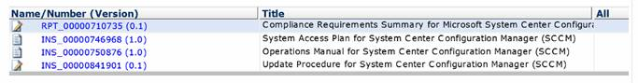

# Primary & Secondary Site Server Configuration

**SCCM Primary Site Server Settings:**

**Site Properties**

The following Screenshots is the configuration for the Site Properties on the Primary Site. Configure each item as specified in the below

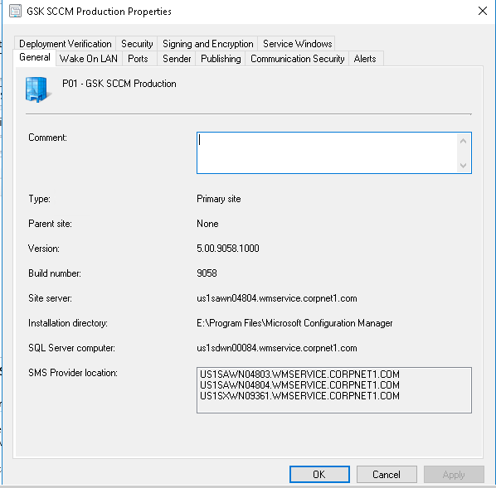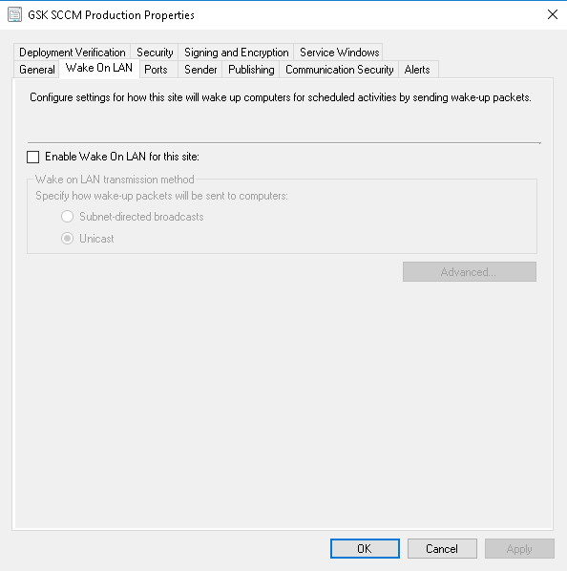

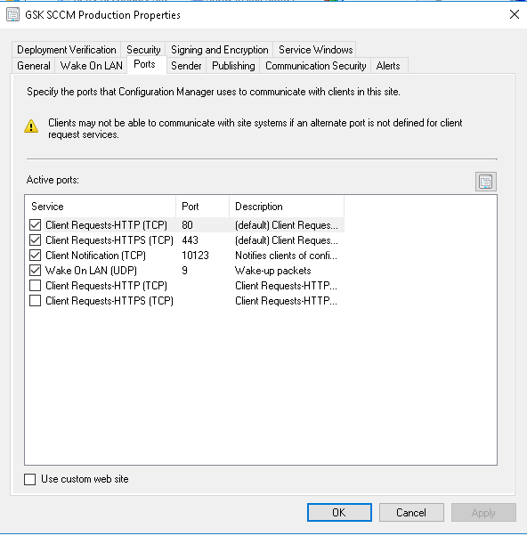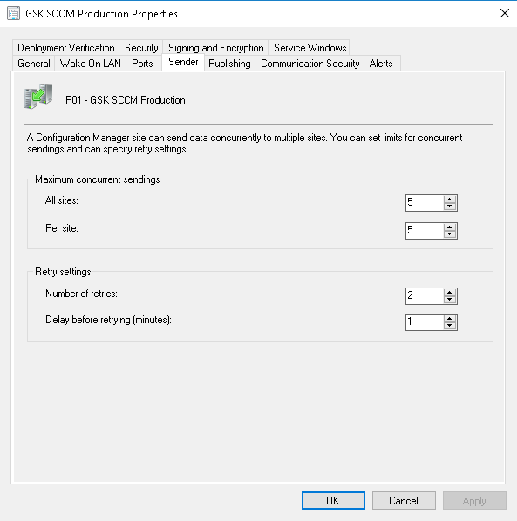

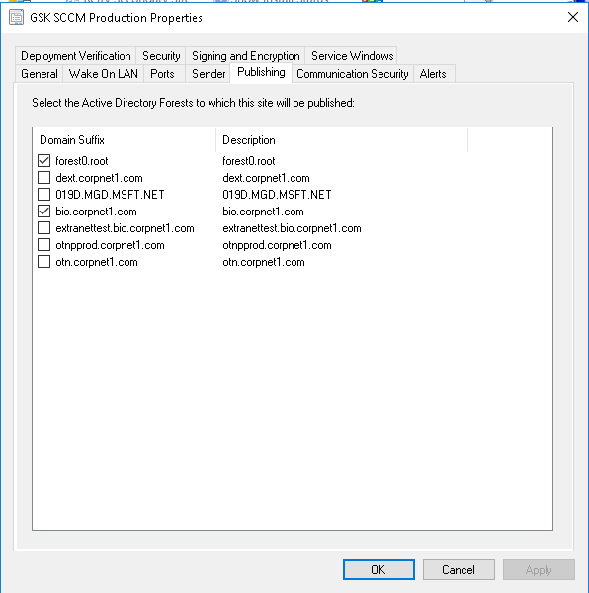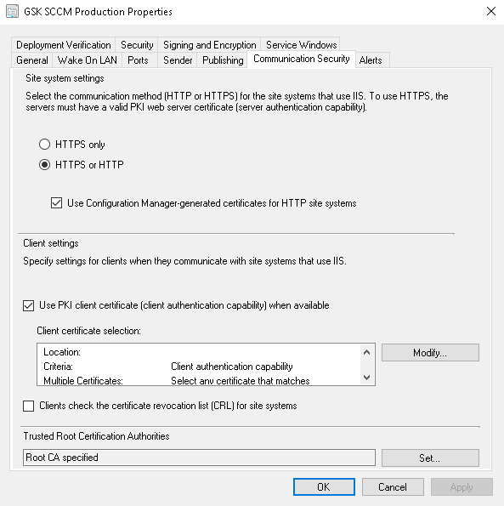

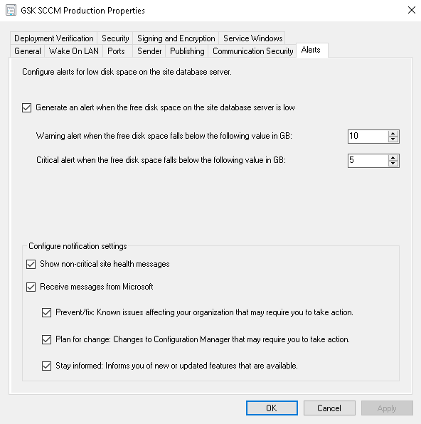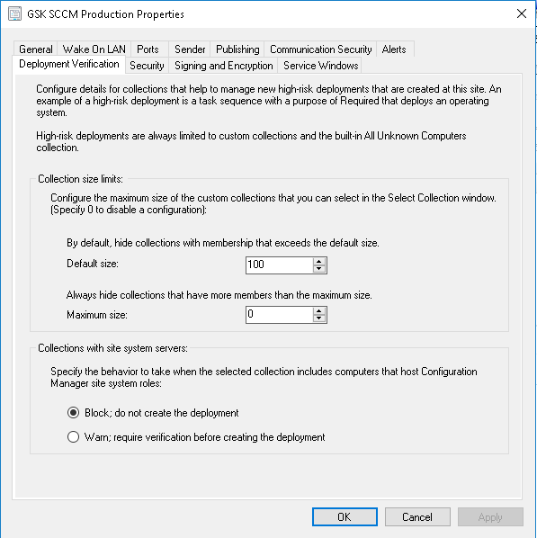

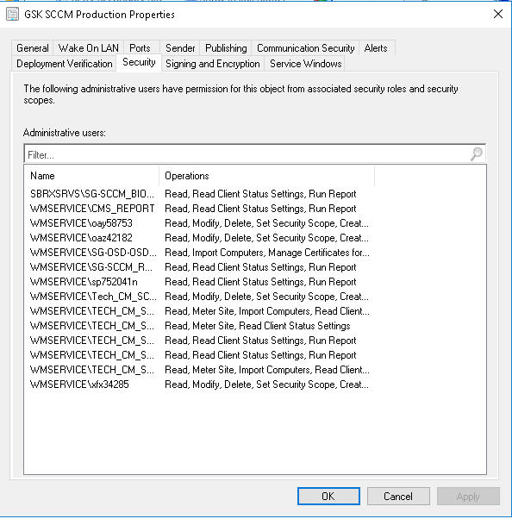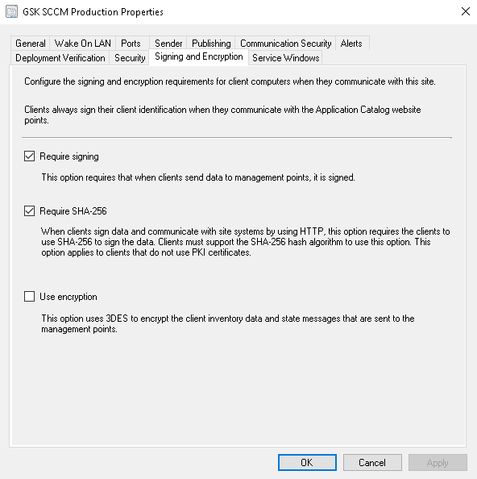

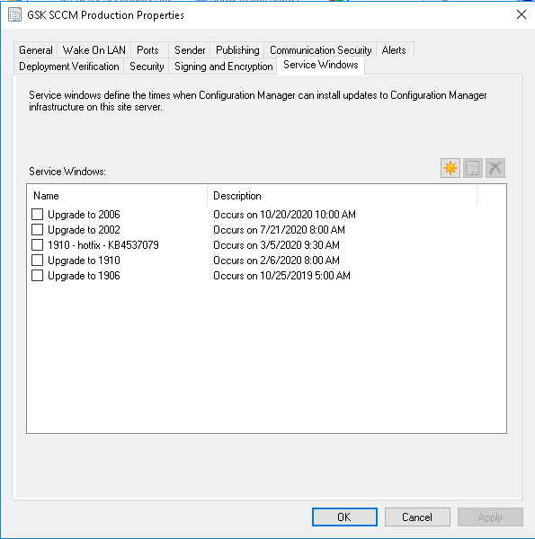

**SCCM Secondary Site Server Settings:**

**Site Properties**

The following Screenshots is the configuration for the Site Properties on the Secondary Site. Configure each item as specified in the below

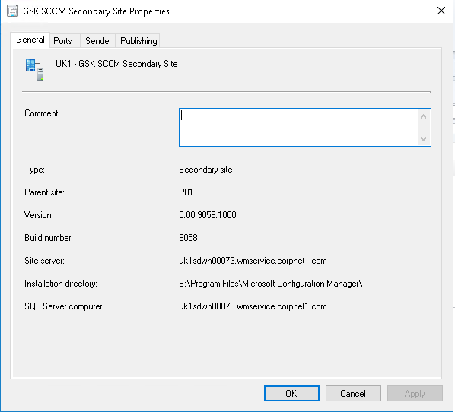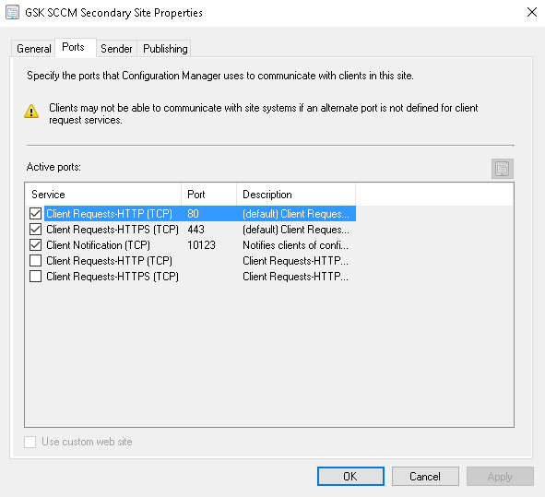

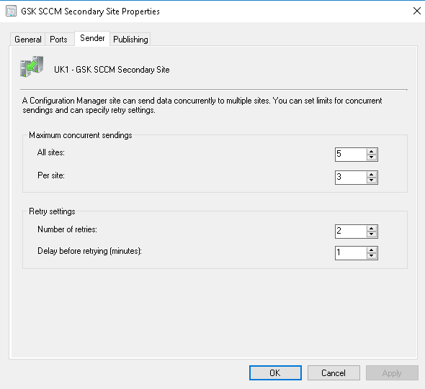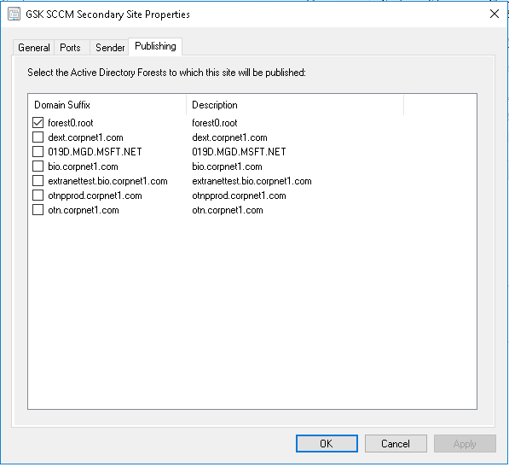

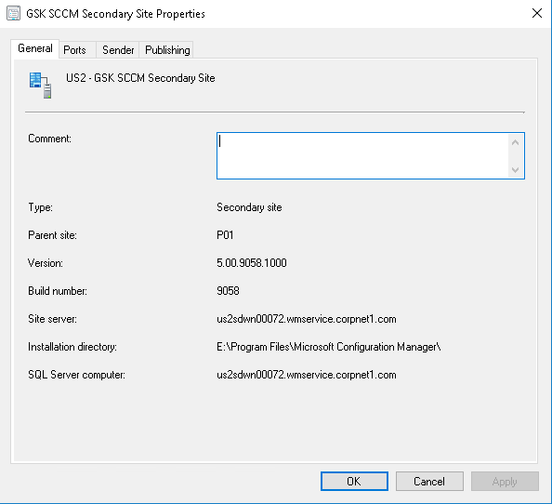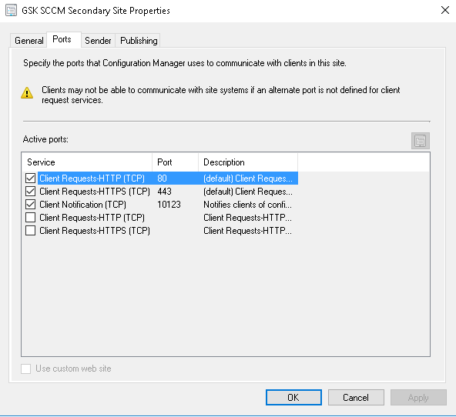

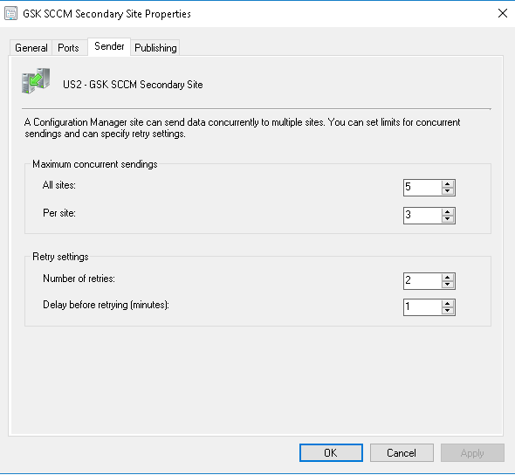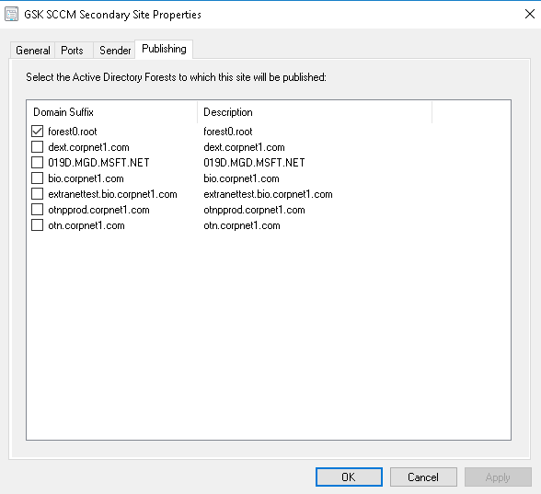

# Client Installation Methods

We can use different methods to install the System Center Configuration Manager client software on devices in enterprise.

In GSK we added the SCCM client into the image. Currently they are using the Win 10 image and it’s contains SCCM client. If any one of the machines having client issue or need to install the client we can use client push Installation.

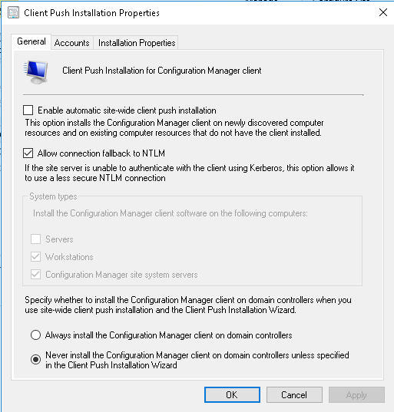 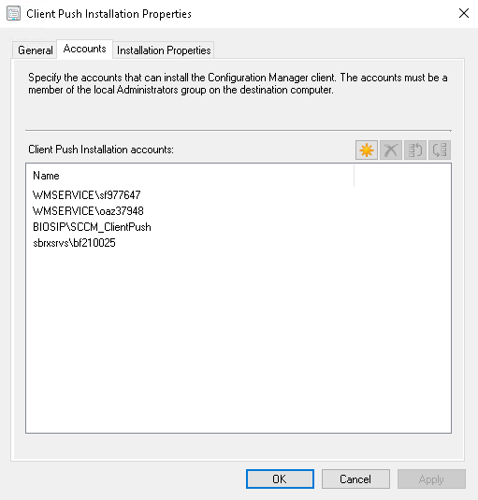

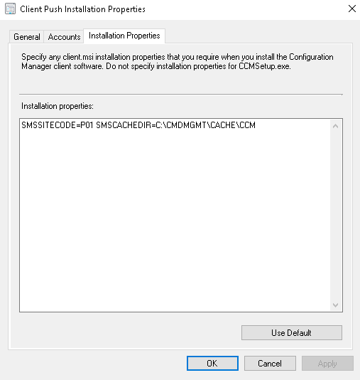

# Client Agents Settings

GSK has customized the client configuration for Workstations (Desktops and Laptops) and selected options as per below configuration

For SCCM Client we have two different custom settings maintained:

* Custom Computer Restart - Computer Agent
* Custom Computer Restart – Computer Agent – Special Cases

Computer Agent settings applies to user notifications for required deployments. When users receive required software, and select the **Snooze and remind me** setting, they can choose from the following options:

* **Later**: Specifies that notifications are scheduled based on the notification setting configured in client settings
* **Fixed time**: Specifies that the notification is scheduled to display again after the selected time. For example, if you select 30 minutes, the notification displays again in 30 minutes.

The maximum snooze time is always based on the notification values configured in the client settings at every time along the deployment timeline.

There are three settings according to deployment deadline:

* Deployment deadline greater than 24 hours, remind user every (hours)
* Deployment deadline less than 24 hours, remind user every (hours)
* Deployment deadline less than 1 hour, remind user every (minutes)

Current Computer Agent Setting:

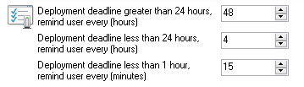

Another Computer Agent setting is:

* Grace period for enforcement after deployment deadline (hours)

In general it is set for 24 hours:



However, it is 0 for **Special Cases** custom setting.



 Special Cases contains two collections:

* Base: Special Equipment
* RebootPrompt – Exclusions

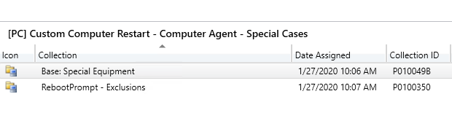

Computer restart settings contains two options that must be shorter in duration than the shortest maintenance window applied to the computer:

* Specify the amount of time after the deadline before a device gets restarted (minutes)
* Specify the amount of time that a user is presented a final countdown notification before a device gets restarted (minutes)

Current **Computer Restart** Setting:

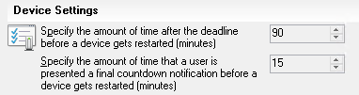

Maintenance windows enable you to define a time when Configuration Manager operations can be carried out on a device collection. You use maintenance windows to help ensure that client configuration changes occur during periods that don’t affect productivity. Starting in Configuration Manager version 1806, your users can see when their next maintenance window is from the **Installation status** tab in the **Software Center**.

Another settings in computer restart are:

* Specify the frequency of reminder notifications presented to the user, after the deadline, before a device gets restarted (minutes)

Current **Computer Restart** Setting:



*Remember: Your snooze duration value should be less than the temporary notification value minus the value for the notification the user cant dismiss.*

* When a deployment requires a restart, show a dialog window to the user instead of a toast notification

Starting in version 1902, configuring this setting to **Yes** changes the user experience to be more intrusive. This setting applies to all deployments of applications, task sequences, and software updates.

Configuring this client setting changes the user experience for all required deployments that require a restart of the following types:

* Application
* Task sequence
* Software update

From the following toast notification:

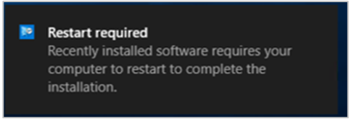

To the following dialog window:

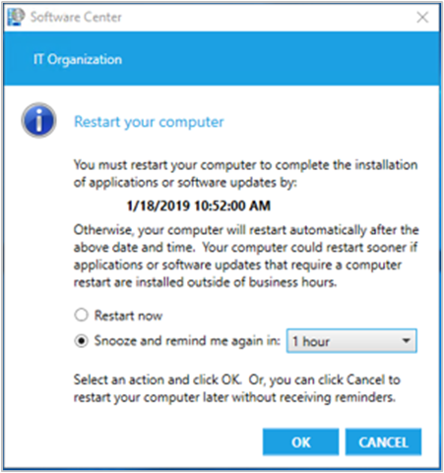

In our organization this setting is set to **Yes**in general. However, it is set to **No**for **Special Cases** custom settings.

Below you can find all the settings in GSK.

* Computer Agent

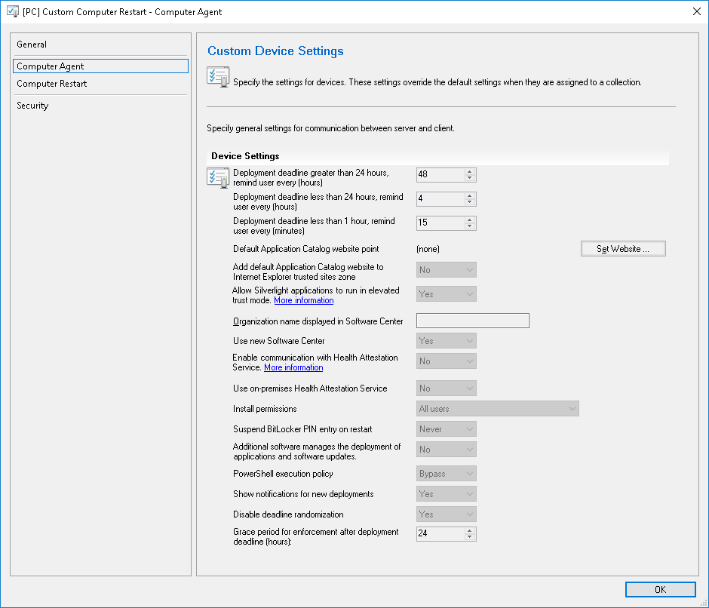

* Special Cases

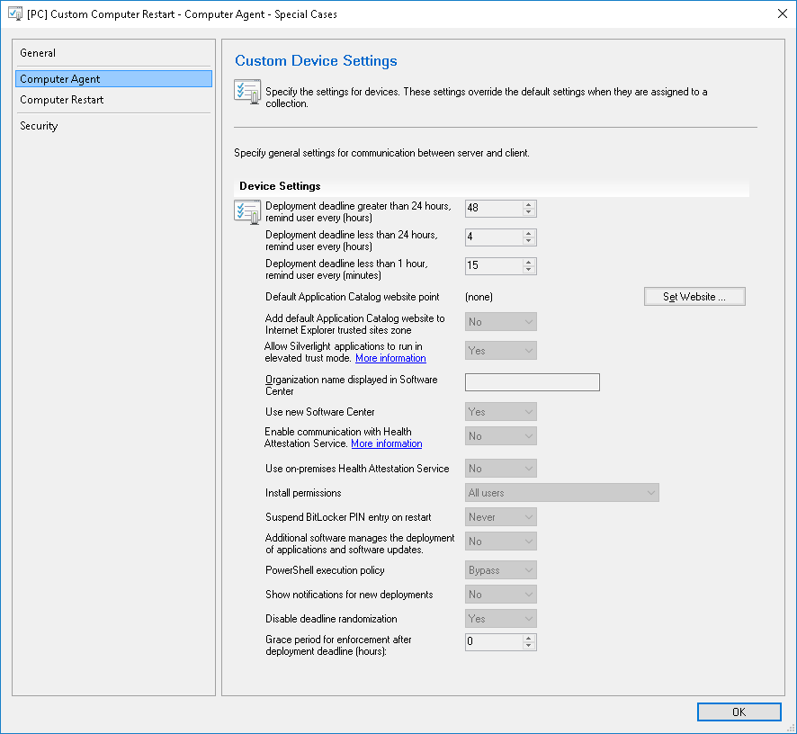

* Computer Restart

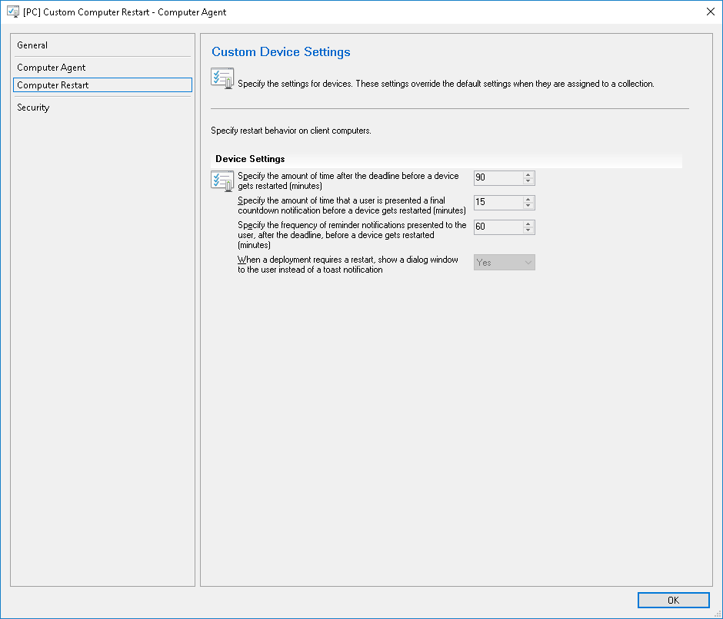

* Special Cases

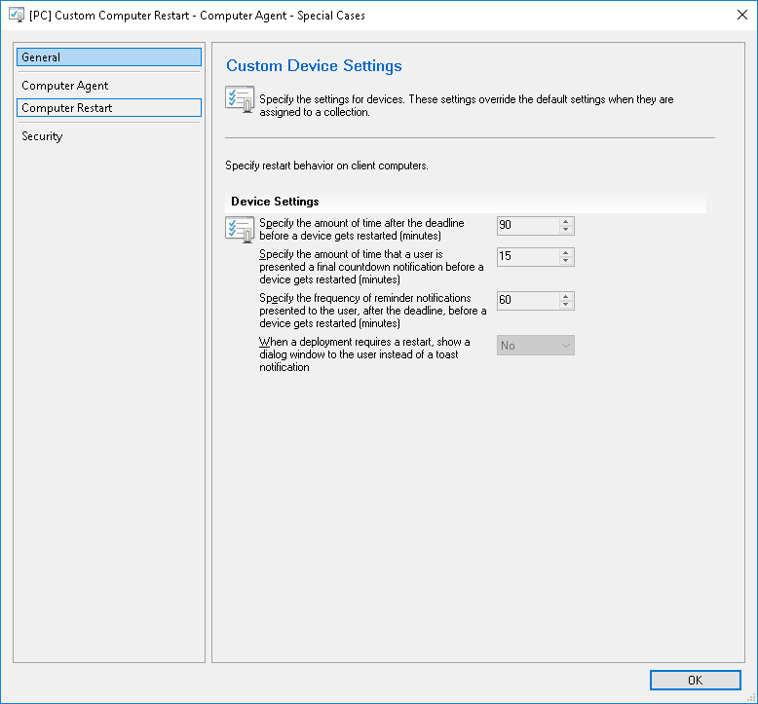

**SCCM Client settings - comparison and recent changes**

|  |  |  |  |  |
| --- | --- | --- | --- | --- |
|  | Default Client Settings | [PC] Custom Computer Restart – Computer Agent | [PC] Custom Restart – Computer Agent – Special Cases | Comments |
| **Computer Agent** | | | | |
| Deployment deadline greater than 24 hours, remind user every (hours) | 48 | 48 | 48 |  |
| Deployment deadline less than 24 hours, remind user every (hours) | 4 | 4 | 4 |  |
| Deployment deadline less than 1 hour, remind user every (minutes) | 15 | 15 | 15 |  |
| Default Application Catalog website point | (none) | (none) | (none) |  |
| Add default Application Catalog website to Internet Explorer trusted sites zone | No | No | No |  |
| Allow Silverlight applications to run in elevated trust mode | Yes | Yes | Yes |  |
| Organization name displayed in Software Center |  |  |  |  |
| Use new Software Center | Yes | Yes | Yes |  |
| Enable communication with Health Attestation Service | No | No | No |  |
| Use on-premises Health Attestation Service | No | No | No |  |
| Install permissions | All users | All users | All users |  |
| Suspend BitLocker PIN entry on restart | Never | Never | Never |  |
| Additional software manages the deployment of applications and software updates | No | No | No |  |
| PowerShell execution policy | Bypass | Bypass | Bypass |  |
| Show notifications for new deployments | No | Yes | No | February 2020:  For [PC] Custom Computer Restart – Computer Agent setting has been changed from No to Yes to resolve issue with lack of notification for non-silent deployments |
| Disable deadline randomization | Yes | Yes | Yes |  |
| Grace period for enforcement after deployment deadline (hours) | 0 | 24 | 0 |  |
| **Computer Restart** | | | | |
| Specify the amount of time after the deadline before a device gets restarted (minutes) | 90 | 90 | 90 | Setting description changed |
| Specify the amount of time that a user is presented a final countdown notification before a device gets restarted (minutes) | 15 | 15 | 15 | Setting description changed |
| Specify the frequency of reminder notifications presented to the user, after the deadline, before a device gets restarted (minutes) | 240 | 60 | 60 | Setting description changed |
| When a deployment requires a restart, show a dialog window to the user instead of a toast notification | No | Yes | No |  |
| Configuration Manager can force a device to restart | YES | YES | NO |  |

**Deployment Re-Evaluation**

* **Production Site PO1**

1. GSK Custom Software update scan schedule – Patching Test Groups and Ring

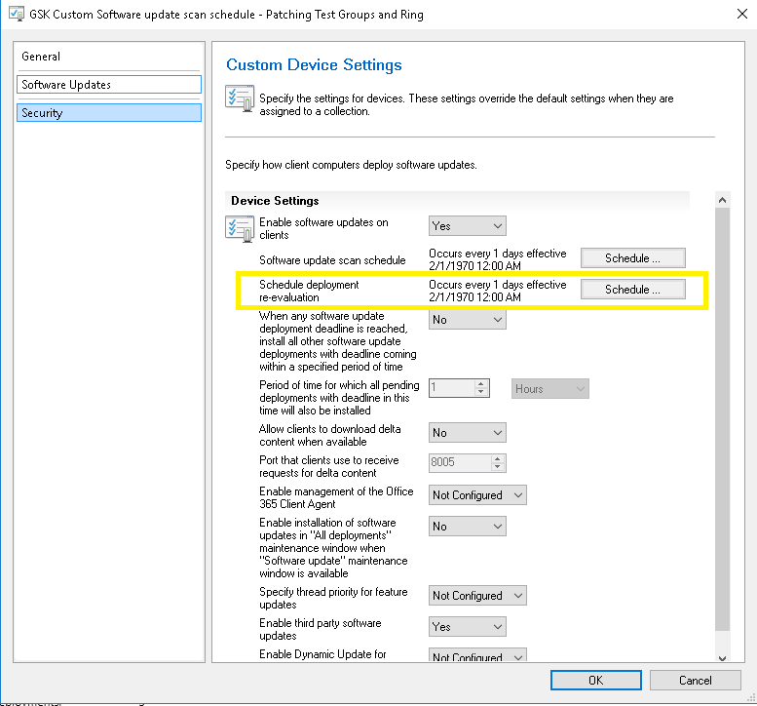

1. Default Settings

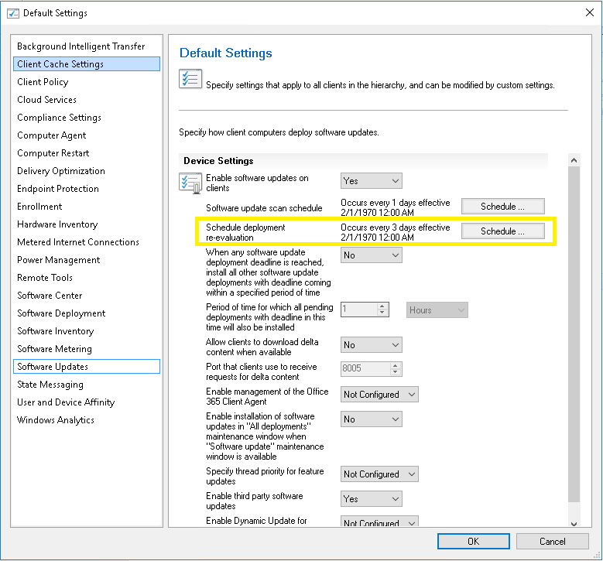

* **Development Site DO1**

1. Default Settings

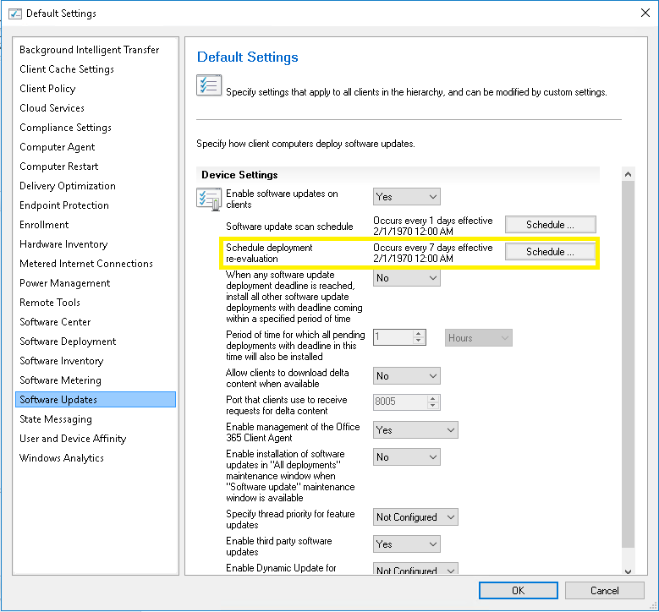

* **Microsoft’s Default Setting for SCCM 2010**

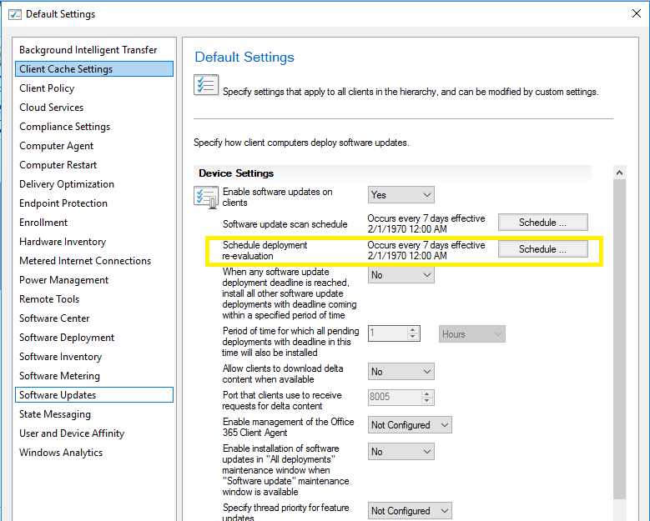

**Client Cache Settings**

* Default Settings

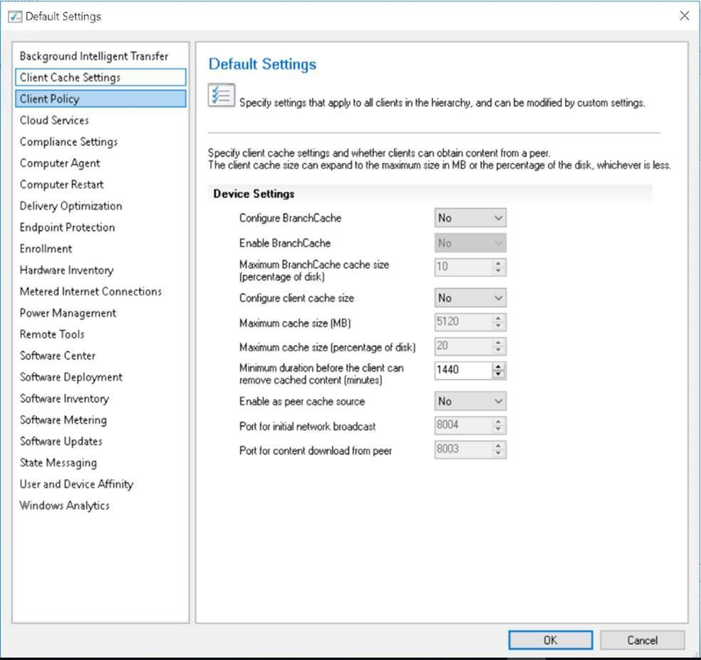

* All Managed Client Settings

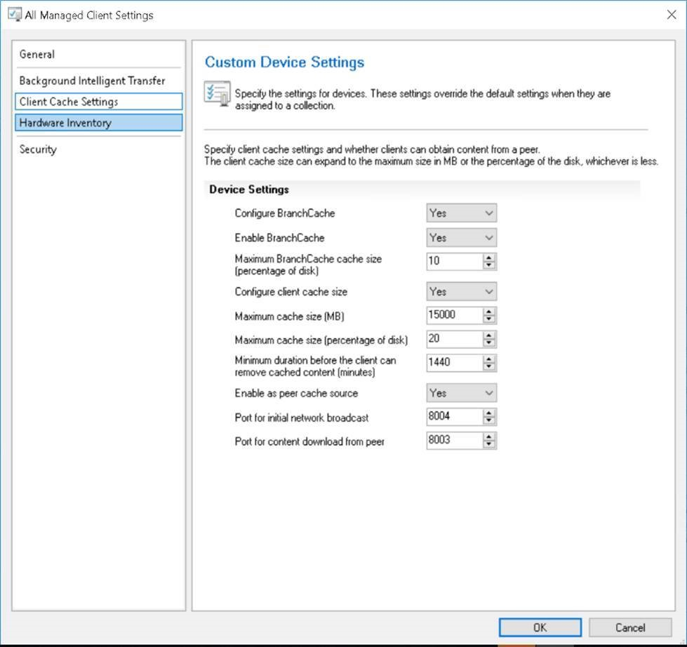

* Custom BranchCache Removal (Priority 7) – It disables BranchCache

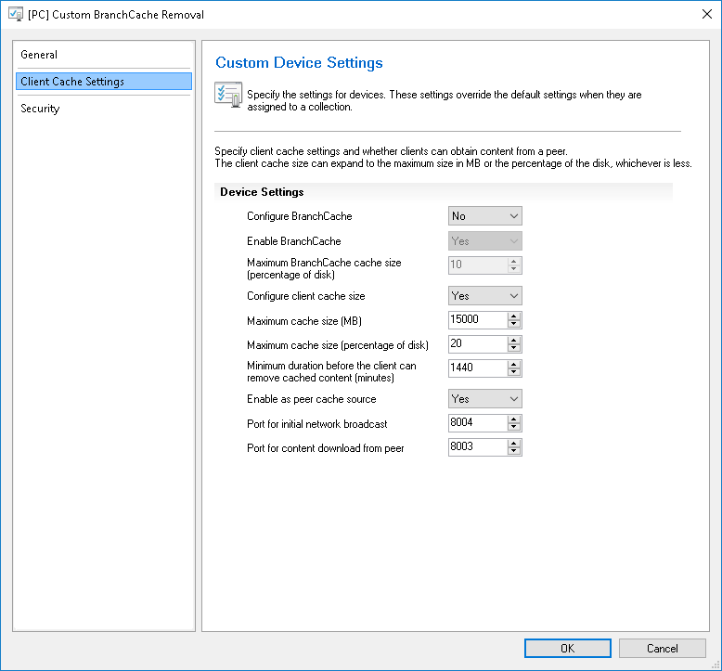

**VDI RAA BITS Client Settings**

* Default Settings

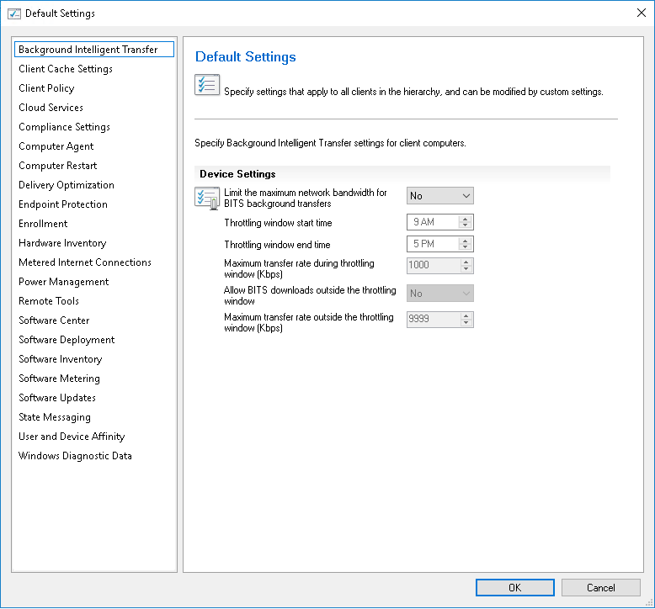

* GSK VDI RAA Client Settings

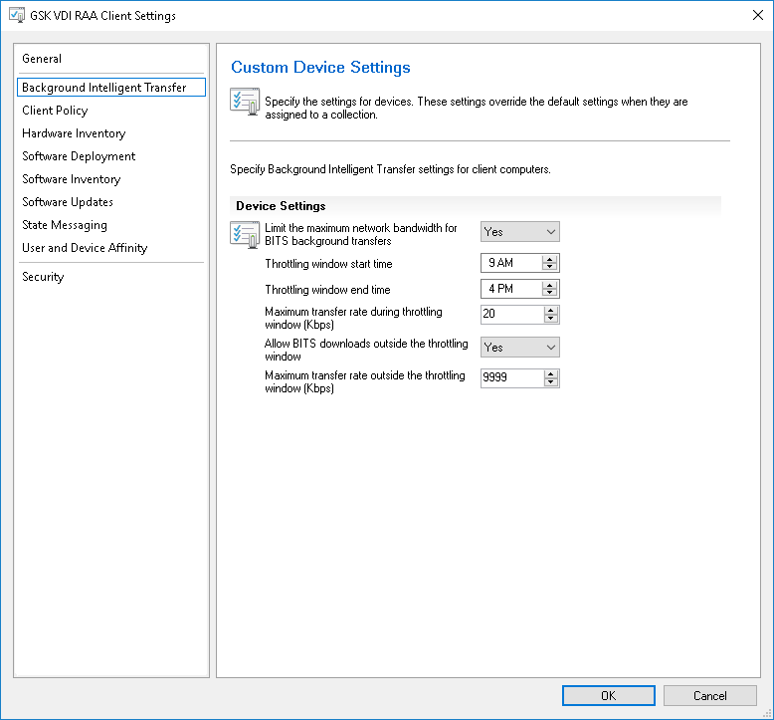

# Monitoring Tools (if any)

Spectrum Tool Agent is installed on all the SCCM Servers and the alerts for the availability of servers will be generated and it will be monitored by Wintel Team.

# 9 VAMT Management

The Volume Activation Management Tool (VAMT) enables administrators and other IT professionals to automate and centrally manage the Windows®, Microsoft® Office, and select other Microsoft products volume and retail-activation process.

VAMT can manage volume activation using Multiple Activation Keys (MAKs).

We can use a MAK or a retail product key to activate Windows Computer or a group of computers. VAMT enables two different activation scenarios:

* **Online activation.**
* **Proxy activation.**

The document is available on [SharePoint Link](https://teams.microsoft.com/l/file/34285E25-A1DB-4B89-8885-7909C0D0CE99?tenantId=63982aff-fb6c-4c22-973b-70e4acfb63e6&fileType=docx&objectUrl=https%3A%2F%2Fmyteams.gsk.com%2Fsites%2FProjectOAK-EndUserServicesCollaborationSite%2FShared%20Documents%2FKnowledge%20Absorption%2FModern%20Workspace%2FPC%20Release%26Patching%2FKuba%2FVAMT%20-%20management.docx&baseUrl=https%3A%2F%2Fmyteams.gsk.com%2Fsites%2FProjectOAK-EndUserServicesCollaborationSite&serviceName=teams&threadId=19:8a929c86556b41f5837557a2f7fe3080@thread.tacv2&groupId=9c47df16-8088-4711-ad0c-59da448debd8) which describes how to install VAMT and use it to configure client computers on GSK network.

# License Management (if applicable)

# 11 ITSM Processes

|  |  |
| --- | --- |
| **Queue** | **Managed by** |
| PC- Release Patching | PC-ReleaseMgt-L2 |
| Win 10 Deployment Issues | PC-Build-L2 |
| Application Distribution | PC-AppCatalogInstall-L2 |
| SCCM Infra & Server Patching | ReleaseIntegration-L2 |

Frequency of Incidents Flow: Less than 100 Incidents/Month

All the Remedy Incidents need to be closed in the Remedy Tool.

Below are the functions with respect to ServiceNow

|  |  |  |  |  |  |
| --- | --- | --- | --- | --- | --- |
| **Function** | **Service Line** | **Service** | **Service Owner** | **Service Offering** | **CI ID** |
| Core Tech | End User Services | Modern Workspace | John Saenz | PC Release Management | S079776120 |
| Core Tech | End User Services | Modern Workspace | John Saenz | PC Release Management | S079776120 |

|  |  |  |  |
| --- | --- | --- | --- |
| **Service Offering Owners** | **Support Group** | **Approval Group** | **Technical/Peer Approvers** |
| Adrianna Tokarska | PC-ReleaseMgt-L2 | AP-PC-ReleaseMgt-L2 | AP-TA-PC-ReleaseMgt |
| Adrianna Tokarska | PC-ReleaseMgt-L2 | AP-PC-ReleaseMgt-L2 |  |

The ServiceNow CABs for Hosting Services SCCM support are:

|  |  |  |  |  |
| --- | --- | --- | --- | --- |
| CAB Name | CAB Type | TimeZone | CAB Manager | CAB Approval Group |
| CoreTech CAB ReleaseIntegration | Normal | US/Eastern | Neil Stewart | AP-CAB-ReleaseIntegration-L2 |
| CoreTech eCAB ReleaseIntegration | Emergency | GMT | Neil Stewart | AP-CAB-ReleaseIntegration-L2 |

Normal changes raised for Server Release activities use the following ServiceNow groups:

* Assignment Group – ReleaseIntegration-L2
* Support Group – ReleaseIntegration-L2
* Technical/Peer Approvers – AP-TA-EnterpriseComputingWindows-L2

# Vendor Management (if applicable)

Connect with **Krzysztof Karpinski** to get access to Microsoft Service Hub Portal [Services Hub (microsoft.com)](https://serviceshub.microsoft.com/support/manage/923616d9-b1f1-44f8-8786-30be5336d28d?state=open).  
From Service Hub portal we can directly create a case with Microsoft for any issue in the environment in order to get technical support.

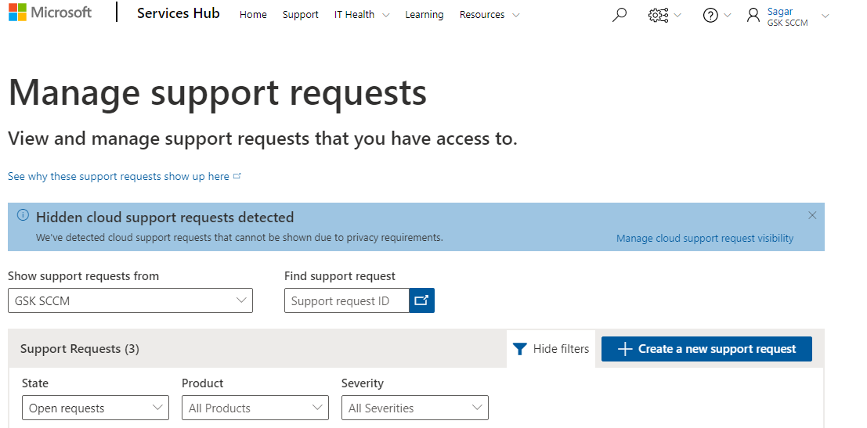

# Support Levels



## SLA

Following table depicts the present service level agreement (SLA) for incident management.

|  |  |  |  |  |  |
| --- | --- | --- | --- | --- | --- |
| **​Current Remedy SLA ​** | | ​ | **​NEW GSK SLA in ServiceNow** | | |
| ​ | **Response** | **Resolution​** | ​ | **​Response** | **Resolution** | **​Schedule** |
| ​**Critical** | ​15 mins | ​2 hours | **​P1 – Critical ​** | ​15 mins ​ | ​2 hours | ​24x7 ​ |
| **Urgent** | ​1 hour | ​4 hours |
| **​High** | ​2 hours | ​1 day | **​P2 – High** | ​1 hour | ​8 hours | ​24x7 |
| **​Medium** | ​4 hours | ​3 days | **​P3 – Moderate** | ​4 hours | ​​3 days | ​9-5 weekdays |
| **​​Low** | ​8 hours | ​10 days | **P4 – Low** | ​8 hours | ​5 days | ​9-5 weekdays |

Service Level Agreement for PC Release and Patching Service is yet to update with the new values and currently the document is available in [CDMS](http://cdms-prod.gsk.com/edoccompliance/edoc-eng/start/home/default.asp?nodename=REC_00000124747&nodetype=document)

## On-Call Rotations

HCL BAU team would be provide support of 24X7 for all Priority 1 and 2 calls.

# Approval Flow Process (if applicable)

# Service Desk Contacts Details

# GSK Key Contacts & Roles

|  |  |  |
| --- | --- | --- |
| **GSK Team** | **Key GSK Contacts** | **Comment** |
| Compute (EMEA) | Grzegorz Gruszecki  Karol Dabrowski | Europe based team who engineer and support Windows, UNIX and Linux |
| Compute (Americas) | Mike Moore | US based team who engineer and support Windows, UNIX and Linux |
| Server Release Team | Neil Stewart  Ray Grab | Team currently responsible for patching Windows (SCCM), Linux (Ansible) and Solaris (Altiris) servers |
| SCCM and Altiris Infrastructure Support | Neil Stewart  Kris Karpinski | Hosting Services team responsible for supporting SCCM infrastructure |
| SCCM Modern Workspace | John Saenz  Ilona Szymoniak  Adrianna Tokarska  Michael Freedberg | EUS team responsible for workstation build, engineering and release management |
| Change Management Team | Don Grant |  |
|  | Bruce Foreacre | Person who is responsible for extension of license for Windows Server 2008 R2 |

# 17 RACI Matrix

**Infrastructure RACI:**

|  |  |  |  |
| --- | --- | --- | --- |
| **Activity** | **HCL SCCM** | **HCL** **Wintel** | **GSK** |
| **Vendor Platform** |  |  |  |
| Develop new functionalities / Enhance existing features | RA |  | C, I |
| Manage vendor relationships including issue review and escalation | I |  | RA, C |
| Smart Controls and RMS Risks | I | C, I | RA |
| Account reconciliation (PAMS) every 90 days. | I | I | RA |
| **Infrastructure** |  |  |  |
| Create / Manage / Remove Site Servers / Roles (DPs) | RA |  | C, I |
| Manage Install / Upgrades / Patches to Platform | RA | I | C, I |
| Agent Ownership (including resolve agent issues on workstations and servers) | RA |  | I |
| Windows server 2008/2008R2 ESU management | I | RA | C, I |
| Package Promotion | RA |  | I |
| Create / Manage Client Settings | RA |  | C, I |
| Capacity Management | C, I | RA | CI |
| Account / Group /Permissions Administration in console (need ownership of accounts) | A, I |  | R , C |
| Infrastructure Documentation-Initial | RA |  | I |
| Infrastructure Documentation-maintenance | RA |  | I |
| Create / Manage / Remove Boundary groups | RA |  | C, I |
| Performance Management | RA |  | C, I |
| Create / Manage / Remove Discovery rules of Active Directory forests | RA |  | C, I |
| Manage Network bandwidth rules (ie packeteer, riverbed) | C, I |  | R, A, C |
| Host protection learn for SCCM client | C, I |  | RA |
| Manage Network firewall rules | I |  | R, A |
| **Software Management** |  |  |  |
| Create / Manage Distribution Point Groups | RA |  | C, I |
| Create / Distribute Applications, Packages, Scripts | RA |  | C, I |
| Decommission Applications (Retire) | RA |  | C, I |
| **Collection Management** |  |  |  |
| Create / Manage / Delete "Platform" (Top Level) Collections (new functionality) | RA |  | I |
| Create / Manage / Delete "Platform" (Top Level) Collections (existing functionality) | RA |  | I |
| Create / Manage / Delete "Service" Collections | RA |  | I |
| Create / Manage / Delete Maintenance Windows | RA |  | I |
| **Patch/Release Management** |  |  |  |
| Create / Manage / Delete ADR's and deployments | RA |  | C, I |
| Create / Manage Schedules | RA |  | C, I |
| Third Party Patching on Servers (if required…) | RA |  | C, I |
| Clean-up Deployments / Superseded Updates / Software Update Groups | RA |  | C, I |
| Customer communication for patch cycles | RA |  | I |
| Monitoring and issue resolution for Windows workstation patching | RA |  |  |
| Monitoring and issue resolution for Windows software/application delivery on workstations | RA |  |  |
| Monitoring and issue resolution for Windows server patching (Failed to install Updates) | C, I | RA | I |
| Patch remediation on windows server | C | RA | I |
| Monitoring and issue resolution for Windows software/application delivery on servers | RA |  | I |
| SCCM Client Management (issue resolution, upgrades) | RA |  | C, I |
| **Custom Reporting/Automation** |  |  |  |
| Develop Custom Server HSC reports | RA |  | I |
| Develop Custom Workstation reports | RA |  | I |
| Develop custom automation for Server (BOB, SIT, Patch) | I |  | RA |
| Develop custom Application distribution automation  (Workstation) (ASIP) | I |  | RA |
| Develop custom automation | I |  | RA |
| Data replication for reporting (Reporting Server) | RA |  | C, I |
| **License Management/Audit/Change** |  |  |  |
| Change Management using ServiceNow | RA | RA | I |
| Audit Accountability | I |  | RA |
| Contract renewals (Microsoft) | I |  | RA |
| Usage Tracking (Licenses) |  |  | RA |
| **Service Documentation** |  |  |  |
| Create / Maintain Operational LINs, SOPs | RA | RA | I |
| **Vulnerability Management** |  |  |  |
| Ownership and review of Archer data for SCCM vulnerabilities | C, I | RA | I |