IRootLab Tutorials

2-region Pre-processing example

Julio Trevisan

30/November/2012

[Creative Commons Licence](http://creativecommons.org/licenses/by-nc-sa/3.0/)  
This document is licensed under a [Creative Commons Attribution-NonCommercial-ShareAlike 3.0 Unported License](http://creativecommons.org/licenses/by-nc-sa/3.0/).

# Contents

2-region Pre-processing example 1

Contents 1

Introduction 1

Summary of operations 1

Load and visualize data 2

High region (3700-2800 cm-1) 3

Low region (1800-900 cm-1) 5

Merge two datasets column-wise 7

Visualize result 7

# Introduction

This tutorial shows how to pre-process two different mid-IR regions separately, and then merge them together into a single dataset.

This tutorial uses Matt’s Nanoparticles Synchrotron data, which is shipped with IRootLab. This dataset has spectra initially in the 4000-900 cm-1 region.

# Summary of operations

* Load data
* High region:
  + Cut original to 3700-2800 cm-1 region
  + Rubberband baseline correction
  + Max normalization
* Low region:
  + Cut original to 1800-900 cm-1 region
  + Rubberband baseline correction
  + Amide I peak normalization
* Merge two datasets column-wise

# Load and visualize data

1. At MATLAB command line, enter browse_demos
2. Click on “LOAD_DATA_MATT_NANOPARTICLES_SYNCHROTRON”
3. Click on “objtool” to launch objtool

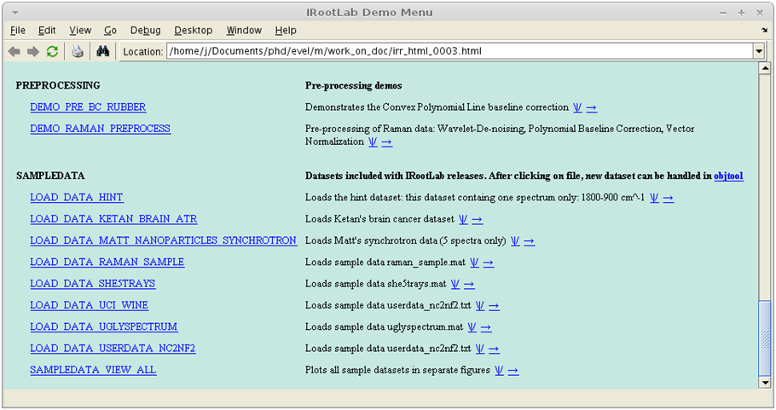

**2**

**3**

1. Click on **vis**
2. Click on **Class means**
3. Click on **Create, train & use**

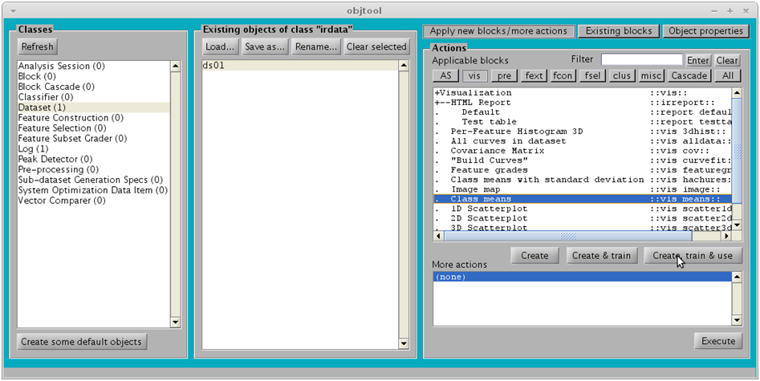

**4**

**5**

**6**

The following figure should appear:

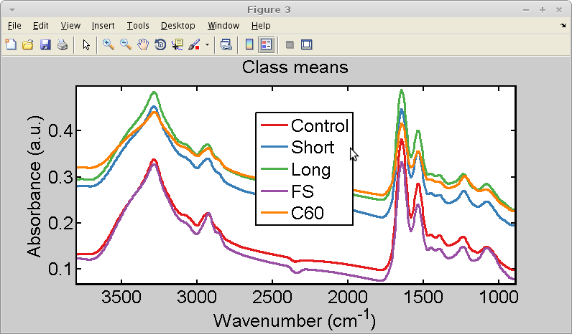

# High region (3700-2800 cm-1)

1. Click on **fsel**
2. Click on **Create, train & use**

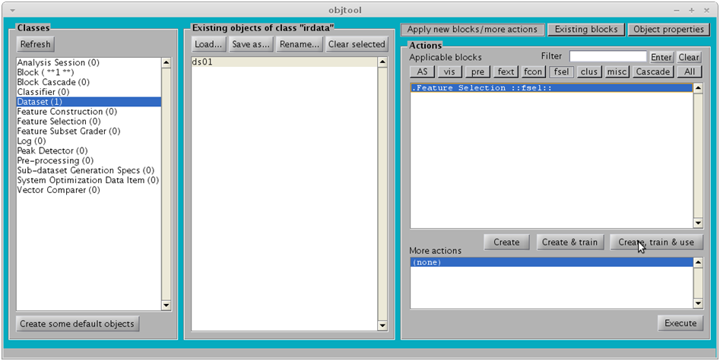

**7**

**8**

1. Specify region **[3700, 2800]** (see below)
2. Click on OK

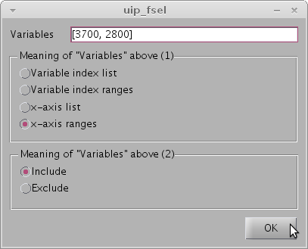

1. Click on ds01_fsel01
2. Click on **pre**
3. Click on **Rubberband-like**
4. Click on **Create, train & use**

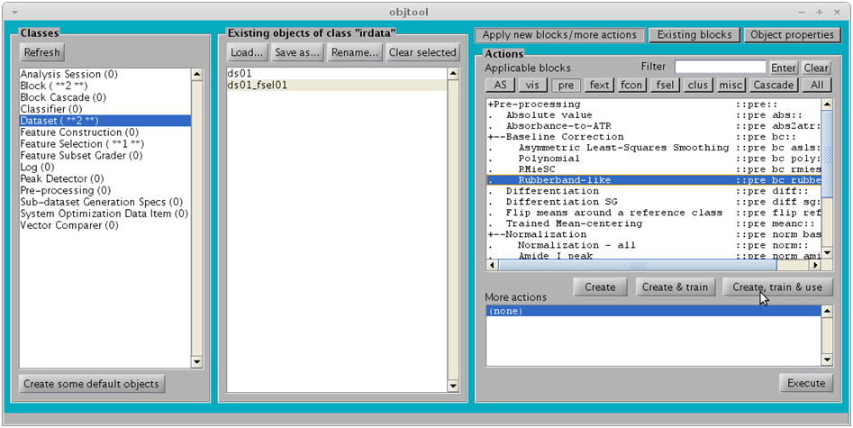

**11**

**12**

**13**

**14**

1. Click on **OK**

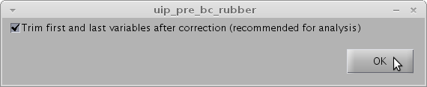

1. Click on **ds01_fsel01_rubber01**
2. Click on **Normalization-all**
3. Click on **Create, train & use**

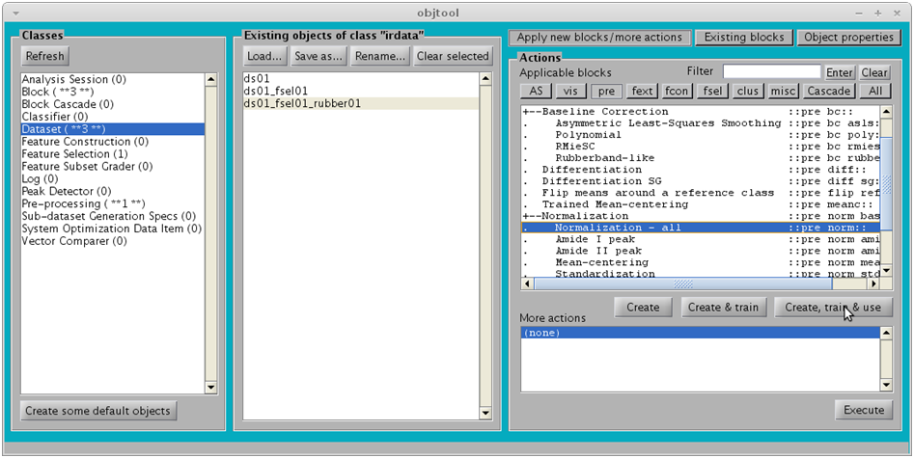

**16**

**17**

**18**

1. Click on **OK**

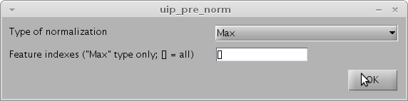

# Low region (1800-900 cm-1)

1. Click on **ds01**
2. Click on **fsel**
3. Click on **Create, train & use**

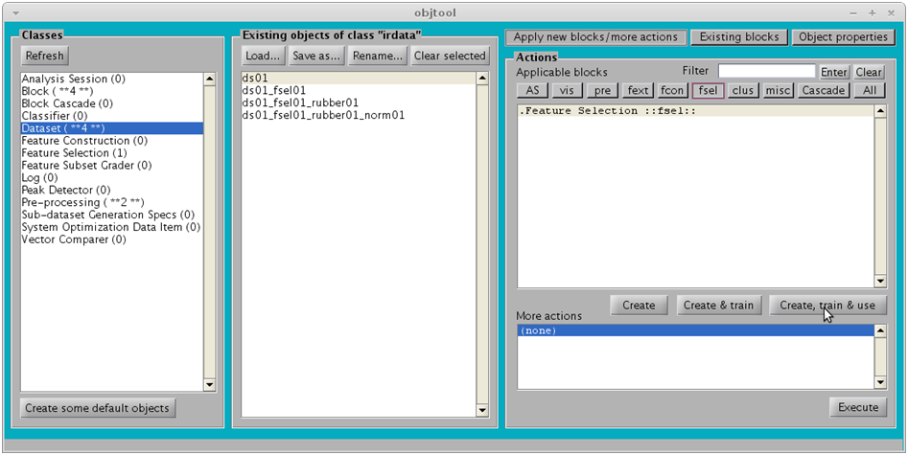

**20**

**21**

**22**

1. Accept the default **[1800, 900]** region (see below)
2. Click on OK

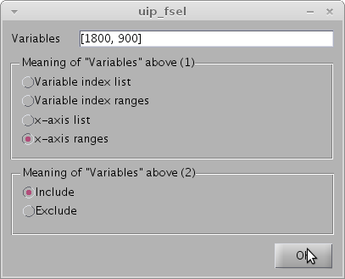

1. Click on **ds01_fsel02**
2. Click on **Existing blocks** (we are going to re-use some blocks)
3. Click on pre_bc_rubber01
4. Click on Use

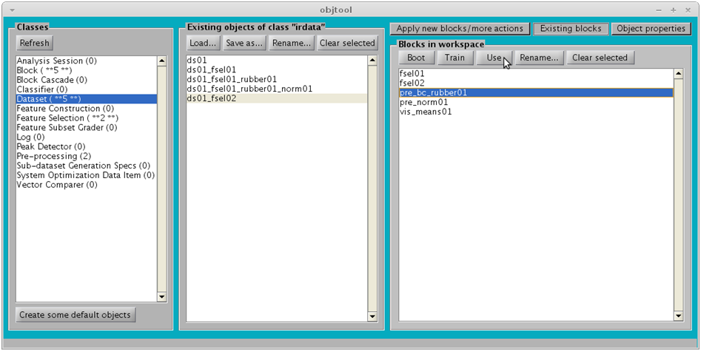

**25**

**27**

**28**

**26**

1. Click on **ds01_fsel02_rubber01**
2. Click on pre_norm01
3. Click on Use

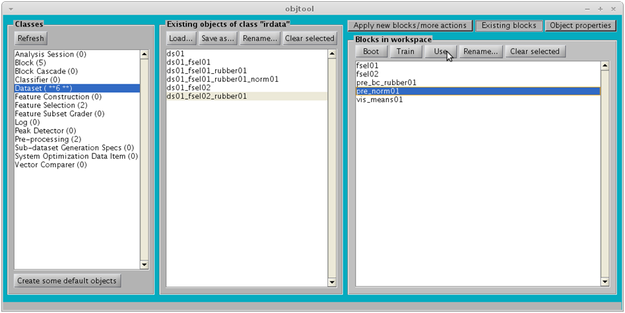

**29**

**30**

**31**

# Merge two datasets column-wise

1. Hold down the “Ctrl” key to select multiple items
2. Select ds01_fsel01_rubber01_norm01 and ds01_fsel02_rubber01_norm01
3. Click on Apply new blocks/more actions
4. Click on Misc
5. Click on Column-wise
6. Click on Create, train & use

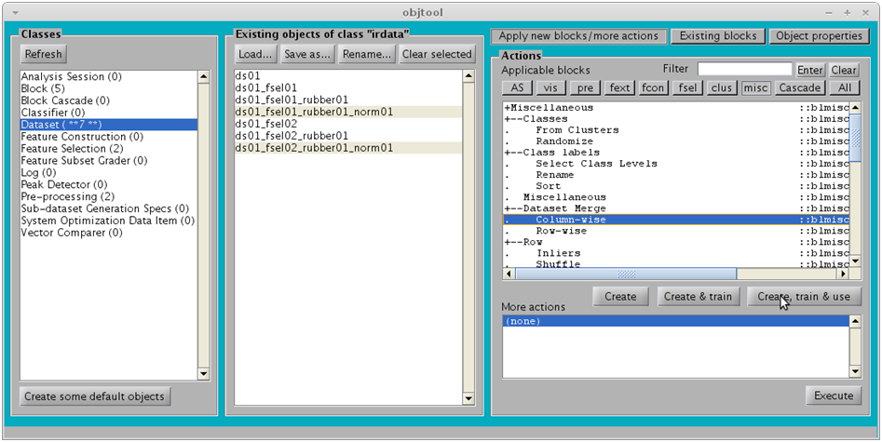

**33**

**35**

**36**

**37**

**34**

# Visualize result

1. Click on irdata_cols01
2. Click on Existing blocks (we are going to re-use the class means visualization block)
3. Click on vis_mean01
4. Click on Use

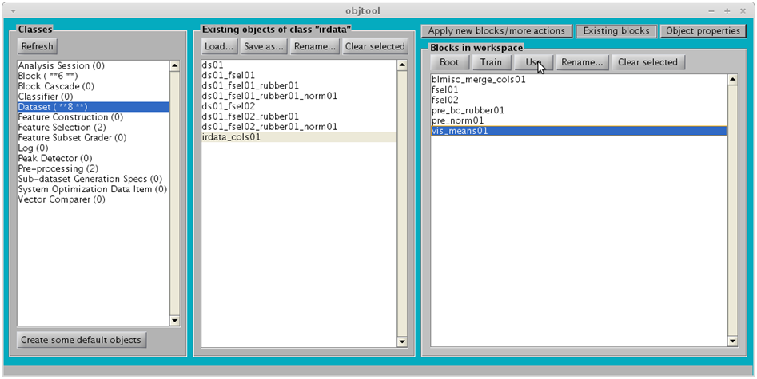

**2**

**1**

**3**

**4**

The following figure should appear:

