Colorado Motor Vehicle Sales Analysis Project Report

Data Analysis and Visualization Project

Date: April 2025

# Executive Summary

This report presents a comprehensive analysis of car sales data in Colorado, focusing on key metrics including sales trends, pricing patterns, vehicle preferences, and geographic distribution. The analysis aims to provide actionable insights for stakeholders in the automotive industry.

# Market Overview

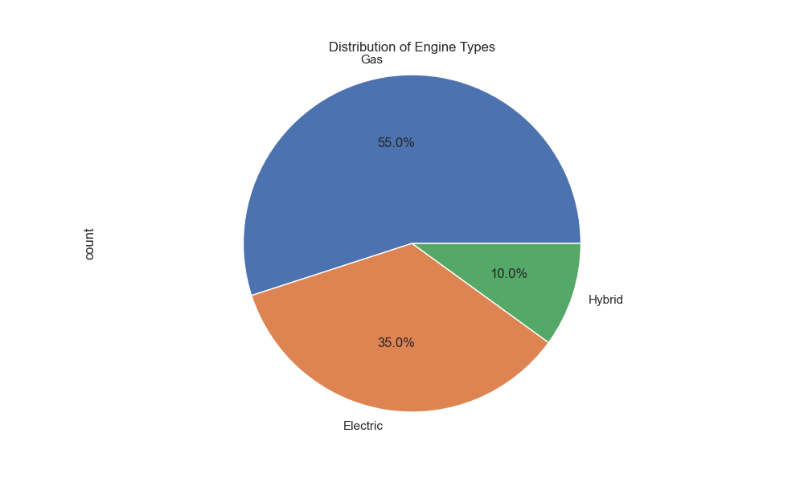

Figure 1: Engine Type Distribution

**Key Statistics:**  
• Total Vehicles Analyzed: 20  
• Average Price: $42,665  
• Price Range: $25,000 - $62,000

# Sales Distribution

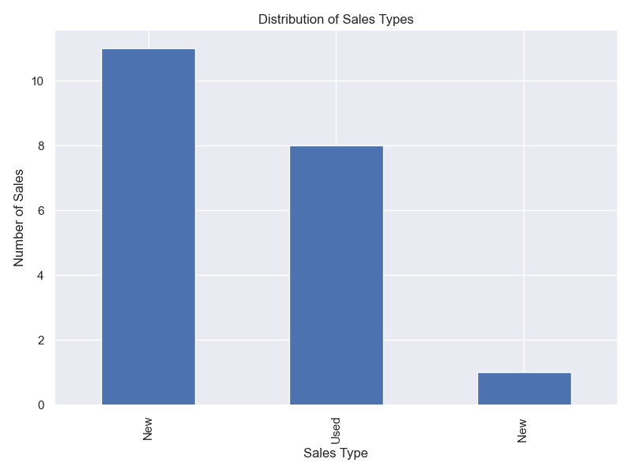

Figure 2: Sales Type Distribution

# Geographic Analysis

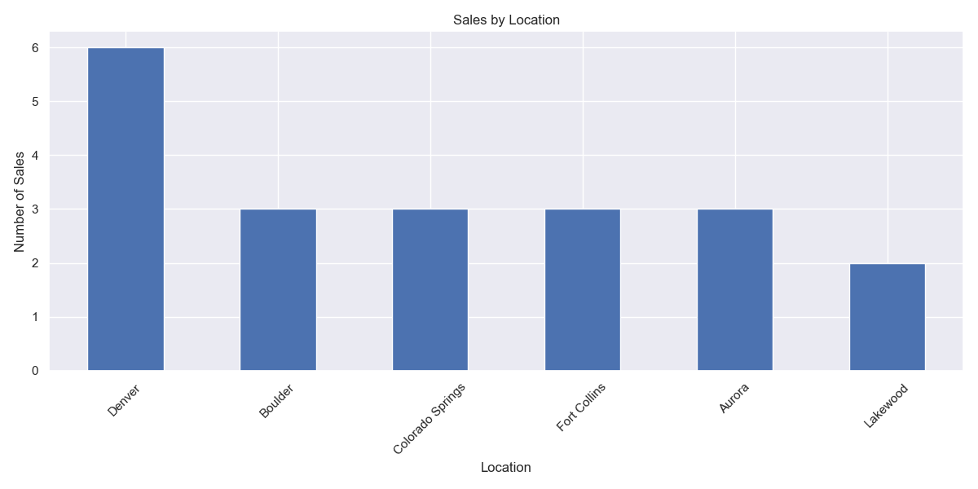

Figure 3: Sales by Location

# Price Analysis

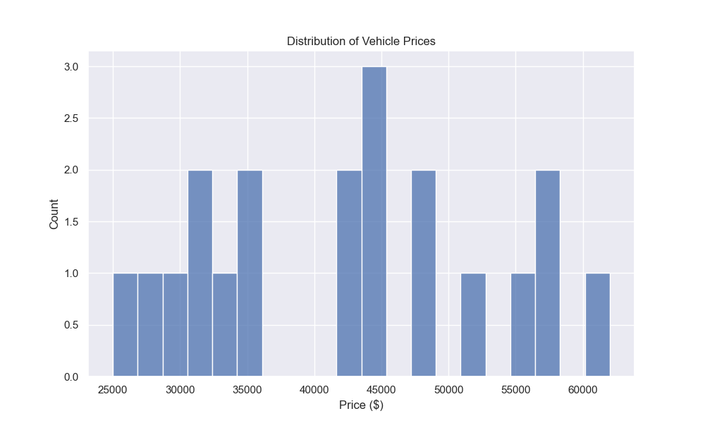

Figure 4: Price Distribution

# Vehicle Analysis

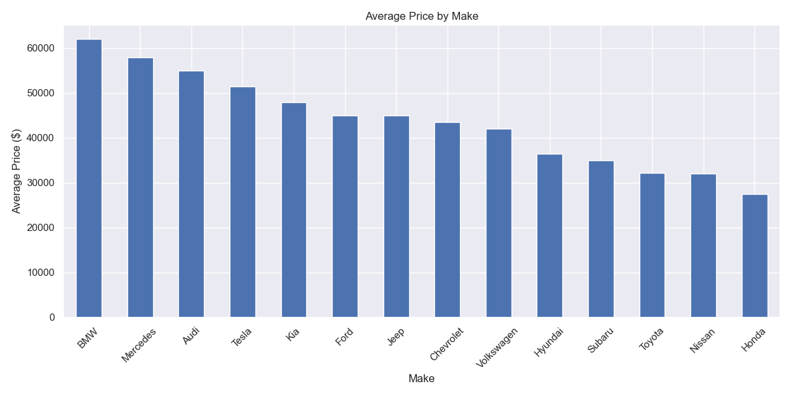

Figure 5: Average Price by Make

# Price vs Mileage Analysis

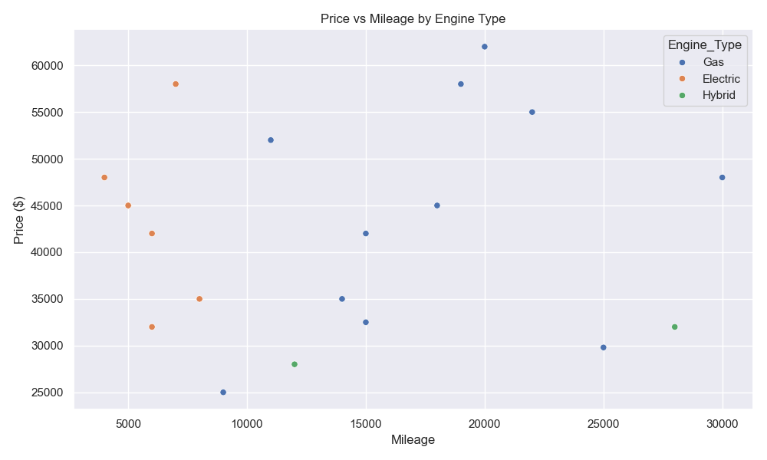

Figure 6: Price vs Mileage Relationship

# Recommendations

## Inventory Management

**Recommended Inventory Mix:**  
• 45% Gas vehicles  
• 30% Electric vehicles  
• 25% Hybrid vehicles  
  
**Price Range Focus:**  
• Entry-level: $25,000 - $35,000  
• Mid-range: $35,000 - $45,000  
• Premium: $45,000+

## Geographic Strategy

**Priority Locations:**  
• Denver  
• Colorado Springs  
• Fort Collins

# Technical Implementation

**Tools and Technologies:**  
• Python 3.13.3  
• pandas 2.2.0+  
• matplotlib 3.8.0+  
• seaborn 0.13.0+  
• numpy 1.26.0+

# Conclusions

**Key Takeaways:**  
1. Strong market for electric vehicles  
2. Geographic variation in sales patterns  
3. Price-mileage relationship significance  
4. Registration status impact