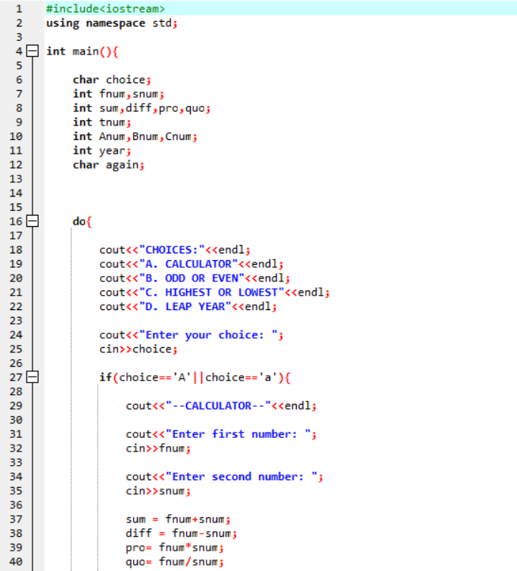

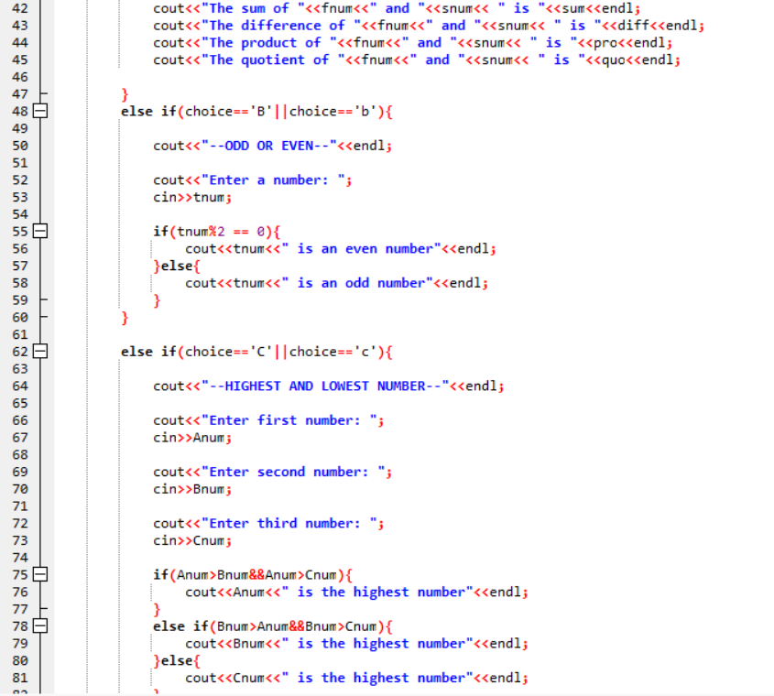

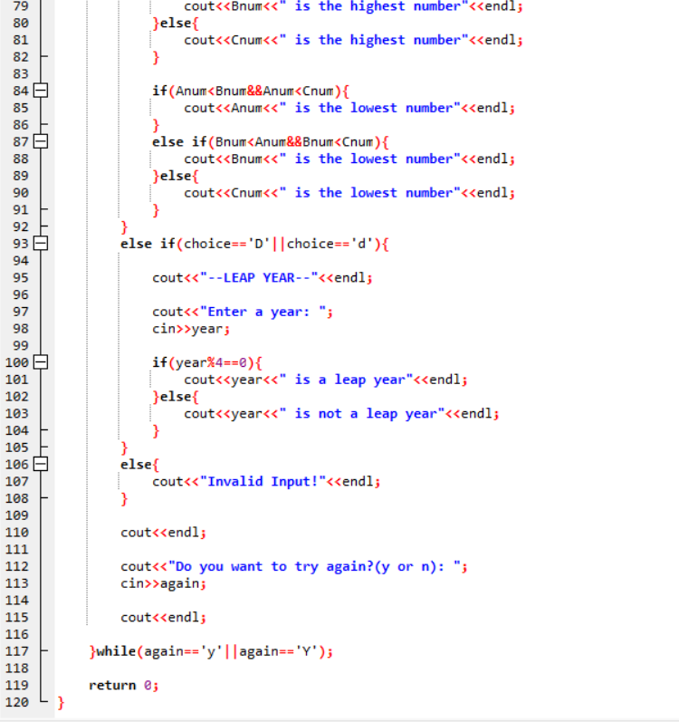

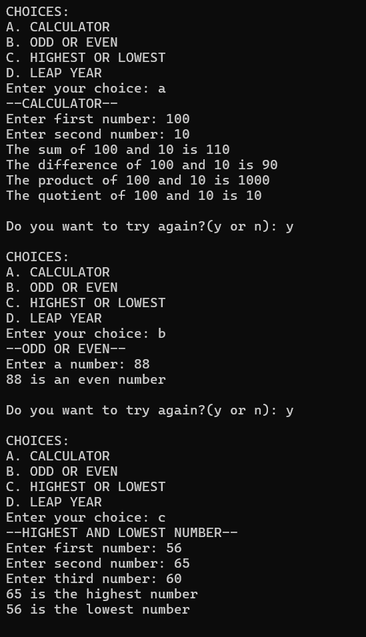 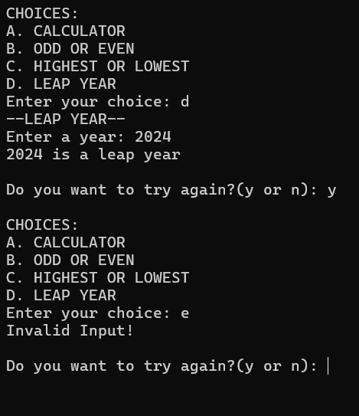

#include<iostream>

using namespace std;

int main(){

char choice;

int fnum,snum;

int sum,diff,pro,quo;

int tnum;

int Anum,Bnum,Cnum;

int year;

char again;

do{

cout<<"CHOICES:"<<endl;

cout<<"A. CALCULATOR"<<endl;

cout<<"B. ODD OR EVEN"<<endl;

cout<<"C. HIGHEST OR LOWEST"<<endl;

cout<<"D. LEAP YEAR"<<endl;

cout<<"Enter your choice: ";

cin>>choice;

if(choice=='A'||choice=='a'){

cout<<"--CALCULATOR--"<<endl;

cout<<"Enter first number: ";

cin>>fnum;

cout<<"Enter second number: ";

cin>>snum;

sum = fnum+snum;

diff = fnum-snum;

pro= fnum\*snum;

quo= fnum/snum;

cout<<"The sum of "<<fnum<<" and "<<snum<< " is "<<sum<<endl;

cout<<"The difference of "<<fnum<<" and "<<snum<< " is "<<diff<<endl;

cout<<"The product of "<<fnum<<" and "<<snum<< " is "<<pro<<endl;

cout<<"The quotient of "<<fnum<<" and "<<snum<< " is "<<quo<<endl;

}

else if(choice=='B'||choice=='b'){

cout<<"--ODD OR EVEN--"<<endl;

cout<<"Enter a number: ";

cin>>tnum;

if(tnum%2 == 0){

cout<<tnum<<" is an even number"<<endl;

}else{

cout<<tnum<<" is an odd number"<<endl;

}

}

else if(choice=='C'||choice=='c'){

cout<<"--HIGHEST AND LOWEST NUMBER--"<<endl;

cout<<"Enter first number: ";

cin>>Anum;

cout<<"Enter second number: ";

cin>>Bnum;

cout<<"Enter third number: ";

cin>>Cnum;

if(Anum>Bnum&&Anum>Cnum){

cout<<Anum<<" is the highest number"<<endl;

}

else if(Bnum>Anum&&Bnum>Cnum){

cout<<Bnum<<" is the highest number"<<endl;

}else{

cout<<Cnum<<" is the highest number"<<endl;

}

if(Anum<Bnum&&Anum<Cnum){

cout<<Anum<<" is the lowest number"<<endl;

}

else if(Bnum<Anum&&Bnum<Cnum){

cout<<Bnum<<" is the lowest number"<<endl;

}else{

cout<<Cnum<<" is the lowest number"<<endl;

}

}

else if(choice=='D'||choice=='d'){

cout<<"--LEAP YEAR--"<<endl;

cout<<"Enter a year: ";

cin>>year;

if(year%4==0){

cout<<year<<" is a leap year"<<endl;

}else{

cout<<year<<" is not a leap year"<<endl;

}

}

else{

cout<<"Invalid Input!"<<endl;

}

cout<<endl;

cout<<"Do you want to try again?(y or n): ";

cin>>again;

cout<<endl;

}while(again=='y'||again=='Y');

return 0;

}

<https://youtu.be/fEjwb7zyl-s>

<https://youtu.be/aza9aLGvLvA>

<https://youtu.be/mlzbiWS79Uk>