HCI Assessed Exercise – Report
Nicole Kearns

The exercise was to create an application for the Glasgow Commonwealth Games 2014, building on the material provided in the lecture notes. I decided to make an application, using Django web framework, which allows you to keep up to date on when the events are and where, provide live updates of what's happening during the games and allow you to view results. I have aimed my application for both people attending the games and those who are unable to attend, allowing them to keep updated with what is happening. The application provides a 'follow your nation' feature which allows you to view updates and results specific to your preferred nation, and also allows you to place your vote, just for fun, on who you think will win any given event.

Wire-frame Design

In order to make my application as easy and simple as possible to use, I provided a consistent interface, allowing the user to become familiar with how it works and navigating through the different pages.

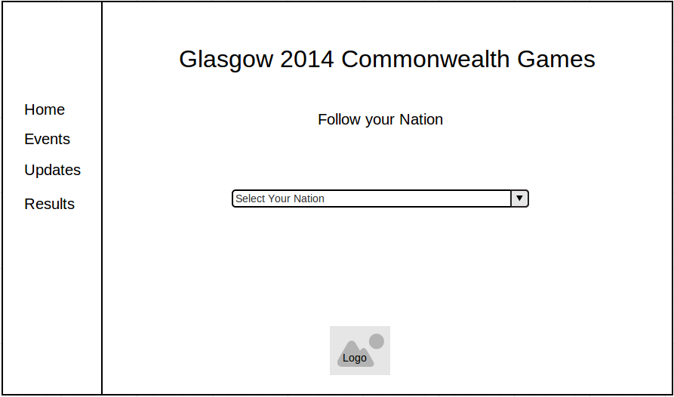
For each page, I have split the page into two sections: A menu and a section providing the information. Having this simple layout, means that the user can access the menu from any page throughout the application and not have to go back to the home page each time they wish to go to another page. For the home page, I provided a simple drop-down list which allows the user to select the nation they would like to 'follow' and this will filter the necessary details throughout the application.
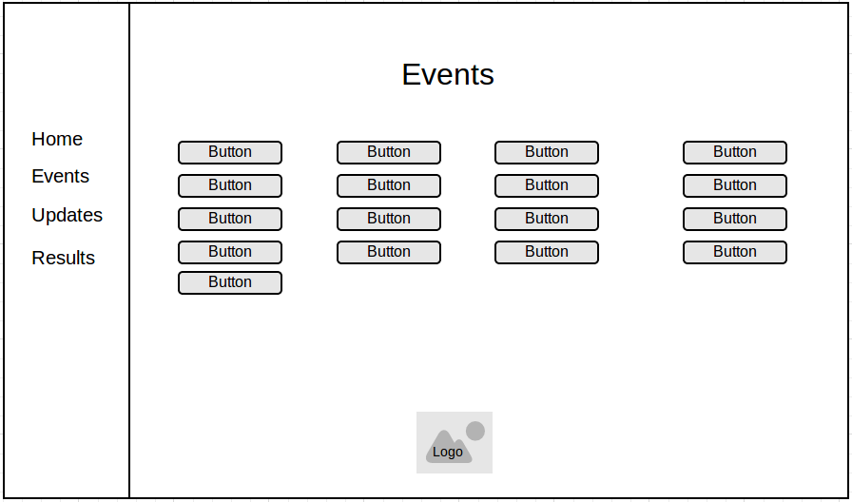
For the events page, I used a large button for each event in order to keep it simple and easy for the user to get to the information they would like to view.

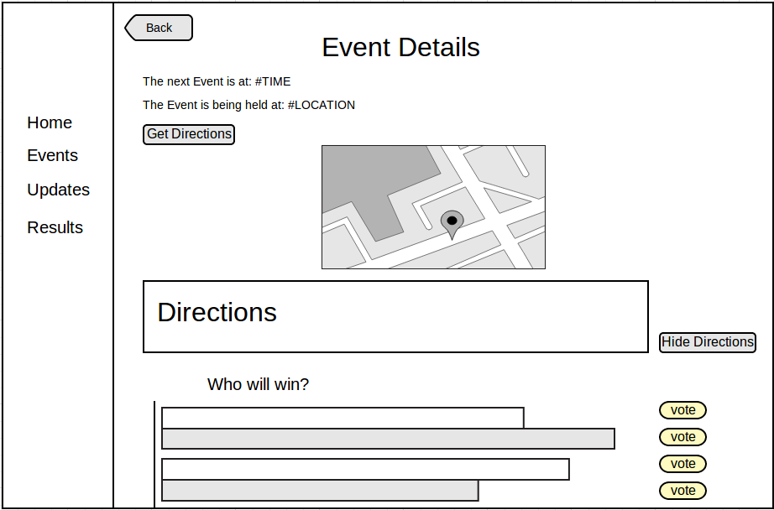
Within each event button, the user will be able to see details about when and where the next event is. For user who may not be from the area or those who are unfamiliar with the area, I used a map in order to show where the event is being held and directions on how to get there. Fot those who don't need directions, I provided a 'Hide Directions' button to remove the map and directions from the page. I added a simple, fun poll at the bottom in order to had a game-like feature to the application, allowing users to vote for who they think will win the event, using simple 'vote' button to place their vote.
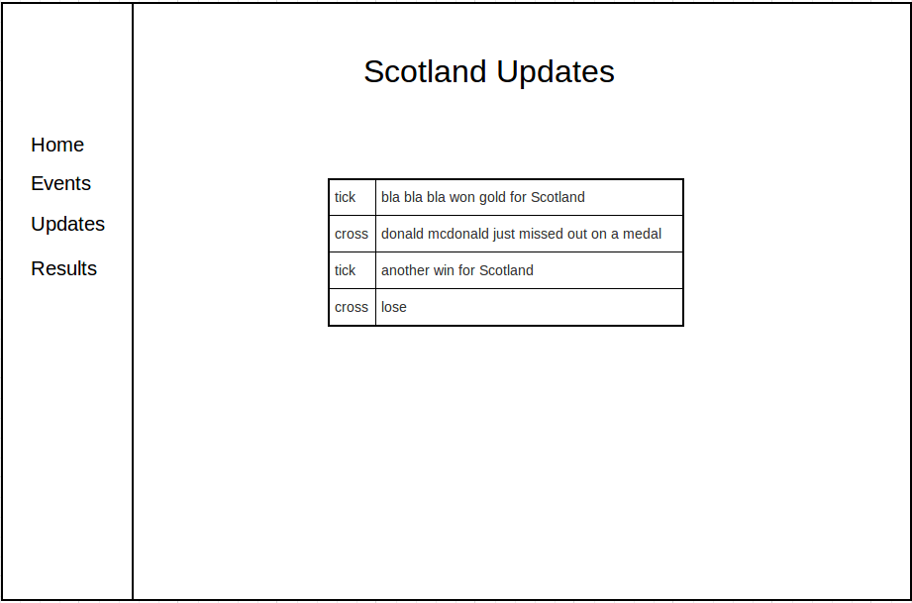
The updates page is filtered to the nation which the user selected to follow from the home page. This provides simple statements for events currently happening, allowing users who may be unable to attend the games to keep up to date with what's happening.

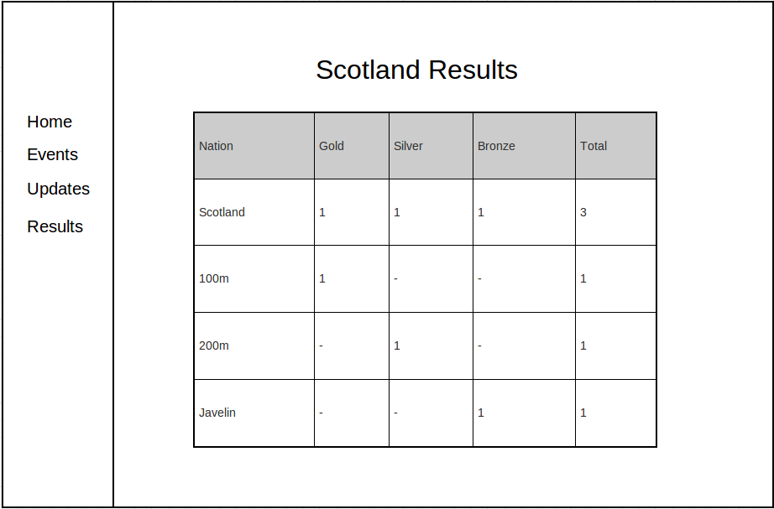
The results page is filtered to the nation which the user selected to follow on the home page. This simply provides a table containing the the number of gold, silver and bronze medals and the total number won, and a breakdown of which events the medals where won.

In order to evaluate my initial design for my application, I created paper prototypes and had a handful of users carry out a few simple tasks on the paper prototypes as if it were a web-application using a Think-aloud technique in order to understand their thoughts throughout each task and identify any problems they come across. The tasks were as follows:

- Starting on the home page, select Scotland as your nation to follow.
- Go to the events and view the event details for 100m track.
- Go to the events page and view the event details for 200m track.
- View event details for table tennis.
- View updates for all nations.
- View the results for Canada.
- View the results for all Nations to see who is currently in the lead.

From the simple evaluation, it was clear that the users had no problems navigating through the different pages and selecting their nation to follow. However, when carrying out task 3, it was suggested that a 'Previous' or 'Back' button be provided in order to prevent having to keep going back to the Events page. I found that having the user select the nation they would like to follow on the home page meant that if they wanted to view results for other nations, they had to go back to the home page in order to change their selection, which means continually having to leave the page you are on to view the information you would like and resulted in being quite time consuming.

After the results from the paper prototype evaluation, I changed the initial design to allow the user to select their nation on the relevant pages, the update and results page, as shown below.

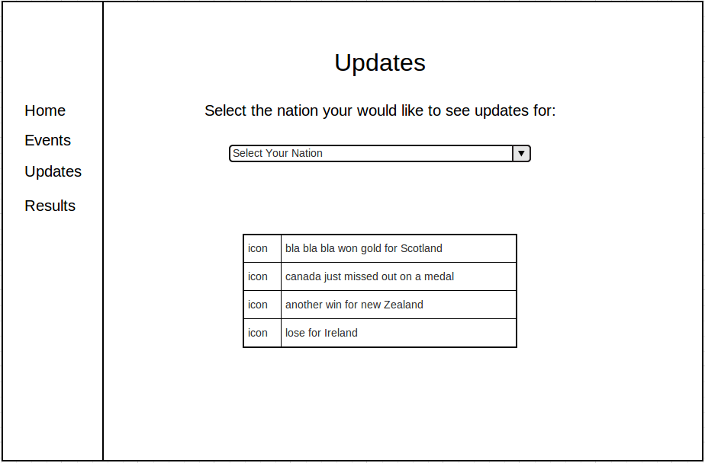
I also provided 'Back' buttons, where necessary, to allow the users to jump back to the previous page.

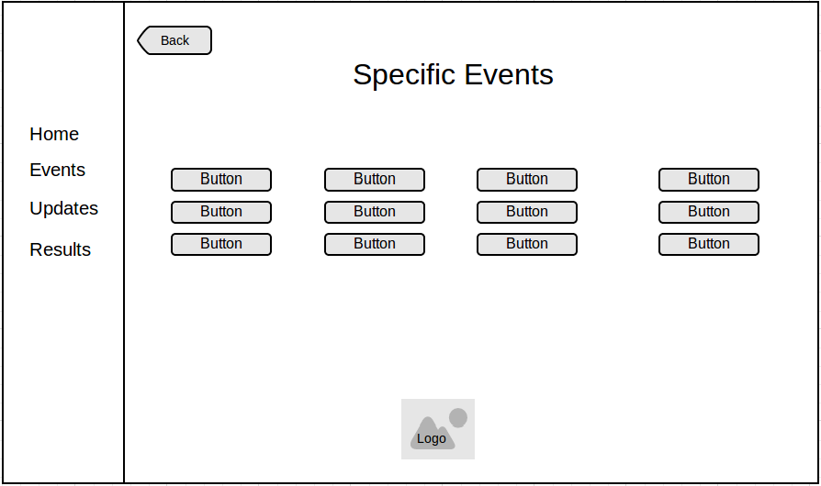
Application Design

The final designs of my application are very similar to the wire frames provided, with only very small changes. I tried to make the application as consistent as possible in order to allow the user to become familiar and confident with the interface. For each page, I used the same simple layout, providing a simple menu and a larger area for the information. Keeping this consistent means that the user can easily use the menu to navigate through the different pages within the application, from within any page of the application.

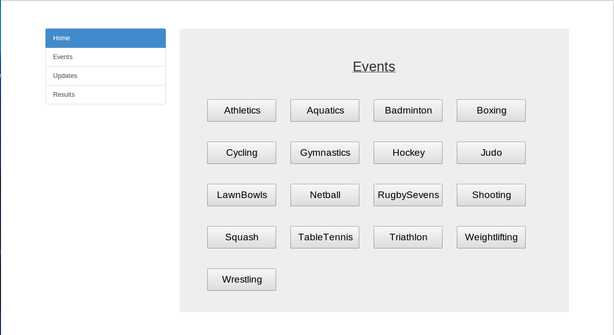
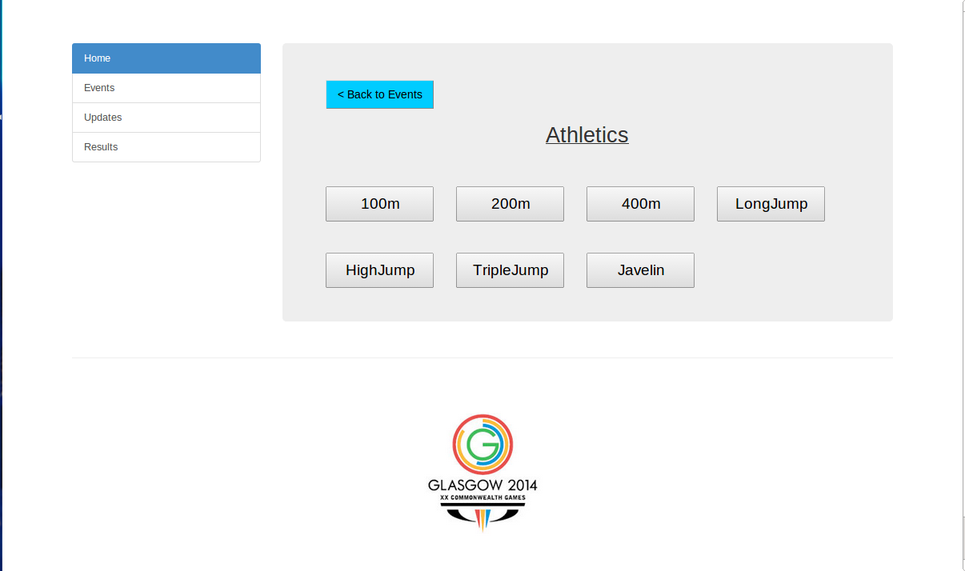

For the events page and the specific events pages, I provided large buttons for each event in order to make them easier for the users to click, as small buttons can sometimes provide issues in that users sometimes over-shoot and miss the buttons they intended to click. I provided sound effects for when the user hovers over the buttons, the name of the event is read out. This is useful for users who are visually impaired as it allows them to identify easily which button they are going to press. I also provided a 'Back to Events' button to allow users to return to the events page without having to use the side bar.

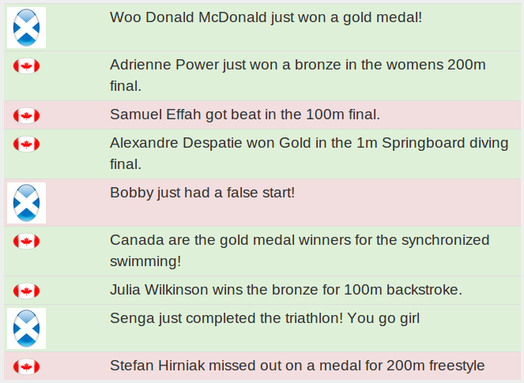
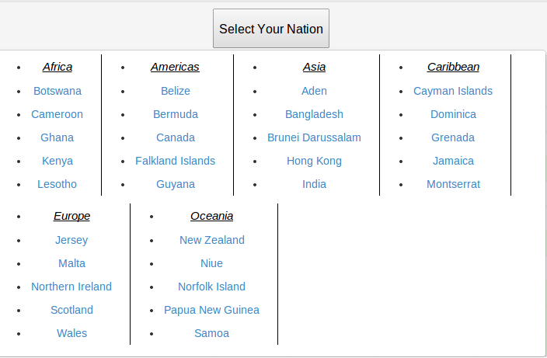

For the Updates page, I provided a simple drop-down which allows the user to select the nation they would like to see updates for. The drop-down is split into 4 columns, allowing all options to be viewed without having to scroll down, as the list is quite large, containing about 70 countries. For each update, I have highlighted the text in either green or red in order to provide instant information about whether or not the information in that update is positive or negative. I also provided either a green tick or red cross to further emphasise the result of the update.
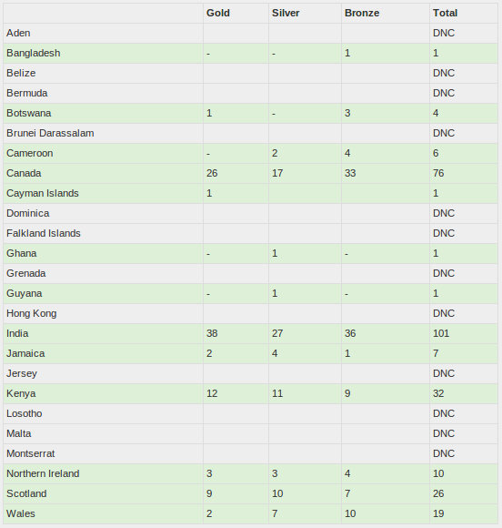

For the results page, I again provided a simple drop-down list to allow the user to select the nation they would like to view the results for. As I used data from a previous commonwealth games, some of the countries this year did not compete, so I simply denoted this with 'DNC'. For the countries which did compete, I highlighted these in green in order to try and make the users drawn more to these results. When a user selects the nation they would like to view results for, the table shows their overall results and a break down of the results, showing which events they won their medals for.

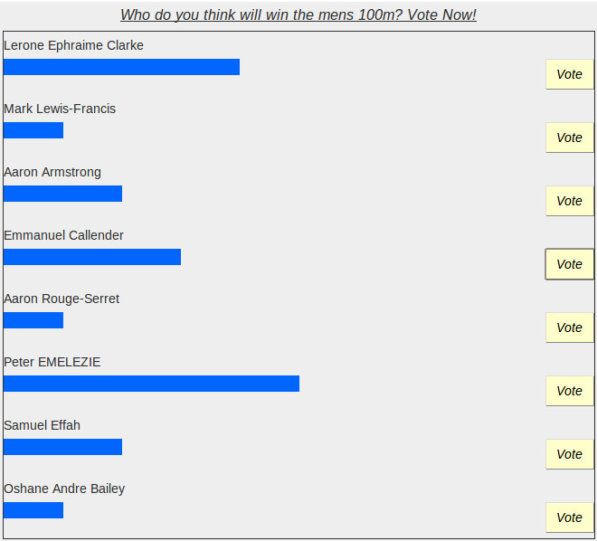

Within the details page for each event, I provided a voting poll to allow users to vote for who they think will win that event. This provides a simple game-like feature to the application and allows them to see what other people think and who the favourite to win is.

Evaluation

In order to evaluate my application, I asked a group of participants to carry out a set of simple tasks and use a think-aloud technique as they proceeded in order to understand their thought and decision-making process as they carried out each task. Before starting the evaluation, I first asked each participant to read and sign a consent form, detailing what the evaluation is for and stating that they are free to stop the evaluation at any time.

- View the event details for the 200m track and record when the next event is.
- View the live updates for Canada and record the number of negative updates.
- View the details of the 100m track and record where it is being held. View the directions on how to get here.
- Vote for who you think may win and record the current leader.
- Record the nation with the most medals so far.
- Record how many gold medals Scotland has won and for which events.
- View updates for Scotland and record how many positive updates so far.

For each participant, I recorded the time taken to perform each task. This allowed me to identify how difficult each user found the tasks as if the task took particularly long, this could indicate that the user was unsure how to do this. For each task, I took the average time taken for all participants and have recorded the results in the table below.

Task Number | Average Time Taken
1 | 44.93
2 | 22.80
3 | 19.63
4 | 15.07
5 | 27.01
6 | 36.27
7 | 10.90

From the results, it is clear that from all the tasks, task 1 and task 6 were the most time consuming tasks, which may indicate that these tasks were harder than the others. With task 1 overall taking the longest time, this could be due to this being the first time the participants are interacting with the application, so they are figuring out how it works and how to navigate through the pages. Task 1 and task 3 are really similar, and from the table it's clear that participants performed task 3 much quicker. This suggests that once participants have performed the task once, it's very simple to do again with no complications. Task 7, on average, takes the least amount of time, indicating that users found this task really simple and had no problems with it.

As each participant used the 'think-aloud' technique while carrying out the evaluation, I was able to record some suggestions and possible problems they were having whilst they performed the tasks. When voting for who you think will win, it would be useful to know how many people had voted or a percentage of how many votes each athlete has. Although the user can see the bar increase when they make their vote, if there had been many more votes cast, this may not be as obvious. It was suggested that it may useful for the application to provide feedback in order to indicate to the user that their vote has been cast, for example, a pop-up box to say “Thanks for your vote.” I was also discovered that a user can place multiple votes, for the same person or for others. This is an error as it will make the results unrealistic. It was also discovered that there is no way for a user to remove their vote or no check to ensure that they want to place their vote. This means that if a user accidentally votes for the wrong person, there is no way to remove your vote.
When viewing the results for the number of medals won, it was suggested to make the table sortable so that the user can sort the results to make it easier for comparisons, for example, having the gold, silver, bronze and total columns sortable would mean that you would be able to see who had won the most or least number of medals, without having to scan through all rows in the table.

Once the participants had completed the set of tasks, I asked each of them to complete the small questionnaire below about how they found the application.

- Overall, how easy did you find it to navigate through the application?
- Did you make any errors? If so, how did you know, did the system notify you?
- Did you find the system consistent?
- How useful did you find the audio? Was it clear and easy to understand?
- Did you feel in control at all times? Was it easy to leave a page if you didn't want to be there?
- Do you have any additional comments?

Overall, all participants found that it was easy to navigate through the application and it was very consistent, having the side menu meant that they can change page easily at any time.
None of the participants made any errors. However, one participant went onto the wrong page by accident and noted that the 'Back' button was very useful as it allowed them to go back to the previous page in order to go to the correct page, without having to go back through all events.
All participants thought the audio was very clear and easy to understand. However, it was noted that when a user hovers over the button and the audio starts, if the cursor leaves the button before the audio is complete, when the cursor goes back over, it doesn't start from the beginning of the audio again, it simply continues from where it left off the previous time.
All of the participants felt in control of the application at all times and felt that due to the side menu and the 'Back' buttons, it was easy to get out of a page if you went into the wrong one and easy to navigate to the page they wanted to go to.

Overall, from both the evaluation and the questionnaire results, it is clear that although there are some issues within the application, like the ability to place multiple votes, and no way to remove your vote, all users found the application very easy to use and simple to obtain the information they were looking for.

