Level 2 Survey Response

To gain a better understanding of what the second year students think about the current teaching methods of Java within the Java Programming 2 (JP2) course, I asked them to fill out a survey with the following questions:

- The material provided for the JP2 course is useful. ( On a scale of strongly agree to strongly disagree)
- What do you find more useful, the lectures or the lab exercises?
- What other resources have you used to understand Java concepts and syntax?
- What resources do you use when you have a specific problem?
- Is there any other resources you would like to be available within this course to help you learn and revise Java?

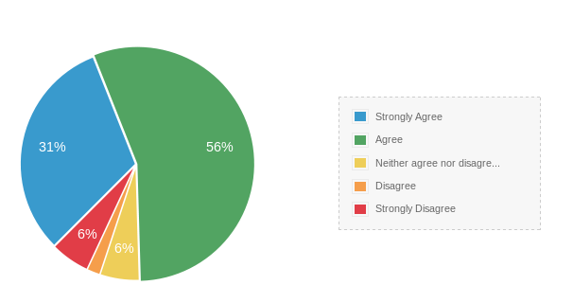

From the graph above, you can clearly see that majority of students think that the material provided for the course is very useful, with very few people thinking that it is not.

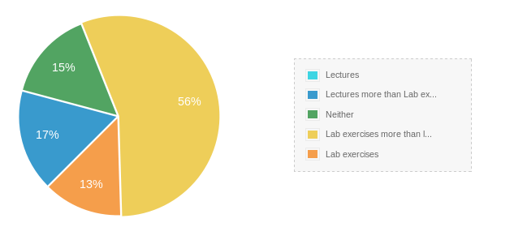

For question 2, when asked what they found more useful, lecture notes or lab exercises, it can be said that a vast majority of students find that the lab exercises are more useful, assuming that this is because this allows them to practice writing code.

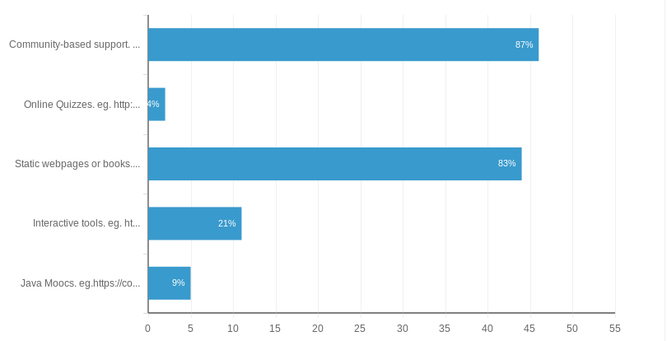
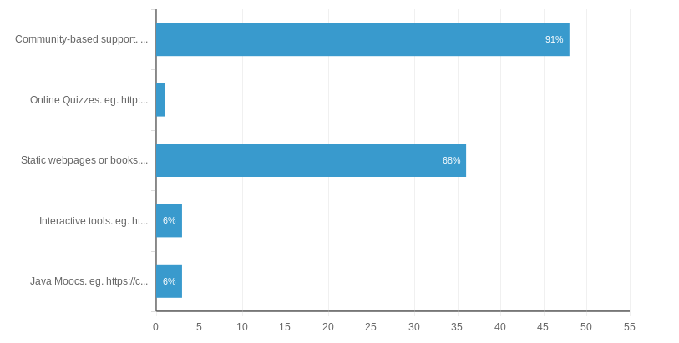

For questions 3 and 4, it would seem that students use the same resources for both learning Java and for referring to when they encounter a problem. The resources which are most popular with the students are community-based support and static webpages/books. Community-based support allows the user to ask questions or post problems that they are struggling with, answer questions from other people, and simply view problems and solutions from other users.

A few suggestions were given for what they would like to be available are:

- Video tutorials
- Mini exercises to create fun mini projects
- The code provided in class to be provided in the notes or on moodle
- Plenty of exercises and examples, especially to emphasise OO programming
- A more simplified explanation of the basics

