**Washington State University**

**School of Electrical Engineering and Computer Science**

**EE 352 Electrical Engineering Laboratory**

**Lab # 1**

**Basic Equipment Familiarization and First Order Electric Circuits**

**Name: Nicholas Keister**

**Partner: Thomas Swanzey**

**Due Date: 9**

**Lab Overview**

In this lab, there were 4 experiments to be conducted while using the function generator and the oscilloscope. The equipment was used to gain familiarity with the tools used in future labs by generating time-varying signals, calibrations of probes, measure the step response of a first order electrical circuit and find the timing constants, measuring the frequency response of a first order electrical circuit and finding the cutoff frequency, also using experimental data to estimate unknown parameters in a mathematical model of a first order circuit. The observed data gathered from pre labs through the PSPICE simulation is gathered in order to compare lab measured results in order to show similarities within a simulation circuit, and a conducted experiment where errors occur with minimal errors occurring.

**Experiment #1: Getting familiar with function Generator and Oscilloscope**

* 1. **Purpose**

The first experiment is to gain basic knowledge and familiarity with using lab equipment. The lab equipment used were BNC connectors, Oscilloscope, digital multimeter, function generator, and oscilloscope probes.

* 1. **Theoretical Background**

Many instruments were used within this experiment to gather data one including the Function Generator provided in Fig.1. The oscilloscope is used to measure voltages at any of the wave forms provided on the oscilloscope, them being sine waves, square waves, triangle waves, and others that were not used during this lab. On the oscilloscope there are multiple channels within the device to measure up to four different voltages within a circuit. The screen shown in Fig.1 is a representation of how the oscilloscope works when displaying the waveform used and the read voltage based on data being read. There are knobs for each channel one being able to adjust the y-axis in order to fit the peak to peak voltages on the screen for an accurate measurement. The other is adjusting the x-axis which increases or decreases the total amount of 2 pi waves displayed on screen. The oscilloscope can move cursors for accurate measurements, also a way to read a voltage or frequency based on the wave read by the oscilloscope. Data can also be saved through a USB drive where data can be looked at later on a computer or laptop.

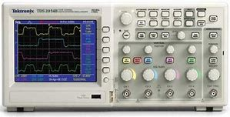

**Fig.1 Oscilloscope**

The next piece of equipment used is the function generator shown in Fig.2. The function generator is used to apply a V­dd voltage at either waveform selected i.e. sin, square, triangle, noise, etc. The frequency can also be changed on the generator from as low as 10 micro Hertz up to 25 Mega Hertz. The function generator also has multiple channels to supply voltages at different points within a circuit. The channels can be used using a BNC connector, or a BNC splitter that feeds into the circuit and the oscilloscope.

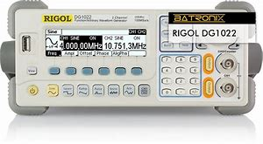

**Fig.2 Function Generator**

The third piece of equipment used was the Digital Multimeter Fig.3 which is used to measure DC and AC voltages along with Resistance and current.

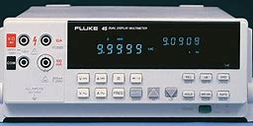

Fig.3 Digital Multimeter

There were several connectors used in the lab. One was the BNC connector which allows a single connection from the function generator to the circuit. A BNC splitter which splits the connection from the function generator to 2 different paths. There were BNC to alligator clips which where used to connect from the function generator to the circuit.

* 1. **Procedure**

Following steps are the steps for experiment 1

1. Use two BNC coaxial leads and a Tee BNC Splitter to connect channel 1 of the function generator to two channels in the oscilloscope.
2. Generate different wave forms and different frequencies and observe the differences between waves
3. Set the probes to X1 and change the frequency and observe the amplitude changes.
4. The same test is applied for the probe at X10 started at 1KHz
   1. **Results & Analysis**

Table 1 shows the measurements of peak to peak voltages from X1 and X10 probes at the minimum and maximum frequencies. The maximum frequency applied for the sin wave is 1MHz at a peak to peak voltage of 5V Fig.1, while the minimum frequency is 1microHz at a peak to peak voltage of 2.1V Fig.2. For the X10 probe the maximum frequency applied was 100MHz at a peak to peak voltage of 20V.

|  |  |  |
| --- | --- | --- |
| Probe | Frequency | Amplitude |
| X1 | 10MHz | 5V |
| X10 | 100MHz | 20V |

Fig.1 – Maximum Frequency

|  |  |  |
| --- | --- | --- |
| Probe | Frequency | Amplitude |
| X1 | 10microHz | 2.1V |
| X10 | 1kHz | 10V |

Fig.2 - Minimum Frequency

**1.5 Conclusion**

The equipment used worked and resulted in different lab results based on higher or lower frequencies.

**Experiment #2: Digital Multimeter (DMM) Versus Oscilloscope**

* 1. **Purpose**

The purpose of the second experiment is the measure the internal impedance within the oscilloscope or digital multimeter. The instruments connection can affect the voltage and current of the circuit.

* 1. **Theoretical Background**

Both the oscilloscope and the function generator were used for this experiment. The X10 probe will be used in this experiment and not the X1. A BNC splitter is used to record more accurate recordings due to the same signal from the same channel being sent. The BNC connectors are considered X1 probes, but the remainder of the probes and oscilloscope will be set to X10. If either off the probes or oscilloscope is set to X1 the data will be incorrect and amplitudes will not represent the actual measurement if using the X10 setting.

The function generator has different wave forms that is used for different measurements such as sin, square, and triangle waves. In order to get accurate measurements, the X10 probe must be calibrated by plugging the probe into the oscilloscope and connected to ground while applying a square wave from the function generator using a square wave. An ideal square wave that is calibrated will have sharp edges at its peak amplitude and a steady amplitude until its other pi wave. When applying different frequencies to the circuit, the voltage divider circuit should not be affected by the frequency. Since the frequency does not give enough change in output voltage, it can be concluded that frequency does not significantly change the amplitude within the circuit.

When adding the digital multimeter to measure the peak to peak voltage with a 300kHz frequency should now affect the amplitude of the circuit. The results ended in a 1V amplitude without the digital multimeter to 4V when applying the digital multimeter within the circuit. When adding higher valued resistors, the expected amplitude should lower when using lower valued resistors due to voltage drop across a resistor. When applying lower frequency, the amplitude should decrease, but with the 10M ohm resistor the results were opposite where the lower the frequency the higher the amplitude was.

* 1. **Procedure**

1. Plug in a X10 probe into the oscilloscope using a BNC connector.
2. Calibrate the probe by using a square wave on the oscilloscope and connecting the probe to ground to display the square wave. Square wave must have sharp edged at its peak amplitude for a calibrated probe
3. Connect the function generator and apply an 80Hz frequency at a 3 peak to peak voltage sine wave with and without applying the digital multimeter.
4. Apply different frequencies to the circuit and measure any discrepancies while adding the digital multimeter, and without.
5. Change the frequency to 300kHz and record the peak to peak voltage with and without the digital multimeter.
6. Replace the 200k ohm resistors with 10M ohm resistors and apply different frequencies and record voltage differences in v­­out.
   1. **Results & Analysis**

The function generator and oscilloscope are tools used to apply frequencies and voltages to a circuit. X10 probes are used to measure the peak to peak voltages within a circuit. The waveforms used in this lab are sin and square waves.

The oscilloscope is used to measure the amplitude of the circuit by using the time scale function on the oscilloscope. The same can be used for zooming in and out of the oscilloscope to get more precise readings on the sine waves. A low frequency is to be applied to the circuit along with a 6 peak to peak voltage sin wave as voltage input. The voltage output when calculated should be half the peak to peak value at 3V peak to peak for the output voltage. When measured the voltage was about 3V for the output voltage which matches the calculated result for v­out. When applying different frequencies to the circuit without the digital multimeter applied, the voltage does not change enough for a conclusion that frequency changes the voltage divider circuit. With an increase in frequency the voltage remains about 2.22V with a 1.57rms value which is not significantly different from a 3V peak to peak value with a much smaller frequency. When setting the frequency of the circuit to 300kHz and measuring the output voltage with and without the digital multimeter, the output voltage drastically changes from 4V without the digital multimeter connected, to 1V peak to peak with the digital multimeter connected. When replacing the resistor with greater values, the output voltage increases as the frequency decreases. The resistor value used is 10Mohm compared to 200kohm which is a 50x greater resistor value.

* 1. **Conclusion**

The function generator and oscilloscope create different peak to peak values when used, but when adding the digital multimeter, the values change drastically. Without the digital multimeter the value does not change enough to say that frequency is the cause of the change in peak to peak voltage, as a low frequency compared to a far greater frequency peak to peak values are relatively similar.

**Experiment #3: Low Pass RL Circuit**

* 1. **Purpose**

The purpose of this lab is to construct an RL circuit and compare the input and output voltages at different frequencies. The cutoff frequency will be at -3db which is the result of 20log10(1/2^1/2). Based on the frequency wo/2pi the resulted frequency should be close to the frequency measured in the experiment at -3db. The step response is to be measured to see the behavior of the circuit when a voltage is applied to the circuit at different frequencies.

* 1. **Theoretical Background**

The oscilloscope and function generator are being used to simulate the RL circuit shown in Fig.1.

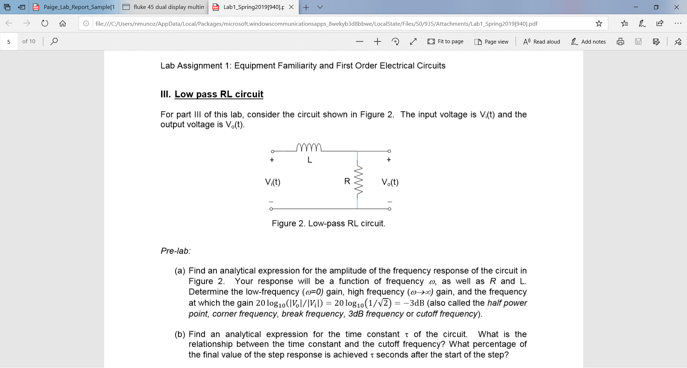

Fig.1 – Low Pass RL Circuit

The input voltage applied should be different than the output voltage when applying different frequencies through the function generator. The trend should be that as the frequency is increased, the input voltage will increase as the output voltage will decrease.

When measuring output voltage, the internal resistance of the AC voltage source must be included in calculation as the AC voltage source also includes a 50ohm resistor in parallel to the inductor.

The cutoff frequency within a frequency response is about 60% of the final value achieved which is the -3db cutoff value on a graphed table where input and output voltages are recorded.

When finding Tau within the circuit, an input voltage is recorded from applying different frequency values. Since the cutoff frequency is about 60% of the peak value, the step response of the system is found multiplying the input voltage found by 63.2% of that input value then measured through the oscilloscope to find the cutoff frequency of that specific input voltage. The resulted step response input voltage will give the time constant.

* 1. **Procedure**

1. Determine the analytical expression for the amplitude of the frequency response in Fig.1. Also finding the analytical time constant tau of the circuit.
2. wo = R/L = 300 rad/s
3. f = wo/2pi = 42.7kHz
4. tau = L/Req = 1mH/350ohms = 2.857micro seconds
5. Setup the oscilloscope and function generator by connecting the probes through the BNC connectors.
6. Connect the probes to the circuit at a low frequency to a higher frequency.
7. The amplitude should be set to a 8V peak to peak starting at 10Hz frequency.
8. Get the input and output voltages and find the measured amplitude response in decibels.
9. Change the sin wave to a square wave and repeat step 4 to record the step response of the circuit.
10. Record tau as a result of the input voltage acquired though different frequency changes.
    1. **Results and Analysis**

The function generator is to be set at a 4 zero to peak voltage and applying several frequencies from 10Hz to a higher frequency for a frequency vs decibel graph. The input voltage compared to the output voltage is the result in different frequencies, and as the frequency increases, the input voltage increases as the output voltage decreases show in Fig.1.

Fig.1 – Input vs output voltage

As the input voltage increases, the output voltage increases to a peak of 17.2 volts and begins to drastically decrease as the input voltage continues to increase due to increase of frequency. As shown in Fig.2, the -3dB cutoff frequency is about 48kHz which is relatively close to the calculated frequency of 42.7kHz.

Fig.2 – cutoff frequency

The step response of a low pass filter calculated from the pre-lab is 2.857micro seconds which is where the cutoff frequency should be. Based on the required results the frequency for the step response falls around 40kHz which is a 5% error from the 42kHz calculated. The 40kHz tau value is about 2.728micro seconds from the frequency between 25kHz and 50kHz. To find tau, the input voltage recorded must be multiplied by .632 which is the cutoff frequency from the max peak amplitude. Vin(.632) will give the tau value when measuring the amplitude at zero to that value at its given frequency.

* 1. **Conclusion**

The function generator applies different frequencies and read through the oscilloscope through input and output voltage. The frequency change resulted in a cutoff frequency of about 47kHz which is very close to the -3dB cutoff frequency. The step response of the circuit has a 2.857micro seconds at a frequency of around 42.7kHz which is a 5% error from the measured result of 40kHz frequency at 2.728micro seconds for a tau value.

**Experiment #4: Oscilloscope Characterization**

* 1. **Purpose**

The purpose of this experiment is to see that the oscilloscope loading effects will model a first order circuit shown in Fig.1

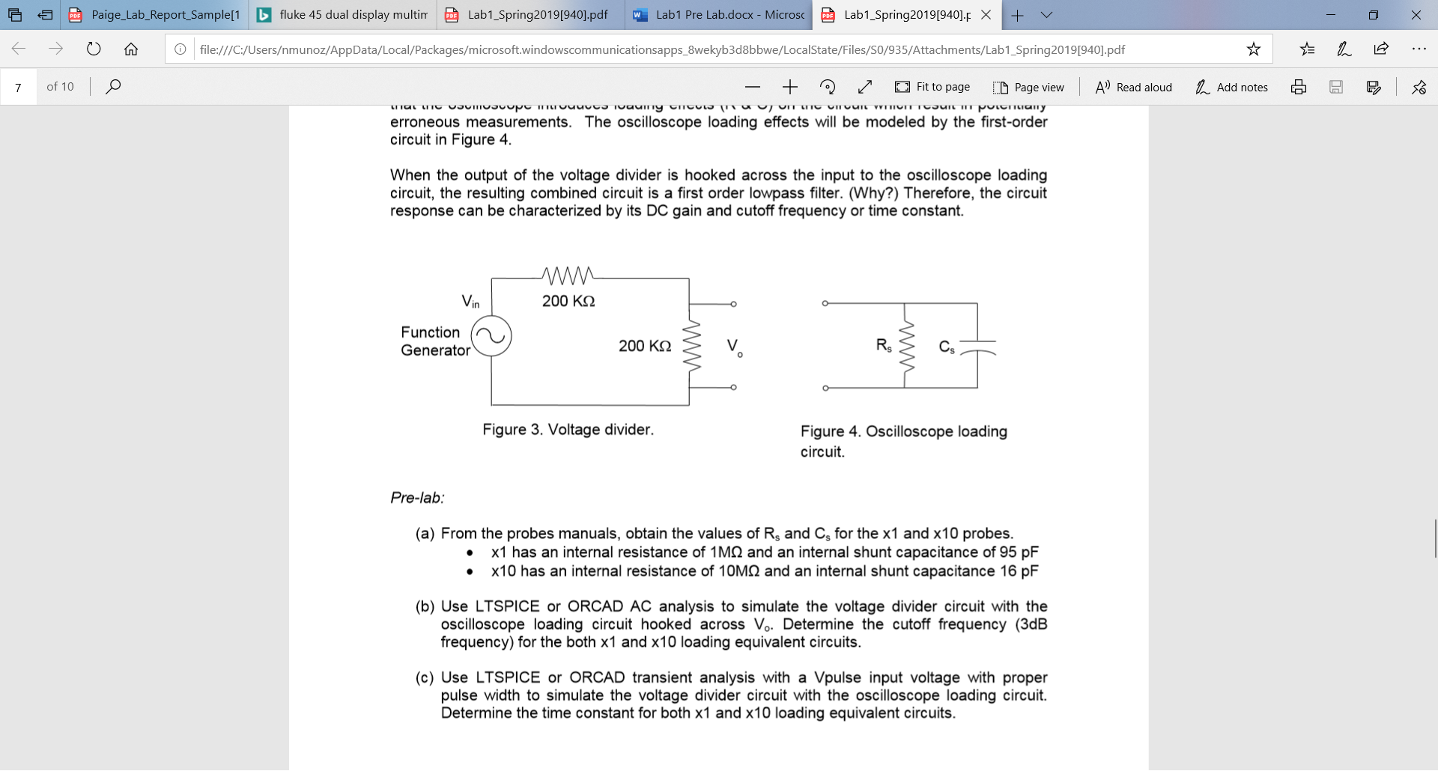

Fig.1 – Oscilloscope loading frequency

When added to the voltage divider in Fig.2



Fig. 2 – Voltage divider

The output voltage is to be measured in response to the sinusoidal input of vin.

**5.2 Theoretical Background**

The circuit constructed will be measured with the X1 and X10 probes to see differences between the two sets of probes set to a different value. With the oscilloscope loading frequency cause a first order circuit, it will use a Capacitor and a resistor where the resistor must be included in the equivalent resistance within the circuit. The capacitor is a storage device that stores negative charges on one side, and negative charges on the other which includes reactive power. The capacitor is filled until capacitor is full of charge.

The cutoff frequency is where the input voltage equals a fraction of the input voltage at -3dB where output voltage divided by input voltage is equal to 1/2^­1/2. When the gain is 1 at low frequencies and 0 at high frequencies, the circuit is a low pass filter. Vis-versa is the gain is 0 at low frequencies, and 1 at high frequencies, the circuit is a high pass filter.

The cutoff frequency of the circuit shown in Fig.3 was simulated in LTSPICE for both X1 and X10 probes in Fig.4 for X1, and Fig.5 for X10 probe.

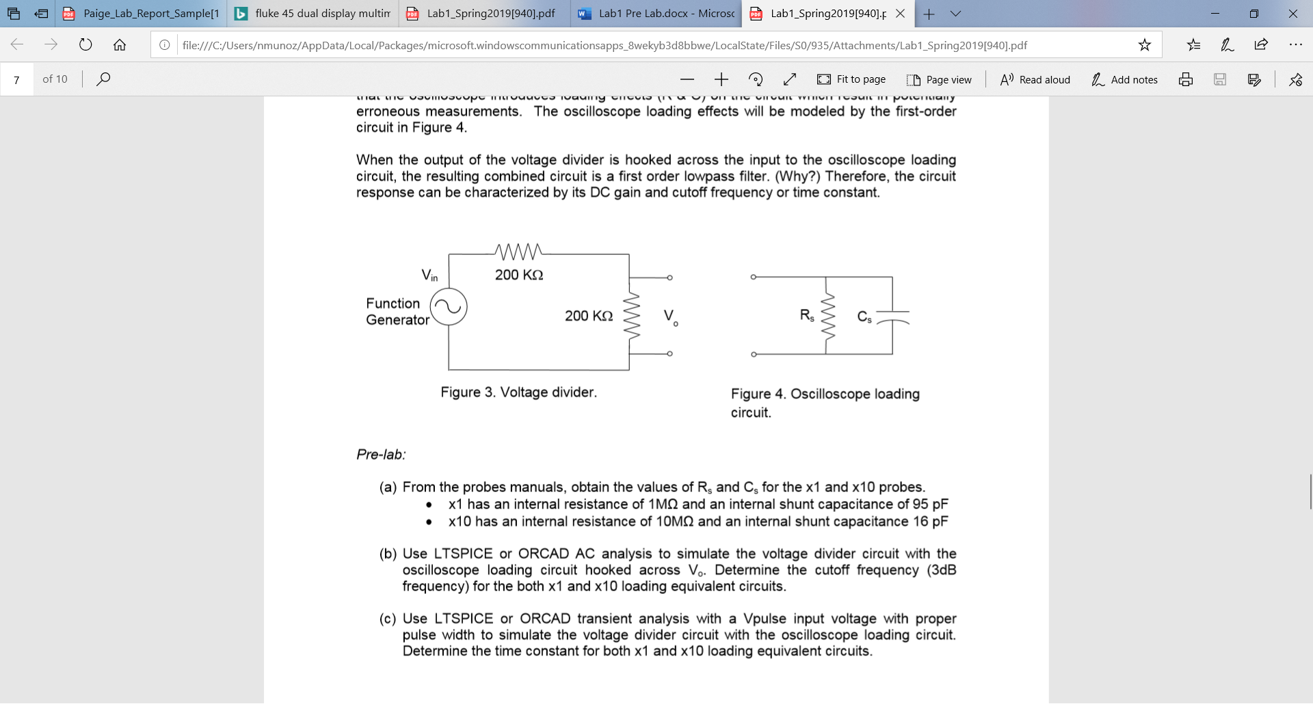

Fig.3

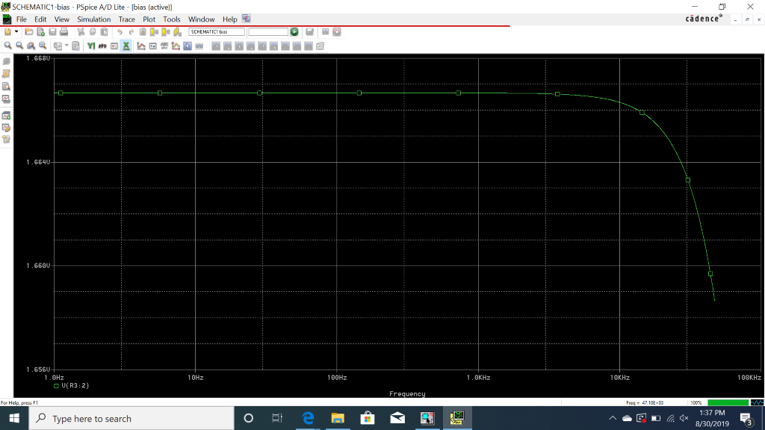

Fig.4 – X1 PSPICE cutoff frequency



Fig.5 – X10 PSPICE cutoff frequency

**5.3 Procedure**

1. Obtain the resistor and capacitance value for the X1 and X10 probes.

2. Simulate the circuit for both X1 and X10 on PSPICE.

3. Construct the circuit on the board and use the oscilloscope and function generator to apply the peak voltage and frequencies.

4. Apply different frequencies and obtain input and output voltages to calculate the dB gain.

5. Use a square wave to find the step response of the system.

6. Repeat steps 4 and 5 for the X1 and X10 probes.

**5.4 Results and Analysis**

The goal of this experiment is to see the change in output voltage due to change in frequencies and determine the cutoff frequency through the input vs output voltages. Finding the equivalent resistance is shorting the voltage source, and an open circuit at the capacitor. The equivalent resistance then becomes 90.k ohms. The cutoff frequency is determined by f = 1/(2piRC) where R = 95pF for X1 and 16pF for X10. The equivalent resistance for the X1 probe is 90.k ohms where the equivalent resistance for the X10 probe is 90.9k ohms. The cutoff frequency found from the results ended in a 18k ohm frequency at -3dB which results in a 2.2% error which is shown in Fig.6.

Fig.6 dB graph

The step response of the circuit was found by using the cursor at the input voltage multiplied by .632 which is around the cutoff frequency. The cursor was used at 0V measure to vin(.632) shown in Fig.7.

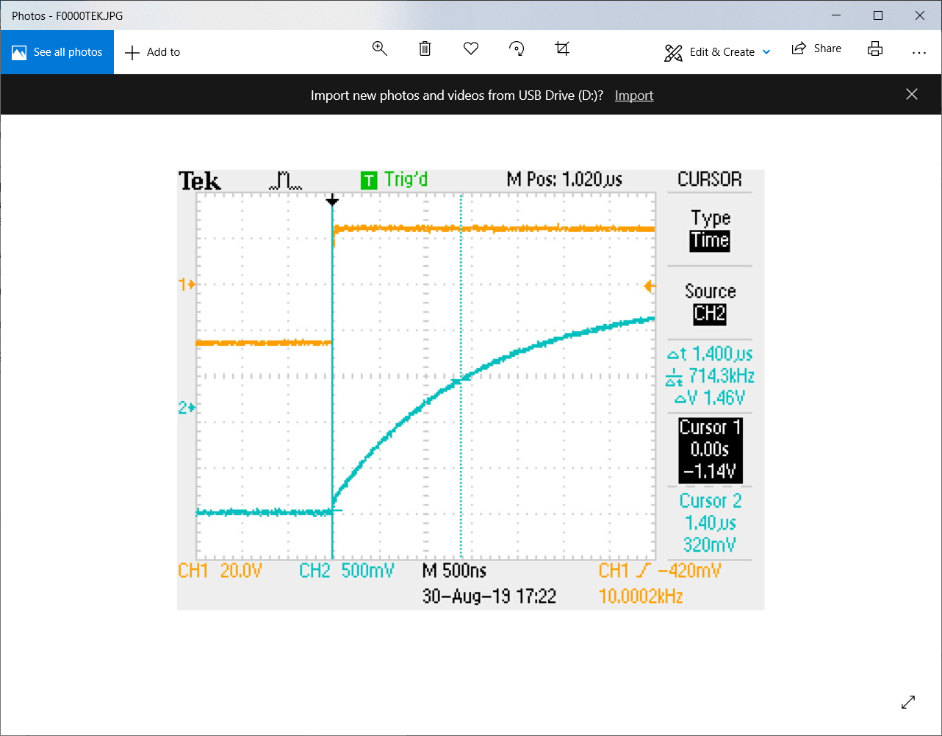

Fig.7 – Measuring step response

The X10 probes had a much higher cutoff frequency than the X1 probes where the desired cutoff frequency is 90.9k ohms. The estimated cutoff frequency for the X10 probe is about 103k ohms shown in Fig.8 which results in a 11% error. The 11% error could be from off calibration of the X10 probe.

Fig8 – Cutoff frequency for X10 probe

**5.5 Conclusion**

The experiment showed that the behavior of the oscilloscope loading circuit does result in a first order circuit. The X1 and X10 resulted in different cutoff frequencies due to different internal resistance and capacitance.