[2] Demonstration 1 & 3

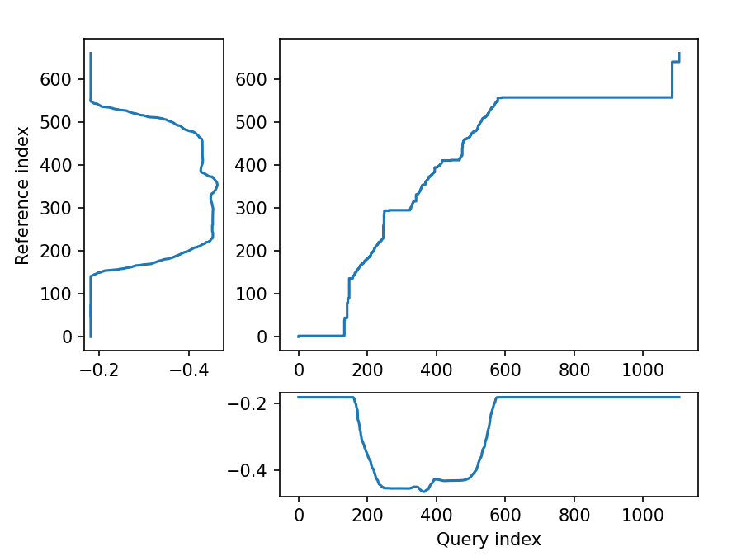

Figure : x-axis alignment

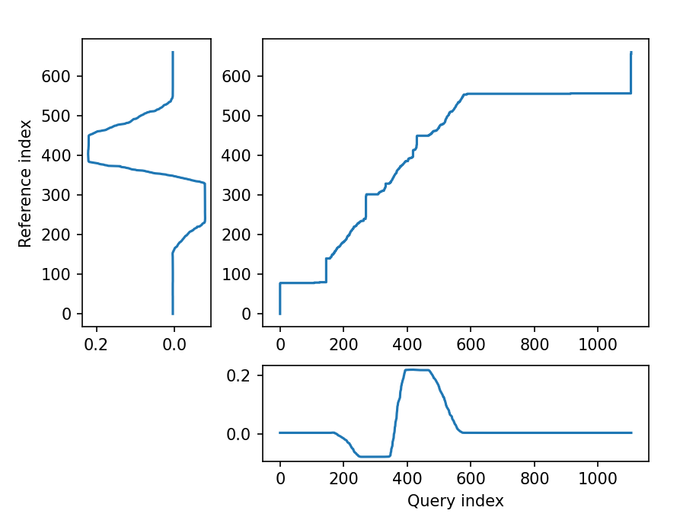

Figure: y-axis alignment

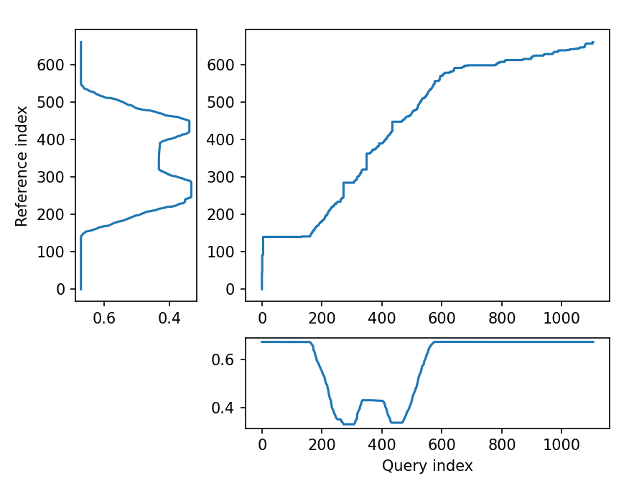

Figure: z-axis alignment