Customer segmentation proof of concept
  - Complete Journey simulated retail data | 22 September 2026

Decision summary
The files contain 1,469,307 purchase lines, 155,848 baskets, and 2,469 transacting households over roughly one year. We could form nonfuel shopping profiles for 2,467 households. The remaining 2 purchased fuel but had no non-fuel purchases. A two-group solution separates basket composition and price-related behavior more than visit frequency. They motivate oral-hygiene and private-label meat coupon tests, without evidence of incremental coupon sales.
The publisher identifies this Python release as simulated educational data. Its household demographics cover 801 of the 2,467 profiled households (32.5%). Thus, neither the group proportions nor the proposed offers describe a real retailer's customers.

What the groups show
Group | Households | Nonfuel baskets | Basket receipts | Private label | Retail discount
Broader baskets | 1,301 (52.7%) | 40 | $30.24 | 16.5% | 12.4%
Value-oriented baskets | 1,166 (47.3%) | 41 | $24.21 | 28.4% | 19.1%
Values are household medians except group size. Receipts are retailer receipts, not a direct measure of customer outlay.
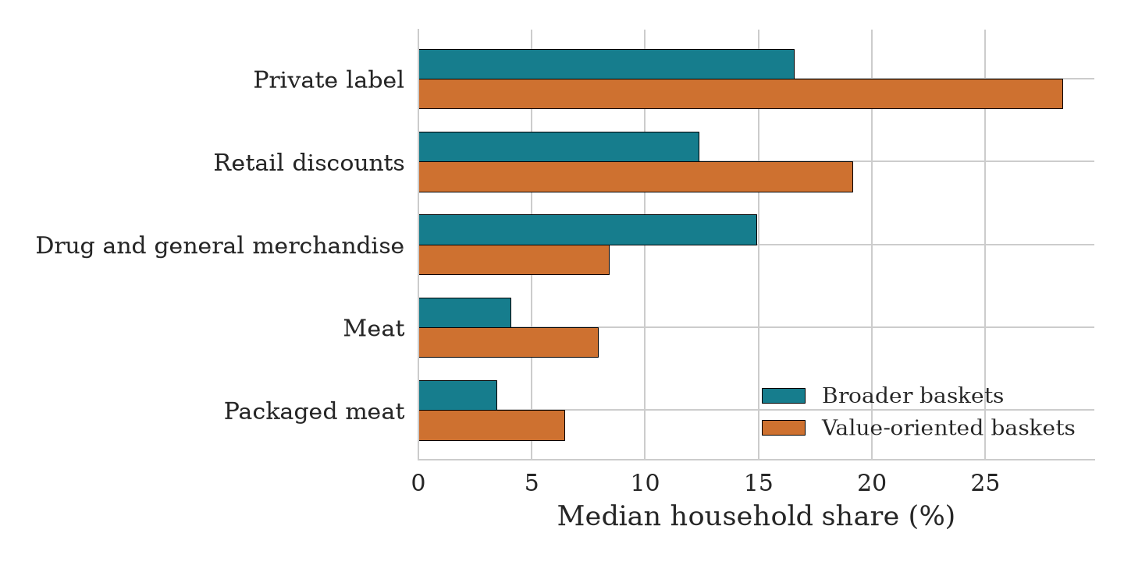
Figure 1. Median shares across households. The value-oriented group allocates more non-fuel receipts to private-label goods and records a larger retail-discount share. Each percentage has its own denominator, and median category shares need not sum to 100%.

How the groups were formed
We linked purchase lines to product metadata and aggregated them to households. The inputs capture nonfuel basket frequency, mean basket receipts, days since the last purchase, private-label share, retail-discount share, and spending shares across major non-fuel departments. We excluded fuel from the grouping because fuel-only trips describe a different purchase occasion. Demographics and coupon redemptions did not determine membership.
Recency, frequency, and monetary measures have a history in customer-base analysis (Fader, Hardie, and Lee 2005). We use related descriptive features here, but do not estimate customer lifetime value.
We applied a log transform to skewed activity measures, clipped each feature at the first and 99th percentiles, scaled by its interquartile range, and gave activity, value orientation, and product mix equal total weight. K-means models with two through eight groups were compared using silhouette separation, repeated 80% household subsamples, and a minimum group size of 5%. The highest eligible silhouette selected two groups.
The selected mean silhouette is 0.159, which indicates modest separation. Mean adjusted Rand agreement across subsamples is 0.986. Adding fuel share changes 30 of 2,467 assignments after matching labels. Removing households with fewer than four nonfuel baskets yields adjusted Rand agreement of 0.990 on the retained households. These diagnostics support a simple descriptive split but do not establish a natural or permanent customer typology.
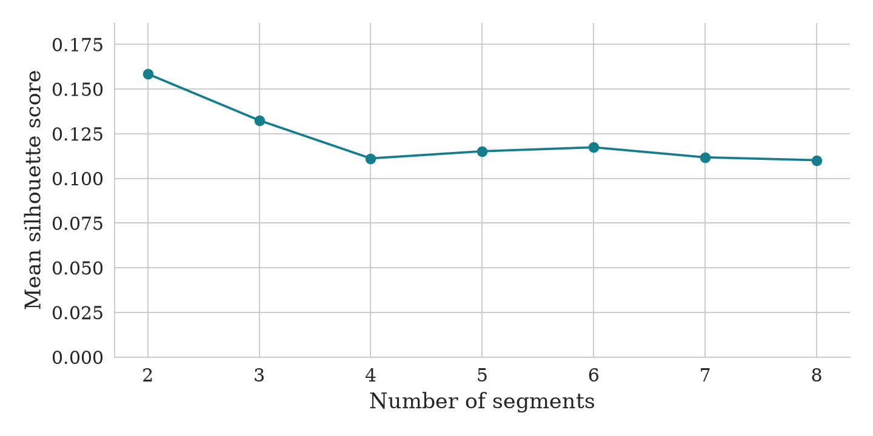
Figure 2. Mean silhouette score by number of groups. The first point marks the selected two-group solution.

Range in household activity
Measure | 10th percentile | Median | 90th percentile
Nonfuel baskets | 8 | 41 | 123
Nonfuel receipts | $160 | $1,160 | $4,018
The wide range in purchase activity motivates robust scaling and limits confidence for households with short histories.

Coupon tests

Broader baskets
Test an oral-hygiene offer against a same-value general nonfuel offer. Oral-hygiene purchases appear in 784 of 1,301 households (60.3%) in this group, compared with 526 of 1,166 (45.1%) in the other group. Buyers in this group made a median of 3 oral-hygiene purchase trips. This is an affinity signal, not evidence that a coupon will add sales.

Value-oriented baskets
Test a private-label meat or packaged-meat offer against a same-value general nonfuel offer. Private-label meat purchases appear in 976 of 1,166 households (83.7%) in this group, compared with 861 of 1,301 (66.2%) in the other group. Buyers in this group made a median of 6 such purchase trips. The pattern does not establish incremental response.
Freeze group assignments using a pre-test purchase period, then randomize households concurrently within each group to the category offer, a general offer with comparable eligibility and cost, or no offer for eight weeks. Calculate the sample size before launch. Record offer delivery, eligibility, redemption, all shopping, discount cost, and true gross margin. The primary comparison is incremental gross margin per assigned household for the category offer versus no offer. The general offer is a secondary contrast. Gopalakrishnan and Park (2021) found coupon effects can arise without redemption, which is why the test must measure all shopping. Daljord et al. (2023) show why optional redemption complicates promotion evaluation.
Campaign-household assignments and coupon lists permit descriptive reach calculations for some historical campaigns. The files contain 2,368 Type B and 574 Type C household-campaign assignments. All 2,102 redemption records match a campaign assignment and fall within campaign dates. Type A's household-specific coupon selection is not fully recorded, and none of these observational records identifies incremental offer effects.

Data limits
No matching product record exists for 4,836 purchase lines, and 102 profiled households have fewer than four non-fuel baskets. The first are retained in an other category. The second have limited individual histories, so their assignments are less secure. Historical campaign records permit descriptive checks but lack random assignment and gross margin for a causal response estimate. The simulated source also prevents external validation with real retail behavior.

Sources
Complete Journey Python documentation, data notice. https://cunningjames.github.io/completejourney_py/user-guide/datasets/
Fader, Hardie, and Lee (2005), RFM and CLV. https://doi.org/10.1509/jmkr.2005.42.4.415
Gopalakrishnan and Park (2021), The Impact of Coupons on the Visit-to-Purchase Funnel. https://doi.org/10.1287/mksc.2020.1232
Daljord et al. (2023), The Design and Targeting of Compliance Promotions. https://doi.org/10.1287/mksc.2022.1420

