**Error Message Validation Report**

|  |
| --- |
| Document Information: |
| **Title**: Error Message Validation Report |
| **URL**: https://www.saucedemo.com/ |

**Abstract**

The report contains a report conducted on Swag Labs for Error Message Validation. The test is done using two datasets- one valid and one invalid. The valid dataset should redirect the URL to another URL while the invalid dataset should display the correct error message.

**Introduction**

Swag Labs is a free demo website used for automation testing. The website has two fields in the form – Username and Password. There is pre-approved list of usernames listed on the website URL. If valid credentials are entered, the login button should redirect into another URL for the inventory.

**Test Cases**

|  |  |  |  |  |  |  |  |
| --- | --- | --- | --- | --- | --- | --- | --- |
| SN | Description | Test Steps | Pre-Conditions | Expected Result | Actual Result | Status | Comments |
| 1 | Launch the browser, enter credentials and click on login. | 1. Open browser.  2. Enter username and password.  3. Click on Login button. | Invalid Username and Password | Error Message should be displayed. | Error Message was displayed. | Pass |  |
| Valid Username and Password. | The user should be navigated to their dashboard. | The user was successfully navigated to their dashboard. | Pass |  |

**Results**

Following are the results of the test conducted.

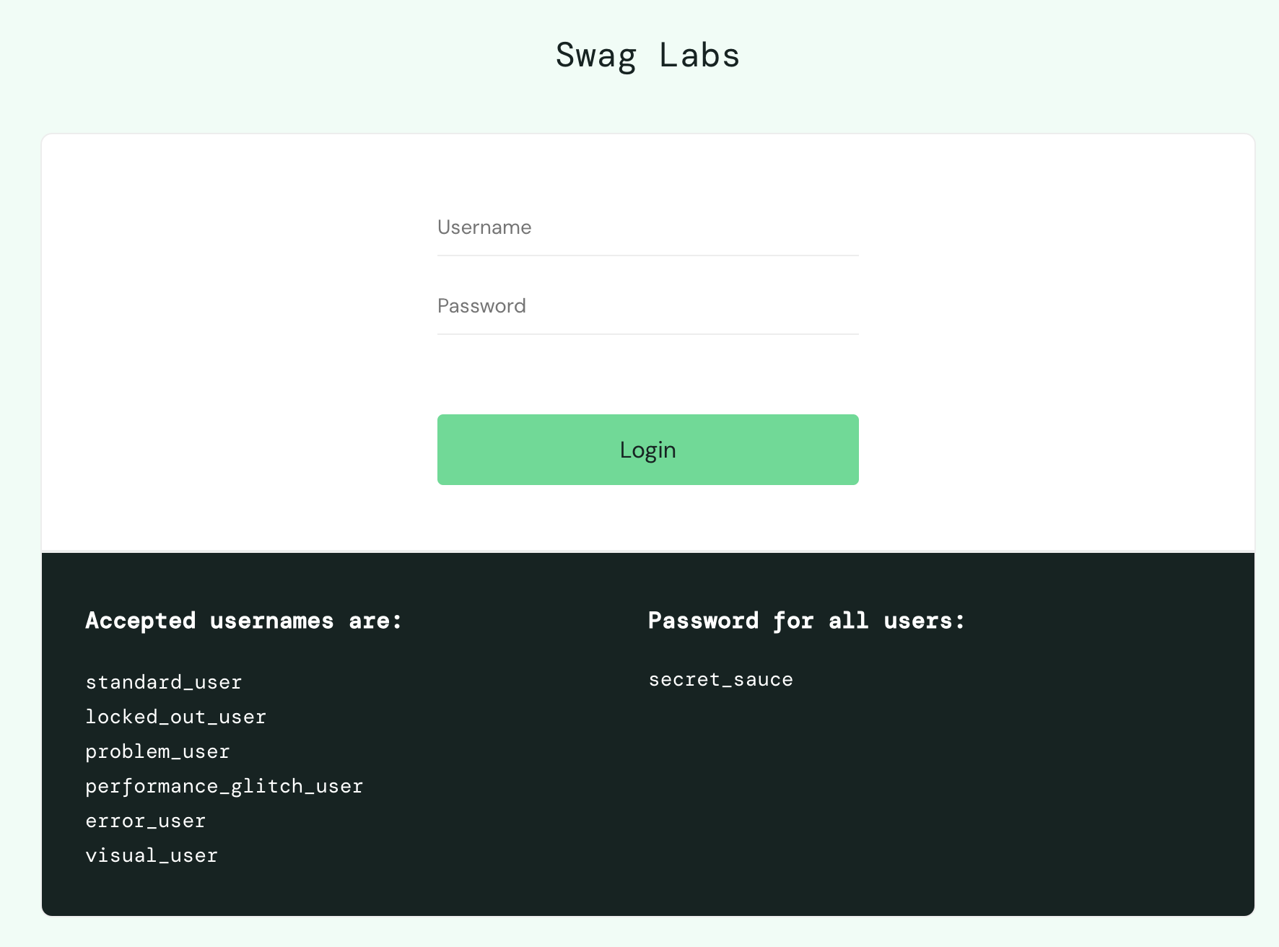

Figure 1: Login Page of Swag Labs

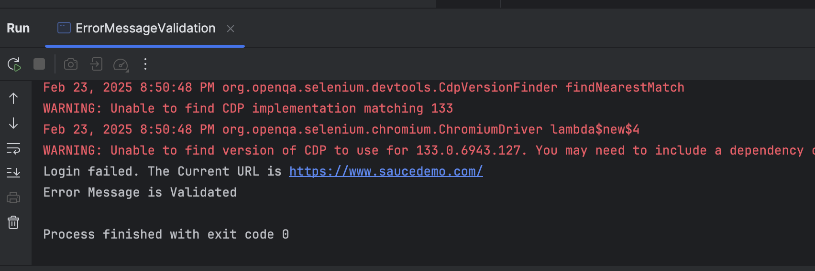

Figure 2: Successful Error Message Validation in Terminal

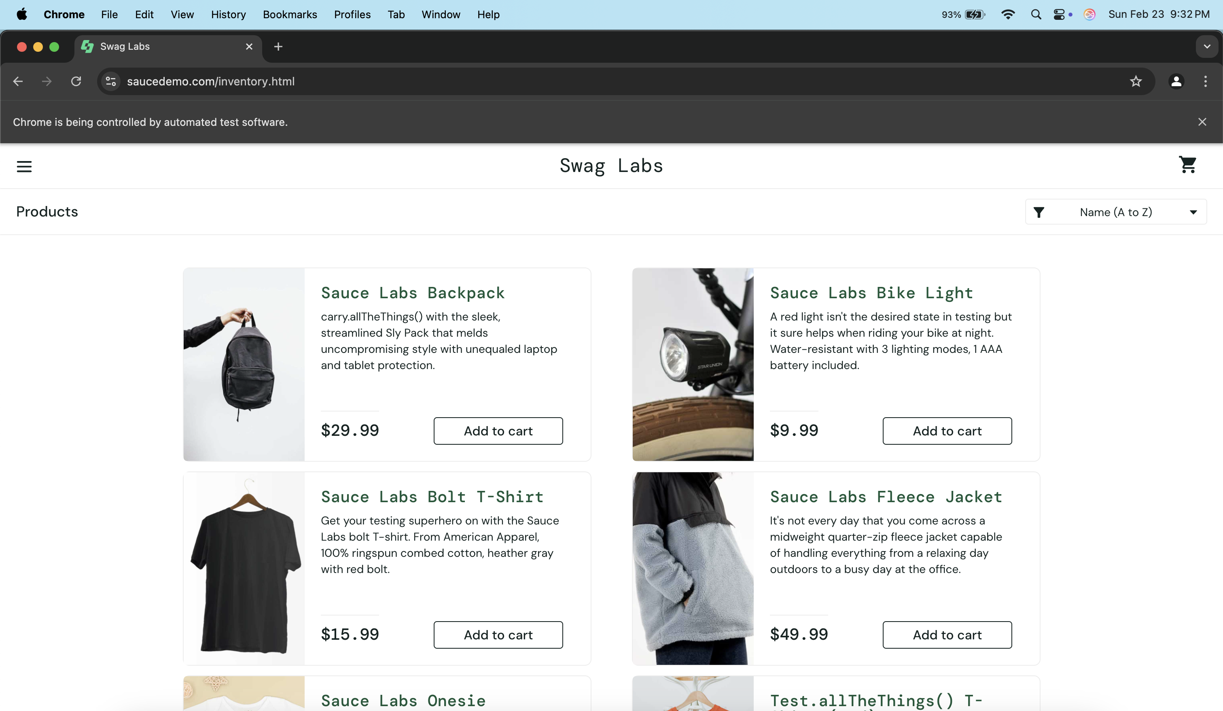

Figure 3: URL after Successful Login

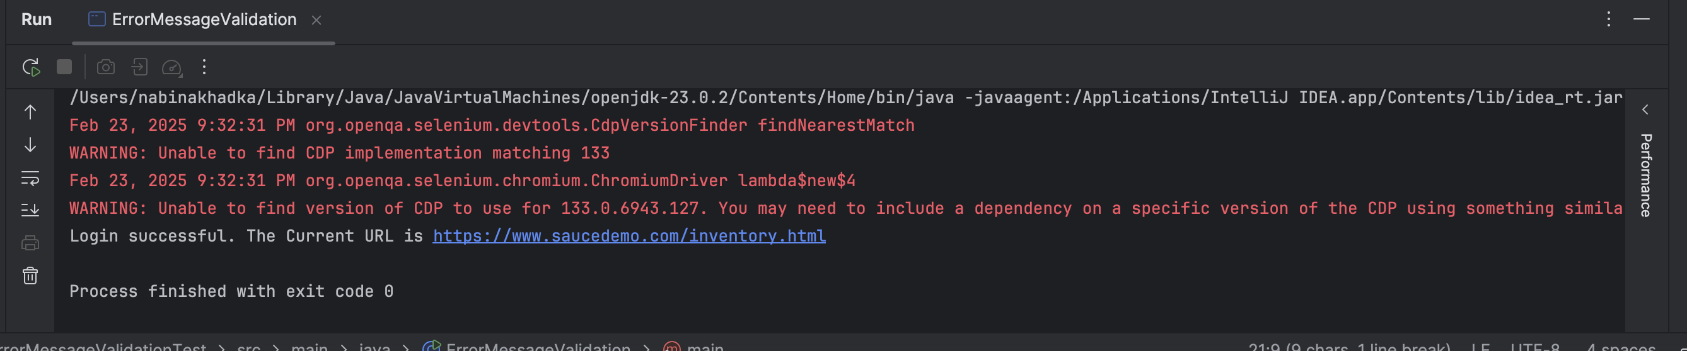

Figure 4: successful login message in Terminal