Steps to install File Handling Component.
Step 1
Copy and open the Setup folder on Target machine where you want to install the component.
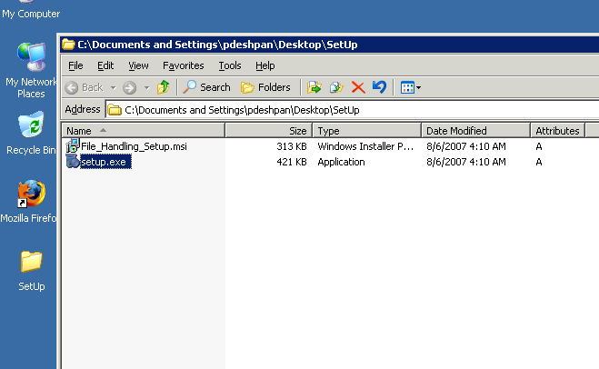

Step 2
Double click the setup.exe to run the setup. You will see the below screen. Click Next to continue.
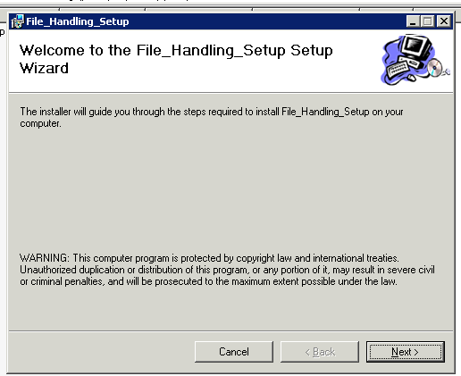

Step 3
Select the folder where you want to install the component. In this case locate the Extranet folder and select the Extranet folder. Change the default path which is shown below. Also change the Just me option to “Everyone” option. Click Next to continue.
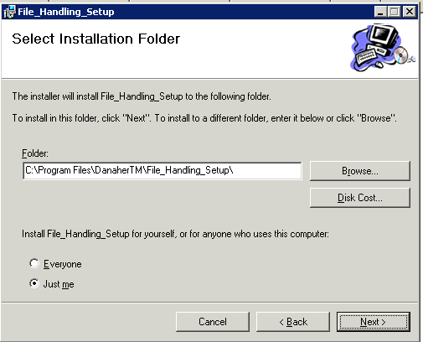

Step 4
Confirm the start of installation. Click Next to continue.
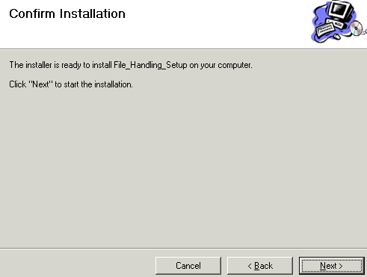

Step 5

Setup will start installing the component.

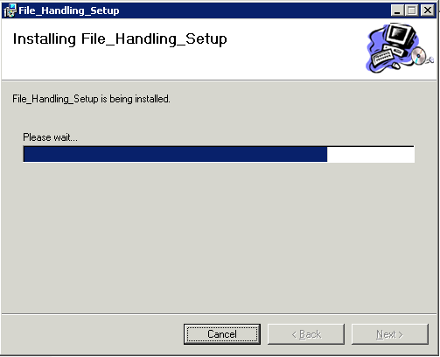

Step 6

Click close to finish installing the component.

