May 2013
© 2000 - 2012 Fluke Corporation, All rights reserved. Printed in USA
All product names are trademarks of their respective companies.

Introduction 3
What are digital assets? 3
Product Introduction / Campaign Creator 4
Partner Portal - Site View 4
Creating a Product Introduction / Campaign / Calendar Event or Library MAC Container 6
Localized Links 16
Subscriptions Notices 19
MAC Typical Configuration Example 23
Cloning / Duplicating Individual Assets, MAC for Alternate Language Use 25
Steps on How to Create a Home Page for an Extranet Site. 28

Introduction

The Partner Portal Sites on Support.Fluke.com were designed to be a secure, self-publishing repository for all Marcom / Marketing digital assets such as PDF documents, Images, MSOffice files, software updates, plus all other electronic digital assets (files), with relational integration into enterprise systems such as Oracle, now MS Dynamics.

Its ease in rapid deployment of new assets and the ability to provide these same assets to resellers, end-users, systems such as Print-On-Demand, Electronic Email Fulfillment (Oracle), Fluke Digital Library (on user facing websites such as www.fluke.com), etc., makes the Partner Portal application and its rich set of rendering and administration tools plus a host of other add-on utilities the primary mechanism for distribution of the same.

The main concept behind the Partner Portal is the ease of adding a digital asset. Besides the file itself, only the minimal other data is required, such as the Library category it should be shown in, the Product or Product Series it is related to, the Title of the asset and Description, Thumbnail image and the electronic asset itself.

Restrictions can be imposed to limit the view of this asset based on System, Group, Country, Begin Date, Public Embargo Date and automatic archival with it’s interface to MS Dynamics Marketing Assets.

In typical application, an automatic digital product launch on the Begin Date could be sent via the subscription email services world-wide, contain descriptions, thumbnails and encoded links to all of the digital launch materials.

Finally, the Partner Portals are multilingual, both in user view and administration tools.

This Content Administrator’s Users Guide will help you understand the asset creation process.

What are digital assets?

Digital asset can be anything that can be contained in a computer file. These include, MSOffice or other files, PDF files, Images, Software, Software Updates, Posters, Audio or Video Files, etc. In addition, digital assets can be website URL’s to other websites or specific pages on those websites, gateways that pass authenticated user credentials to another application, etc. The end-point for a digital asset is almost endless. In other words if you can view it on your computer, chances are you can make that same media available via the internet to other users.

Product Introduction / Campaign Creator

Partner Portal - Site View
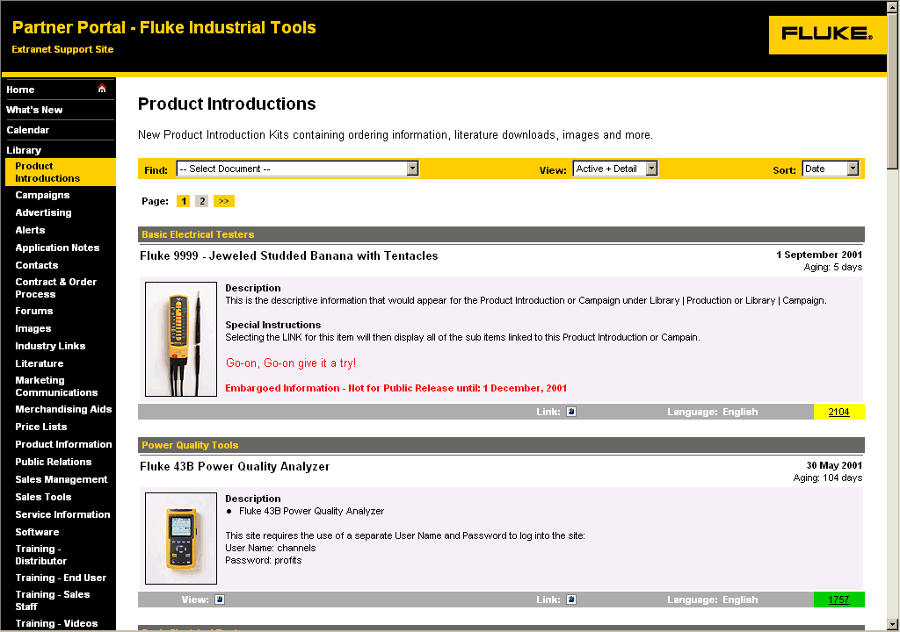
Figure 1 - Product Introduction - User Site View
The creation of either a Product Introduction Kit or Campaign is identical, except for the fact that the entry point into the actual collection of content or calendar items fall under the navigation button, "Product Introductions" or "Campaigns" respectively. On other portal sites, these may have been renamed as “Product List” or “Education Modules”. Regardless of the name, the functionality is the same. For simplicity, the acronym MAC, short for Master Asset Container will be used throughout the remainder of this document to reference "Product Introduction”, “Campaign" or the MAC Creator Process itself.

What is presented to the user is the MAC container or “Book Cover” to each MAC collection of individual assets. The page showing many MAC container listing is no different than any other listing, except for the fact that the container is used to introduce the attached (related) assets and to provide a LINK to the next page that displays the collection of individual assets.

In the screen shot above, a sample Product Introduction MAC has been created called the "Fluke 9999".

Clicking on the View or Link Icon will advance the user to the MAC containers container view (Figure 2 - Product Introduction Container - User View).
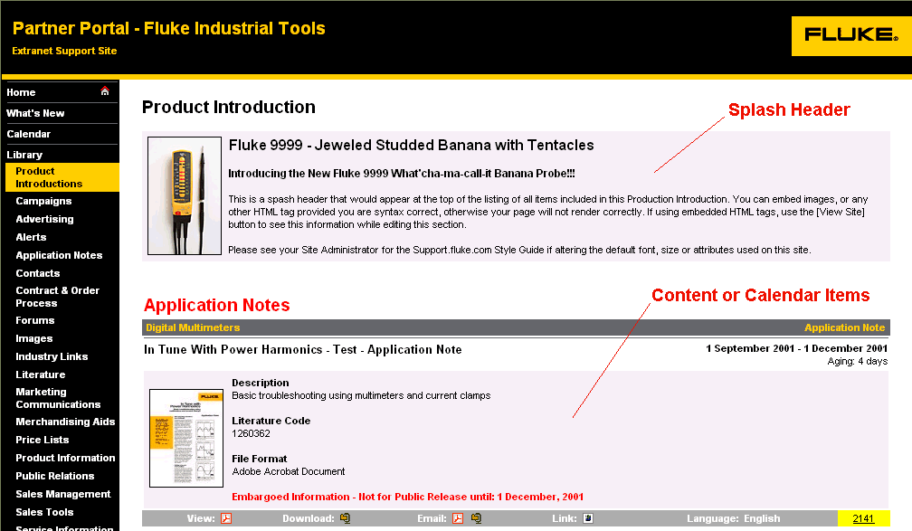
Figure 2 - Product Introduction Container - User View
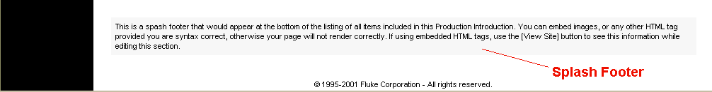
Figure 2 above, shows the MAC container asset view for the "Fluke 9999” Product Introduction. The MAC container introduces the individual assets by presenting a Splash Header (optional), then the associated content or calendar event assets, in order of Category, Sub-Category, and Title and followed by the Splash Footer (optional).

Although these content or calendar event items appear in the MAC container, they can optionally appear as individual items in each of their respective Library Categories. This is accomplished by setting the Items Content Grouping specification to "Product Introduction + Individual" or “Campaign + Individual” in each assets administration page.

Selecting "Product Introduction Only" will list the item within the MAC container, but will not show the asset under its individual Library Category.

Selecting "Individual" will only show the asset under its individual Library Category and will not include it in the MAC container.

Creating a Product Introduction / Campaign / Calendar Event or Library MAC Container

The creation of a MAC is only available to those administrators who have Content or Site Administration credentials. Content Submitters are prohibited from creating a MAC; however they are able to edit those assigned to them.

Initially the MAC container itself needs to be created. Once created, all content or calendar items may be grouped within this MAC.

To create a MAC, logon to your Site Administration screen, under the Site Utility, ADD - Content or Event into Category, choose either “Product Introduction” or “Campaign”.

Error: Reference source not found.

The next screen that will appear will be the Content / Event Administration Screen. This screen is the same screen used for entering Individual Calendar Event or Library Asset items as well as defining the MAC container item. The difference between an individual content or calendar event asset and a MAC container asset is the addition of the Splash Header and Splash Footer text areas.

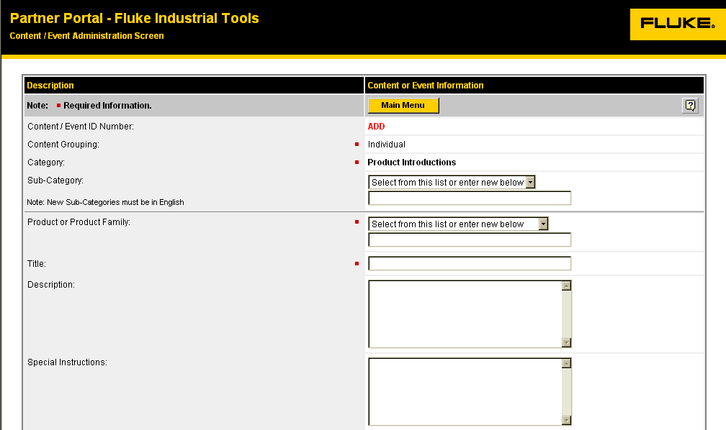
Figure 3 - Content / Event Administration Screen - Category and Product / Product Family Specific Fields

- Content / Event ID Number The ID number will either display ADD for a new item or the actual record ID number for an existing item you are editing.

- Content Grouping Individual
Item appears under its Library Category Only.
Product Introduction + Individual
Item appears as an individual item under its respective Library Category, and with the MAC container.
Product Introduction Only
Item appears in the MAC container only.
Campaign + Individual
Item appears as an individual item under its respective Library Category, and with the MAC container.
Campaign Only
Item appears in the MAC container only.

For a MAC container, "Individual" is the only option available.

- Category Defines where the item will appear under the Calendar or Library navigation buttons. The Category is pre-selected when you select from the Add menu. Note: This cannot be changed, unless you first delete this record and re-enter the data under a new Content or Event Category.
- Sub-Category Select from the pre-defined list. If you do not find a sub-category that adequately describes your item, contact your Site Administrator. All New Sub-Categories must be in English, however will be automatically translated to the user's preferred language once Infrastructure Translations are done (typically as needed by special request or quarterly.)

- Product or Product Family The Product or Product Family is a critical sorting/grouping field. Please try to add new Content or Event records using one of the pre-existing selections, or if you require a new Product or Product Family name, contact your Content Administrator to specify a new name by using the input box. All New Product or Product Family names must be in English however will be automatically translated to the user's preferred language once Infrastructure Translations are done (typically as needed by special request or quarterly.)

- Title Title of the Content or Event item. (Included with Subscription email.)

- Description Short narrative description of the Content or Event item. (Included with Subscription Service)

- Special Instructions Short instructions of how to use, order, or other instructions related to the Content or Event item.

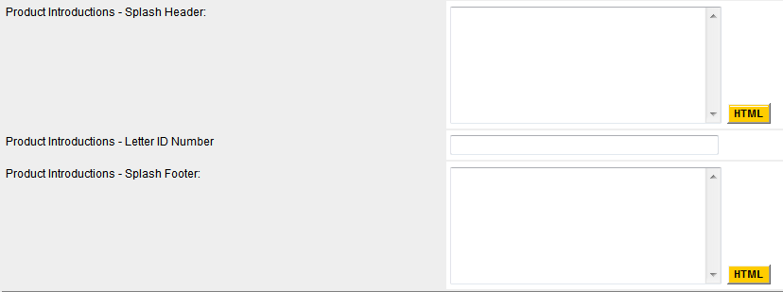

Figure 4 – Content/Event Administration Screen – Product Introduction/Campaign Specific Fields

- Splash Header This is the MAC introduction header used to introduce the MAC. This field would not appear when creating a non-MAC content or event item.

- Letter ID Number Item number of product introduction letter.
- Splash Footer This is the MAC footer used to conclude the MAC. This field would not appear when creating a non-MAC content or event item.

Figure 5 – Content/Event Administrations Screen – Item/Reference Numbers (This section not available on MAC)

- Generic Button This button may be used to generate an non-MS Dynamics item / reference number for an asset. This number can then be used in the find_it.asp links to the asset on web pages.

- Item / Reference Number 1 Item / Reference Number 1 is used to provide the MS Dynamics Item Number to users related to the content items physical order number. This number is also required for any content item designated in the Group Section as "User". When these two are used in combination, the document file is available for EFF eFulfillment through the Fluke Document Fulfillment System or the POD Everett Print-On-Demand System. For all other cases, this is an optional reference number.

- Rev. This is used to place the current version letter of the item and will be used in building the PDF file name stored on the server when uploading files.

- Show This checkbox, if checked will display the Item Number in the content's description.

(Whether or not this field is available for use depends on how the Site Administrator has configured this category. For MAC, this field is not available.)

- Item / Reference Number 2 An Optional secondary reference number. For a Cloned alternate language asset, this field will contain the original English Item Number and Revision for reference.

(Whether or not this field is available for use depends on how the Site Administrator has configured this category. For MAC, this field is not available.)

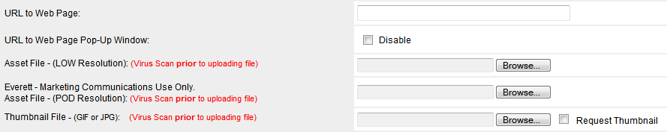
Figure 4 - Content / Event Administration Screen - Content Information and Asset File Fields

- URL to Web Page If the Content or Event has additional information located on another web page, supply the complete URL.

(Whether or not this field is available for use depends on how the Site Administrator has configured this category. For MAC, this field is not available.)

- URL to Web Page Pop-Up If disabled (checked), the URL Link to a Web Page opens in the same window as opposed to using a separate pop-up browser window. A Session variable, Session("BackURL") can be interrogated by the link to obtain the parent link to restore this view when the link application is done.

(Whether or not this field is available for use depends on how the Site Administrator has configured this category. For MAC, this field is not available.)

- Asset File - (Low Resolution) Supplies a link for this record so the user can view the asset on-line, download or self-email, email to an associate, the asset or a compressed zip archive file of the asset.

Use the [Browse] button to locate the file on your local drive. The file you selected will be uploaded to this server, once you have clicked on the [Save / Update] button below.

Note: This can be a PDF file, Microsoft Word or Excel document, text file, etc.

Zip Archive files are automatically created for each uploaded file.

At a later time, if you wish to update this asset, unattach the current file from this record, click on the checkbox to the right of the file name, then clicked on the [Save / Update] button below, then repeat the asset upload process described above.

- Asset File (POD) Supplies a link for this record to be used by the Everett Print-On-Demand System.

Use the [Browse] button to locate the file on your local drive. The file you selected will be uploaded to this server, once you have clicked on the [Save / Update] button below.

Note: This file must be a PDF file.

Zip Archive files are automatically created for each uploaded file.

At a later time, if you wish to update this asset, unattach the current file from this record, click on the checkbox to the right of the file name, then clicked on the [Save / Update] button below, then repeat the asset upload process described above.

(Whether or not this field is available for use depends on how the Site Administrator has configured this category. For MAC, this field is not available.)

- Thumbnail Image Adds a visual thumbnail image to this record.

Use the [Browse] button to locate the file on your local drive. The file you selected will be uploaded to this server, once you have clicked on the [Save / Update] button below. At a later time, if you wish to unattach this file from this record, click on the checkbox to the right of the file name.

- Request Thumbnail If you do not have the ability to create your own thumbnail image file for this asset, check this checkbox to have a thumbnail image created. Thumbnails are 80 pixels wide variable height, type .jpg

The following section will only be visible if you are adding a Technical Forum

Figure 7 - Content / Event Administration Screen - Forum Specific Fields (This section not available on MAC)

- Forum ID Number If this asset container is to be used to link to one of the forums available on Support.Fluke.com, enter the forum's ID number. To create a new forum, simply copy this asset container's ID number into this field.

- Forum Moderated Forums can be moderated or non-moderated. If a forum is moderated, a Forum Administrator needs to be selected from the Moderator Name selection box. To configure a Forum Moderator, the Account Administrator needs to update the account of the designated Forum Moderator by selecting the [x] Forum Moderator in the Group Affiliation section of the user's profile.

(Whether or not these fields are available for use depends on how the Site Administrator has configured this category. For MAC, this field is not available.)
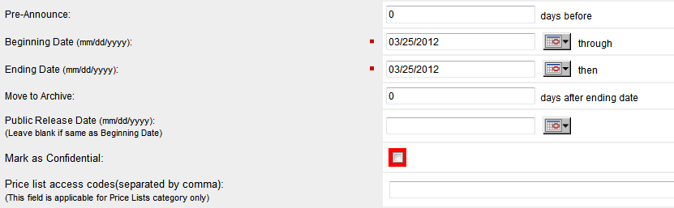
Figure 8 - Content / Event Administration Screen - Content Date Rule Specific Fields
- Pre-Announce Number of days prior to the Beginning Date to display this Content or Event. Default=0 - No effect on Beginning Date.
- Beginning Date Actual Beginning Date of Event or Partner Notification Date of the content. (Included with Subscription Service)
- Ending Date Actual Ending Date of Event or Expiration Date of the content. (Included with Subscription Service)
- Move to Archive Number of days after the Ending Date to display the Content or Event. Default=0, No effect on Ending Date.
- Public Release Date The date that this information can be released to the public. A Public Release Date Notice will appear in the Description section of the Content Item or Event.
- Mark as Confidential The caption "Confidential - Not for Public Release" will appear in the Description section of the Content Item or Event. This disables the Email and Send links at the bottom of the asset listing displayed to the user.
- Price list access codes These are special codes entered by Contracts department for price list assets. The codes allow only companies with a code to see their specific pricing. DO NOT ERASE OR MODIFY THESE CODES IN ANY WAY!!!

Note: For assets that are directly related to MS Dynamics Marketing Assets, the Archive status in MS Dynamics will override any date restrictions above, except for ending dates and move to archive days. If these date/days are reached, the asset will change to archive status although it may still be active in MS Dynamics.

Note: It is advised to not set a hard ending date or move to archive days for an asset that has an MS Dynamics item number such as an “Application Note” PDF file and let MS Dynamics control the retirement of this item from the Portal automatically.

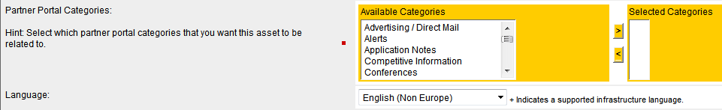
Figure 8 - Content / Event Administration Screen - Partner Portal Categories and Language Fields
- Partner Portal Categories This allows the asset to be displayed in more than one category on the Portal Site. One category is selected when you first create the asset container. Here you may select additional categories where users can find the asset on the Portal. Select one or more (hold the Ctrl key while selecting) additional categories from the Available Categories list and click the left arrow move button to move it to the Selected Categories list. You can remove it from the Selected Categories list by selecting the category and clicking the right arrow remove button.
- Language Specify the language of the asset by choosing from the drop down list.

All Portal sites will have this this Partner Portal Categories section.

Note: If you have an asset that you need to have posted up on one of the Fluke websites, you need to request this integration to be done by the web content team

Portal sites which are integrated with the customer facing website’s Product Catalog (PCat) will have three additions to the user interface to accommodate this integration as shown in Figure 9 below.

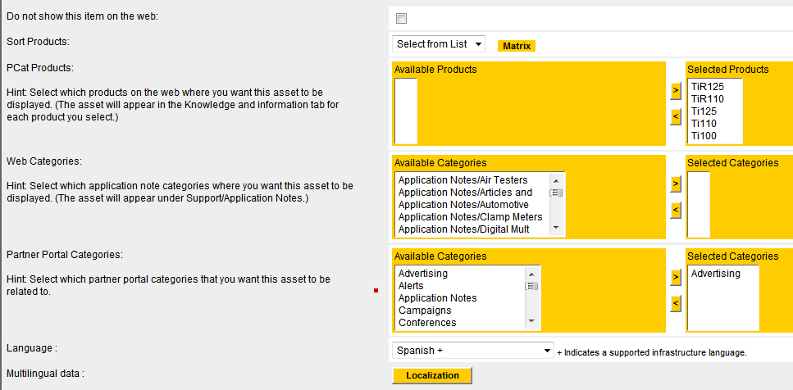

Figure 9 - Content / Event Administration Screen - Partner Portal PCat and Web Categories Fields

- Do not show this item on the web This box should be unchecked if this asset will be displayed on the customer facing website. Note: For any Price Lists, this box should always be checked!!!
WARNING: After checking the “Do not show this item on the web” checkbox, the Sort Products dropdown list and the Web Categories list boxes will be disabled The Selected Products and Selected Categories lists will also be cleared.
- Sort Products This drop down list filters what products in the Product Catalog are displayed in the Available Products list. By choosing a letter or number, the products beginning with that letter or number will be displayed in the Available Products list below. Note: Many products begin with “Fluke” at the beginning of the name, so you may find the product under the letter “F”.
- Matrix Button This displays a pop-up reference list of Product Catalog IDs (PIDs) and the corresponding product names. See Figure 10 below.
- PCat Products For each product you choose from the Available Product list and move to the Selected Products, a link to this asset will be placed in the “Knowledge and Information” tab on that product page on the website. Select one or more (hold the Ctrl key while selecting) products from the Available Products list and click the left arrow move button to move it to the Selected Products list. You can remove it from the Selected Products list by selecting the product and clicking the right arrow remove button.
- Web Categories For each Web Category you choose from the Available Categories list and move to the Selected Categories, a link to this asset will be placed in that Application Notes Category on the website. Select one or more (hold the Ctrl key while selecting) categories from the Available Categories list and click the left arrow move button to move it to the Selected Categories list. You can remove it from the Selected Categories list by selecting the category and clicking the right arrow remove button.
- Multilingual Data/Localization This button brings up the asset’s multilingual management window where you can add the localized title link to the asset to one or more country/region web sites. See Figure 11.

Portal sites which are integrated with the customer facing website’s Product Catalog (PCat) are:

Partner Portal - Fluke Industrial Tools
Partner Portal – Biomedical
Fluke Networks Asset Management System

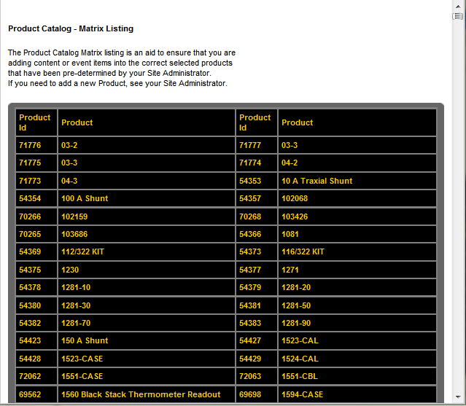

Figure 10 - Content / Event Administration Screen - Product ID/Product Matrix Listing

Localized Links

By clicking the Localization button, the asset’s multilingual data management popup window will open on screen as shown in Figure 11 below.

Here you can add localized language links for the asset to the locales (language and country/region) that it applies.
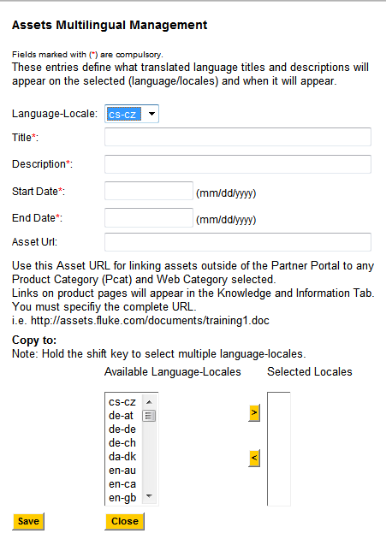

Figure 11 - Content / Event Administration Screen - Asset Multilingual Management

- Select the desired Locale from “Locales” dropdown list. The locale is made of the two letter language abbreviation and the country or region abbreviation. If a localized link was already applied to this locale, the fields will populate with the data applied for that locale. See Figure 12 below.
- Enter the localized title.
- Current BUG: The description field is not displaying anywhere. Enter the localized description.
- Enter the Start Date of when you want the link to be live.
- Enter the End Date when you want the link to be removed.
- If you want to link an asset that is outside the Portal Site to Product Page or Web Category, enter the complete URL.
- Select any additional Locales from the left Available Locales list and move them to the right Selected Locales list to apply these same settings to these Locales

- After selection click on the Save button to save the details.

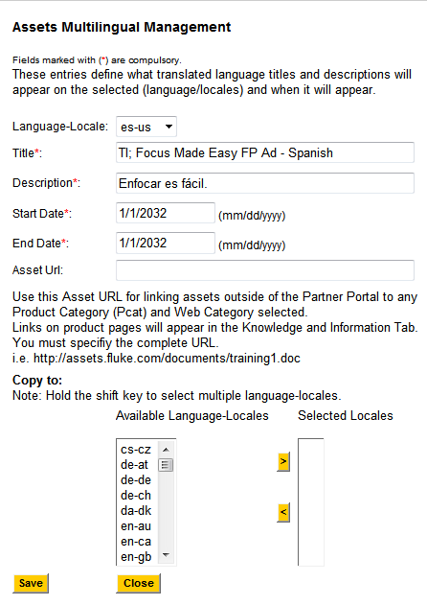

Figure 12 - Content / Event Administration Screen - Product ID/Product Matrix Listing

- Click on Close button to exit the pop-up window.
- Click the asset Update button to save the settings.

Subscriptions Notices

Figure 10 - Content / Event Administration Screen - Content Email Subscription Specific Field
  - Send Notice via Subscription Service Sends a customized email to the user containing Title, Product/Series, Date, Description and link of the record to the Channel Group enabled, whose User Profiles have Subscription Service enabled. The information is sent on the Beginning Date or Pre-Announce Date if specified.

Two broadcast times are available, 9:00pm PST (Pacific Standard Time) or 12:00 pm PST (noon). You can check what is in the Subscription Service queue for today or previous days by using Misc – Site Utilities: Subscription Service – Queue, available from the Main Menu.

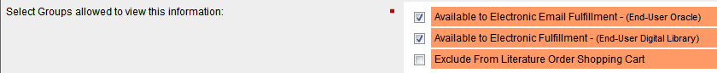

- Available to Electronic Email… Enables an asset to be available for electronic email fulfillment to End-users in Oracle orders. We are no longer using Oracle order fulfillment, so this item is not used.

- Available to Electronic Fulfillment Allows the asset to be available as a Digital Library asset to be linked to any website such as www.fluke.com.

- Exclude From Literature Order… If checked, this prevents the item from being added by a partner portal user to their shopping cart.

(Whether or not this field is available for use depends on how the Site Administrator has configured this category. For MAC, this field is not available.)

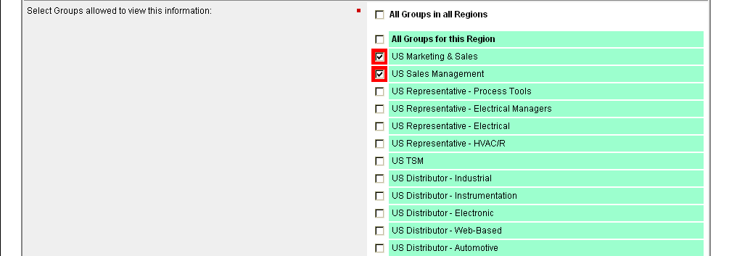
- Groups Select each group that is allowed to view this Content or Event. For new Content or Event additions, pre-selected (default) group(s) checkboxes are displayed in red.

Figure 12 - Content / Event Administration Screen - Content Administrator Group Specific Fields
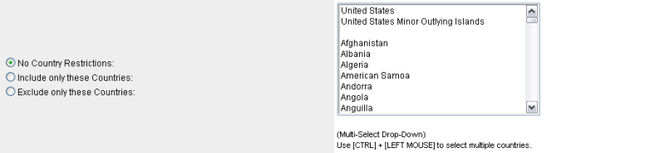
- Restricted to Countries Select each Country allowed to view this Content or Event or leave blank if no countries are restricted. This is a multi-select area. To select more than one restricted country, hold down the [CTRL] key while selecting with your mouse.

(o) No Country Restrictions – (default) allows all countries to view the asset or clears any previous country restrictions.
(o) Include only these Countries – Check this option and select “Canada” if the asset is only available for Canadian users.
(o) Exclude only these Countries – Check this option select “Brazil”, “Mexico” to exclude this asset from these countries.
- Group Assigned to Approve As a Content / Event Administrator, you can select yourself as reviewer of this submission (default), or you can reassign this asset to another group for review, approval and maintenance of this information. Note: For this submission to appear in the submitter’s or other content administrator's queue, the “Reassign Owner of this Content to:” the appropriate person. The “Reassign Owner of this Content to:” selection will only appear after initial submission of a new asset and will not appear during the initial "Add" new asset.

- Request Review by Email If you have selected another Content / Event Administrator, all submissions will automatically appear in the approval queue of the assigned Content Administrator, however, you may want to inform the Content Administrator by email of your submission for date sensitive assets or other reasons that a review is pending. Note: This selection will only appear after initial submission of a new asset and will not appear during the initial "Add" new asset.
- Special Characters Certain characters have special meaning in HTML documents. The following entity names are used in HTML, always prefixed by ampersand (&) and followed by a semicolon. They represent particular graphic characters, which have special meanings in places in the markup, or may not be part of the character set available to the writer.
Glyph | Name | Syntax | Description
< | lt | &lt; | Less Than
> | gt | &gt; | Greater Than
& | amp | &amp; | Ampersand
" | quot | &quot; | Double Quote
" | rdquo | &rdquo; | Right Double Quote
“ | ldquo | &ldquo; | Left Double Quote
´ | rsquo | &rsquo; | Right Single Quote
‘ | lsquo | &lsquo; | Left Single Quote
® | reg | &reg; | Registered
© | copy | &copy; | Copyright

- Font Attribute Tags Certain combinations of characters have special meaning in HTML documents to format the appearance of the text prefixed and suffixed by these font-formatting attributes. The following font attribute names are used in HTML, always prefixed by a > and suffixed by a < sign. Do not use the above conversions for these special characters.
Syntax | Description
<B> | Bold Enabled
</B> | Bold Disabled
<I> | Italics Enabled
</I> | Italics Disabled
<U> | Underline Enabled
</U> | Underline Disabled

MAC Typical Configuration Example

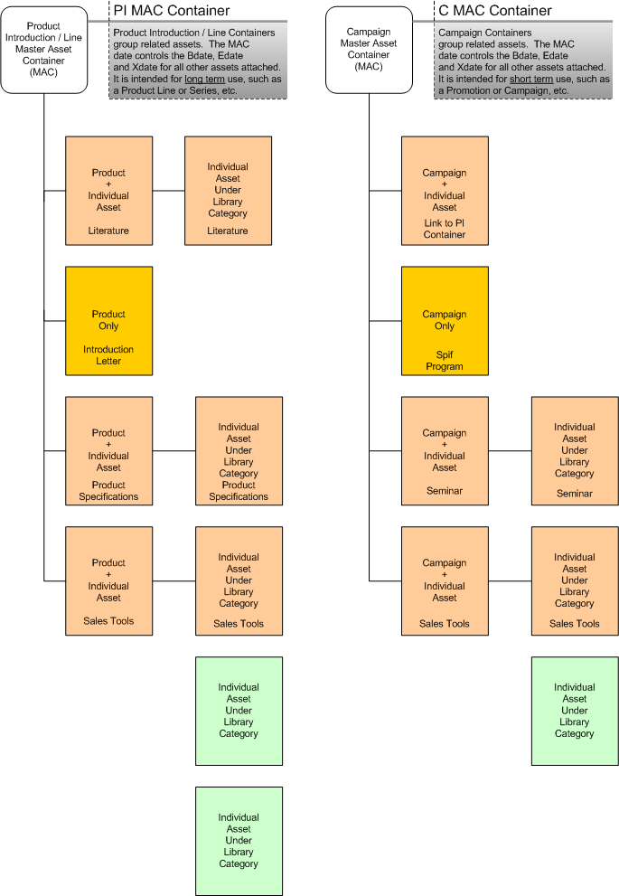
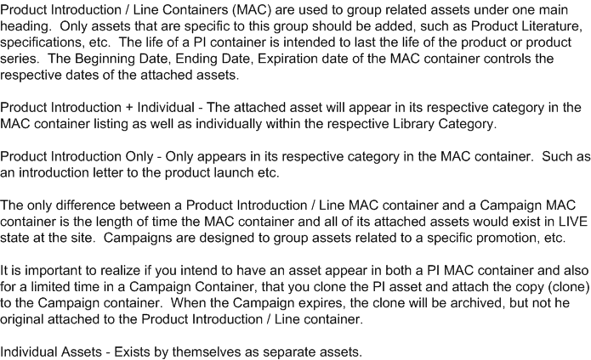

Cloning / Duplicating Individual Assets, MAC for Alternate Language Use
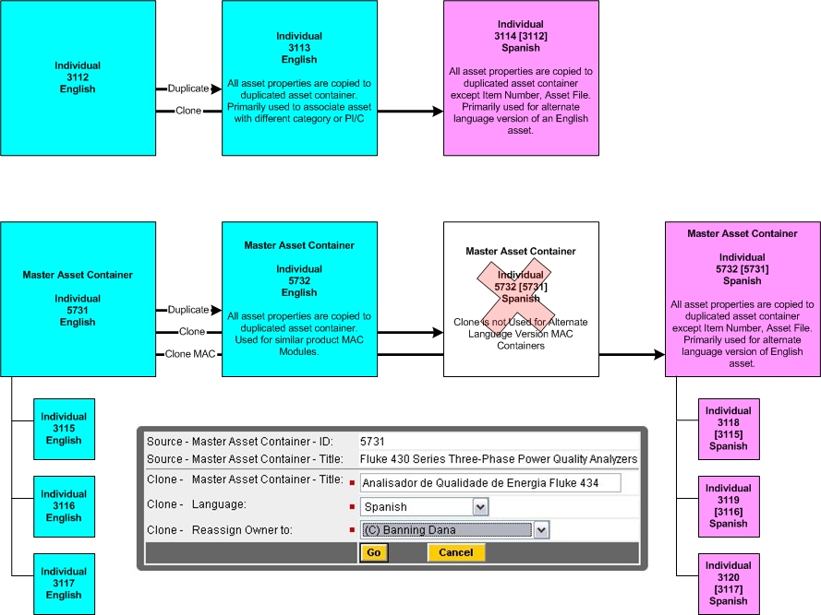
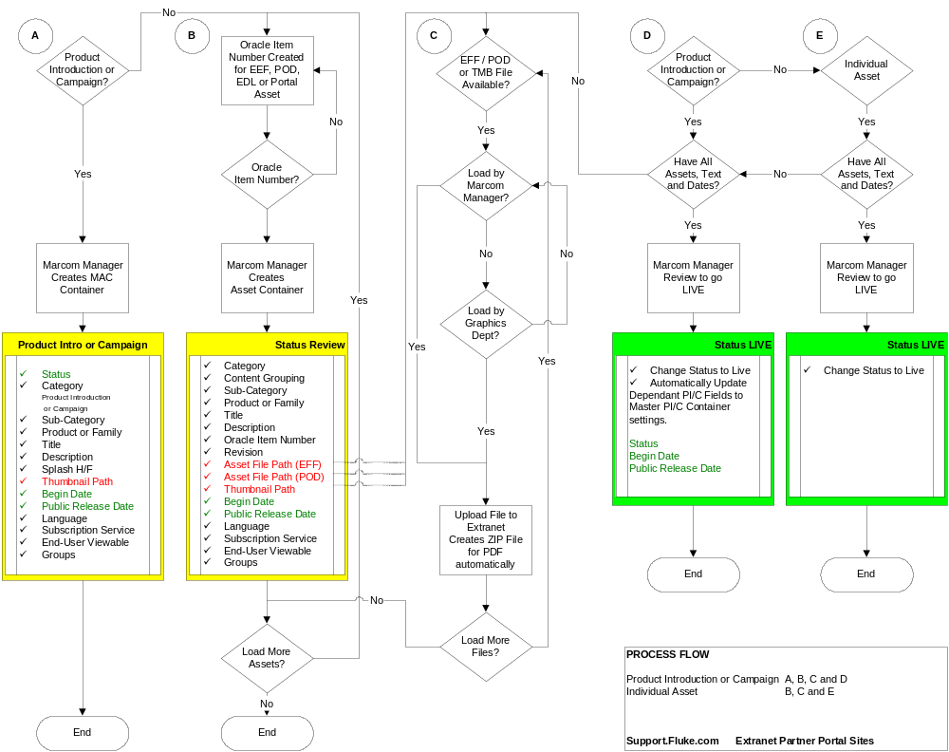
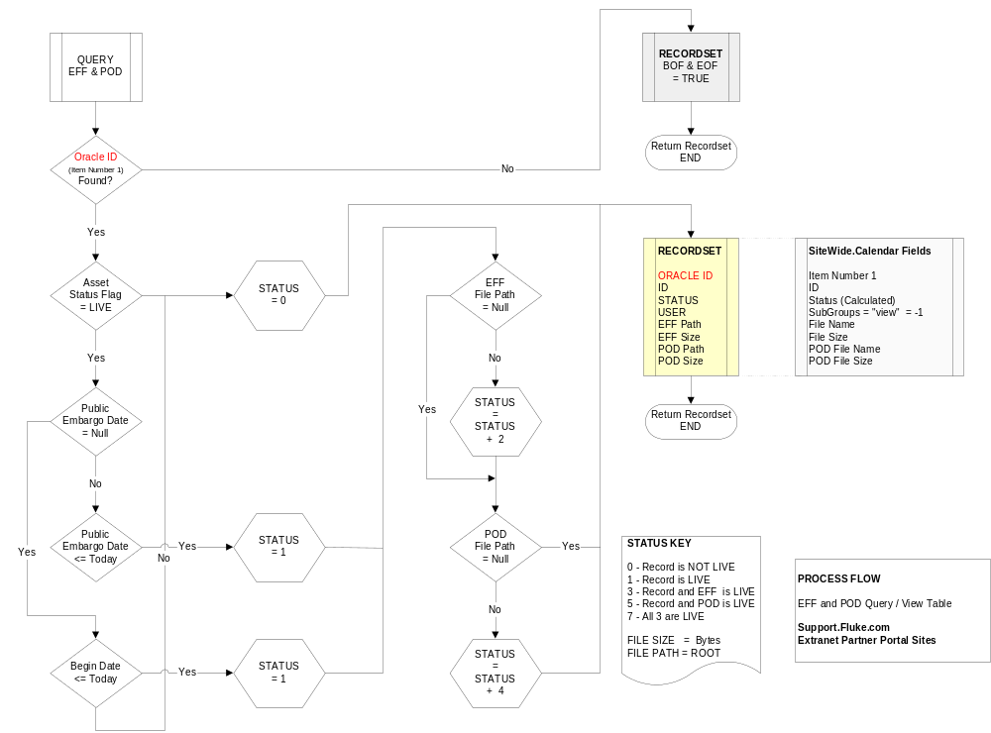

Steps on How to Create a Home Page for an Extranet Site.

1. Browse the Extranet URL - https://support.fluke.com/register/default.asp

2. Select the site from the site selection dropdown for which you want to modify the home page and click Logon.

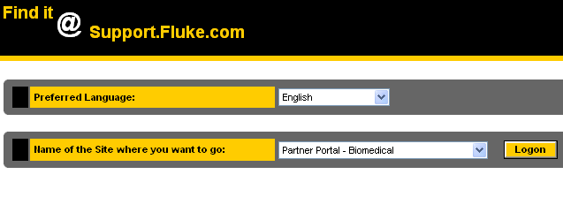
3. Enter the Content Administrator credentials for the selected site and click OK.
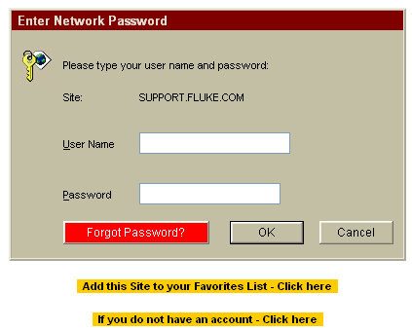

4. User will be redirected to the home page for the site. Example is shown below.

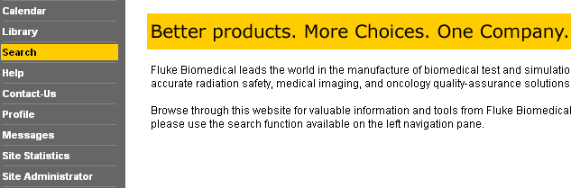

5. Click on the Site Administrator link which will be present on the left hand side navigation menu. User will be redirected to the following page.

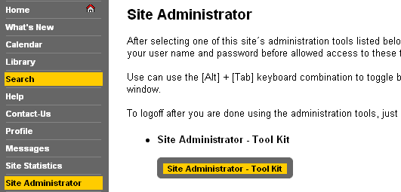

6. Click on the “Site Administrator – Tool Kit” link which will be displayed in the right pane.

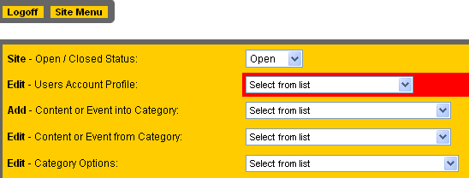

7. From the Edit – Category dropdown, select option “Welcome Home” as shown in below snapshot.

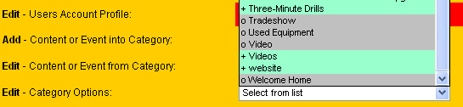

8. User will be redirected to below page

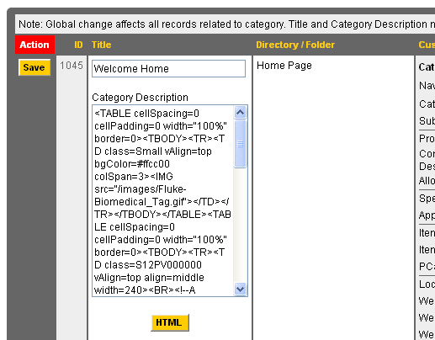

9. Enter HTML in the Category Description text box for creating the home page.(Refer above snapshot. HTML can also be constructed by clicking the HTML button which will open a HTML editor.
Please see below snapshot which displays the HTML editor.
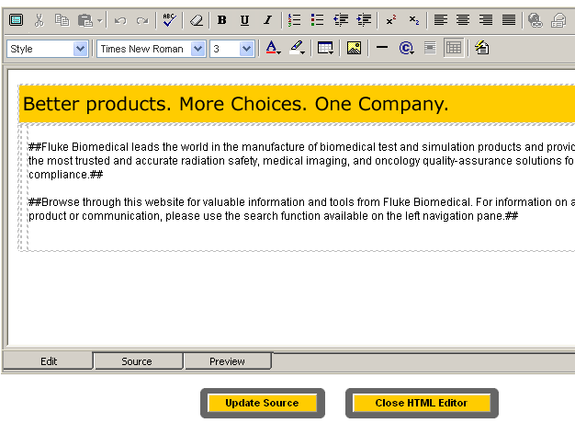

10. Clicking Update Source will bring the user back to the original page and the HTML will be displayed in the category description text box.

11. Lastly click Save to update the HTML to the database. This will build the home page for the site. Again navigate to the Extranet Site home page to view the results.(follow steps 1 through 4 ,else check if the first extranet window is open, and click Home which will be present in left hand navigation menu)

