

Information Store Console
Digital Asset Manager

Users guide for the upload, profiling and management
of digital images for the

Fluke Global ImageStore

Gerda Meijer
Kelly Whitlock (US / Intercon regional notes)

July 27, 2005
Table of Contents
1. Introduction 1
2. Using the Information Store Console 2
3. How to Add a New Image 3
4. How to Manage Existing Digital Images 12
5. Contact Information 14

- Introduction

The Digital Asset Manager is an independent system from the Partner Portal sites that reside on Support.Fluke.com. Therefore, when setting up a new Digital Asset Manager Administration account, your username and password may be different from the one you use to access the Partner Portal sites and/or the Partner Portal administrator’s tool kit. When a user accesses the ImageStore, through a link provided in the Partner Portal (via the “Images” link on the left navigation menu), the portal passes logon credentials through a gateway to the ImageStore application. In this scenario, for the user, the same username and password is common to both systems.

The Fluke Information Store Console: This tool (a subset of the Digital Asset Manager) is used to manage and profile the images in the Fluke Global ImageStore, (a third-party application and service that we contract with to manage our image library.) With the Digital Asset Manager, new IDs, descriptions like model number, product name, photo type etc. can be specified for each image and once the digital image file is in the system, edited, archived or deleted. These images can then be accessed by Partner Portal users via the “Images” link on the left navigation menu of the Partner Portal sites.

The logon screen for the Information Store Console can be accessed directly at http://console.informationstore.net

Only Information Store administrators have access to the Digital Asset Manager tool. Contact Gerda Meijer (see contact information on page 20) for account setup.

- Using the Information Store Console

After logon, click on the first tab “Digital Asset Manager”, as indicated below:
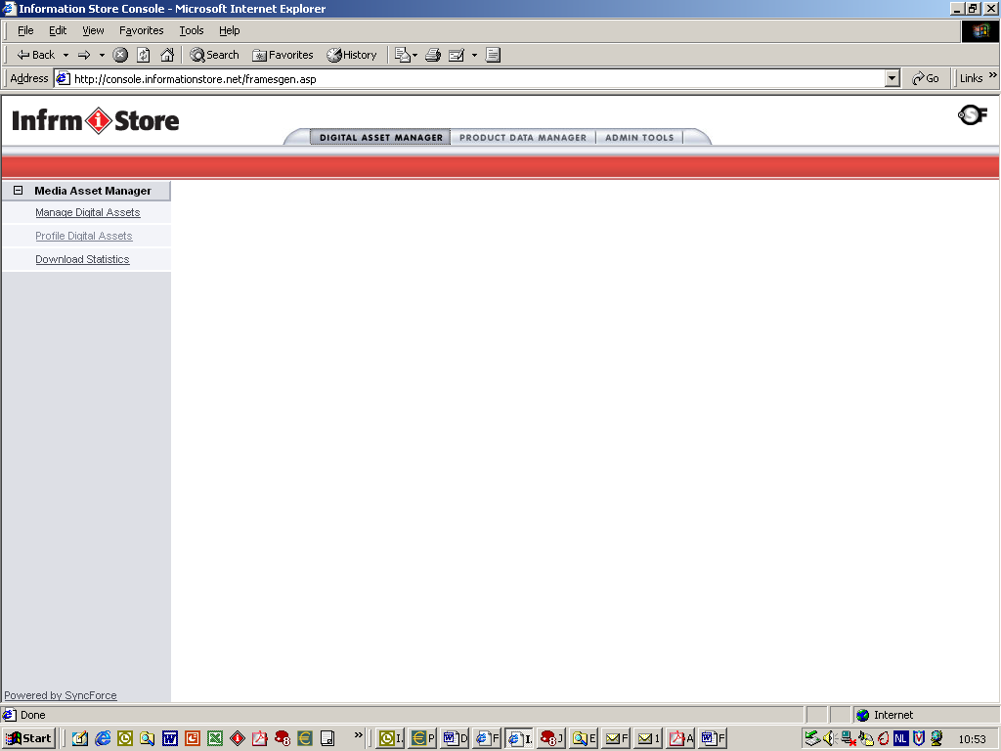

Note: We do not use the Product Data Manager or the Admin Tools tab. These functions are for other companies that use the Information Store services.

- How to Add a New Image

- Only one source file per image, preferably in RGB, needs to be uploaded and configured. This image file should be the largest possible height and width size at 300 dpi resolution you have available. Check with Louis Fliger to ensure that the image has not already been profiled and uploaded otherwise duplication will occur. From this master image file the following lower resolution versions of this image will automatically be created :
Thumbnail: max. 128 x 128 px, GIF
Preview: max. 350 x 350 px, JPEG
Windows JPG: max. 1280 x 1024 px,
Windows JPEG: max. 100 x 100 mm, 300 dpi (in Euroscale), TIF or EPS
Medium Resolution: max. 100 x 100 mm, 300 dpi (in US-SWOP), TIF or EPS
High Resolution: largest possible file in 300 dpi (in Euroscale), TIF or EPS
High Resolution: largest possible file in 300 dpi (in US SWOP), TIF or EPS
The difference between the TIF and EPS file type is that the EPS has a cut out path available in the file for free-standing use.
- To add a new image click on “Add New Digital Asset”

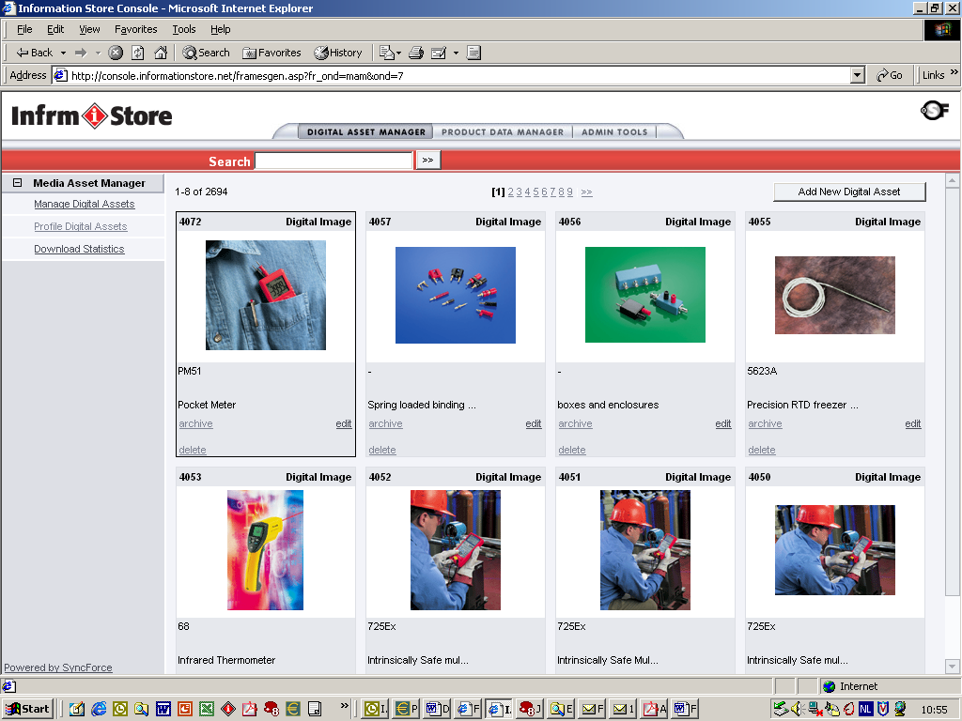

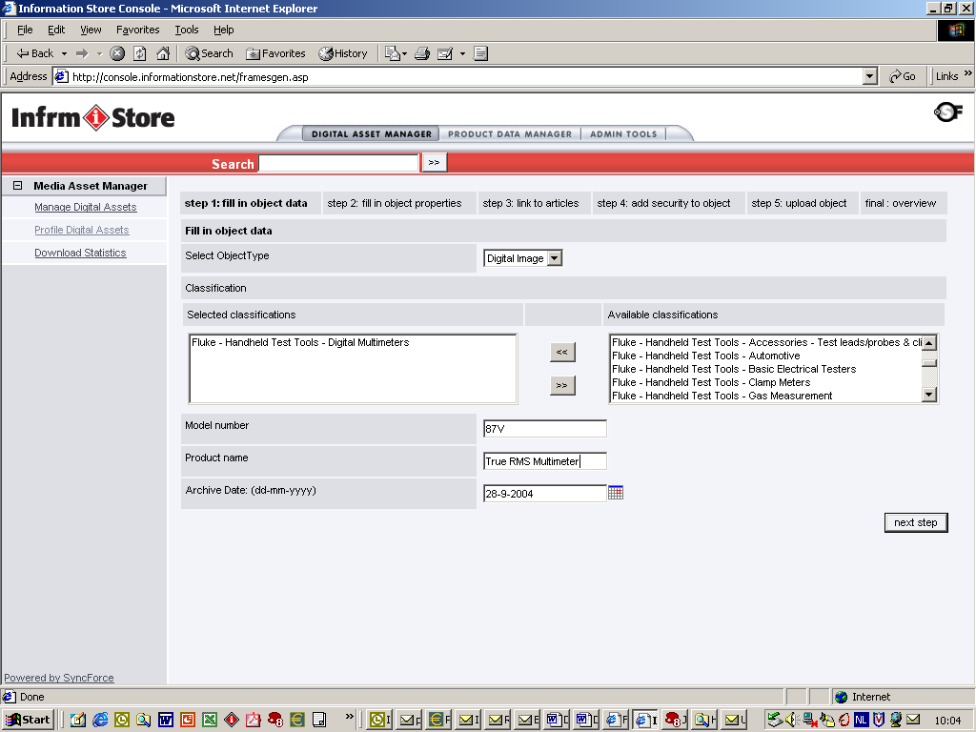

- Select from the Available Classification from the list. Use the arrow keys to move it to the left box. If you do not see a classification for your image, contact Gerda Meijer (see contact information on page 20) to set up a new classification.

- Fill in the Model Number as it is written on the product, but without the brand name such as “Fluke”. This is important because the application can search on a model number and therefore a consistent convention in specifying model numbers is required.
Example:
87V
179
i400, etc.

When there are, more products shown on an image, separate the entry using comma and space: 87V, 179, 189.

- Fill in the Product Name as it appears on the actual product. For accessories use the name as it is used in the Test Tools Catalog. Use title case where applicable so that the beginning letter of each word is capitalized.

Example:
True RMS Multimeter
ScopeMeter
Electrical Tester
Temperature Calibrator
SureGrip Silicone Test Lead Set
Pipe Clamp Temperature Probe

- The Archive Date is automatically filled in.

- Click on “next step”.

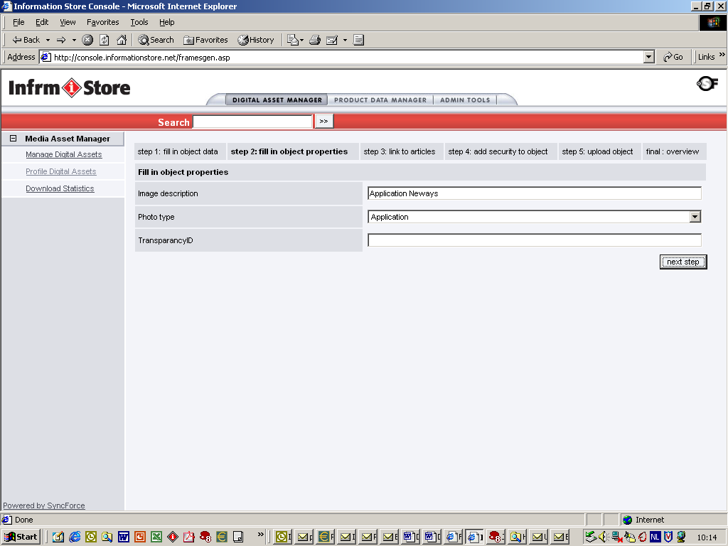

- Fill in Image Description. This is optional. For an application shot, you can provide a description of where the image was “shot”.

- Fill in Photo Type. Select from the drop-down menu. The subdivisions are:

  - Application : for application shots
  - Front cover : for beauty shots
  - Group photo : for more instruments on one picture
  - Product shot : for frontal shots of the product with or without background
- Transparency ID. (Ignore this field.)

- Click on “Next step”.

- The screen shown below is not for Fluke use. Click again on “Next step”:

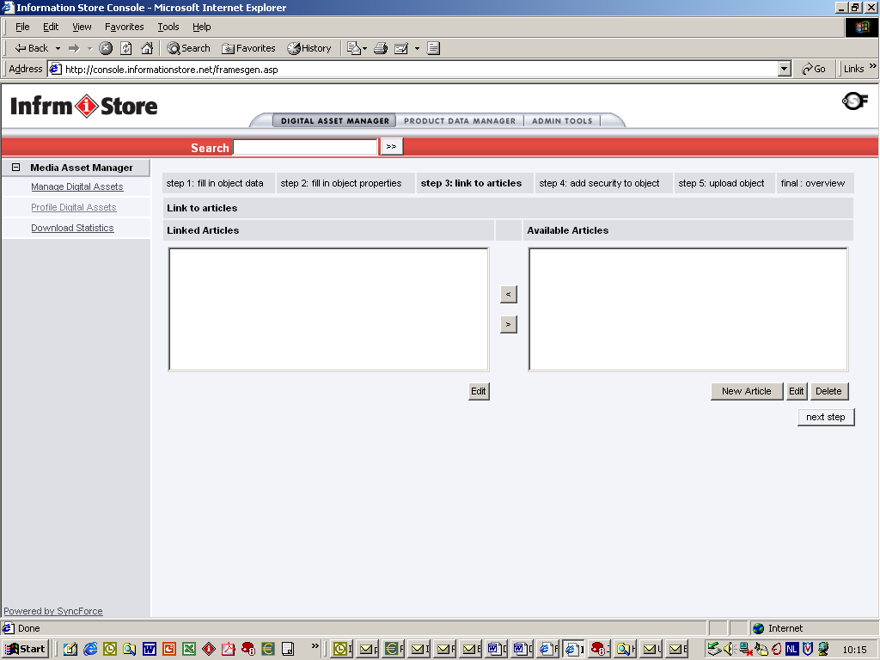
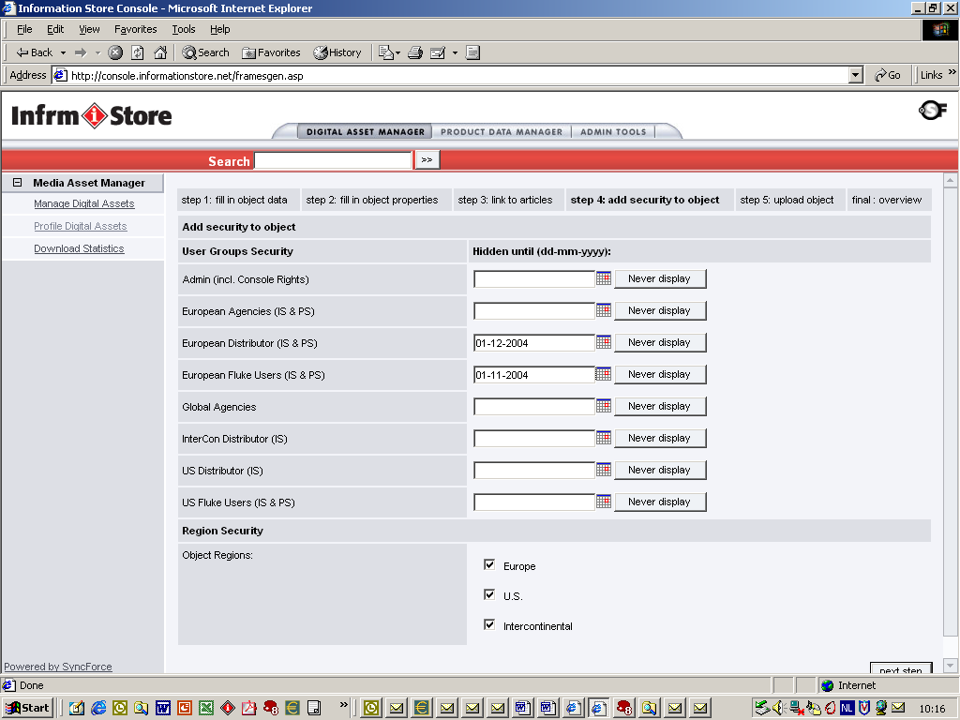

- On the above screen, set the security levels:
User Group Security:
E.g., product introduction images Fluke Entity users may be allowed to see images earlier than distributors. The security date for distributors then would depend on the date of the MRR or Embargo Date.
The following user groups are available:

  - Admin (people in the Fluke MarCom departments). This includes Console Rights.
  - European Agencies (advertising agencies in the countries)
  - European Distributor
  - European Fluke Users
  - Global Agencies (agencies used by the central MarCom department, like e.g. our European agency, The Unit)

US / Intercon:

  - Intercon Distributor
  - US Distributor
  - US based Fluke users

Attention: People in the US and Intercon who log in via the US Fluke Partner Portal sites all have US distributor access rights. However, if these images are not intended for European view, ensure you have set the [Never Display] attribute.

Region object security:

Three regions can be selected:

- Europe
- USA
- Intercon

Because the US / Intercon users log in to the ImageStore via the US Partner Portal sites they only see the USA allocated images.

- Press “Next step” to go to the next screen.

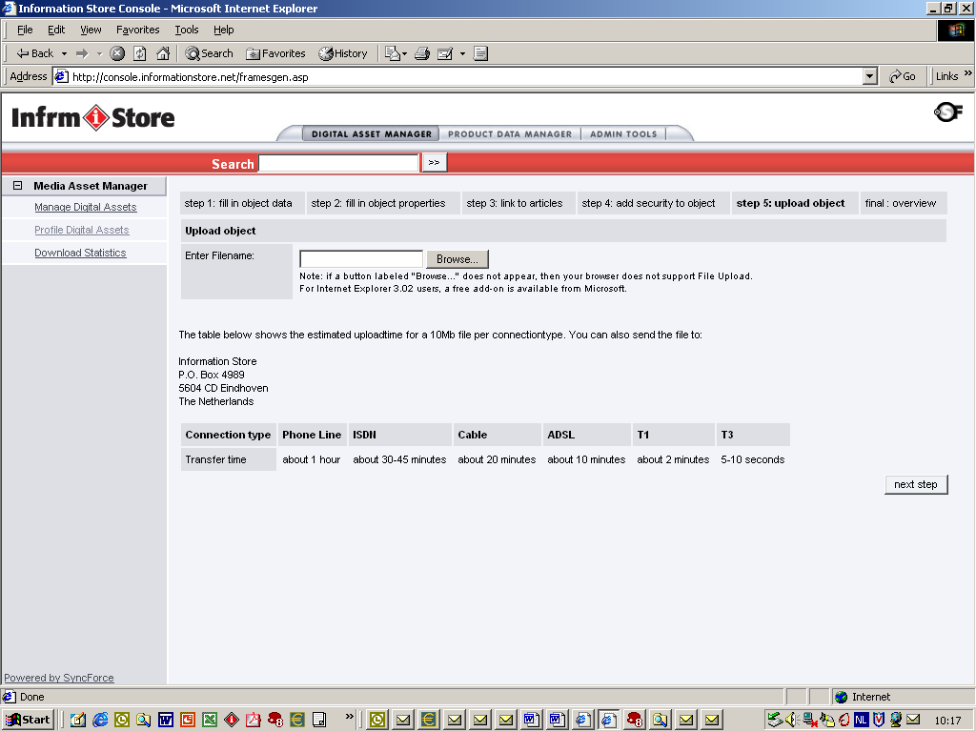

- The Upload Object function is used to upload the image directly to the ImageStore. Use the browse button to select the image you want from your local drive to upload. Click on “next step” to start the upload.
Alternative upload possibilities :

- Upload images to the US NAS server (US uploads only). The image will be processed by SyncForce, technical details will be added and the administrator will receive an e-mail in order he / she can then profile the image.

- Send CD-ROM to SyncForce with images to be uploaded. SyncForce will process the images and the administrator will receive an e-mail in order he / she can profile the image.

- Profile the images in console first and then send a CD-ROM to SyncForce. Indicate with each image the corresponding Object ID number. SyncForce will upload the image with the appropriate Object ID number.

- If the upload object function is not used, click “Next step”.

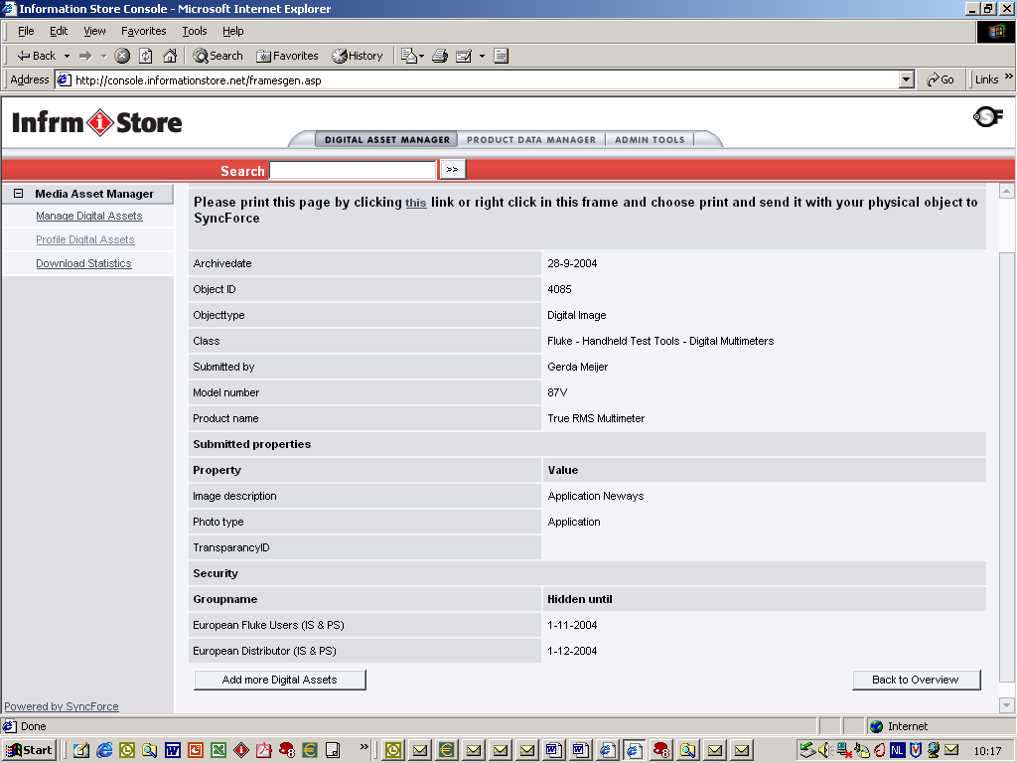

- Profile overview screen, also showing Object ID number.

- Click on “Add new Digital Asset”, in case you want to profile another Object ID or go back to the Overview.

- How to Manage Existing Digital Images
Go to the Digital Asset Manager opening screen as shown below:

For each image the following functions can be performed:

- Edit
- Archive
- Delete

Edit: Press Edit and make the appropriate changes in General Specs and or in Security. Click “Apply changes”.

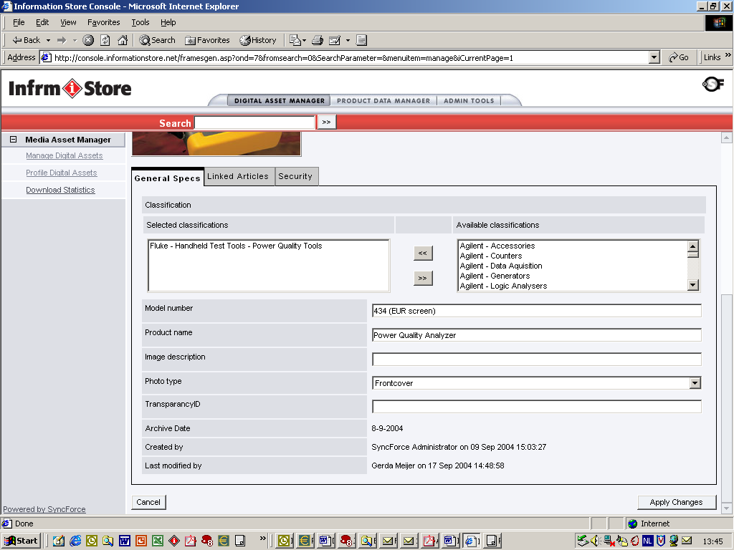

Archive: The images will remain in the database; however, they will not be visible.
If you click “Also search archived digital assets” in the Extended Search screen of the ImageStore, these archived images will become visible.

Delete: The image information and master digital file will be deleted completely.
- Image Collections

Related Image can be grouped into collections for easy reference via an asset container link. This section will guide you through the process of creating an image collection and how to link the image collection with a Partner Portal asset container.

The Campaign Manager (part of the Information Store Console) is a tool that allows the administrator to create a link to a collection of related images in the Fluke Global ImageStore.

Click on Admin Tools and you will see the following screen:

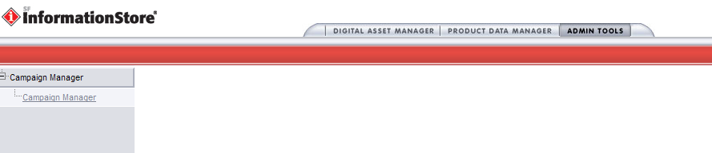

- How to create an Image Collection (Campaign)

Click on Campaign Manager, New Campaign and you will see the following screen:

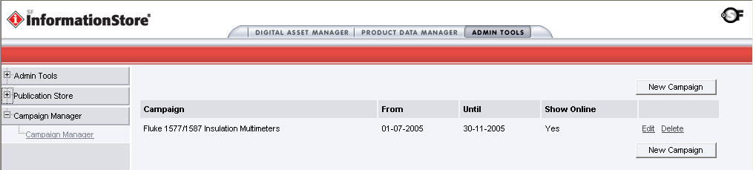

Fill in the following details for the New Image Collection (Campaign)

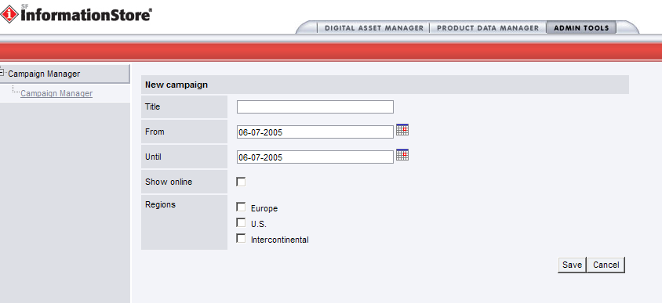

- Title - Image Collection Title
- Date From - Embargo Date (if From Date = Until Date, the collection will never archive
- Date Until - Archive Date
- Show online - Checkbox to make available externally
- Regions: US - Select regions that apply (typically for US assets, U.S. and Intercontinental regions only)

Click on Save

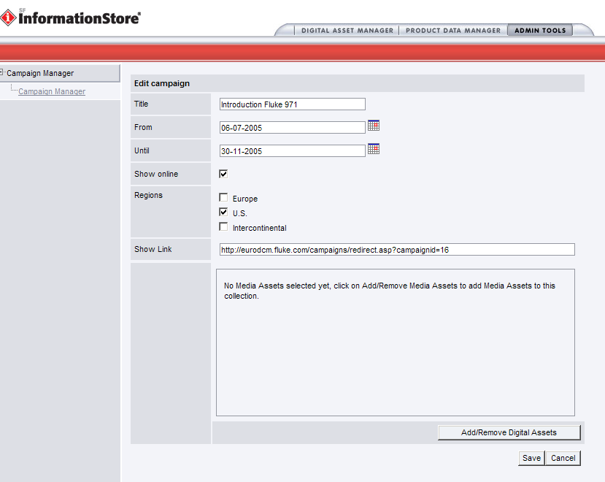

The “Show Link” is the URL to the collection used by the Partner Portal asset container field: “URL to Web Page”.

Now you can start creating your collection of images.

Click on Add/Remove Digital Assets.

Via Quick Search of Extended Search select the images you would like to add to your collection. For instance in this example the images of the Fluke 971.

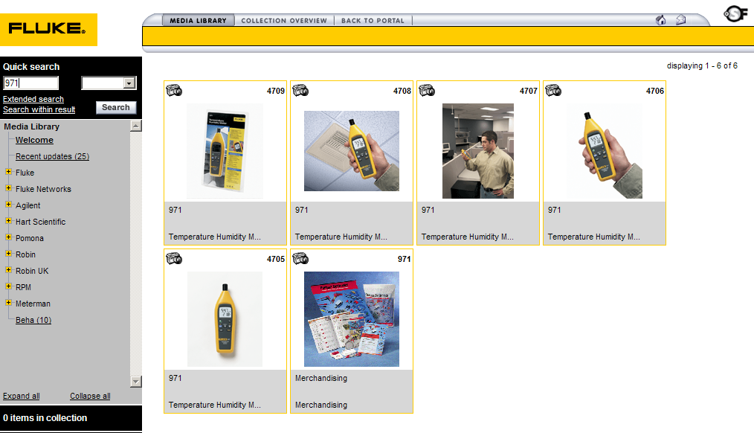

Click on the image you would like to add and click on “Add to collection”.

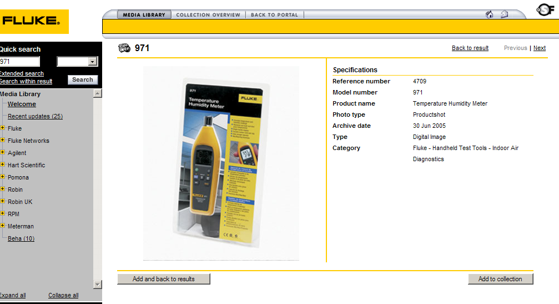

Click on “Add more” in the Collection Overview to add a new image to the collection or click on [Back to Portal] to close the Collection Overview window.

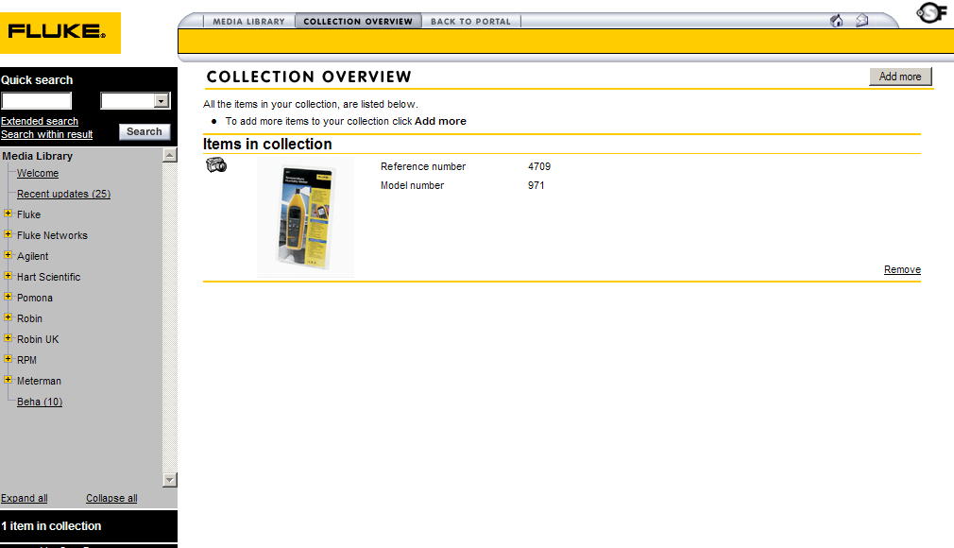
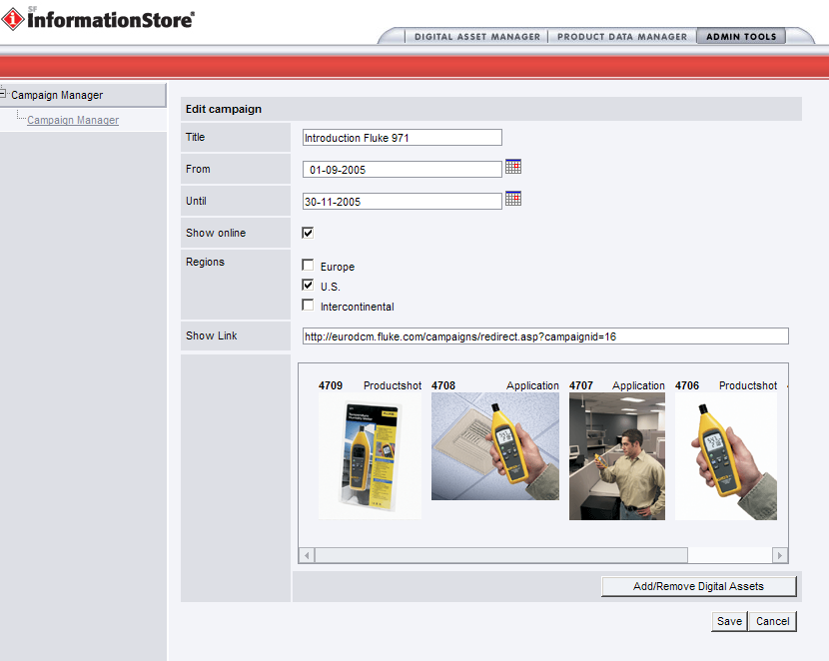

Click on “Save” to save your collection (campaign).

Using you mouse, highlight and copy [ctrl + c] the Show Link URL.

- Contact Information

Gerda Meijer Gerda.Meijer@fluke.nl +31-(0)40-2675213
ImageStore configuration issues and ImageStore Administrator account requests and new product classifications.

Kelly Whitlock Kelly.Whitlock@fluke.com x5973
Partner Portal / ImageStore access issues via Partner Portal sites.

Louis Fliger Louis.Fliger@fluke.com x5079
US / Intercon Administrator for the upload and maintenance of US / Intercon images.

SyncForce Send CD images for bulk upload to the following address:

SyncForce t.a.v dhr Remko Kool
Rooijakkersstraat 2
5652 BB Eindhoven
The Netherlands

Contact: Remko Kool r.kool@syncforce.com
Phone: +31-(0)40-2392200
Fax: +31-(0)40.2392201

