

Collection Manager

Users guide for the creation of grouped images
for display on the US Partner Portal sites.

Fluke Global ImageStore

Gerda Meijer
Kelly Whitlock (US / Intercon regional notes)

July 27, 2005
Table of Contents
1. Introduction 1
2. Using the Information Store Console 2
3. How to Add a New Image 3
4. How to Manage Existing Digital Images 12
5. Contact Information 14

- Introduction

The Campaign Manager is a tool to create a link to a selection of images from the ImageStore. This program can be accessed by those who have US Admin rights in the Image Store.
The Campaign Manager can be found in the Information Store Console at www.flukepartnerportal.com :

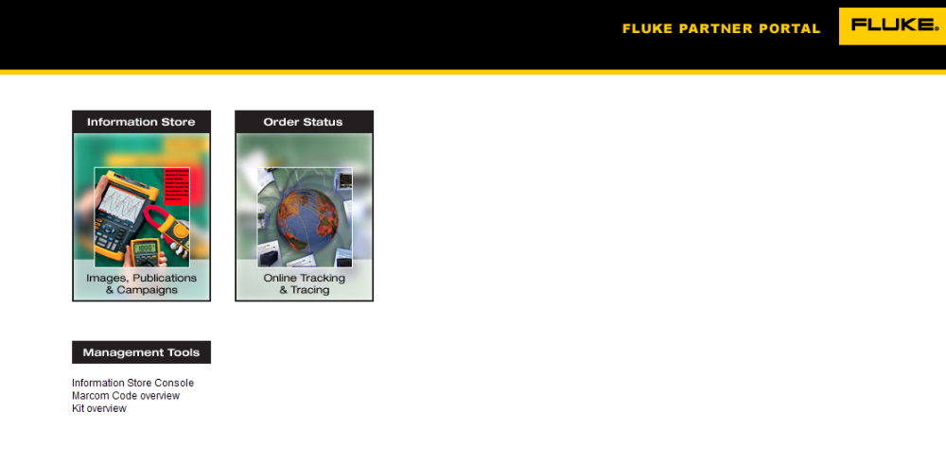

under the tab Admin Tools:

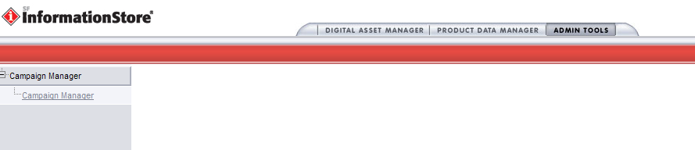

- How to create a campaign

Click on Campaign Manager, New Campaign and you will see the following screen:

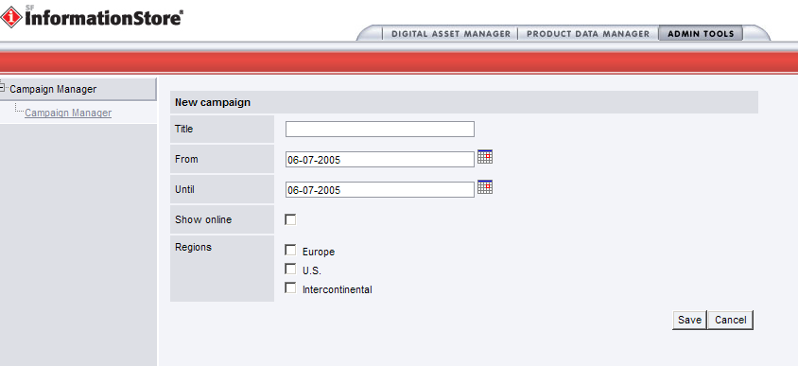

Fill in the following details for the New Campaign

- Title
- Date From
- Date Until
- Show online
- Regions: US

Click on Save

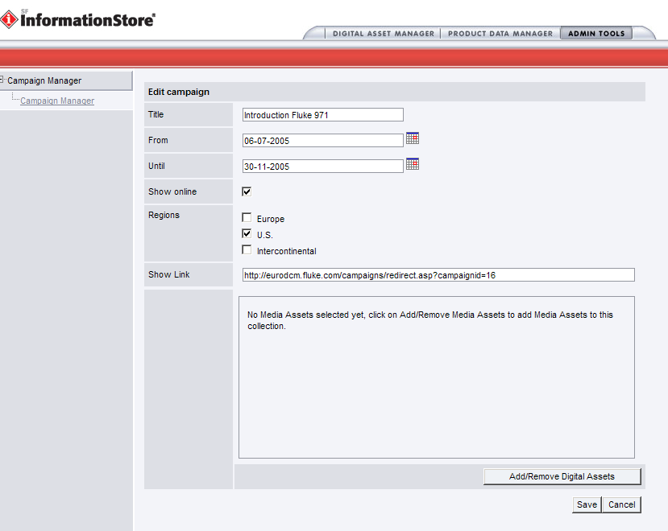

Now you can start creating your collection of images.
Click on Add/Remove Digital Assets.
Via Quick Search of Extended Search select the images you would like to add to your collection. For instance in this example the images of the Fluke 971.

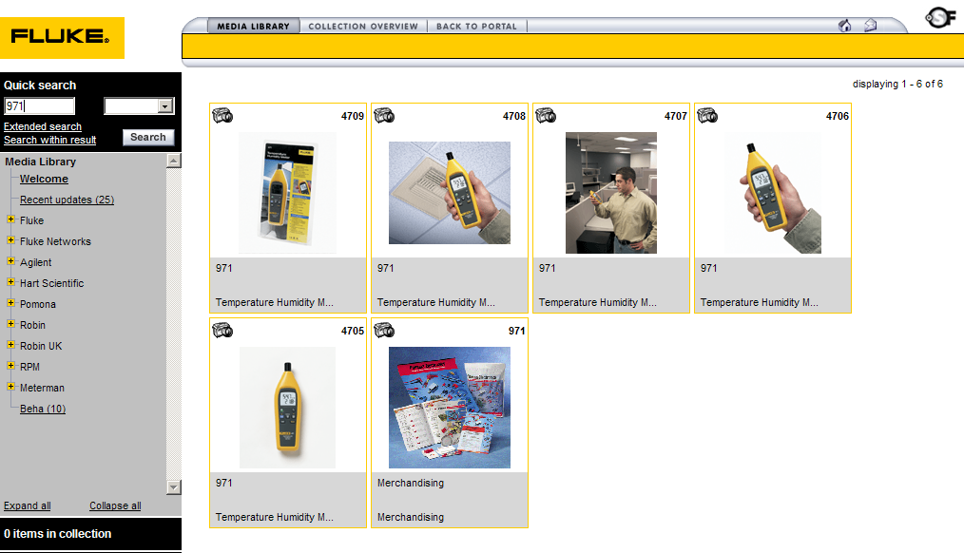

Click on the image you would like to add and click on “Add to collection”.

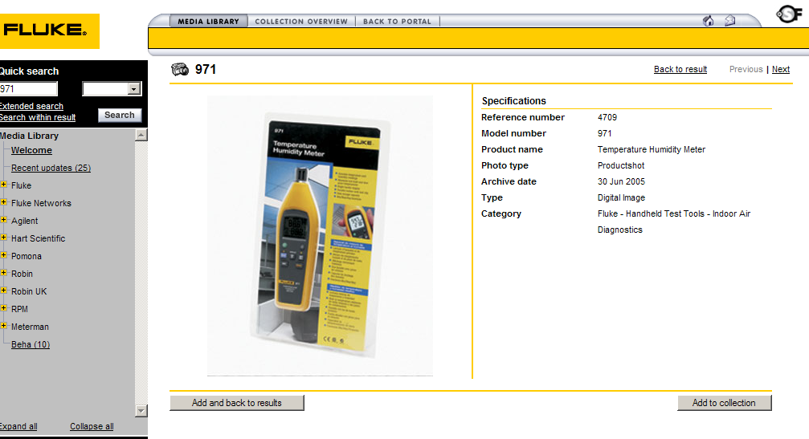

Click on “Add more” in the Collection Overview to complete your selection.

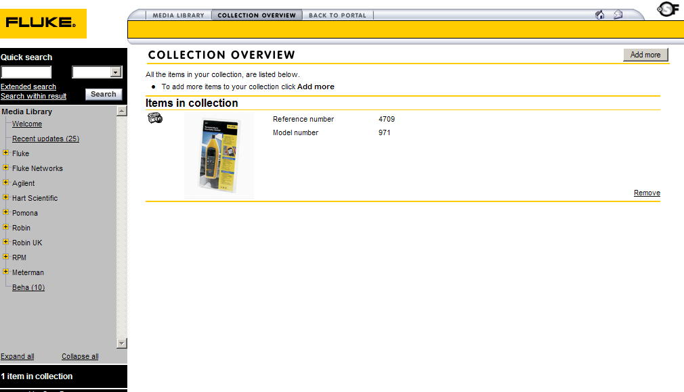

When the collection is complete, click on “Back to Portal”.

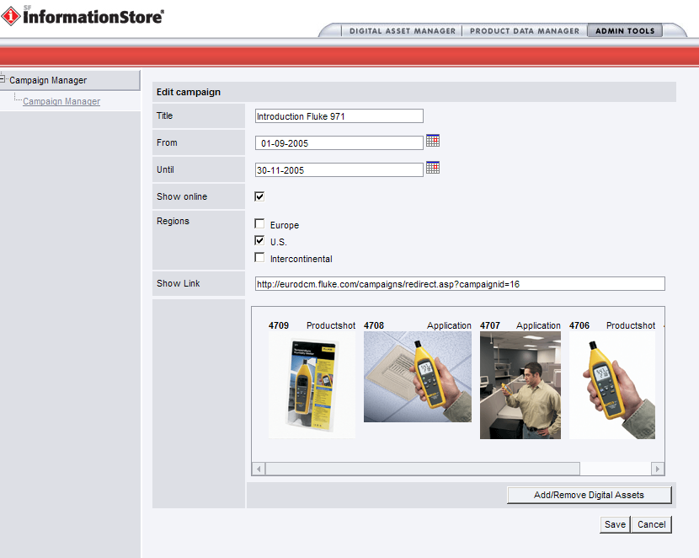

Click on “Save” to save your campaign.

Add the link on the appropriate place in the US Partner Portal.

