Product Introduction / Campaign Creator

Site View

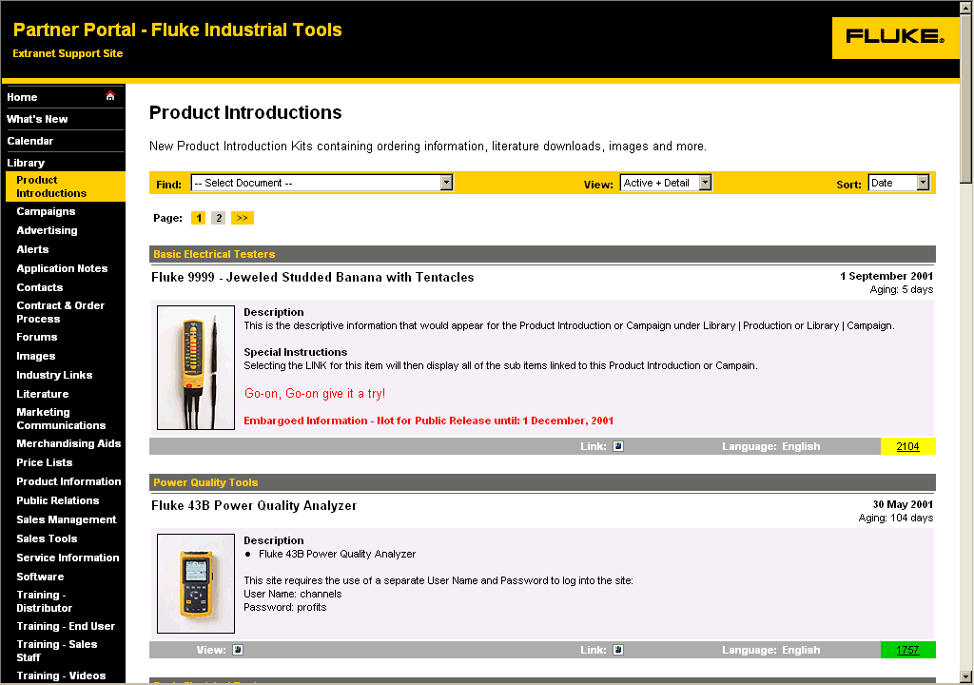
Figure 1 - Product Introduction - User Site View

The creation of either a Product Introduction Kit or Campaign is identical, except for the fact that the entry point into the actual collection of content or calendar items fall under the navigation button, "Product Introductions" or "Campaigns" respectively. For simplicity, the acronyms PICC or PIC will be used throughout the remainder of this document to reference "Product Introduction / Campaign" or the PIC Creator itself."

What is initially presented to the user is the container or gateway each PIC collection. This item listing is no different than any other item listing, except for the fact that it is used to introduce the PIC and provide a LINK to the actual collection.

In the screen shot above, a sample PIC has been created called the "Fluke 9999".

Clicking on the link icon , will advance the user to view the actual PIC container view (Figure 2 - Product Introduction Container - User View).
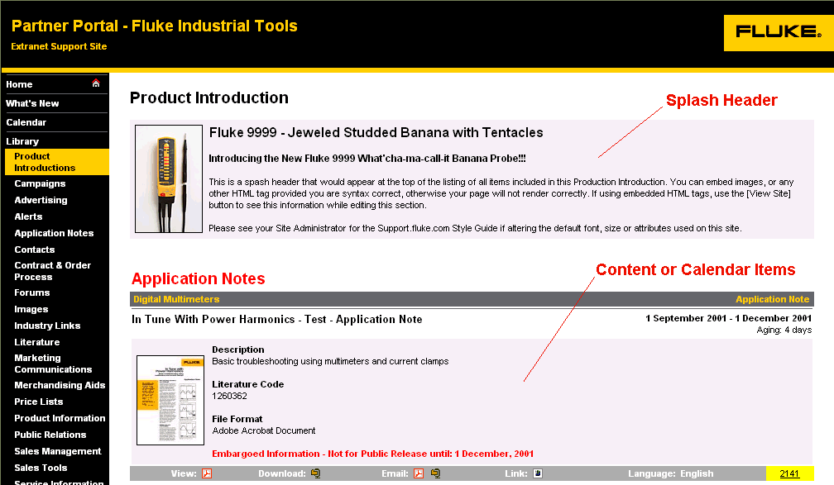
Figure 2 - Product Introduction Container - User View
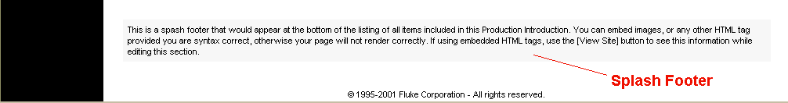
The figure above, shows the PIC container or user view for the "Fluke 9999 Product Introduction". This container contains a Splash Header (optional), the associated content or calendar event items, in order of Category, Sub-Category, Title, followed by the Splash Footer (optional).

Although these content or calendar event items appear in the PIC container, they can optionally appear as individual items in each of their respective Library Categories. This is accomplished by setting the Items Content Grouping specification to "Product Introduction + Individual".

Selecting "Product Introduction Only" will list the item within the PIC container, but will not show the asset under its individual Library Category.

Selecting "Individual" will only show the asset under its individual Library Category and will not include it in the PIC container.

Creating a Product Introduction or Campaign

The creation of a PIC is only available to those administrators who have Content or Site Administration credentials. Content Submitters are prohibited from creating a PIC.

Initially the PIC container itself needs to be created. Once created, all content or calendar items may be grouped within this PIC.

To create a PIC, logon to your Site Administration screen. Under the Site Utility, ADD - Content or Event into Category, choose either Product Introduction or Campaign (Figure 3 - Site Administration - Main Menu).

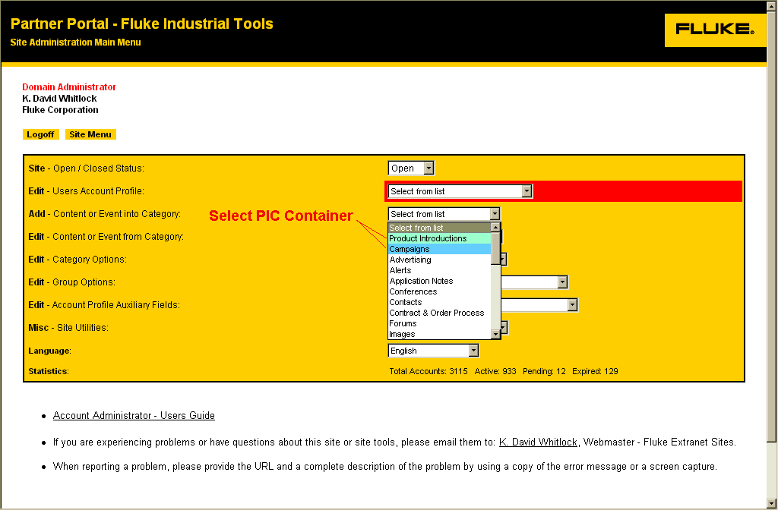
Figure 3 - Site Administration - Main Menu

The next screen that will appear will be the Content / Event Administration Screen. This screen is the same screen used for entering Individual items as well as defining the PIC container item. The difference between an individual content or calendar event item and a PIC container item is the addition of the Splash Header and Splash Footer text areas.

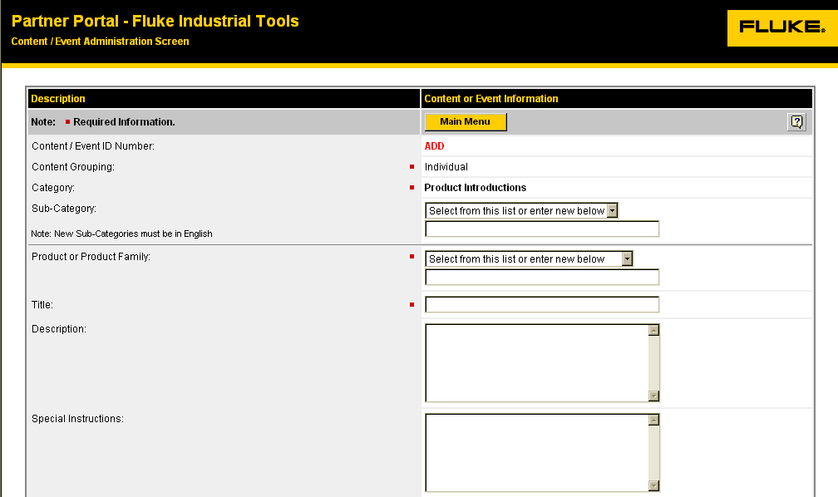
Figure 4 - Content / Event Administration Screen - Category and Product / Product Family Specific Fields
- Content / Event ID Number The ID number will either display ADD for a new item or for an existing item, the actual record ID number will be displayed.

- Content Grouping Individual
Item appears under its Library Category Only.
Product Introduction + Individual
Item appears as an individual item under its respective Library Category, and with the PIC container.
Product Introduction Only
Item appears in the PIC container only.
Campaign + Individual
Item appears as an individual item under its respective Library Category, and with the PIC container.
Campaign Only
Item appears in the PIC container only.

For a PIC container, "Individual" is the only option available.

- Category Defines where the item will appear under the Calendar or Library navigation buttons. The Category is pre-selected when you select from the Add menu. This cannot be changed, unless you first delete this record and re-enter the data under a new Content or Event Category.
- Sub-Category Select from the pre-defined list. If you do not find a sub-category that adequately describes your item, contact your Content Administrator. All New Sub-Categories must be in English, however will be automatically translated to the user's preferred language.

- Product or Product Family The Product or Product Family anme is a critical sorting/grouping field. Please try to add new Content or Event records using one of the pre-existing selections, or if you require a new Product or Product Family name, contact your Content Administrator to specify a new name by using the input box. All New Product or Product Family names must be in English, however will be automatically translated to the user's preferred language.

- Title Topic or title of the Content or Event item. (Included with Subscription email.)

- Description Short narrative description of the Content or Event item. (Included with Subscription Service)

- Special Instructions Short instructions of how to use, order, or other instructions related to the Content or Event item.
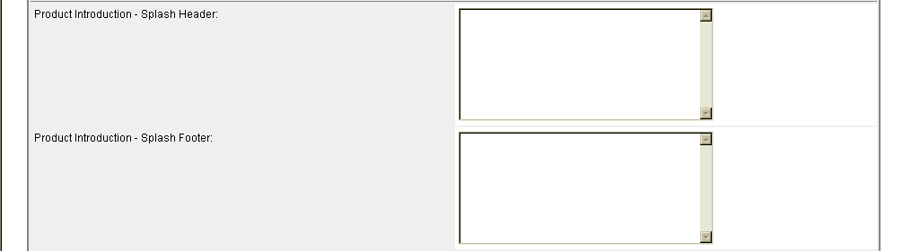
- Splash Header This is the PIC introduction header used to introduce the PIC. This field would not appear when creating a non-PIC content or event item.
Figure 5 - Content / Event Administration Screen - Product Introduction / Campaign Specific Fields
- Splash Footer This is the PIC footer used to conclude the PIC. This field would not appear when creating a non-PIC content or event item.

- Item / Reference Number 1 Item / Reference Number 1 is used to provide the Oracle Item Number to user's related to the content items physical order number. This number is also required for any content item designated in the Group Section as "User". When these two are used in combination, the document file is available for fulfillment through the Fluke Document Fulfillment System. The show checkbox, if checked will display the Item Number in the content's description.
Figure 6 - Content / Event Administration Screen - Item / Reference Numbers

For all other cases, this is an optional reference number.

(Whether or not this field is available for use depends on how the Site Administrator has configured this category. For PIC, this field is not available.)

- Item / Reference Number 2 Optional secondary reference number.

(Whether or not this field is available for use depends on how the Site Administrator has configured this category. For PIC, this field is not available.)

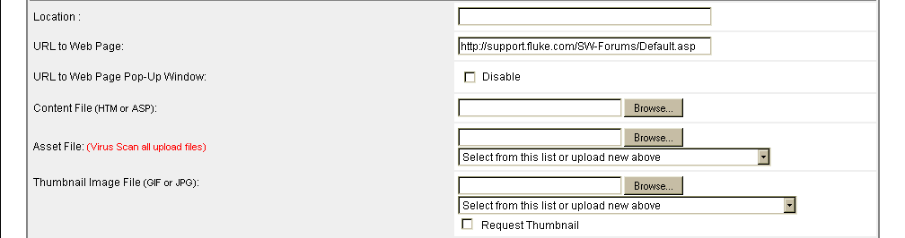
Figure 7 - Content / Event Administration Screen - Content Locator Specific Fields

- Location Reference to a Building, City, State, Country information. Optional secondary reference number.

(Whether or not this field is available for use depends on how the Site Administrator has configured this category. For PIC, this field is not available.)

- URL to Web Page If the Content or Event has additional information located on another web page, supply the complete URL.

(Whether or not this field is available for use depends on how the Site Administrator has configured this category. For PIC, this field is not available.)

- URL to Web Page Pop-Up If disabled, then the URL Link to a Web Page is direct (same window) as opposed to using a separate pop-up browser window. A Session variable, Session("BackURL") can be interogated by the link to obtain the parent link to restore this view when the link application is done.

(Whether or not this field is available for use depends on how the Site Administrator has configured this category. For PIC, this field is not available.)

- Content File Future Feature.

(Whether or not this field is available for use depends on how the Site Administrator has configured this category. For PIC, this field is not available.)

- Asset File Supplies a link for this record so the user can view the asset on-line, or download or self-email the asset or a compressed zip archive file of the asset.

Use the [Browse] button to locate the file on your local drive. The file you selected will be uploaded to this server, once you have clicked on the [Save / Update] button below.

Zip Archive files are automatically created for each uploaded file.

At a later time, if you wish to update this asset, unattach the current file from this record, click on the checkbox to the right of the file name, then clicked on the [Save / Update] button below, then repeat the asset upload process described above.

(Whether or not this field is available for use depends on how the Site Administrator has configured this category. For PIC, this field is not available.)

- Thumbnail Image Adds a visual thumbnail image to this record.

Use the [Browse] button to locate the file on your local drive. The file you selected will be uploaded to this server, once you have clicked on the [Save / Update] button below. At a later time, if you wish to unattach this file from this record, click on the checkbox to the right of the file name.

