End-to-End Documentation: Delta Live Tables Bronze Layer with Governance

1. Catalog & Governance Setup

🔹 Step 1: Create a Catalog
In Unity Catalog, we created a catalog for our project:
CREATE CATALOG hetul_project02_catalog;

🔹 Step 2: Create a Schema (inside the catalog)
CREATE SCHEMA hetul_project02_catalog.retail_compliance_p2;

📌 Now we have:
- Catalog → hetul_project02_catalog
- Schema → retail_compliance_p2
All our DLT tables will be saved here.

🔹 Step 3: Governance & Permissions
We applied Unity Catalog governance:
- Assign owners (who can manage objects).
- Grant read/write access to relevant users/groups.

This ensures fine-grained access control.

2. Bronze Layer Development

🔹 Step 4: Why Bronze Layer?
- Bronze = raw ingestion (no transformations).
- Ingest data as-is from ADLS.
- Keep schema simple & stable (all StringType).
- Later in Silver, we do casting & data cleansing.

🔹 Step 5: Common Problems Faced

❌ Problem 1: Schema Conflicts
Error:
[DELTA_MERGE_INCOMPATIBLE_DATATYPE] Failed to merge incompatible data types LongType and StringType

- Different file formats inferred different types for product_id.
Fix → In Bronze, we forced all columns as StringType.

❌ Problem 2: Conflict Between Schema Evolution & Fixed Schema
Error:
Schema evolution mode addNewColumns is not supported when the schema is specified

- You can’t fix schema and also infer types.
Fix → Disabled inferSchema & used .schema(...) manually.
Kept schemaEvolutionMode = addNewColumns (safe to add new columns later).

3. Final Bronze DLT Code
import dlt
from pyspark.sql.types import *

# =====================================
# SCHEMAS (all as StringType for Bronze)
# =====================================

# Sales schema
sales_schema = StructType([
StructField("sale_id", StringType(), True),
StructField("product_id", StringType(), True),
StructField("region", StringType(), True),
StructField("store_id", StringType(), True),
StructField("quantity", StringType(), True),
StructField("sales_amount", StringType(), True),
StructField("sale_date", StringType(), True)
])

# Products schema
product_schema = StructType([
StructField("product_id", StringType(), True),
StructField("product_name", StringType(), True),
StructField("category", StringType(), True),
StructField("price", StringType(), True),
StructField("discount_rate", StringType(), True)
])

# =====================================
# Bronze Sales (CSV source)
# =====================================
@dlt.table(
comment="Bronze layer: raw sales data from CSV files",
table_properties={"quality": "bronze"}
)
def bronze_sales():
return (
spark.readStream.format("cloudFiles")
.option("cloudFiles.format", "csv")
.option("header", "true")
.option("cloudFiles.schemaEvolutionMode", "addNewColumns")
.schema(sales_schema)
.load("abfss://raw02hetul@hetulstorage.dfs.core.windows.net/raw_data_02/sales/")
)

# =====================================
# Bronze Products CSV
# =====================================
@dlt.table(
comment="Bronze layer: raw product data from CSV files",
table_properties={"quality": "bronze"}
)
def bronze_products_csv():
return (
spark.readStream.format("cloudFiles")
.option("cloudFiles.format", "csv")
.option("header", "true")
.option("cloudFiles.schemaEvolutionMode", "addNewColumns")
.schema(product_schema)
.load("abfss://raw02hetul@hetulstorage.dfs.core.windows.net/raw_data_02/products/")
)

# =====================================
# Bronze Products JSON
# =====================================
@dlt.table(
comment="Bronze layer: raw product data from JSON files",
table_properties={"quality": "bronze"}
)
def bronze_products_json():
return (
spark.readStream.format("cloudFiles")
.option("cloudFiles.format", "json")
.option("cloudFiles.schemaEvolutionMode", "addNewColumns")
.schema(product_schema)
.load("abfss://raw02hetul@hetulstorage.dfs.core.windows.net/raw_data_02/products/")
)

4. Silver Layer
The Silver layer cleans, casts, and deduplicates data and applies anomaly detection.
Data Type Casting & Threshold Checks:
Table | Column | From | To
Products | product_id | string | long
Products | price | string | double
Products | discount_rate | string | double
Sales | sale_id | string | long
Sales | product_id | string | long
Sales | quantity | string | int
Sales | sales_amount | string | double
Sales | sale_date | string | date
DLT Silver Products:
- import dlt
- from pyspark.sql.functions import *

- @dlt.table(comment="Silver: cleaned and unified product data", table_properties={"quality":"silver"})
- def silver_products():
- df_csv = dlt.read("bronze_products_csv")
- df_json = dlt.read("bronze_products_json")

- df = df_csv.unionByName(df_json, allowMissingColumns=True)

- df_cast = df.select(
- col("product_id").cast("long"),
- col("product_name").cast("string"),
- col("category").cast("string"),
- col("price").cast("double"),
- col("discount_rate").cast("double")
- )

- df_clean = df_cast.filter(
- (col("product_id").isNotNull()) &
- (col("price") >= 0) &
- (col("discount_rate").between(0,1))
- )

- df_final = df_clean.dropDuplicates(["product_id"])\
- .withColumn("_ingest_timestamp", current_timestamp())
- return df_final

DLT Silver Sales (with unique sale ID):
- @dlt.table(comment="Silver: cleaned sales with robust unique sale ID", table_properties={"quality":"silver"})
- def silver_sales():
- df = dlt.read("bronze_sales")

- df_cast = df.select(
- col("sale_id").cast("long"),
- col("product_id").cast("long"),
- col("region").cast("string"),
- col("store_id").cast("string"),
- col("quantity").cast("int"),
- col("sales_amount").cast("double"),
- to_date(col("sale_date"), "yyyy-MM-dd").alias("sale_date")
- )

- df_clean = df_cast.filter(
- (col("sale_id").isNotNull()) &
- (col("product_id").isNotNull()) &
- (col("quantity")>0) &
- (col("sales_amount")>=0)
- )

- df_unique = df_clean.withColumn(
- "unique_sale_id",
- concat_ws("_",
- col("sale_date").cast("string"),
- sha1(concat_ws("_",
- col("sale_id").cast("string"),
- col("product_id").cast("string"),
- col("region"),
- col("store_id"),
- col("quantity").cast("string"),
- col("sales_amount").cast("string"))))
- )

- df_final = df_unique.dropDuplicates(["unique_sale_id"])\
- .withColumn("_ingest_timestamp", current_timestamp())

- return df_final

Why:
- Type casting ensures numeric calculations work.
- Threshold-based anomalies remove invalid data (negative sales, prices, discounts).
- Unique sale ID prevents duplicates from daily sales restarting at 1.
- Deduplication & timestamp enable accurate lineage.

5. Gold Layer
Gold layer is aggregated, enriched, and business-ready.
DLT Gold Sales Aggregates:
- @dlt.table(comment="Gold: aggregated sales metrics", table_properties={"quality":"gold"})
- def gold_sales_aggregates():
- sales = dlt.read("silver_sales")
- products = dlt.read("silver_products")

- df = sales.join(products, on="product_id", how="left")

- df_agg = df.groupBy("sale_date", "region", "product_id", "product_name", "category")\
- .agg(
- sum("quantity").alias("total_quantity"),
- sum("sales_amount").alias("total_sales"),
- avg("discount_rate").alias("avg_discount"),
- max("sales_amount").alias("max_single_sale")
- )\
- .withColumn("_ingest_timestamp", current_timestamp())

- return df_agg

Why:
- Joins sales and products for enriched analytics.
- Aggregates provide KPIs like daily revenue, product performance.
- Gold is ready for reporting in PowerBI or compliance dashboards.
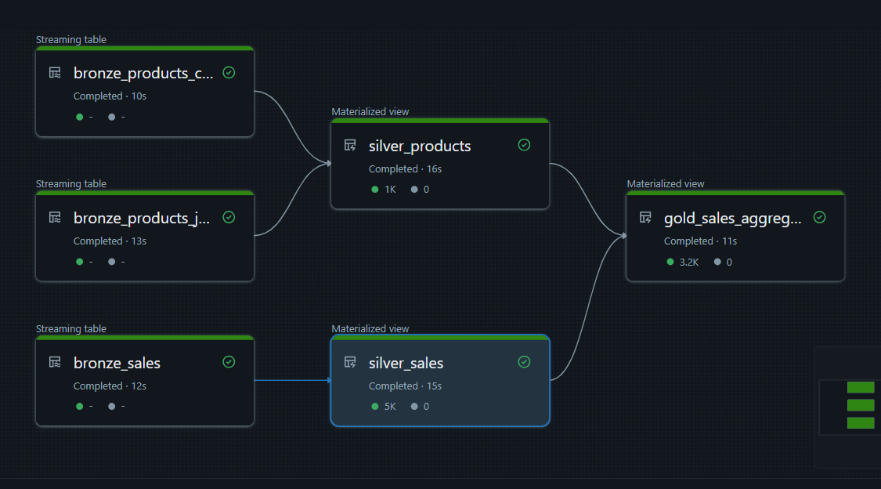

6. Summary of Implementation
Layer | Key Features | Reason
Bronze | Raw ingestion, all strings, no schema evolution | Preserve raw data, prevent errors
Silver | Type casting, anomaly detection, deduplication, unique IDs | Clean data for reliable analytics
Gold | Aggregated KPIs, enriched sales with product info | Business-ready reporting & compliance
Additional Features Implemented:
- Threshold-based anomaly detection for numeric columns.
- Deduplication for products and sales.
- Unique sale IDs for daily file ingestion.
- Ingestion timestamps for audit and lineage.

Part 5: Monitoring & Troubleshooting

1. Monitoring DLT Pipelines in Databricks
Databricks Delta Live Tables (DLT) provides an integrated Monitoring UI to observe pipeline health, track data quality, and troubleshoot failures.
Steps to monitor DLT pipelines:
- Navigate to the Databricks workspace → Jobs → Delta Live Tables.
- Select your pipeline (e.g., retail_compliance_p2) to view its Pipeline Details page.
- Key tabs for monitoring:
  - Flow: Shows table dependencies and transformations.
  - History: Lists each pipeline run, with statuses: Success, Running, Failed.
  - Metrics: Displays ingestion rate, number of rows processed, errors, and quality metrics.
  - Events: Provides detailed logs for each run, including schema mismatches, missing data, or anomalies.
Example Observation:
- Bronze ingestion: 1000 rows per file.
- Silver transformations: 980 valid rows after anomaly filtering.
- Gold aggregates: 50 rows per region/day after grouping.

2. Generating Sample Errors for Troubleshooting
To test error handling and schema evolution:
- Add a new column to an incoming CSV file (e.g., promo_code) in the raw_data_02/sales/ folder.
- Upload a corrupted file (e.g., missing headers or malformed JSON) into the same folder.
Expected pipeline behavior:
- Bronze ingestion captures new columns when cloudFiles.schemaEvolutionMode="addNewColumns" is used.
- Pipeline logs in the Events tab show rows rejected due to schema mismatch or corrupted format.
- DLT automatically routes problematic rows to the _rescued_data path for manual inspection.
Query to inspect rescued rows:
-- Show all rescued rows in Bronze Sales
SELECT * FROM hetul_project02_catalog.retail_compliance_p2.bronze_sales_temporary_rescued_data;

3. Interpreting Event Logs
The Events tab provides:
- Error Type: e.g., SchemaMismatch, DataTypeMismatch.
- Affected Table: e.g., bronze_sales.
- Row/Column details: Shows which rows or columns failed ingestion.
Action Steps:
- Check the schema of the incoming file.
- Compare with Bronze table schema.
- Update schema hints or fix the file.
- Re-run pipeline to resume ingestion.

4. Incremental Processing and Recovery
DLT automatically handles incremental loads:
- Only new files are processed in each run.
- Failed rows are logged in _rescued_data for later correction.
- Reprocessing a corrected file does not duplicate already processed rows.

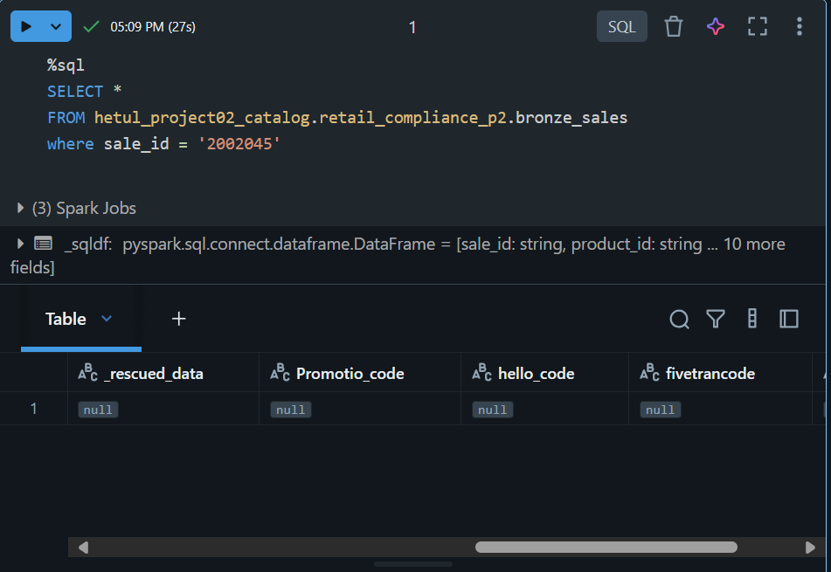

Part 6: Delta Lake Time Travel
Time Travel allows querying or restoring past versions of Delta tables for audit, compliance, debugging, and recovery purposes.

1. Inspect Table History
DESCRIBE HISTORY silver_sales;

- Shows all versions with timestamp, user, operation, and operation parameters.

2. Query Historical Data
By Version Number:
SELECT *
FROM silver_sales VERSION AS OF 2;

By Timestamp:
SELECT *
FROM silver_sales TIMESTAMP AS OF '2025-08-26 10:00:00';

3. Restore Deleted Rows
Suppose a row was mistakenly deleted in silver_sales:
-- Create temporary view from older version
CREATE OR REPLACE TEMP VIEW restored_sales AS
SELECT *
FROM silver_sales VERSION AS OF 2;

-- Insert deleted row back
INSERT INTO silver_sales
SELECT *
FROM restored_sales
WHERE sale_id = 101;

4. Revert Entire Table
RESTORE TABLE silver_sales TO VERSION AS OF 2;

- The table is restored to the exact state of version 2, undoing any unintended changes.

Part 7: Automation with Databricks Workflows
- Created a Databricks Workflow to trigger the DLT pipeline daily.
- Added a PySpark task to generate a daily compliance report for high-value sales (sales > $10,000).
- Configured task dependencies so the compliance report runs only after the DLT pipeline completes successfully.
- Enabled email notifications on workflow failure.
Sample PySpark Task Code for Compliance Report:
from pyspark.sql.functions import col

# Read Gold table
gold_sales = spark.table("hetul_project02_catalog.gold_sales_aggregates")

# Filter high-value sales
compliance_report = gold_sales.filter(col("high_value_flag") == True)

# Save daily report
compliance_report.write.format("parquet").mode("overwrite") \
.save("/mnt/reports/compliance_report_daily.parquet")

Part 8: Visualization in Power BI
- Connected Gold Layer (gold_sales_aggregates) to Power BI.

