Project: Healthcare patient monitoring
Business Objectives
- Provide real-time patient alerts (e.g., abnormal vitals, threshold breaches) to clinicians within seconds.
- Maintain historical patient records for trend analysis, treatment planning, and regulatory reporting.
- Enable predictive models for early detection of health risks (e.g., cardiac arrest, hypoglycemia).
- Govern all patient data with strict security, auditability, and compliance controls.

STEP 1 : Creation of storage account to store patient data in below shown fold structure
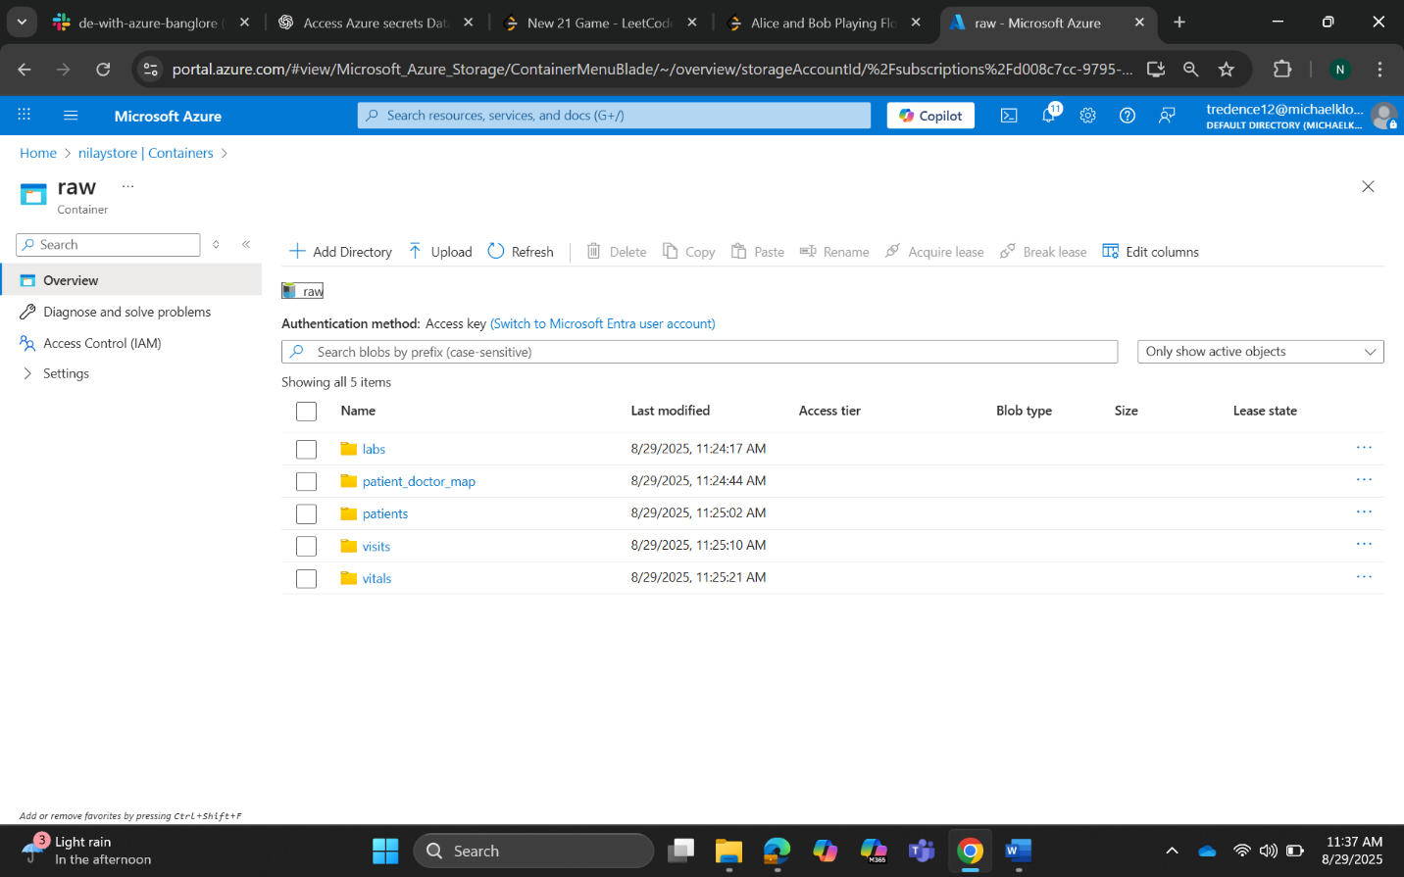
Step 2: Creation of azure access connector for databricks
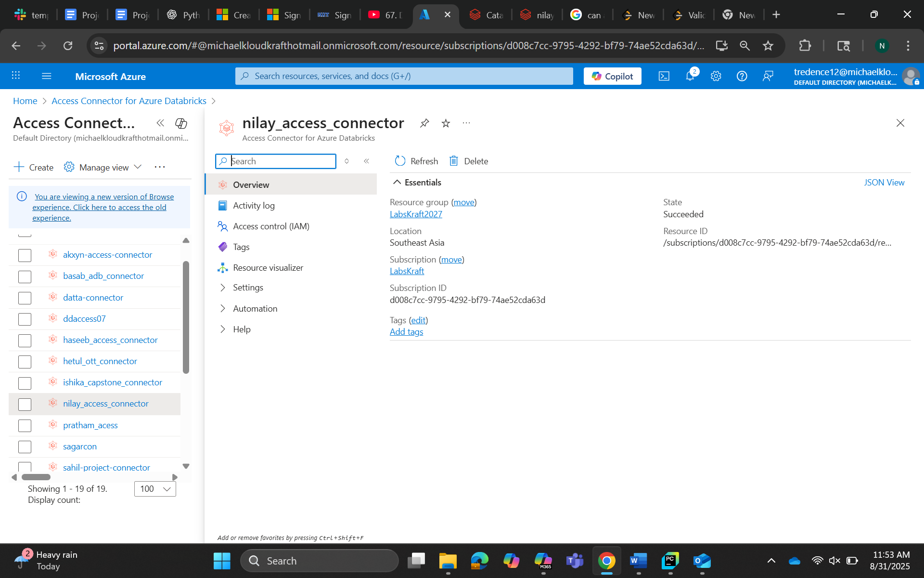
Step 3 : Giving storage blob data contributor access to access connector
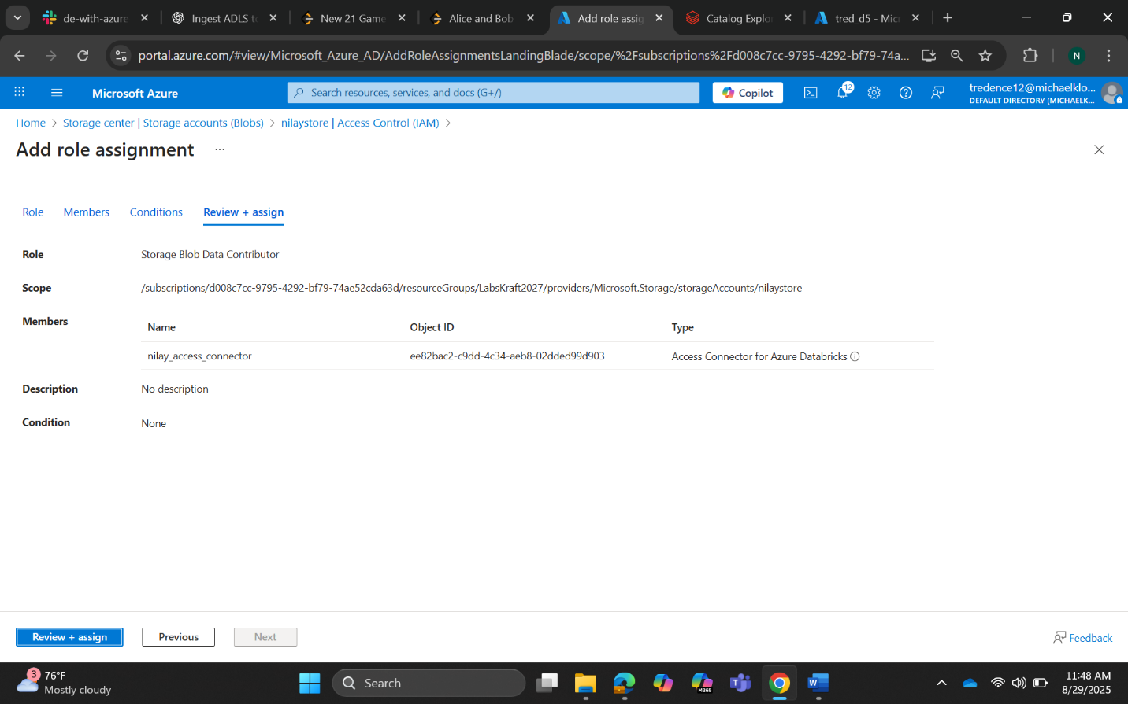
Step 4: Creation of unity catalog by defining storage location
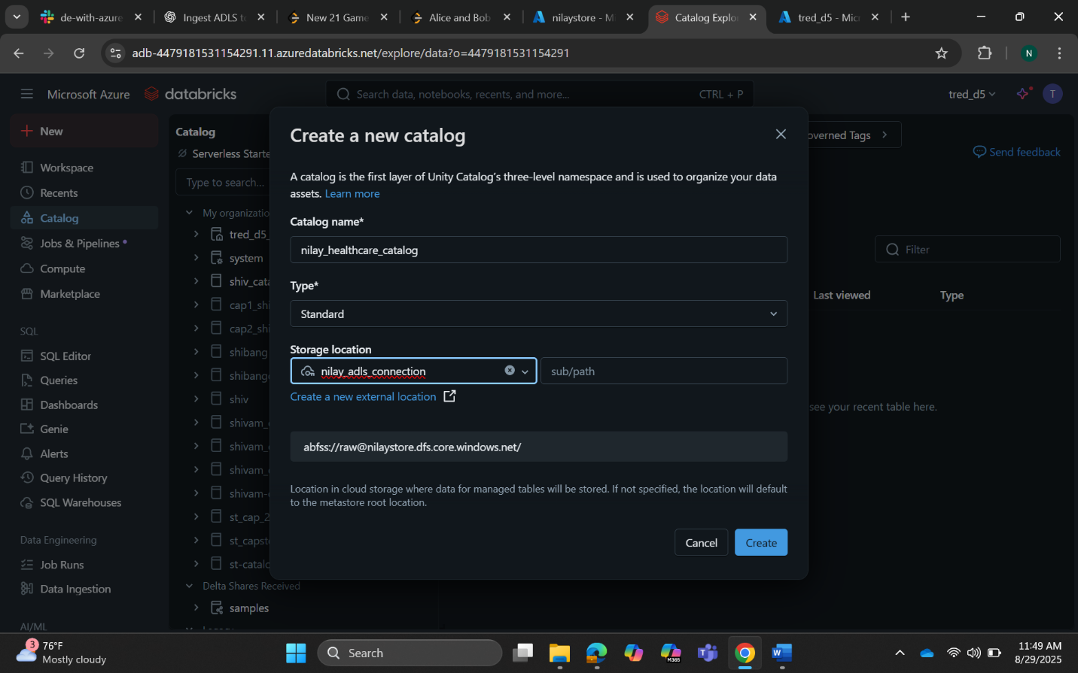
Step 5: Updating external location to current storage account location
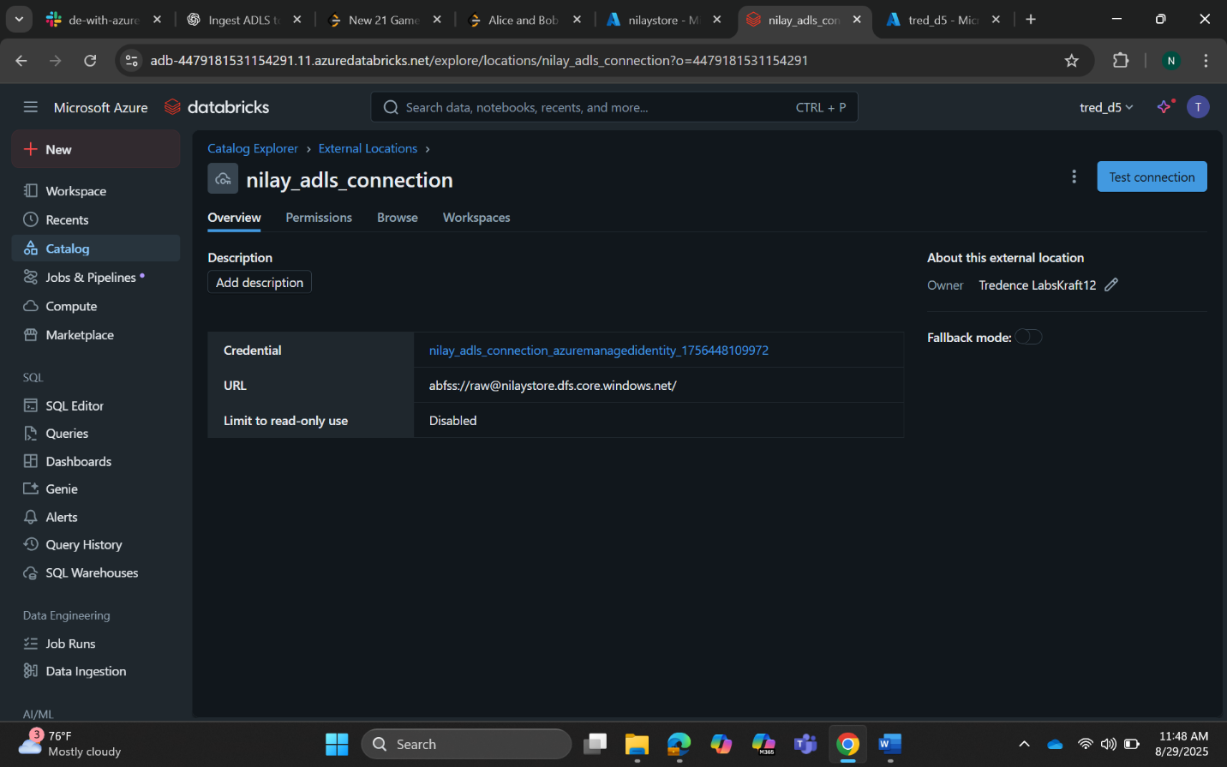
Step 6: Checking connection to the ADLS gen2 container
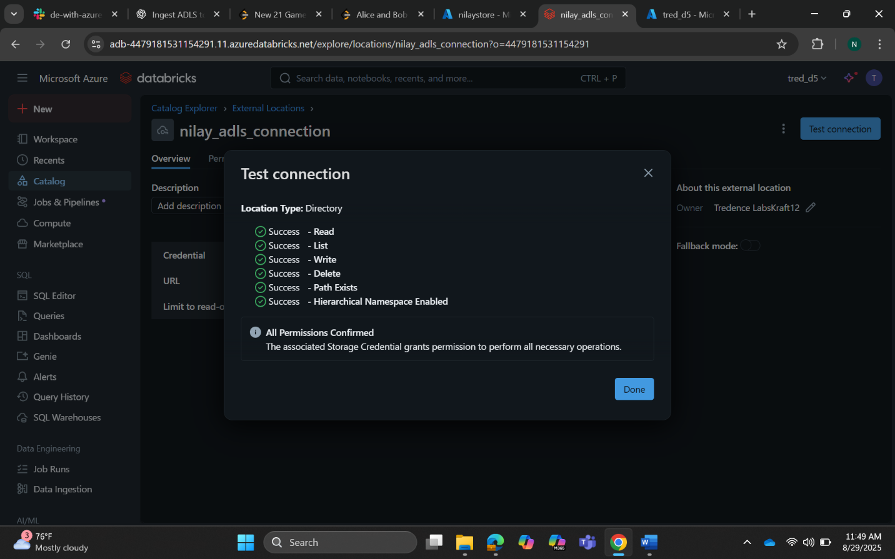
Step 7: Creating eventhub namespace to send streaming vital data from local machine because we don’t have access to cloud VM
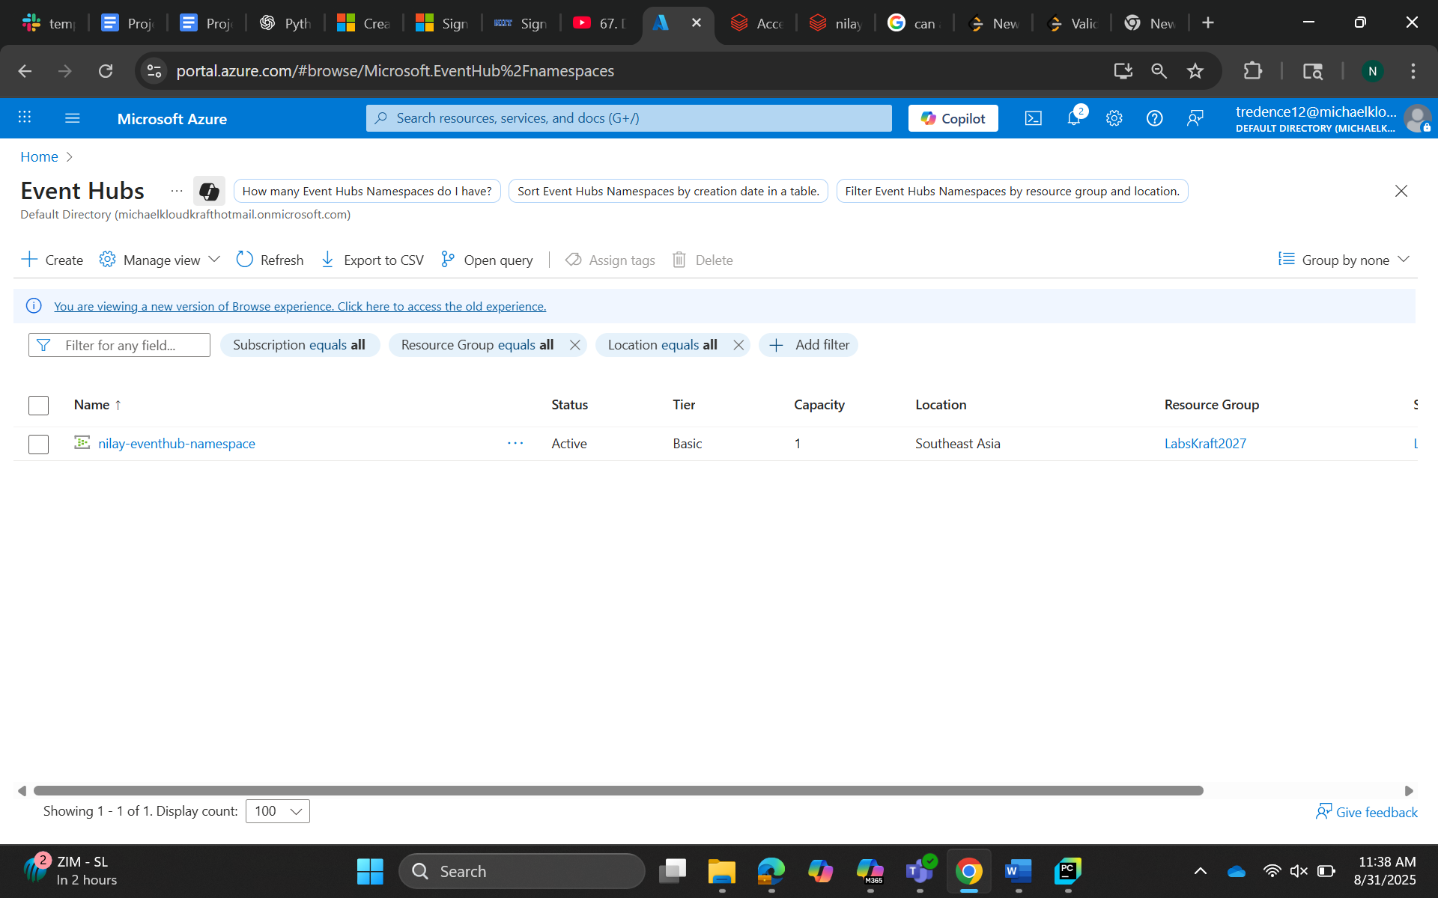
Step 8: Already wrote script to send data but getting firewall issue on office laptop, some of the data are able to reach EventHub
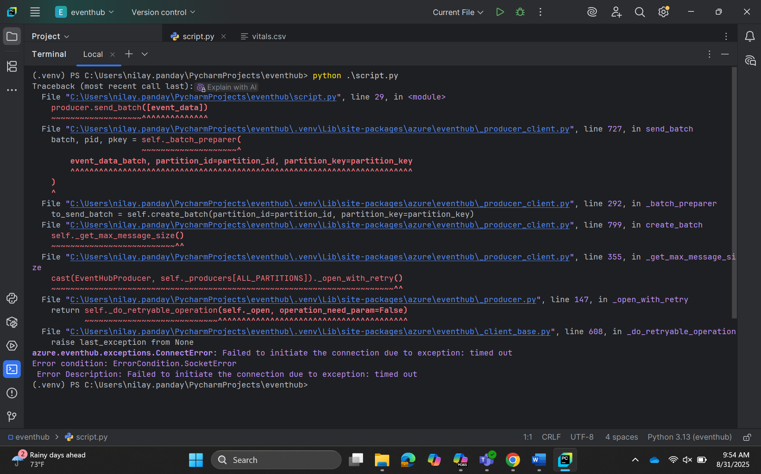Step 9: Data captured by event hub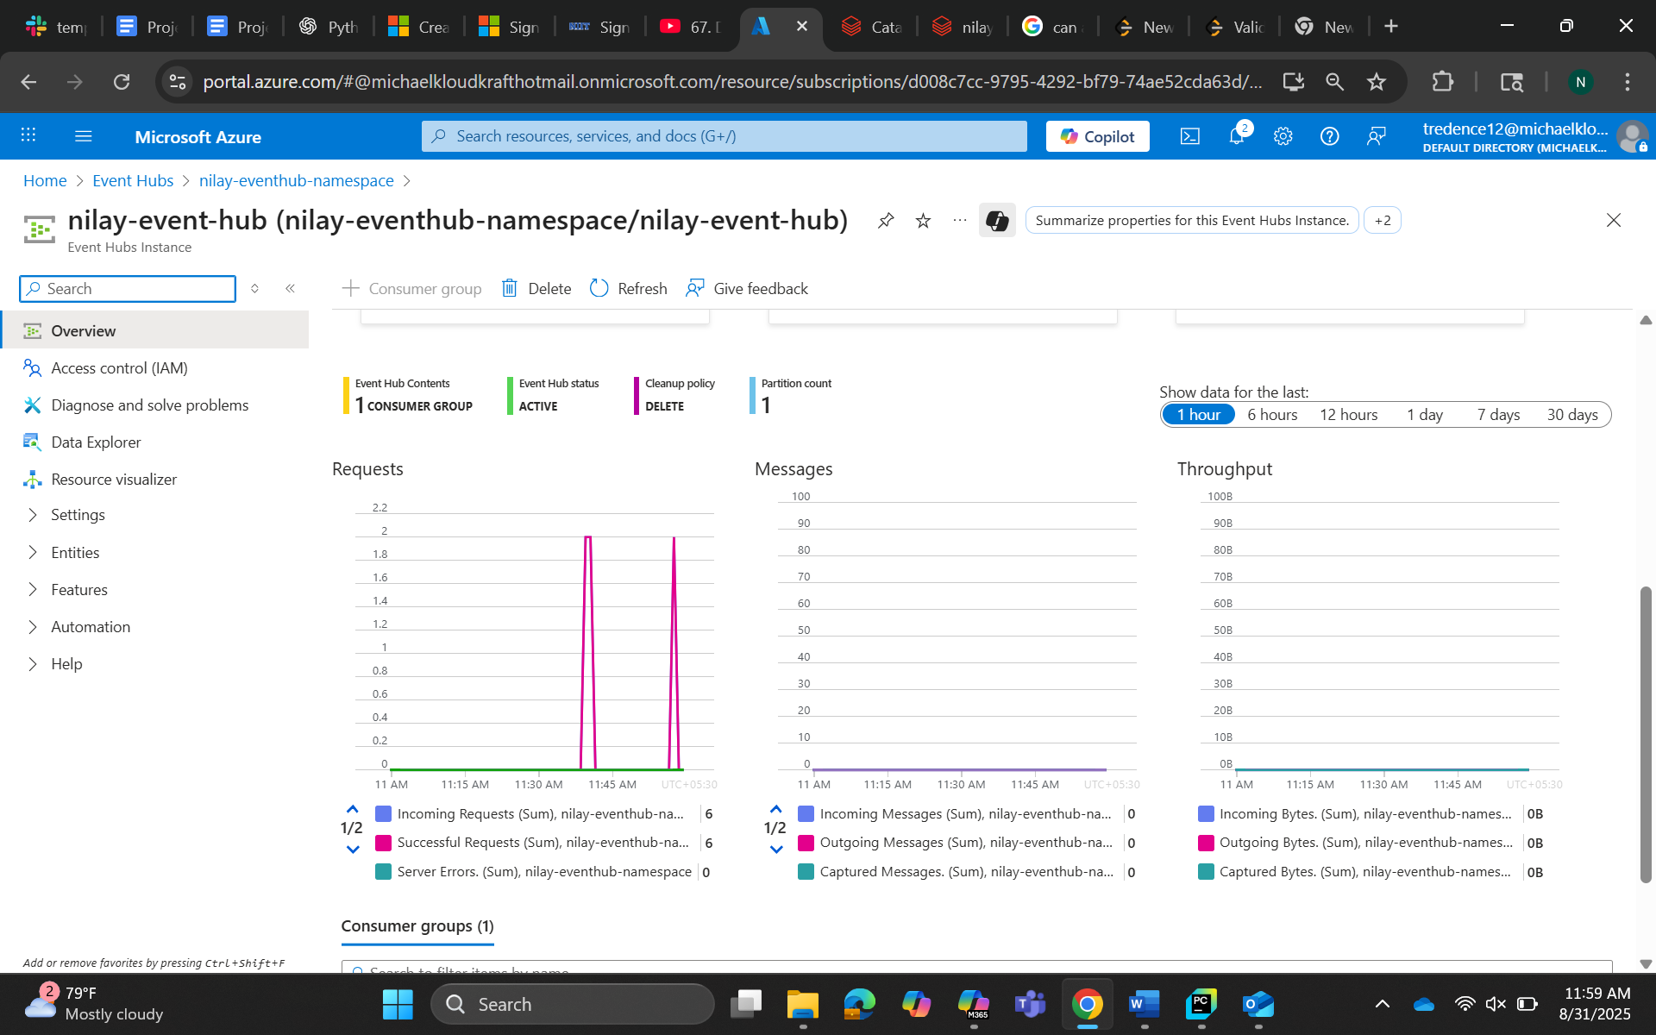
Step 10: Getting error that EventHub java is not available. We need to download it in out cluster
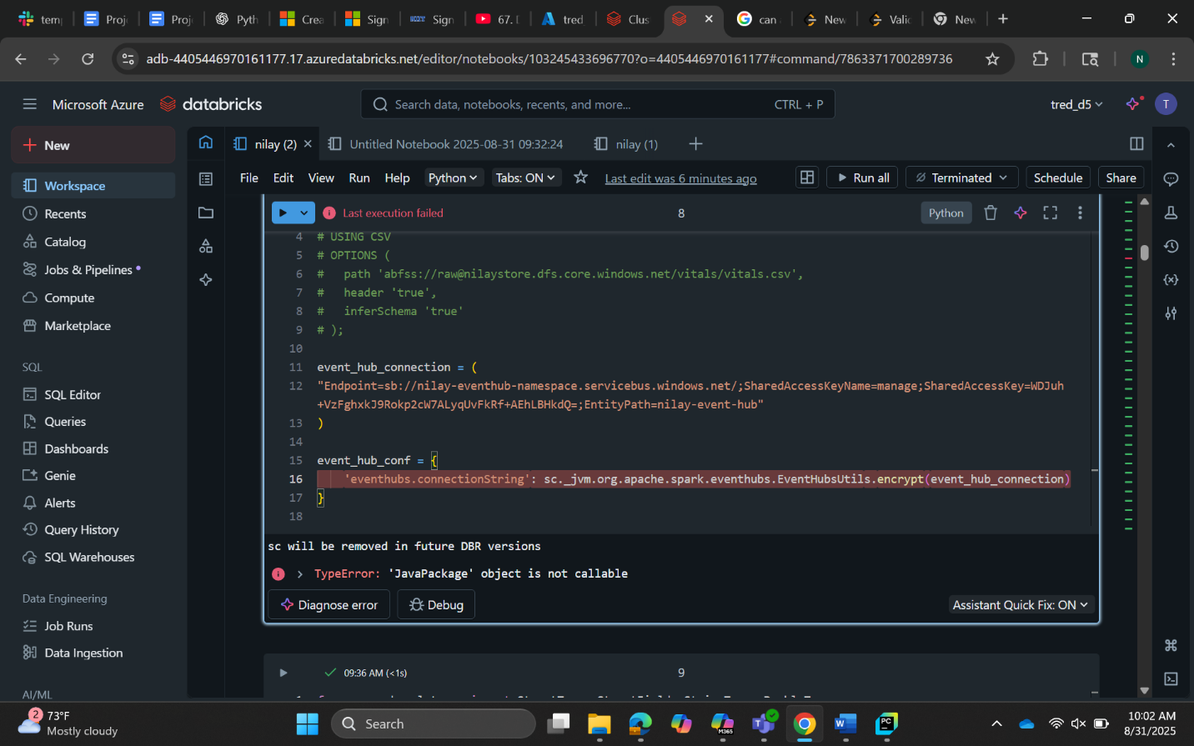
Step 11: We don’t have access to add package EventHub java package to compute cluster. Instead streaming using batch ingestion for vitals data
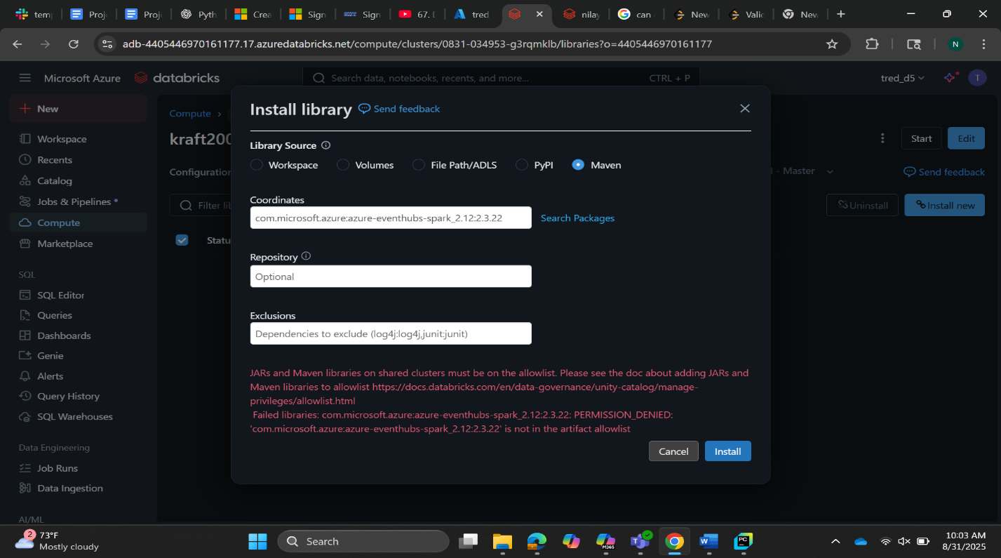
Anomalies in the dataset
1. Patients Dataset Anomalies
- Patient ID: Contains null values and invalid IDs prefixed with INVALID_.
- Name: Some entries are null or start with the prefix INVALID_.
- Age: Contains null values and outliers. Data type must be standardized to INTEGER.
- Gender: Contains null values and invalid entries prefixed with INVALID_.
- Diagnosis: Includes invalid entries prefixed with INVALID_ and placeholders such as NONE.
- Prescription: Contains null, invalid (INVALID_), and placeholder (NONE) values.

2. Patient_Doctor_Map Dataset Anomalies
- Patient ID: Null values and invalid IDs prefixed with INVALID_.
- Doctor ID: Null values and invalid IDs prefixed with INVALID_.
- Care Team: Contains null values and invalid values prefixed with INVALID_.

3. Labs Dataset Anomalies
- Patient ID: Null values and invalid IDs prefixed with INVALID_.
- Test Name: Null values and invalid entries prefixed with INVALID_.
- Result: Null values and invalid entries prefixed with INVALID_.
- Unit: Null values and invalid entries prefixed with INVALID_.
- Date: Null values and invalid entries prefixed with INVALID_.

4. Visits Dataset Anomalies
- Patient ID: Null values and invalid IDs prefixed with INVALID_.
- Admission Date: Null values and invalid entries prefixed with INVALID_.
- Discharge Date: Null values and invalid entries prefixed with INVALID_.
- Reason: Null values and invalid entries prefixed with INVALID_.

5. Vitals Dataset Anomalies
- Patient ID: Null values and invalid IDs prefixed with INVALID_.
- Device ID: Null values and invalid IDs prefixed with INVALID_.
- Timestamp: Null values and invalid entries prefixed with INVALID_.
- Vital Type: Null values and invalid entries prefixed with INVALID_.
- Vital Value: Contains null, invalid (INVALID_) values, and outliers (values > 500) which are not realistic.
All the necessary transformations done for cleansing is mentioned in the notebook code.

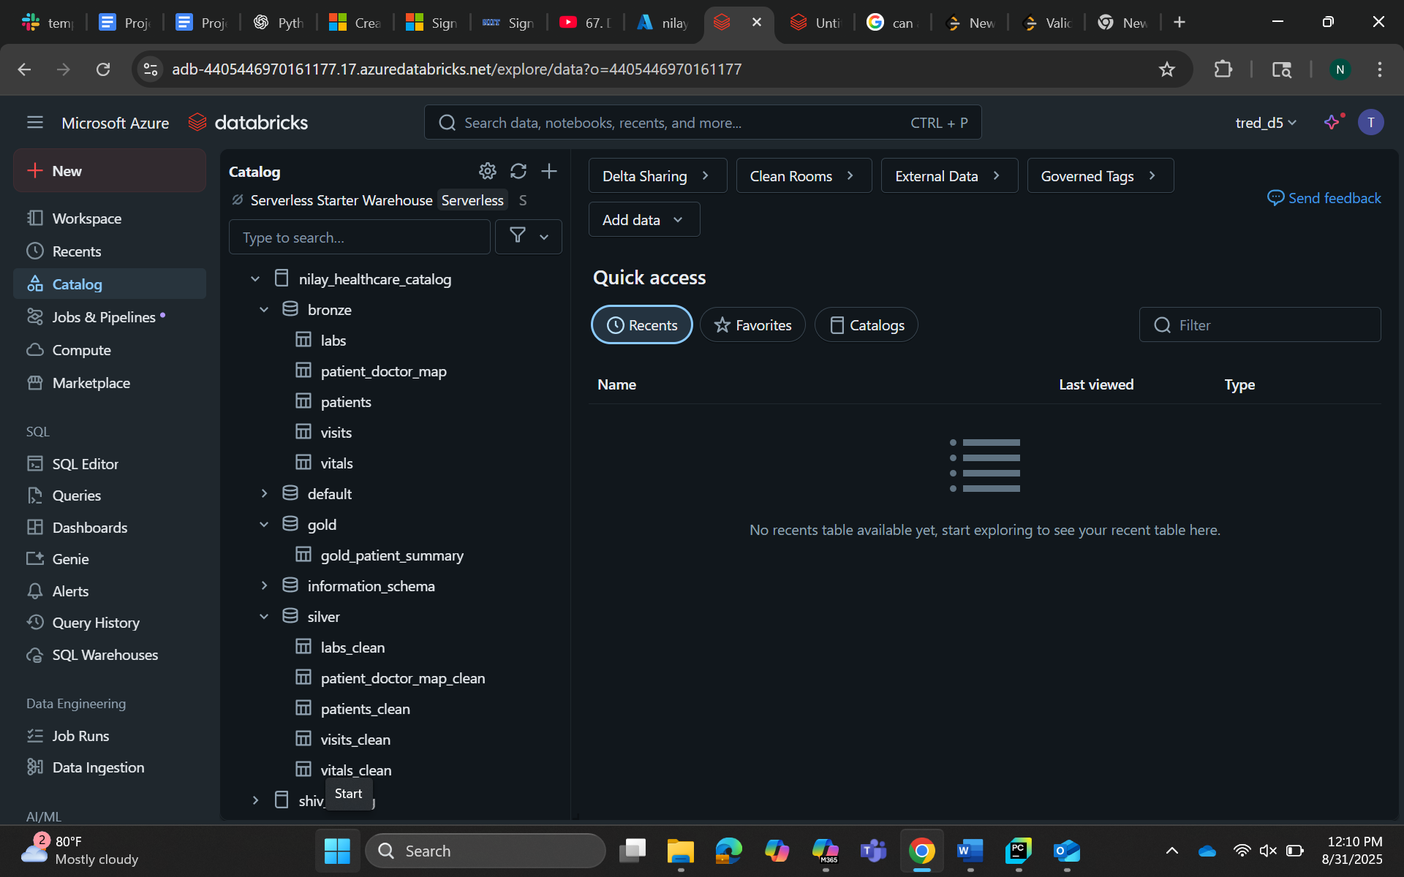

Power BI integration:

