📓 Project Log – Hetul ETL Pipeline with Unity Catalog & DLT

1. Azure Setup
- Created ADLS Gen2 storage account: hetulstorage
- Created container:
  - raw01hetul → uploaded raw file retail_iot_data.csv
  - 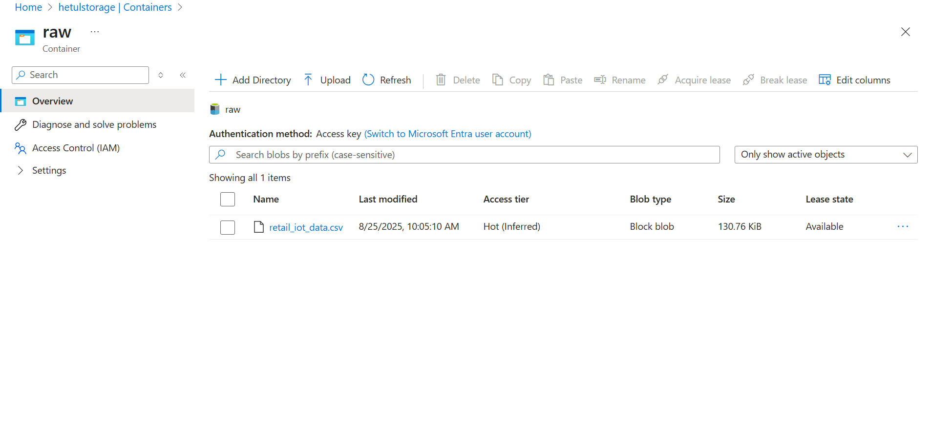

2. Unity Catalog Setup
- Created Unity Catalog: hetul_project01_catalog
- Created schema:
CREATE SCHEMA IF NOT EXISTS hetul_project01_catalog.capstone_retail_hetul
COMMENT 'Schema for BI Integration demo with DLT';
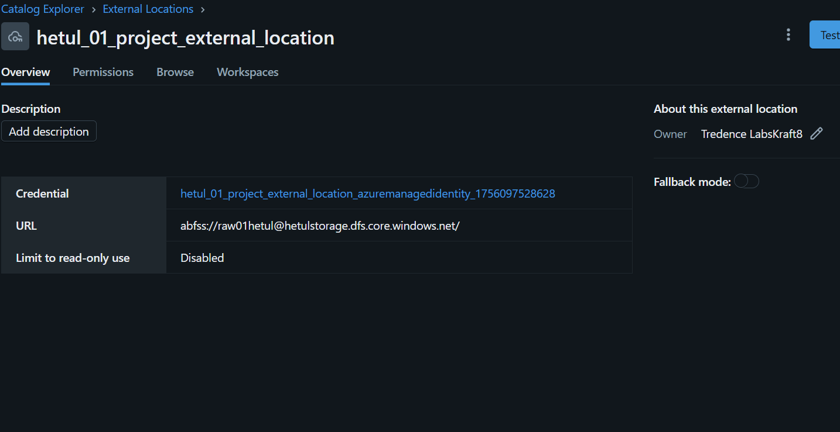
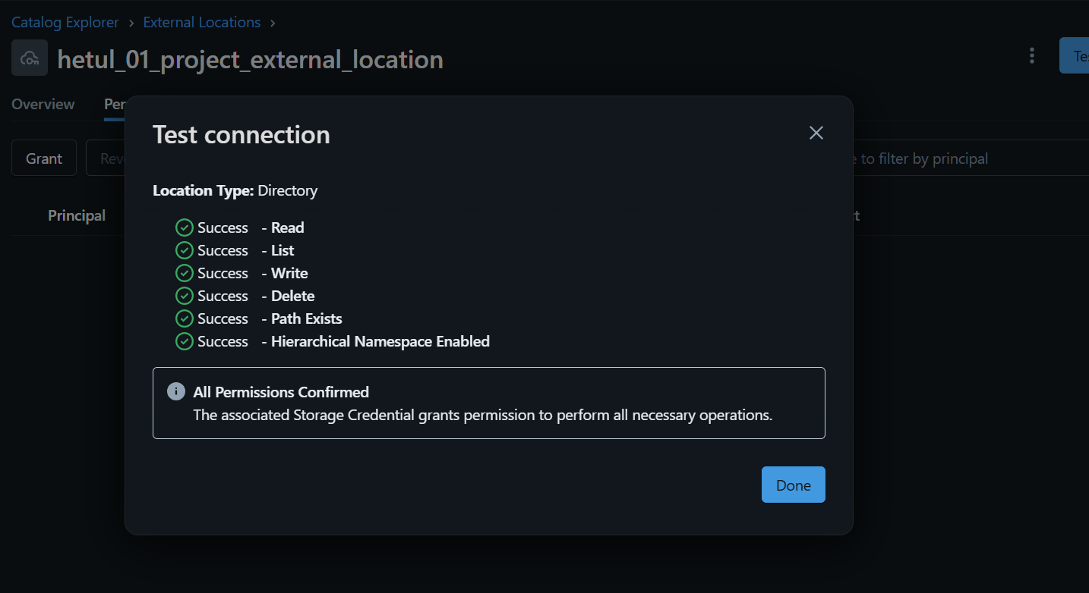
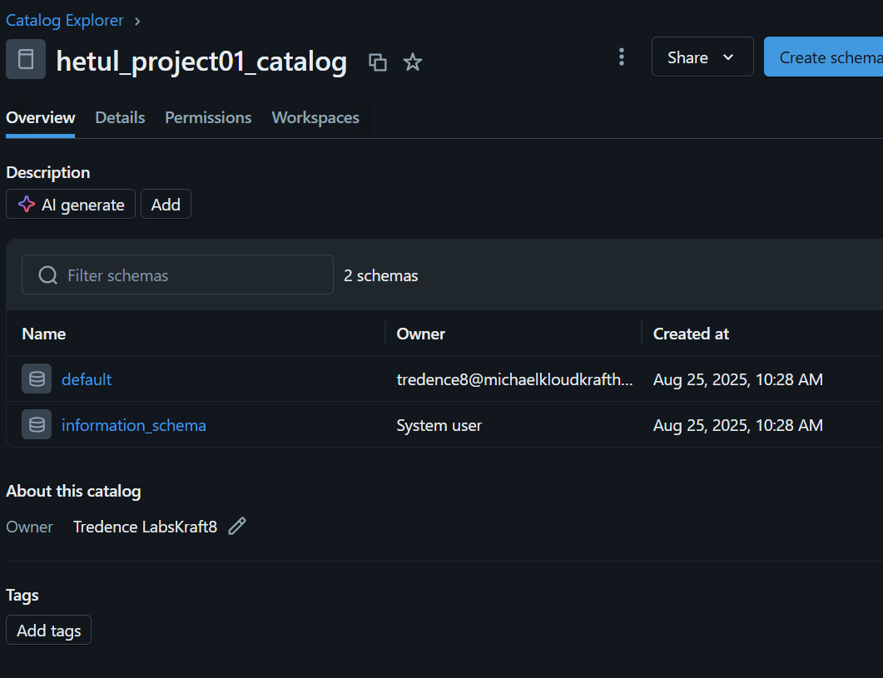

3. Bronze Layer – Ingestion
- Created DLT Notebook: project_01_etl_pipeline_hetul
- Defined schema manually (to avoid Auto Loader empty path issue)
- Used Auto Loader (cloudFiles) to stream data from ADLS
from dlt import table
import pyspark.sql.functions as F
from pyspark.sql.types import StructType, StructField, StringType, DoubleType, IntegerType, TimestampType

# ✅ Define schema for retail IoT CSV
iot_schema = StructType([
StructField("OrderID", StringType(), True),
StructField("CustomerID", StringType(), True),
StructField("Region", StringType(), True),
StructField("StoreID", StringType(), True),
StructField("Product", StringType(), True),
StructField("Quantity", IntegerType(), True),
StructField("UnitPrice", DoubleType(), True),
StructField("SalesAmount", DoubleType(), True),
StructField("OrderTime", StringType(), True), # can cast to Timestamp later in Silver
StructField("DeviceType", StringType(), True),
StructField("Temperature", DoubleType(), True),
StructField("DeviceStatus", StringType(), True),
StructField("AnomalyFlag", IntegerType(), True),
StructField("AnomalyType", StringType(), True)
])

# ✅ Paths (use subdirectories to avoid overlap with DLT system files)
raw_path = "abfss://raw01hetul@hetulstorage.dfs.core.windows.net/raw_data/"
schema_path = "abfss://raw01hetul@hetulstorage.dfs.core.windows.net/dlt_schemas/bronze_orders_hetul"
checkpoint_path = "abfss://raw01hetul@hetulstorage.dfs.core.windows.net/dlt_checkpoints/bronze_orders_hetul"

@table(
name="hetul_project01_catalog.capstone_retail_hetul.bronze_orders",
comment="Bronze table - raw ingested IoT retail data via Auto Loader"
)
def bronze_orders():
return (
spark.readStream
.format("cloudFiles")
.option("cloudFiles.format", "csv")
.option("header", True)
.option("cloudFiles.schemaLocation", schema_path)
.schema(iot_schema) # ✅ manually set schema (no infer needed)
.load(raw_path) # ✅ points to /raw_data/ folder
)

4. Verification of Bronze
- Checked table in Data Explorer
- Queried via SQL:
USE CATALOG hetul_project01_catalog;
USE SCHEMA capstone_retail_hetul;

SELECT COUNT(*) FROM bronze_orders;
SELECT * FROM bronze_orders LIMIT 20;
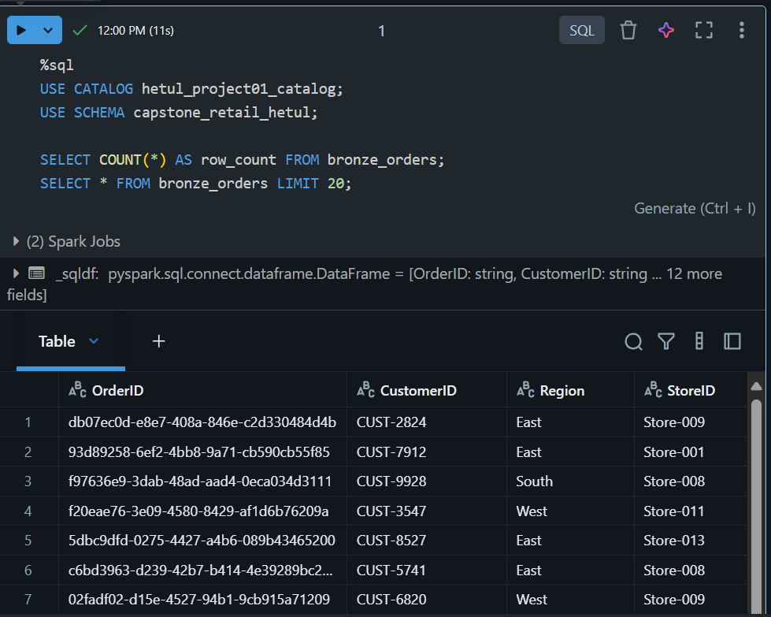

Silver Layer (Transformation)
Purpose: Data cleaning, deduplication, anomaly handling, business rules
✅ Implemented Silver transformation logic:
- Removed duplicates (distinct).
- Handled nulls with fillna.
- Standardized schema (ensured consistent datatypes).
- Joined device anomaly info with sales.
- Added business rule: flagged sales where anomaly occurred (AnomalyFlag = 1).
from dlt import table
import pyspark.sql.functions as F
from pyspark.sql.types import DoubleType, IntegerType

# =========================================
# Silver Layer - Cleaned IoT Orders
# =========================================
@table(
name="capstone_retail_hetul.silver_orders",
comment="Silver layer: cleaned and deduplicated IoT orders with anomaly handling"
)
def silver_orders():
# Read Bronze
orders = dlt.read("bronze_orders")

# Standardize schema
orders = (
orders.withColumn("Quantity", F.col("Quantity").cast(IntegerType()))
.withColumn("UnitPrice", F.col("UnitPrice").cast(DoubleType()))
.withColumn("SalesAmount", F.col("SalesAmount").cast(DoubleType()))
.withColumn("Temperature", F.col("Temperature").cast(DoubleType()))
.withColumn("OrderTime", F.to_timestamp("OrderTime", "M/d/yyyy H:mm"))
)

# Deduplicate by OrderID
orders = orders.dropDuplicates(["OrderID"])

# Handle missing anomaly type
orders = orders.withColumn(
"AnomalyType",
F.when((F.col("AnomalyFlag") == 1) & (F.col("AnomalyType").isNull()), "Unknown")
.when((F.col("AnomalyFlag") == 1) & (F.col("AnomalyType") == ""), "Unknown")
.otherwise(F.col("AnomalyType"))
)

# Add business rule fields
orders = (
orders.withColumn("IsAnomaly", F.col("AnomalyFlag") == 1)
.withColumn("DeviceStatus", F.upper(F.col("DeviceStatus")))
.withColumn("NormalizedStoreID", F.upper(F.col("StoreID")))
.withColumn("NormalizedProduct", F.upper(F.col("Product")))
)

return orders

🔹 Step 4 – Gold Layer (Aggregation & Enrichment)
Purpose: Business KPIs, aggregations, and reporting-ready data
✅ Implemented 5 Gold tables:
- gold_sales_region → Daily/Monthly Sales per Region
- gold_anomaly_trends → Device Anomaly Trend per Store
- gold_conversion_impact → Conversion Rate Impact when devices fail
- gold_store_tiers → Store classification (High/Medium/Low performers)
- gold_weighted_sales_anomalies → Weighted average of Sales vs Anomalies
from dlt import table, read
import pyspark.sql.functions as F

# ===============================
# Gold Layer Tables (capstone_retail.gold)
# ===============================

# 1. Daily / Monthly Sales per Region
@table(
name="hetul_project01_catalog.capstone_retail_hetul.gold_sales_region",
comment="Daily & Monthly Sales per Region"
)
def gold_sales_region():
return (
read("hetul_project01_catalog.capstone_retail_hetul.silver_orders")
.withColumn("OrderDate", F.to_date("OrderTime", "M/d/yyyy H:mm"))
.withColumn("YearMonth", F.date_format("OrderDate", "yyyy-MM"))
.groupBy("Region", "OrderDate", "YearMonth")
.agg(F.sum("SalesAmount").alias("TotalSales"))
)

# 2. Device Anomaly Trend per Store
@table(
name="hetul_project01_catalog.capstone_retail_hetul.gold_anomaly_trends",
comment="Device Anomaly Trend per Store"
)
def gold_anomaly_trends():
return (
read("hetul_project01_catalog.capstone_retail_hetul.silver_orders")
.withColumn("OrderDate", F.to_date("OrderTime", "M/d/yyyy H:mm"))
.groupBy("StoreID", "OrderDate", "DeviceType", "AnomalyType")
.agg(F.count("*").alias("AnomalyCount"))
)

# 3. Conversion Rate Impact when devices fail
@table(
name="hetul_project01_catalog.capstone_retail_hetul.gold_conversion_impact",
comment="Conversion rate impact of device failures"
)
def gold_conversion_impact():
df = read("hetul_project01_catalog.capstone_retail_hetul.silver_orders")
total_orders = df.groupBy("StoreID").agg(F.count("*").alias("TotalOrders"))
failed_orders = (
df.filter(df.AnomalyFlag == 1)
.groupBy("StoreID")
.agg(F.count("*").alias("FailedOrders"))
)
return (
total_orders.join(failed_orders, "StoreID", "left")
.withColumn("FailedOrders", F.coalesce(F.col("FailedOrders"), F.lit(0)))
.withColumn("FailureRate", F.col("FailedOrders") / F.col("TotalOrders"))
)

# 4. Store Tier Classification
@table(
name="hetul_project01_catalog.capstone_retail_hetul.gold_store_tiers",
comment="Store tiers based on total sales (High / Medium / Low performers)"
)
def gold_store_tiers():
df = (
read("hetul_project01_catalog.capstone_retail_hetul.silver_orders")
.groupBy("StoreID")
.agg(F.sum("SalesAmount").alias("TotalSales"))
)

return (
df.withColumn(
"StoreTier",
F.when(F.col("TotalSales") > 100000, "High")
.when(F.col("TotalSales") > 50000, "Medium")
.otherwise("Low")
)
)

# 5. Weighted Average Sales vs Anomalies
@table(
name="hetul_project01_catalog.capstone_retail_hetul.gold_weighted_sales_anomalies",
comment="Weighted average of sales vs anomalies per store"
)
def gold_weighted_sales_anomalies():
df = read("hetul_project01_catalog.capstone_retail_hetul.silver_orders")
return (
df.groupBy("StoreID")
.agg(
F.sum("SalesAmount").alias("TotalSales"),
F.sum(F.when(F.col("AnomalyFlag") == 1, 1).otherwise(0)).alias("TotalAnomalies")
)
.withColumn("SalesPerAnomaly",
F.when(F.col("TotalAnomalies") > 0, F.col("TotalSales") / F.col("TotalAnomalies"))
.otherwise(F.lit(None))
)
)

✅ Current Status
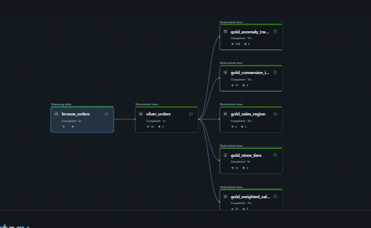
- Bronze ✅ (Raw data ingestion)
- Silver ✅ (Cleaned + Anomaly Handling)
- Gold ✅ (Aggregations + KPIs + Enrichment)
Absolutely! I can create a complete structured log outline for your ETL project starting from Synapse Workspace creation through the Bronze → Silver → Gold pipeline with Event Hub integration. I’ll leave all the actual outputs as empty placeholders so you can fill them with your real logs.
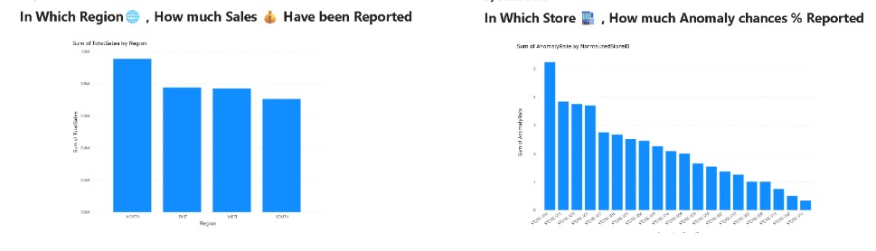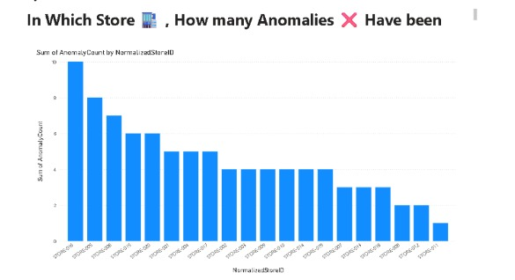
=========================================

Capstone Retail ETL Pipeline – Complete Logs Synapse

=========================================

1️⃣ Azure Synapse Workspace Creation
- # Action: Create Synapse Workspace
- # Name: <Your Synapse Workspace Name>
- # Region: <Region>
- # Subscription: <Azure Subscription ID>
- # Resource Group: <Resource Group Name>

- # Expected outcome: Workspace successfully created
- # Actual output / Logs:
- # [Paste here any system messages, notifications, or creation timestamps]

2️⃣ Synapse SQL Pool / Database Setup
- # Action: Create SQL Pool / Database
- # Database Name: CapstoneRetailDB
- # Performance Level: <DW100c / DW200c / etc.>
- # Collation: SQL_Latin1_General_CP1_CI_AS

- # Expected outcome: SQL Pool is ready
- # Actual output / Logs:
- # [Paste system messages, pool status, creation timestamp]

3️⃣ Create Tables in Synapse
- # Bronze Historical Sales Table
- # Table: dbo.RetailIoTData
- # Columns: OrderID, CustomerID, Region, StoreID, Product, Quantity, UnitPrice, SalesAmount, OrderTime
- # Data type verification
- # Sample data output:
- # [Paste top 5–10 rows from Synapse query SELECT TOP 10 * FROM dbo.RetailIoTData]

- # Any errors during creation or data load:
- # [Paste errors if any]

7️⃣ Pipeline Run
- # Pipeline Name: CapstoneRetail_ETL
- # Mode: Continuous / Triggered
- # Start Time: <timestamp>
- # End Time: <timestamp>

- # Total rows ingested from:
- # - CSV: <number>
- # - Event Hub: <number>
- # - Synapse Historical Sales: <number>

- # Total rows after Unified Bronze: <number>
- # Silver transformation applied: [Deduplication, Type Casting, Anomaly Handling]
- # Gold transformation applied: [Aggregations, Store Tiers, Sales vs Anomalies]

- # Any errors / warnings during pipeline run:
- # [Paste any pipeline exceptions, warnings, or retries]

8️⃣ Verification Queries
- # Verify Bronze Layer:
- SELECT TOP 10 * FROM hetul_project01_catalog.capstone_retail_hetul.bronze_orders;

- # Verify Silver Layer:
- SELECT TOP 10 * FROM hetul_project01_catalog.capstone_retail_hetul.silver_orders;

- # Verify Gold Layer:
- SELECT TOP 10 * FROM hetul_project01_catalog.capstone_retail_hetul.gold_sales_region;
- SELECT TOP 10 * FROM hetul_project01_catalog.capstone_retail_hetul.gold_anomaly_trends;

- # Logs / Output:
- # [Paste actual outputs]

Synapse code
# =========================================
# Databricks DLT Notebook – Bronze Layer
# =========================================

from dlt import table
import pyspark.sql.functions as F
from pyspark.sql.types import StructType, StructField, StringType, DoubleType, IntegerType, TimestampType

# ============================
# 1️⃣ Bronze Orders - IoT CSV (Streaming via Auto Loader)
# ============================

iot_schema = StructType([
StructField("OrderID", StringType(), True),
StructField("CustomerID", StringType(), True),
StructField("Region", StringType(), True),
StructField("StoreID", StringType(), True),
StructField("Product", StringType(), True),
StructField("Quantity", IntegerType(), True),
StructField("UnitPrice", DoubleType(), True),
StructField("SalesAmount", DoubleType(), True),
StructField("OrderTime", StringType(), True), # will cast to Timestamp in Silver
StructField("DeviceType", StringType(), True),
StructField("Temperature", DoubleType(), True),
StructField("DeviceStatus", StringType(), True),
StructField("AnomalyFlag", IntegerType(), True),
StructField("AnomalyType", StringType(), True)
])

raw_path = "abfss://raw01hetul@hetulstorage.dfs.core.windows.net/raw_data/"
schema_path = "abfss://raw01hetul@hetulstorage.dfs.core.windows.net/dlt_schemas/bronze_orders_hetul"
checkpoint_path = "abfss://raw01hetul@hetulstorage.dfs.core.windows.net/dlt_checkpoints/bronze_orders_hetul"

@table(
name="hetul_project01_catalog.capstone_retail_hetul.bronze_orders",
comment="Bronze table - raw ingested IoT retail data via Auto Loader"
)
def bronze_orders():
df = (
spark.readStream
.format("cloudFiles")
.option("cloudFiles.format", "csv")
.option("header", True)
.option("cloudFiles.schemaLocation", schema_path)
.schema(iot_schema)
.load(raw_path)
)
# Cast OrderTime safely
df = df.withColumn("OrderTime", F.to_timestamp("OrderTime", "yyyy-MM-dd HH:mm:ss"))
return df

# ============================
# 2️⃣ Bronze Historical Sales – Synapse
# ============================

jdbc_hostname = "hetulsynapesproject01.sql.azuresynapse.net"
jdbc_port = "1433"
jdbc_database = "CapstoneRetailDB"
jdbc_username = "admin123"
jdbc_password = "Password1234"
jdbc_url = f"jdbc:sqlserver://{jdbc_hostname}:{jdbc_port};database={jdbc_database};encrypt=true;trustServerCertificate=false;loginTimeout=30;"

historical_table = "dbo.HistoricalSales"
iot_table = "dbo.RetailIoTData"

@table(
name="hetul_project01_catalog.capstone_retail_hetul.bronze_historical_sales",
comment="Bronze table - historical sales data from Synapse"
)
def bronze_historical_sales():
try:
return (
spark.read.format("jdbc")
.option("url", jdbc_url)
.option("dbtable", historical_table)
.option("user", jdbc_username)
.option("password", jdbc_password)
.option("driver", "com.microsoft.sqlserver.jdbc.SQLServerDriver")
.load()
)
except Exception:
schema = StructType([
StructField("OrderID", StringType(), True),
StructField("CustomerID", StringType(), True),
StructField("Region", StringType(), True),
StructField("StoreID", StringType(), True),
StructField("Product", StringType(), True),
StructField("Quantity", IntegerType(), True),
StructField("UnitPrice", DoubleType(), True),
StructField("SalesAmount", DoubleType(), True),
StructField("OrderTime", TimestampType(), True)
])
return spark.createDataFrame([], schema)

# ============================
# 3️⃣ Bronze IoT from Synapse – RetailIoTData
# ============================

@table(
name="hetul_project01_catalog.capstone_retail_hetul.bronze_iot_synapse",
comment="Bronze table - IoT retail data from Synapse"
)
def bronze_iot_synapse():
df = (
spark.read.format("jdbc")
.option("url", jdbc_url)
.option("dbtable", iot_table)
.option("user", jdbc_username)
.option("password", jdbc_password)
.option("driver", "com.microsoft.sqlserver.jdbc.SQLServerDriver")
.load()
)
df = df.withColumn("OrderTime", F.to_timestamp("OrderTime"))
return df

Other silver and gold are same
Pipeline error -
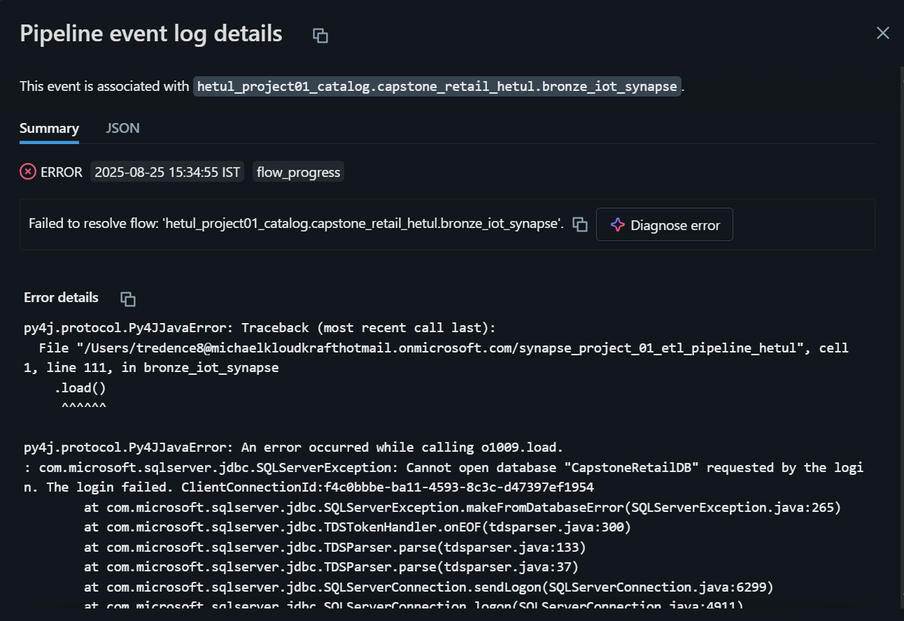

=========================================

Capstone Retail ETL Pipeline – Complete Logs Synapse

=========================================

1️⃣ Virtual Machine Setup (Data Generation)

- Task: Generate synthetic IoT data every second.
Schema:
OrderID, CustomerID, Region, StoreID, Product, Quantity,
UnitPrice, SalesAmount, OrderTime, DeviceType, Temperature,
DeviceStatus, AnomalyFlag, AnomalyType

- Python Script: iot_stream.py
  - Generates 1 row per second.
  - Writes CSV locally.
Example row generation logged:
Added row: {'OrderID': 'uuid', 'CustomerID': 'CUST1234', ... }

2️⃣ Event Hub Setup
- Event Space: hetulproject01eventspace
- Event Hub: hetulhub
Connection String Example:
Endpoint=sb://hetulproject01eventspace.servicebus.windows.net/;
SharedAccessKeyName=hello;
SharedAccessKey=<key>;
EntityPath=hetulhub

- VM: Script updated to send rows to Event Hub using azure-eventhub SDK.
Log Example:
Sent event to Event Hub: {'OrderID': '...', 'CustomerID': '...', ...}
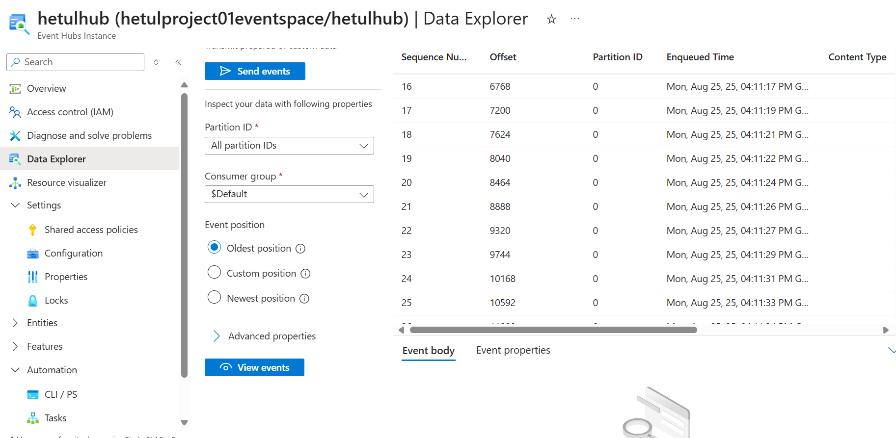

3️⃣ Databricks DLT Notebook (Bronze Layer)
- Bronze tables:
  - bronze_orders – from CSV (Auto Loader).
  - bronze_iot_synapse – from Synapse table.

4️⃣ Silver Layer (Cleaning + Transformation)
- Deduplicated OrderID.
- Cast types for Quantity, UnitPrice, SalesAmount, Temperature, OrderTime.
- Handle missing AnomalyType.
- Add derived columns: IsAnomaly, NormalizedStoreID, NormalizedProduct.

5️⃣ Gold Layer (Aggregations & Business Metrics)
- Tables:
  - gold_sales_region – daily/monthly sales per region
  - gold_anomaly_trends – anomaly trends per store
  - gold_conversion_impact – failure rate per store
  - gold_store_tiers – tier classification based on sales
  - gold_weighted_sales_anomalies – sales per anomaly
Code for eventhub
# =========================================
# Bronze → Silver → Gold with Event Hub Integration
# =========================================

from dlt import table, read
import pyspark.sql.functions as F
from pyspark.sql.types import *

# ================================
# 1️⃣ Bronze Layer: Schema & CSV
# ================================
iot_schema = StructType([
StructField("OrderID", StringType(), True),
StructField("CustomerID", StringType(), True),
StructField("Region", StringType(), True),
StructField("StoreID", StringType(), True),
StructField("Product", StringType(), True),
StructField("Quantity", IntegerType(), True),
StructField("UnitPrice", DoubleType(), True),
StructField("SalesAmount", DoubleType(), True),
StructField("OrderTime", StringType(), True),
StructField("DeviceType", StringType(), True),
StructField("Temperature", DoubleType(), True),
StructField("DeviceStatus", StringType(), True),
StructField("AnomalyFlag", IntegerType(), True),
StructField("AnomalyType", StringType(), True)
])

raw_path = "abfss://raw01hetul@hetulstorage.dfs.core.windows.net/raw_data/"
schema_path = "abfss://raw01hetul@hetulstorage.dfs.core.windows.net/dlt_schemas/bronze_orders_hetul"

@table(
name="hetul_project01_catalog.capstone_retail_hetul.bronze_orders_csv",
comment="Bronze table - raw IoT CSV"
)
def bronze_orders_csv():
return (
spark.readStream
.format("cloudFiles")
.option("cloudFiles.format", "csv")
.option("header", True)
.option("cloudFiles.schemaLocation", schema_path)
.schema(iot_schema)
.load(raw_path)
.withColumn("OrderTime", F.to_timestamp("OrderTime"))
)

# ================================
# 2️⃣ Bronze Layer: Event Hub IoT
# ================================
eventhub_connection_string = "Endpoint=sb://hetulproject01eventspace.servicebus.windows.net/;SharedAccessKeyName=hello;SharedAccessKey=Cqw6MObIR0mIlhVGqOjbbEtH6s6lvgxI2+AEhDNW7r4="
consumer_group = "$Default"

ehConf = {
'eventhubs.connectionString': eventhub_connection_string,
'eventhubs.consumerGroup': consumer_group,
'eventhubs.startingPosition': '@latest'
}

@table(
name="hetul_project01_catalog.capstone_retail_hetul.bronze_orders_eventhub",
comment="Bronze table - live IoT data from Event Hub"
)
def bronze_orders_eventhub():
df = spark.readStream \
.format("eventhubs") \
.options(**ehConf) \
.load()
# Event Hub body is bytes → convert to string → parse JSON
df1 = df.selectExpr("cast(body as string) as json_string")
df_parsed = df1.select(F.from_json(F.col("json_string"), iot_schema).alias("data")).select("data.*")
return df_parsed.withColumn("OrderTime", F.to_timestamp("OrderTime"))

# ================================
# 3️⃣ Unified Bronze Table
# ================================
@table(
name="hetul_project01_catalog.capstone_retail_hetul.bronze_orders",
comment="Unified Bronze table (CSV + Event Hub)"
)
def bronze_orders():
df_csv = read("hetul_project01_catalog.capstone_retail_hetul.bronze_orders_csv")
df_eh = read("hetul_project01_catalog.capstone_retail_hetul.bronze_orders_eventhub")
return df_csv.unionByName(df_eh)

# ================================
# 4️⃣ Silver Layer
# ================================
@table(
name="hetul_project01_catalog.capstone_retail_hetul.silver_orders",
comment="Silver layer: cleaned and deduplicated IoT orders with anomaly handling"
)
def silver_orders():
orders = read("hetul_project01_catalog.capstone_retail_hetul.bronze_orders")

orders = (
orders.withColumn("Quantity", F.col("Quantity").cast(IntegerType()))
.withColumn("UnitPrice", F.col("UnitPrice").cast(DoubleType()))
.withColumn("SalesAmount", F.col("SalesAmount").cast(DoubleType()))
.withColumn("Temperature", F.col("Temperature").cast(DoubleType()))
.withColumn("OrderTime", F.to_timestamp("OrderTime", "M/d/yyyy H:mm"))
)

orders = orders.dropDuplicates(["OrderID"])

orders = orders.withColumn(
"AnomalyType",
F.when((F.col("AnomalyFlag") == 1) & (F.col("AnomalyType").isNull()), "Unknown")
.when((F.col("AnomalyFlag") == 1) & (F.col("AnomalyType") == ""), "Unknown")
.otherwise(F.col("AnomalyType"))
)

orders = (
orders.withColumn("IsAnomaly", F.col("AnomalyFlag") == 1)
.withColumn("DeviceStatus", F.upper(F.col("DeviceStatus")))
.withColumn("NormalizedStoreID", F.upper(F.col("StoreID")))
.withColumn("NormalizedProduct", F.upper(F.col("Product")))
)

return orders

# ================================
# 5️⃣ Gold Layer
# ================================
@table(
name="hetul_project01_catalog.capstone_retail_hetul.gold_sales_region",
comment="Daily & Monthly Sales per Region"
)
def gold_sales_region():
return (
read("hetul_project01_catalog.capstone_retail_hetul.silver_orders")
.withColumn("OrderDate", F.to_date("OrderTime", "M/d/yyyy H:mm"))
.withColumn("YearMonth", F.date_format("OrderDate", "yyyy-MM"))
.groupBy("Region", "OrderDate", "YearMonth")
.agg(F.sum("SalesAmount").alias("TotalSales"))
)

@table(
name="hetul_project01_catalog.capstone_retail_hetul.gold_anomaly_trends",
comment="Device Anomaly Trend per Store"
)
def gold_anomaly_trends():
return (
read("hetul_project01_catalog.capstone_retail_hetul.silver_orders")
.withColumn("OrderDate", F.to_date("OrderTime", "M/d/yyyy H:mm"))
.groupBy("StoreID", "OrderDate", "DeviceType", "AnomalyType")
.agg(F.count("*").alias("AnomalyCount"))
)

@table(
name="hetul_project01_catalog.capstone_retail_hetul.gold_conversion_impact",
comment="Conversion rate impact of device failures"
)
def gold_conversion_impact():
df = read("hetul_project01_catalog.capstone_retail_hetul.silver_orders")
total_orders = df.groupBy("StoreID").agg(F.count("*").alias("TotalOrders"))
failed_orders = (
df.filter(df.AnomalyFlag == 1)
.groupBy("StoreID")
.agg(F.count("*").alias("FailedOrders"))
)
return (
total_orders.join(failed_orders, "StoreID", "left")
.withColumn("FailedOrders", F.coalesce(F.col("FailedOrders"), F.lit(0)))
.withColumn("FailureRate", F.col("FailedOrders") / F.col("TotalOrders"))
)

@table(
name="hetul_project01_catalog.capstone_retail_hetul.gold_store_tiers",
comment="Store tiers based on total sales (High / Medium / Low performers)"
)
def gold_store_tiers():
df = (
read("hetul_project01_catalog.capstone_retail_hetul.silver_orders")
.groupBy("StoreID")
.agg(F.sum("SalesAmount").alias("TotalSales"))
)
return (
df.withColumn(
"StoreTier",
F.when(F.col("TotalSales") > 100000, "High")
.when(F.col("TotalSales") > 50000, "Medium")
.otherwise("Low")
)
)

@table(
name="hetul_project01_catalog.capstone_retail_hetul.gold_weighted_sales_anomalies",
comment="Weighted average of sales vs anomalies per store"
)
def gold_weighted_sales_anomalies():
df = read("hetul_project01_catalog.capstone_retail_hetul.silver_orders")
return (
df.groupBy("StoreID")
.agg(
F.sum("SalesAmount").alias("TotalSales"),
F.sum(F.when(F.col("AnomalyFlag") == 1, 1).otherwise(0)).alias("TotalAnomalies")
)
.withColumn("SalesPerAnomaly",
F.when(F.col("TotalAnomalies") > 0, F.col("TotalSales") / F.col("TotalAnomalies"))
.otherwise(F.lit(None))
)
)

Pipeline Output
