Reproducible Research: Peer Assessment 1

## Introduction

This assignment utilizes data from a personal activity monitoring device. The device collected data at 5 minute intervals through out the day, for two two months, dayly. The data were obtained from an anonymous subject, and were collected in October and November of 2012. The data include the number of steps taken by the subject in 5 minute intervals, each day.

"The data for this assignment can be downloaded from the course web site:<https://d396qusza40orc.cloudfront.net/repdata%2Fdata%2Factivity.zip>

Dataset: Activity monitoring data [52K] The variables included in this dataset are:

steps: Number of steps taking in a 5-minute interval (missing values are coded as NA) date: The date on which the measurement was taken in YYYY-MM-DD format interval: Identifier for the 5-minute interval in which measurement was taken The dataset is stored in a comma-separated-value (CSV) file and there are a total of 17,568 observations in this dataset." (quoted from the text of the Assingmwent)

## Loading and preprocessing the data

#Reading Data file:  
ProjectData<-read.csv("activity.csv", sep=",", header=TRUE, stringsAsFactors=TRUE)  
summary(ProjectData)

## steps date interval   
## Min. : 0.00 2012-10-01: 288 Min. : 0.0   
## 1st Qu.: 0.00 2012-10-02: 288 1st Qu.: 588.8   
## Median : 0.00 2012-10-03: 288 Median :1177.5   
## Mean : 37.38 2012-10-04: 288 Mean :1177.5   
## 3rd Qu.: 12.00 2012-10-05: 288 3rd Qu.:1766.2   
## Max. :806.00 2012-10-06: 288 Max. :2355.0   
## NA's :2304 (Other) :15840

## What is mean total number of steps taken per day?

DayStepsMean<- aggregate(steps~date,ProjectData, mean, na.rm=TRUE)  
summary(DayStepsMean)

## date steps   
## 2012-10-02: 1 Min. : 0.1424   
## 2012-10-03: 1 1st Qu.:30.6979   
## 2012-10-04: 1 Median :37.3785   
## 2012-10-05: 1 Mean :37.3826   
## 2012-10-06: 1 3rd Qu.:46.1597   
## 2012-10-07: 1 Max. :73.5903   
## (Other) :47

Mean total number of steps taken per day (consistent with the summary above):

mean(DayStepsMean$steps)

## [1] 37.3826

# 37.3826

# Calculating the total number of steps taken per day:

##Steps taking per day:  
DaySteps<- aggregate(steps~date,ProjectData, na.rm=T, sum)  
head(DaySteps,3)

## date steps  
## 1 2012-10-02 126  
## 2 2012-10-03 11352  
## 3 2012-10-04 12116

summary(DaySteps)

## date steps   
## 2012-10-02: 1 Min. : 41   
## 2012-10-03: 1 1st Qu.: 8841   
## 2012-10-04: 1 Median :10765   
## 2012-10-05: 1 Mean :10766   
## 2012-10-06: 1 3rd Qu.:13294   
## 2012-10-07: 1 Max. :21194   
## (Other) :47

# Making a histogram of the total number of steps taken each day:

hist(DaySteps$steps, main = "Steps per day (NA's removed) ", xlab = "Steps per day", ylab = "Frequency", ylim=c(0,30), col = "magenta")

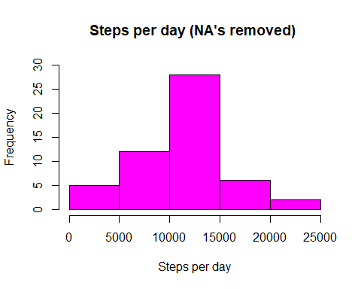

#dev.off()  
#ping("chunk5")  
#hist(DaySteps$steps, main = "Steps per day (NA's removed) ", xlab = "Steps per day", ylab = "Frequency", col = "magenta")  
#dev.off()

# Calculating and reporting the mean and median of the total number of steps taken per day:

# Mean of the total number of steps taken per day:

TotalDayStepsMean<-mean(DaySteps$steps,na.rm=TRUE)  
TotalDayStepsMean

## [1] 10766.19

# 10766.19

# Median of the total number of steps taken per day:

TotalDayStepsMedian<-median(DaySteps$steps)  
TotalDayStepsMedian

## [1] 10765

# 10765

## What is the average daily activity pattern?

Make a time series plot (i.e. type = “l”) of the 5-minute interval (x-axis) and the average number of steps taken, averaged across all days (y-axis)":

library(ggplot2)  
DaylyActivity<- aggregate(steps~interval , ProjectData, mean)  
  
p<- ggplot(DaylyActivity, aes(interval,steps,color=steps))+ ggtitle("Dayly Activity")  
p + geom_line(size=.5)+labs(x = "5-minute interval")+labs(y = "Average number of steps taken in 5-minute intervals" ) +theme(axis.text=element_text(color="black",size=13))+theme(panel.background=element_rect(fill="khaki"))+theme(axis.title.x=element_text(color='blue',vjust=1.5),axis.title.y=element_text(color="blue",vjust=1.5), plot.title=element_text(color="blue",size=15,vjust=1),  
plot.background=element_rect(fill="lightblue"))

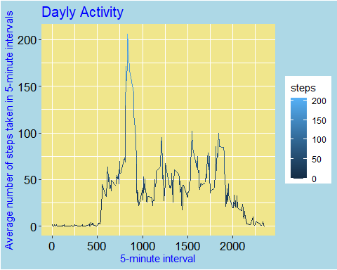

# plot(plotname)

# Which 5-minute interval, on average across all the days in the dataset, contains the maximum number of steps?

maxStepsIndex <- which(DaylyActivity$steps == max(DaylyActivity$steps))  
maxNumberStepsInterval <-DaylyActivity$interval[maxStepsIndex]  
maxNumberStepsInterval

## [1] 835

# 835

## Imputing missing values:

# Calculating and reporting the total number of missing values in the dataset (i.e. the total number of rows with NAs):

summary(is.na(ProjectData))

## steps date interval   
## Mode :logical Mode :logical Mode :logical   
## FALSE:15264 FALSE:17568 FALSE:17568   
## TRUE :2304

#There are 2304 NA’s in step variable, in initial dataset ProjectData, and 0 NAs in date and 0 NA’s in interval columns

# Devise a strategy for filling in all of the missing values in the dataset. The strategy does not need to be sophisticated:

To devise a strategy for filling missing values in the dataset the article “Tutorial on 5 Powerful R Packages used for imputing missing values” was utilized:[<https://www.analyticsvidhya.com/blog/2016/03/tutorial-powerful-packages-imputing-missing-values/>]

Hmisc package was used for bootstraping sample and predictive mean matching to impute missing values.

missForest library was used to seed 10% missing values, with seed 81,to make results reproducible:

library(missForest)

## Loading required package: randomForest

## randomForest 4.6-14

## Type rfNews() to see new features/changes/bug fixes.

##   
## Attaching package: 'randomForest'

## The following object is masked from 'package:ggplot2':  
##   
## margin

## Loading required package: foreach

## Loading required package: itertools

## Loading required package: iterators

library(Hmisc)

## Loading required package: lattice

## Loading required package: survival

## Loading required package: Formula

##   
## Attaching package: 'Hmisc'

## The following objects are masked from 'package:base':  
##   
## format.pval, units

#Load Data  
#ProjectData  
#seed 10% missing values  
set.seed(81)  
ProjectData.mis<-prodNA(ProjectData, noNA =0.1)  
#impute steps with predictive mean matching values:  
ProjectData.mis$imputedSteps<- with(ProjectData.mis, impute(steps, mean))  
#after Imputing "steps" NA's with Hmisc(imputing with mean option):  
summary(is.na(ProjectData.mis))

## steps date interval imputedSteps   
## Mode :logical Mode :logical Mode :logical Mode :logical   
## FALSE:13743 FALSE:15759 FALSE:15850 FALSE:17568   
## TRUE :3825 TRUE :1809 TRUE :1718

There are now NA’s observed in ProjectData.mis “date” and “interbval” columns, but no NA’s in “imputedSteps” column

As the task was to replace NAs, and in the initial dataset NA’s were only in the “steps” column, and were completly imputed by mean (see “ImputedSteps” column in ProjectData.mis), and considering “The strategy does not need to be sophisticated”, the column “steps” of the initial dataset Project Data (the only column that had NA’s ) was populated with data from the column “imputedSteps”, from the ProjectData.mis by the following operation:

ProjectData$steps<-ProjectData.mis$imputedSteps  
#Which resulted in no NA's in the modified DataFrame ProjectData:  
summary(is.na(ProjectData))

## steps date interval   
## Mode :logical Mode :logical Mode :logical   
## FALSE:17568 FALSE:17568 FALSE:17568

The modidfied dataset ProjectData has now imputed column “steps”, and is re-named, not to confuse it with original dataset ProjectData:

ProjectDataImputed<-ProjectData

# Making a histogram of the total number of steps taken each day and Calculating and reporting the mean and median total number of steps taken per day:

#Calculating steps taking per day with steps imputed by mean:  
DayStepsImputed<- aggregate(steps~date, ProjectDataImputed, sum)

hist(DayStepsImputed$steps, main = "Total number of steps taken each day (with steps NAs inputed)", xlab = "Steps per day", ylab = "Frequency", xlim=c(0,25000),ylim=c(0,35), col = "magenta")

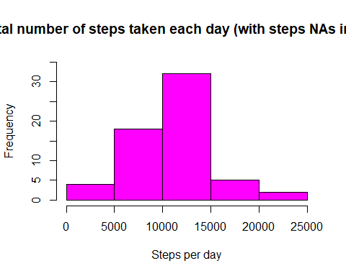

Comparing two histograms, with steps NA’s removed and with steps NA’s imputed:

par(mfrow=c(2,1))  
hist(DaySteps$steps, main ="Total number of steps taken each day (NA's removed)" , xlab = "Steps per day", ylab = "Frequency", ylim=c(0,30), col = "magenta")  
hist(DayStepsImputed$steps, main ="Total number of steps taken each day (NAs imputed)", xlab = "Steps per day", ylab = "Frequency", xlim=c(0,25000), ylim=c(0,35), col = "magenta")

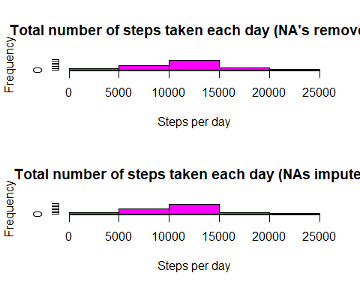

# Calculating and reporting the mean and median total number of steps taken per day (with NA imputed):

summary(DayStepsImputed$steps)

## Min. 1st Qu. Median Mean 3rd Qu. Max.   
## 1207 9418 10733 10733 12807 21279

mean total number of steps taken per day (with NA imputed):

TotalDayStepsImputedMean<-mean(DayStepsImputed$steps)  
TotalDayStepsImputedMean

## [1] 10732.64

# 10732.64

median total number of steps taken per day (with NA imputed):

TotalDayStepsImputedMedian<-median(DayStepsImputed$steps)  
TotalDayStepsImputedMedian

## [1] 10732.64

# 10732.64

# Do these values differ from the estimates from the first part of the assignment? What is the impact of imputing missing data on the estimates of the total daily number of steps?

Yes, there is a difference:both, mean and median have decrased after the imputation of steps with mean, and the mean and median values after the imputation has become equial:

TotalDayStepsMean = 10766.19 | TotalDayStepsMedian = 10765  
 TotalDayStepsImputedMean = 10732.64 | TotalDayStepsImputedMedian = 10732.64

## Are there differences in activity patterns between weekdays and weekends?

Make a time series plot (i.e. type = “l”) of the 5-minute interval (x-axis) and the average number of steps taken, averaged across all days (y-axis)

library(ggplot2)  
DaylyActivityImputed<- aggregate(steps~interval,ProjectDataImputed, mean)  
p<- ggplot(DaylyActivity, aes( interval, steps,color=steps))+ ggtitle("Dayly Activity (with steps NA's imputed)")  
p + geom_line(size=.5)+labs(x = "5-minute interval")+labs(y = "Average number of steps taken" ) +theme(axis.text=element_text(color="black",size=13))+theme(panel.background=element_rect(fill="khaki"))+theme(axis.title.x=element_text(color='blue',vjust=1.5),axis.title.y=element_text(color="blue",vjust=1.5), plot.title=element_text(color="blue",size=15,vjust=1),  
plot.background=element_rect(fill="lightblue"))

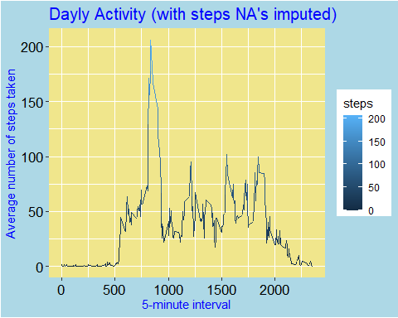

# Create a new factor variable in the dataset with two levels – “weekday” and “weekend” indicating whether a given date is a weekday or weekend day:

#Converting date variable to Date format   
library(anytime)  
  
ProjectDataImputed$date<-anydate(ProjectDataImputed$date)  
head(ProjectDataImputed,3)

## steps date interval  
## 1 37.2661 2012-10-01 0  
## 2 37.2661 2012-10-01 5  
## 3 37.2661 2012-10-01 10

class(ProjectDataImputed$date)

## [1] "Date"

#creating weekdays column   
ProjectDataImputed$weekdays<-weekdays(ProjectDataImputed$date, abbreviate = FALSE)   
head(ProjectDataImputed,3)

## steps date interval weekdays  
## 1 37.2661 2012-10-01 0 Monday  
## 2 37.2661 2012-10-01 5 Monday  
## 3 37.2661 2012-10-01 10 Monday

#Create a new factor variable in the dataset with two levels - "weekday" and "weekend" indicating whether a given date is a weekday or weekend day.  
   
#1 duplicating wekdays column as dayofweek column (for check later conversion to "Weekdays" and "Weekends")  
library(dplyr)

##   
## Attaching package: 'dplyr'

## The following objects are masked from 'package:Hmisc':  
##   
## src, summarize

## The following object is masked from 'package:randomForest':  
##   
## combine

## The following objects are masked from 'package:stats':  
##   
## filter, lag

## The following objects are masked from 'package:base':  
##   
## intersect, setdiff, setequal, union

ProjectDataImputed<-mutate(ProjectDataImputed, dayofweek=weekdays)   
head(ProjectDataImputed,3)

## steps date interval weekdays dayofweek  
## 1 37.2661 2012-10-01 0 Monday Monday  
## 2 37.2661 2012-10-01 5 Monday Monday  
## 3 37.2661 2012-10-01 10 Monday Monday

#converting names of weekdays to "Weekday" or "Weekend"  
  
ProjectDataFinalImputed<-ProjectDataImputed%>%mutate(weekdays = case_when(  
 weekdays == 'Sunday' ~ 'Weekend',  
 weekdays == 'Saturday' ~ 'Weekend',  
 TRUE ~ 'Weekday'))  
  
#Check conversion to Weekdays :   
  
head(ProjectDataFinalImputed,3)

## steps date interval weekdays dayofweek  
## 1 37.2661 2012-10-01 0 Weekday Monday  
## 2 37.2661 2012-10-01 5 Weekday Monday  
## 3 37.2661 2012-10-01 10 Weekday Monday

# Calculate avarage number of steps for weekdays:

DaylyActivityWeekdaysImputedFinal<- aggregate(steps~interval+weekdays, ProjectDataFinalImputed, mean)  
head(DaylyActivityWeekdaysImputedFinal,3)

## interval weekdays steps  
## 1 0 Weekday 10.081355  
## 2 5 Weekday 8.681355  
## 3 10 Weekday 10.093182

tail(DaylyActivityWeekdaysImputedFinal,3)

## interval weekdays steps  
## 574 2345 Weekend 8.612394  
## 575 2350 Weekend 4.658262  
## 576 2355 Weekend 11.645656

## Comparing weekdays and weekends activities:

g<-ggplot(DaylyActivityWeekdaysImputedFinal, aes(interval, steps, color=weekdays))+ ggtitle("Comparing Weekdays and Weekends activities")  
g + geom_line(size=.6)+ labs(x = "Time interval")+labs(y = "Avarage number of steps taken") +theme(axis.text=element_text(color="black",size=13))+theme(axis.title.x=element_text(color='blue',vjust=1.5), axis.title.y=element_text(color="blue",vjust=1.5))

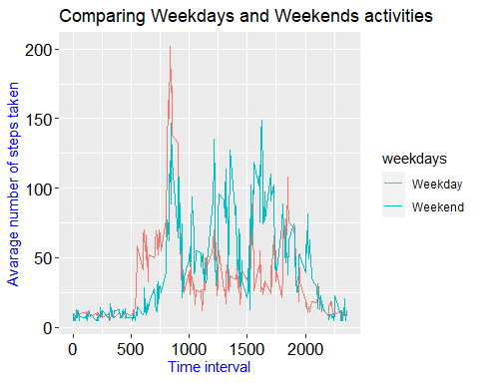

## Yes, there are differences in activity patterns between weekdays and weekends:

More steps, in general, are observed starting from about 1000s 5 minute interval and untill the end of the day, during the weekends, compare to the weekdays, while more steps are observed around 800s 5 mimute interval, during the weekdays, compare to weekends.

# Make a panel plot containing a time series plot (i.e. type = “l”) of the 5-minute interval (x-axis) and the average number of steps taken, averaged across all weekday days or weekend days (y-axis).

#plot(plotname)  
library(lattice)  
with(DaylyActivityWeekdaysImputedFinal, xyplot(steps ~ interval | weekdays, type="l", xlab = "Time interval", ylab = "Avarage number of steps taken", layout = c(1, 2)))

