**SVKM’s NMIMS**

**Mukesh Patel School of Technology Management & Engineering**

**Computer Engineering Department**

Program: B. Tech. Semester: VIII

**Course: Software Project Management**

**Experiment No.07**

PART A

(PART A: TO BE REFFERED BY STUDENTS)

**A.1 Aim:** Create a Work Breakdown Structure for developing a software for buying/selling/renting a house.

**A.2 Prerequisite:** Project Management Planning and Schedule/Organizational Structure

**A.3 Outcome:**

**After successful completion of this experiment students will be able to know**

1. How to organize the Task for a software project
2. How to estimate **cost on the basis of WBS** for a software project

**A.4 Theory:**

WBS In Project Management

Making a WBS is the first step in developing a project schedule. It defines all the work that needs to be completed (and in what order) to achieve the project goals and objectives. By visualizing your project in this manner, you can understand your project scope, and allocate resources for all your project tasks.

A well-constructed work breakdown structure helps with important project management process groups and knowledge areas such as:

* Project Planning, Project Scheduling and Project Budgeting
* Risk Management, Resource Management, Task Management and Team Management

In addition, a WBS helps avoid common project management issues such as missed deadlines, scope creep and cost overrun, among others.

In other words, a work breakdown structure serves as your map through complicated projects. Your project scope may include several phases, or smaller sub-projects—and even those sub-projects can be broken down into tasks, deliverables, and work packages! Your WBS can help you manage those items, and gain clarity into the details needed to accomplish every aspect of your project scope.

## Work Breakdown Structure Example

Now that we’ve gone through the definition of a WBS and learned why they are a great project management tool, let’s take a look at a work breakdown structure example.

The final project deliverable, as well as the tasks and work packages associated with it rest on top of the WBS diagram, and the WBS levels below subdivide the project scope to indicate the tasks, deliverables and work packages that are needed to complete the project from start to finish.

For our WBS example, we’ll be creating a work breakdown structure to guide a commercial building construction project. This is potentially a complex project, but a WBS chart will take that complexity and boil the project scope down to simpler tasks to make the project manageable.

Study the phase-based work breakdown structure example of a construction project below:

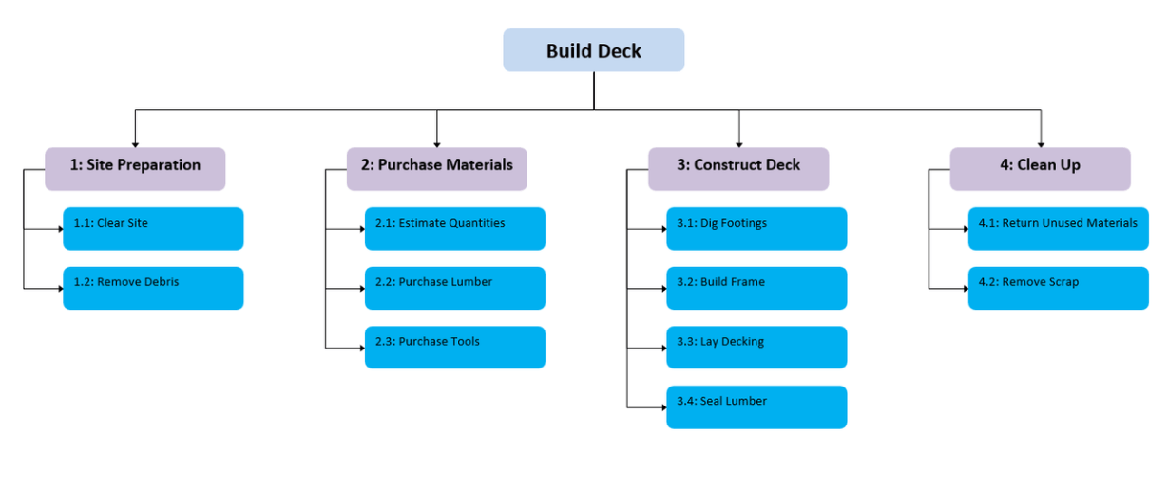

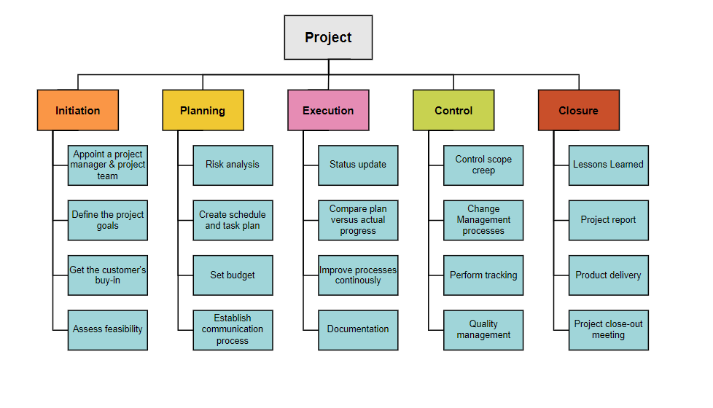

At the top of the work breakdown structure is your final deliverable (in this instance, the construction project). Immediately beneath that is the next WBS level, which are the main project phases required to complete the project. The third and lowest level shows work packages. Most WBS charts have 3 levels, but you can add more depending on the complexity of your projects.

Each of those five project phases—initiation, planning, execution, control and closeout, also act as control accounts and branch off the main deliverable at the top. Once decided, they are then broken down into a series of deliverables. For example, the initiation phase includes site evaluation **work and creating the project charter.

You’ll also need a work package to go with each of those project deliverables. In the execution phase in our construction example, we can look at the interior work deliverable. That deliverable is divided into two work packages, which are installing the plumbing and setting up the electricity.

The WBS, when created as thoroughly as possible, is the roadmap to guide you to completion of what would seem to be a very complicated project scope. However, when broken down with a WBS, project planning, scheduling and resource planning suddenly become much more manageable.

## WBS Elements

A typical project work breakdown structure is made up of several key components. We’ll use our WBS example above to identify each of the main WBS elements.

* **WBS Dictionary:** A WBS dictionary is a document that defines the various WBS elements. It’s an important component of a WBS because it allows the project participants and stakeholders to understand the work breakdown structure terminology with more clarity.
* **WBS Levels:** The WBS levels are what determines the hierarchy of a WBS element. Most work breakdown structures have 3 levels that represent the project’s main deliverable, control accounts, project deliverables and work packages.
* **Control Accounts:** Control accounts are used to group work packages and measure their status. They’re used to control areas of your project scope. In our example the execution project phase could be a control account because it has several deliverables and work packages associated to it.
* **Project Deliverables:** Project deliverables are the desired outcome of project tasks and work packages. In our WBS example, we can observe some examples of project deliverables such as the project budget or interior work. Both of them are the result of smaller tasks and work packages.
* **Work Packages:** As defined by the project management institute (PMI) in its project management body of knowledge book (PMBOK) a work package is the “lowest level of the WBS”. That’s because a work package is a group of related tasks that are small enough to be assigned to a team member or department. As a project manager you can estimate costs and duration of these work packages, which makes them an essential WBS element.
* **Tasks:** Your tasks make up your work packages and therefore, your project scope. A WBS will help you define each task requirements, status, description, task owner, dependencies, and duration.

Steps to create Work Breakdown Structure:

1. Determine and describe the project statement.
2. Highlight all the necessary phases of the project.
3. Create and list the deliverables.
4. Divide the deliverables into manageable tasks.
5. Assign responsibilities and clarify roles.
6. Track the progress of a project.
7. Identify risk.

Let us conclude why we should use WBS in Project management.

* There are several reasons why breaking down a large project is beneficial. Some of them are,
* It helps you with cost estimation.
* It helps you to establish dependencies.
* Provides a visual representation of all parts of a project.
* Identify the risks.
* Improves productivity.
* Helps to identify resources.
* Assign responsibilities and clarify roles.
* Helps to track the progress of a project

**A.5 Task to be completed in PART B**

**A.5.1. Task 1:**

**Every student needs to follow following steps and record the findings in appropriate section of PART B**

**Create a Work Breakdown Structure for given problem (buying selling and Renting house).**

******************

**PART B**

(PART B: TO BE COMPLETED BY STUDENTS)

**(Students must submit the soft copy as per following segments within two hours of the practical. The soft copy must be uploaded on the Blackboard or emailed to the concerned lab in charge faculties at the end of the practical in case the there is no Black board access available)**

|  |  |
| --- | --- |
| Roll No. C050 | Name: Nisha Kini |
| Program : BTI | Division: B |
| Batch: B2 | Date of Experiment: 27.2.24 |
| Date of Submission: : 27.2.24 | Grade : |

**B.1 Tasks given in PART A to be completed here**

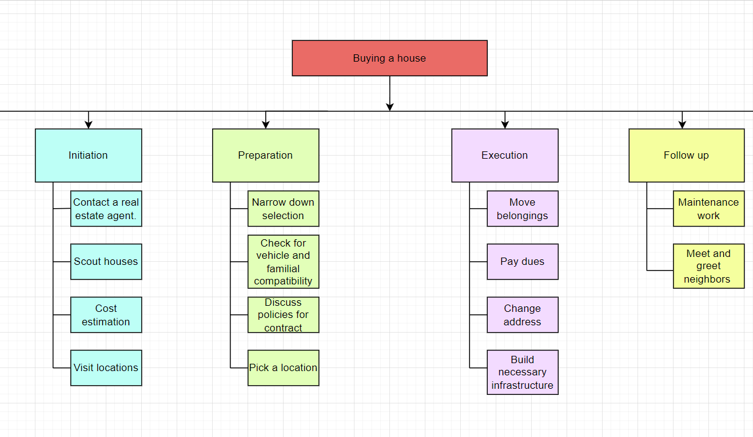

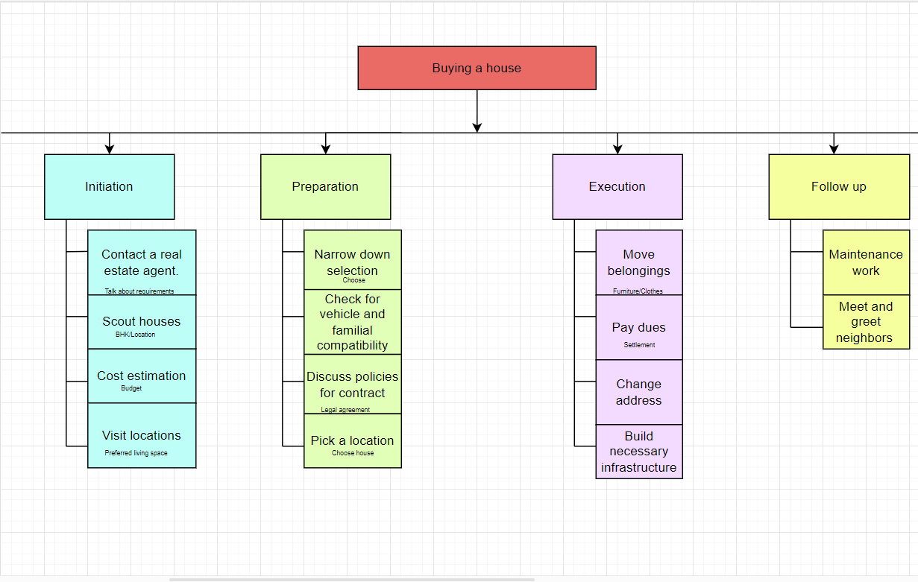

**B.2 Observations and Learning:**

A WBS can be Deliverable-Based or Phase-Based. The Deliverable-Based approach focuses on project deliverables and their relationship to the project scope, while the Phase-Based approach divides work associated with multiple elements unique to each level 1 element.

**B.3 Conclusion:**

When creating a WBS, it is essential to follow an iterative process by defining the project, breaking it down into smaller components without excessive detail, identifying team members responsible for each element, and creating a Gantt chart to visualize the project schedule

**B.4 Question of curiosity:**

1. When should WBS be used?

A Work Breakdown Structure (WBS) is a hierarchical and deliverable-oriented deconstruction of a project into smaller components. It serves as a planning tool to help project teams plan, define, and organize scope with deliverables. The WBS is used for various purposes in project management, such as integrating scope, cost, and schedule baselines, ensuring project plans are aligned

2. What are the main uses of work breakdown structure WBS?

**Main Uses of Work Breakdown Structure (WBS)**

1. **Planning Tool**: Helps in planning, defining, and organizing project scope with deliverables.
2. **Integration Tool**: Integrates scope, cost, and schedule baselines to align project plans.
3. **Monitoring and Controlling Tool**: Assists in monitoring and controlling the project progress.
4. **Resource Management**: Aids in managing resources effectively.
5. **Avoiding Project Management Issues**: Helps in avoiding missed deadlines, scope creep, and cost overruns.

***************