AWS Certified AI Practitioner
Fundamentals from the Practice Video
Study summary based on the uploaded AWS-AI_pract.mp4

How to use this document
This is a fundamentals-first study guide derived from the concepts and answer explanations visible in the uploaded practice video. It reorganizes the material by topic instead of reproducing the mock exam question-by-question. The video is approximately 57 minutes and covers machine learning basics, generative AI, AWS AI services, responsible AI, model evaluation, security, and operations.

1. Machine Learning Fundamentals

Problem types
Regression predicts a continuous numeric value, such as price. Classification predicts a category or class. Clustering groups similar observations without predefined labels. Dimensionality reduction reduces the number of features while retaining useful information.

Training concepts
An epoch is one complete pass through the training dataset. Hyperparameters are settings chosen before or during training, such as learning rate. Model weights are learned parameters, not hyperparameters.

Overfitting and underfitting
Overfitting occurs when a model performs well on training data but poorly on new data. Underfitting occurs when the model is too simple or insufficiently trained to capture the underlying pattern. A useful target is low bias and low variance.

Improving model performance
Data augmentation increases the amount or diversity of training data. Hyperparameter tuning searches for better training settings. Feature engineering creates or transforms useful inputs. Dimensionality reduction simplifies high-dimensional data.

Transfer learning and fine-tuning
Transfer learning adapts an existing model to a related task. Fine-tuning uses task/domain-specific labeled examples to adjust a pretrained model. For instruction/style customization, the video highlights text pairs of prompts and desired responses as suitable training data.
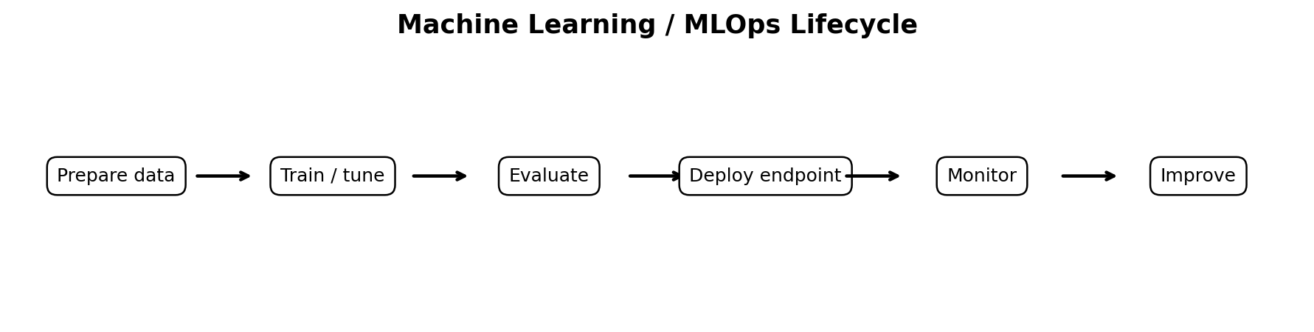

2. Core Algorithms and Deep Learning
Technique | What it does | Typical use
Linear regression | Predicts a continuous value from feature relationships | Prices, demand, numeric forecasts
Logistic regression | Models probability of a class, commonly binary | Yes/no classification
Decision trees | Recursively split data using feature values | Interpretable classification/regression
Graph neural networks | Learn from interconnected graph structures | Social networks and relationship data
CNNs | Learn spatial/local patterns | Images and grid-like data
RNNs | Process sequential information | Text/time-series sequences
GANs | Two competing networks generate new data | Synthetic content
Stable Diffusion | Diffusion-based generative architecture | Image generation

3. Generative AI and Foundation Models

Foundation models and Amazon Bedrock
The video positions Amazon Bedrock as the managed AWS service for building generative-AI applications using existing foundation models without managing the underlying model infrastructure. Amazon Titan is identified as an Amazon-developed foundation-model family available through Bedrock. For unpredictable usage across different foundation models, on-demand pricing is the flexible pattern; foundation-model usage is commonly associated with input and output token consumption.

Inference controls
Temperature controls randomness/creativity. Top-k restricts choices to the k most likely tokens. Top-p selects from tokens whose cumulative probability reaches a threshold. Greedy search chooses the most likely token at each step, while beam search tracks multiple candidate sequences. The model's maximum context window matters when users submit long prompts.

NLP units
- Token: Basic unit of text after tokenization, often a word or subword.
- Vector embedding: Numeric representation of text or other content in a continuous vector space.
- n-gram: Sequence of n consecutive words/characters used to capture local language patterns.
- Vocabulary: Set of units the model recognizes and processes.

4. RAG, Embeddings, and Vector Search
Retrieval-Augmented Generation (RAG) improves an LLM response by retrieving relevant external information and supplying it as context at inference time. This is especially useful when answers should reflect enterprise or domain information without retraining the model.
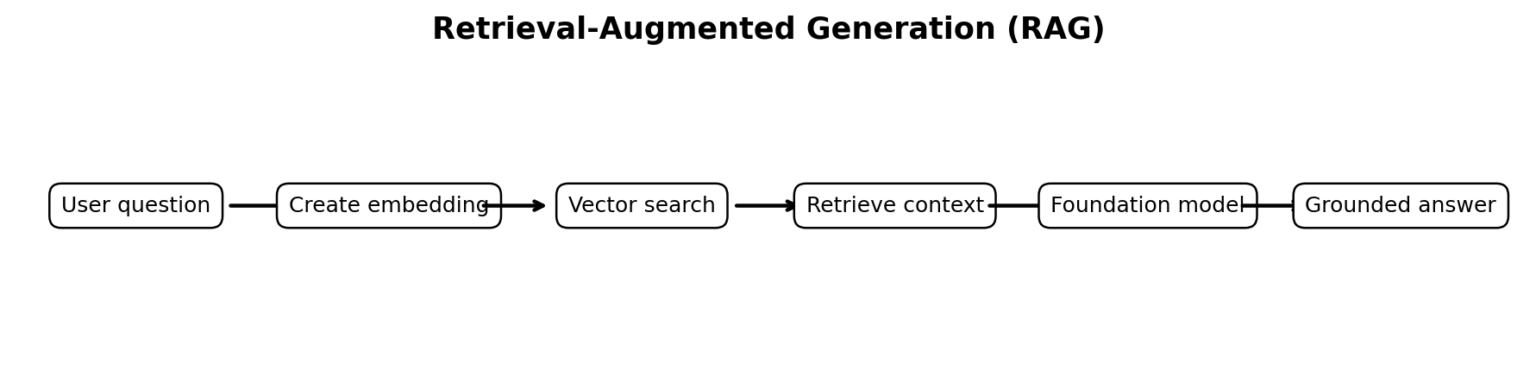
The video calls out vector-capable storage/search options including Amazon OpenSearch, Amazon MemoryDB, Amazon Aurora/RDS PostgreSQL with pgvector, Amazon Kendra, and third-party vector databases. For enterprise natural-language search over large unstructured collections, Amazon Kendra is highlighted. For product embeddings and similarity search, the practice content also points to vector-search-capable services such as OpenSearch.

4.1 Expanded RAG Fundamentals from the RAG Training Video

Why RAG is used
The video explains RAG as a way to connect a large language model to external knowledge instead of relying only on what the model learned during training. This is useful for customer support, medical, legal, finance, compliance, and other knowledge-intensive applications where the answer should reflect specific source information. The main benefits emphasized are reducing hallucination, keeping knowledge more current, improving cost effectiveness compared with repeatedly retraining a model, and maintaining greater control over private enterprise data.

Core idea: retrieve before you generate
A normal LLM flow is essentially Question -> LLM -> Generated response. RAG inserts a retrieval step. The application first finds the pieces of enterprise knowledge that are most relevant to the user question. Those retrieved passages become context for the prompt, and the LLM generates the answer using the question plus that context. A useful mental model from the video is: Prompt = Query + Context + instructions.
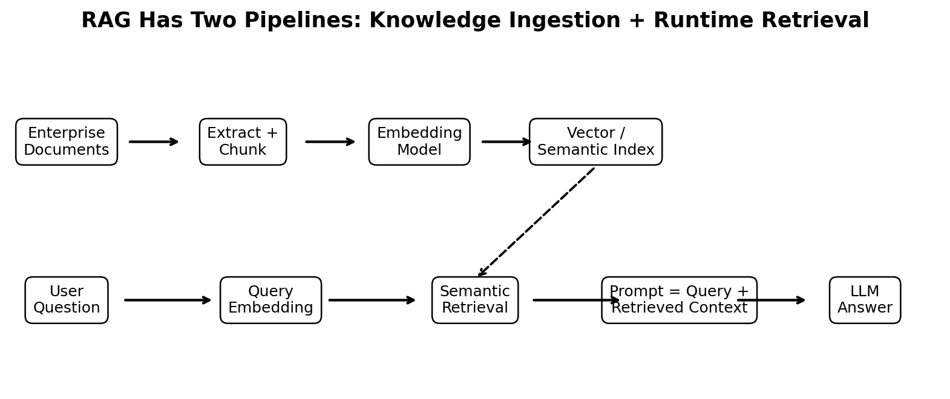

The knowledge-ingestion pipeline
The video separates preparation of the knowledge base from the runtime user query. Source material such as PDFs is extracted and split into smaller chunks. An embedding model converts each chunk into a vector representation. The vectors are stored in a semantic/vector index together with the source chunks. This indexed collection becomes the knowledge base that the runtime RAG system searches.

Why chunking matters
Documents are usually too large to retrieve as one block, so they are split into chunks. The video discusses fixed-size chunking, hierarchical chunking, and semantic chunking. Fixed-size chunking is straightforward and may use overlap between adjacent chunks. Hierarchical chunking preserves parent/child relationships between larger and smaller sections. Semantic chunking tries to create boundaries based on meaning, so related information stays together. Chunk quality directly affects what the retriever can find and therefore what context the LLM receives.
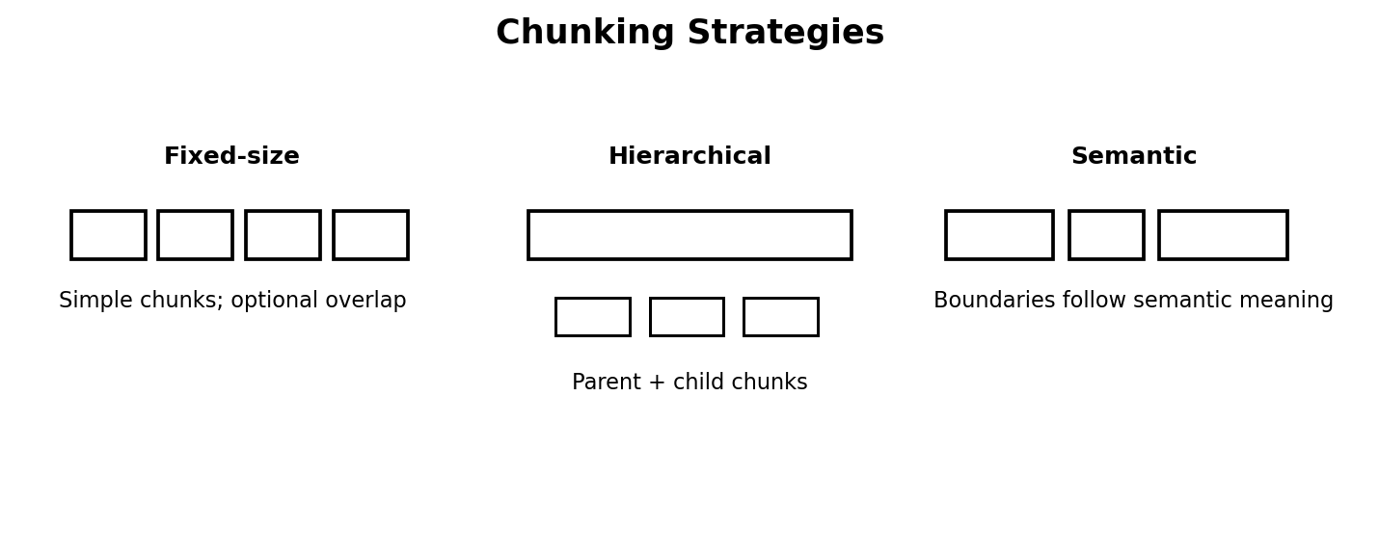

Embeddings and semantic search
An embedding is a numeric vector that represents the semantic meaning of text. During ingestion, document chunks are embedded and stored. At runtime, the user query is also embedded. Semantic search compares the query vector with stored vectors to find chunks that are close in meaning, even when the exact words differ. The video uses examples such as related medical terms to illustrate why meaning-based retrieval can outperform literal word matching.

Runtime retrieval and generation
At runtime the user question is converted into an embedding, the semantic index is searched, and the most relevant chunks are retrieved. The retrieved results can be ranked before being supplied to the LLM. The final prompt combines the user query, selected context, and instructions. The LLM then generates a response grounded in those retrieved sources rather than answering only from pretrained knowledge.

RAG architecture choices
The video stresses that RAG is not one fixed architecture. Different retrieval patterns are appropriate for different use cases. Standard RAG uses vector retrieval. Hybrid RAG combines vector similarity with keyword search because pure semantic retrieval can be strong for meaning but weaker for exact names, IDs, codes, or literal matches. RAG with memory adds conversational context. Graph RAG uses relationships between entities. Agentic RAG introduces multi-step reasoning/tool use. Multimodal RAG retrieves across formats such as text and images. Self-RAG adds a reflective or corrective step intended to improve answer quality.
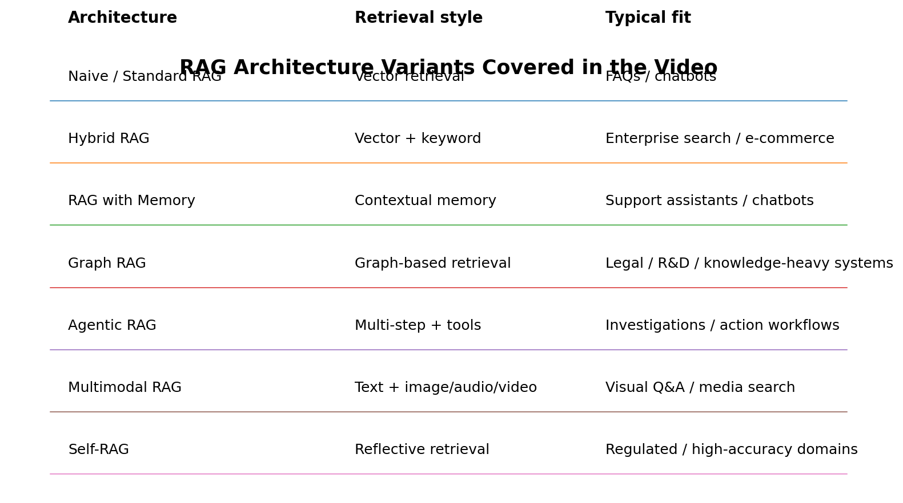

Training takeaway: choosing the RAG pattern
- Standard RAG: start here for straightforward knowledge-grounded FAQs and chatbots.
- Hybrid RAG: useful when both semantic meaning and exact keyword matching matter, especially enterprise search and e-commerce.
- RAG with Memory: useful when the assistant must retain conversational context across turns.
- Graph RAG: useful when relationships among entities are important, such as knowledge-heavy legal or research domains.
- Agentic RAG: useful for workflows that require multiple retrieval/action steps or tools.
- Multimodal RAG: useful when the knowledge is not only text but also images, audio, video, or other modalities.
- Self-RAG: useful when the workflow needs additional reflection/validation before accepting the generated answer.

RAG vs. model retraining
The key distinction is that RAG changes the information supplied to the model at inference time; it does not inherently retrain the model. When enterprise knowledge changes, the knowledge base can be updated and re-indexed without training a new foundation model. This makes RAG particularly useful for dynamic knowledge and private organizational information.

Practical design considerations from the video
- Choose chunk size and chunking strategy carefully because retrieval quality depends on the units being indexed.
- Choose an embedding model that represents the language/domain of the source content and user queries well.
- Use semantic/vector search for meaning; consider hybrid retrieval when exact keyword matching also matters.
- Re-rank or filter retrieved results before generation when better relevance is needed.
- Keep the knowledge base current; stale source data can still produce a grounded but outdated answer.
- Use memory only when the use case needs prior conversational context rather than adding it by default.
- For high-stakes or regulated domains, retrieval quality, source governance, privacy, and answer validation remain essential even when RAG reduces hallucination.

Simple example
Suppose a user asks, “Can you explain the price hike of gold in 2025 and compare it with other metals?” A standard LLM may depend on what it learned during training. A RAG application can retrieve current documents or market records relevant to the date, reasons for the price change, and comparable metal prices, then provide those retrieved facts as context before generating the response. Follow-up questions can additionally benefit from a memory-enabled RAG design.

5. Responsible AI, Governance, and Safety
Governance establishes policies, accountability, and oversight for AI development and use. Responsible AI also requires attention to bias/fairness, transparency, data protection, security, reliability, and appropriate human oversight.
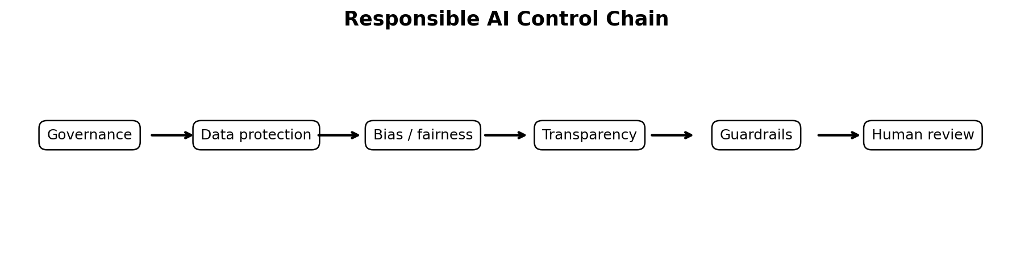

AWS tools highlighted
- AWS AI Service Cards — information intended to improve transparency and understanding of AWS AI services.
- Amazon SageMaker Clarify — helps identify bias and explain model predictions.
- Guardrails for Amazon Bedrock — helps enforce application safeguards for generated content.
- Amazon A2I (Augmented AI) — supports human review workflows.
- Amazon Macie — identifies sensitive information in data such as S3 datasets.
- Amazon Inspector — helps identify vulnerabilities in supported AWS workloads.

Generative-AI risks
Hallucination means producing false or misleading information. The video also discusses prompt attacks: jailbreaking attempts to bypass safety constraints; prompt poisoning introduces biased or misleading prompt/context data; adversarial prompting deliberately tries to exploit weaknesses or force incorrect behavior. Human review remains important when generated content could be inappropriate, misleading, or high impact.

6. Important AWS AI / ML Services
AWS service | Fundamental purpose from the video
Amazon SageMaker Canvas | Build ML models with a visual/no-code or low-code experience.
Amazon SageMaker JumpStart | Prebuilt models/templates and accelerated starting points.
Amazon SageMaker Autopilot | Automates ML experimentation/model-building steps for rapid prototyping.
SageMaker Feature Store | Stores and manages ML features for workflows.
SageMaker Endpoints | Hosts trained models for real-time inference.
SageMaker Model Monitor | Monitors deployed models for quality/performance issues.
SageMaker Model Parallelism | Distributes very large model training across compute resources.
Amazon Bedrock | Managed access to foundation models for generative-AI applications.
Bedrock Agents | Orchestrates multi-step actions and enterprise-data interactions.
Amazon Q Business | Enterprise assistant/knowledge-based question answering.
Amazon Q Developer | Assists developers with coding tasks and technical queries.
Amazon Comprehend Medical | Extracts information from unstructured clinical/medical text.
Amazon Kendra | Enterprise search across large unstructured content collections.
AWS PrivateLink | Private connectivity between VPCs/services without exposing traffic to the public internet.

7. Model Evaluation Metrics
- Accuracy: Overall fraction of correct predictions.
- Precision: Of predicted positives, the proportion that are actually positive.
- Recall / Sensitivity: Of actual positives, the proportion correctly identified.
- F1 score: Harmonic mean of precision and recall; useful when both matter.
- AUC-ROC: Ability to distinguish positive from negative classes across thresholds.
- BLEU: Translation/text-generation overlap-oriented evaluation.
- BERTScore: Semantic similarity using contextual embeddings.
- ROUGE: Commonly evaluates generated summaries against references.
- Word Error Rate (WER): Error rate for speech-recognition transcription.
- Perplexity: Measures uncertainty in language modeling; lower generally indicates better next-token prediction.

8. MLOps, Deployment, and Monitoring
MLOps is broader than deployment: it is a set of practices for managing the lifecycle of ML systems, including training, versioning, deployment, monitoring, governance, and continuous improvement. For real-time inference, the video highlights SageMaker endpoints; for large offline inference where latency is not important, batch inference is appropriate. Monitoring deployed models is necessary to detect quality or reliability degradation.

9. Security and Shared Responsibility
Under the AWS Shared Responsibility Model, AWS secures the underlying cloud infrastructure while the customer remains responsible for protecting its data and correctly configuring access and security controls. The practice video specifically emphasizes customer responsibility for securing customer data stored in S3. For private partner connectivity, AWS PrivateLink is highlighted as a way to keep service traffic private rather than exposing it to the public internet.

10. High-Value Exam Distinctions
Distinction | Remember
Bedrock vs SageMaker | Bedrock: consume/customize foundation models for GenAI. SageMaker: broader ML build, train, deploy, and monitor platform.
RAG vs fine-tuning | RAG injects retrieved external knowledge at inference time. Fine-tuning changes model behavior/weights using training examples.
Parameter vs hyperparameter | Parameters are learned by the model; hyperparameters such as learning rate are configured for training/inference.
Training vs inference | Training learns model parameters; inference uses a trained model to generate predictions or outputs.
Precision vs recall | Precision asks whether positive predictions are correct; recall asks whether actual positives were found.
Real-time vs batch inference | Real-time favors low-latency interactive predictions; batch favors cost-efficient processing when immediate response is unnecessary.
Model monitoring vs human review | Monitoring detects model quality/behavior issues; human review inserts people into decisions/workflows where judgment is needed.

11. Rapid Review Checklist
- Know when a problem is regression, classification, clustering, or dimensionality reduction.
- Know overfitting, underfitting, epoch, hyperparameter, bias, and variance.
- Know the purpose of Bedrock, SageMaker, Q Business, Q Developer, Kendra, Comprehend Medical, Macie, Inspector, and PrivateLink.
- Understand RAG, embeddings, vector search, fine-tuning, and transfer learning.
- Know temperature, top-k, top-p, greedy search, beam search, tokens, and context windows.
- Know hallucination, governance, guardrails, bias/explainability, and human review.
- Know accuracy, precision, recall, F1, AUC-ROC, BLEU, BERTScore, ROUGE, WER, and perplexity.
- Understand MLOps, model deployment, real-time vs batch inference, monitoring, and shared responsibility.

Source note
Source: uploaded video AWS-AI_pract.mp4. This guide is based on the practice questions, answer highlights, and concept-summary slides visible in the video. It is intentionally reorganized into a study guide rather than a verbatim transcript.

12. Expanded Training Session Notes
This section expands the video-derived study guide into instructor-friendly explanations. Use it as speaking notes during a training session: introduce the concept, give the intuition, show the diagram, then use the checkpoint question.

12.1 AI, ML, Deep Learning, and Generative AI
Artificial intelligence is the broad goal of building systems that perform tasks associated with human intelligence. Machine learning is a subset of AI in which systems learn patterns from data rather than relying only on explicitly programmed rules. Deep learning is a subset of ML built around multi-layer neural networks. Generative AI is focused on creating new content—such as text or images—based on patterns learned from large datasets.
Training explanation: emphasize that these terms are nested, not interchangeable. A traditional classifier can be AI/ML without being generative AI. A foundation model can support generative tasks, but the business application still needs prompts, security, grounding, monitoring, and governance.
Checkpoint: If the requirement is “predict whether a transaction is fraudulent,” think classification. If the requirement is “generate a customer-facing explanation,” think generative AI.

12.2 Training, Validation, and Inference
Training is the learning phase: examples are processed and model parameters are adjusted. An epoch is one complete pass through the training dataset. Validation is used to judge how well the model generalizes while choices such as hyperparameters are being tuned. Inference is what happens after training, when the model receives a new input and produces a prediction or generated output.
A useful training analogy is learning for an exam: training is studying examples, validation is taking practice tests and adjusting the study strategy, and inference is taking the real exam. If performance is excellent on the study examples but poor on unseen questions, the model is overfitting.
Checkpoint: learning rate is a hyperparameter; learned weights are model parameters.

12.3 Overfitting, Underfitting, Bias, and Variance
Overfitting means the model has learned the training data too specifically and does not generalize well. Underfitting means the model has not captured enough of the underlying relationship. In training discussions, connect underfitting with excessive bias and overfitting with excessive variance.
Ways discussed in the video that can improve model performance include adding/diversifying data, data augmentation, hyperparameter tuning, feature engineering, and dimensionality reduction. The correct technique depends on the failure mode rather than applying every technique automatically.
Trainer prompt: ask the audience why 99% training accuracy is not automatically evidence of a good production model.

12.4 Foundation Models, Bedrock, and SageMaker
A foundation model is a large pretrained model that can be adapted to many downstream tasks. Amazon Bedrock provides managed access to foundation models for generative-AI applications. The video also references Amazon Titan as an Amazon-developed model family. SageMaker represents the broader ML lifecycle: preparing data, training or tuning models, hosting endpoints, and monitoring them.
For training, frame the distinction as “consume/adapt foundation models” versus “build/manage the broader ML workflow.” The boundaries can overlap, but this mental model helps answer scenario questions.
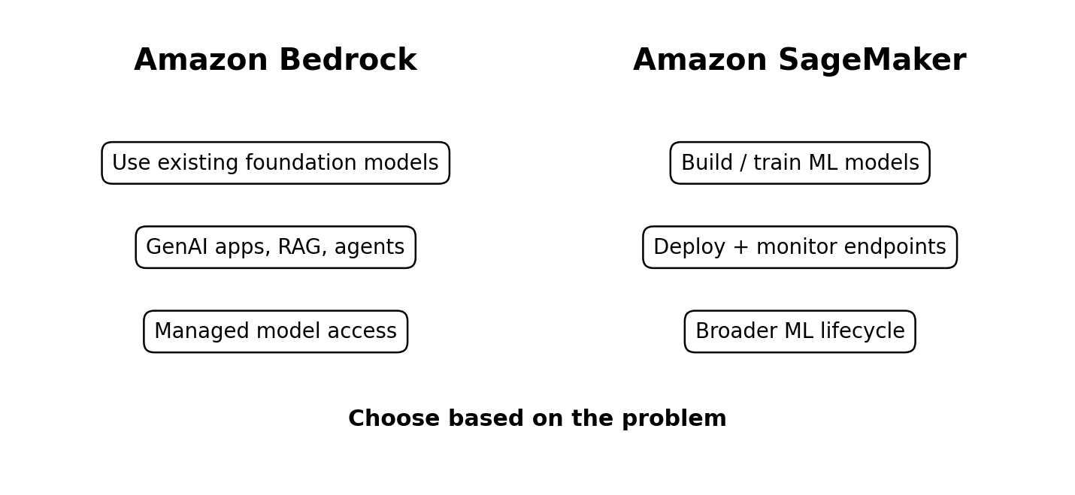

12.5 RAG — Why Retrieval Matters
A foundation model does not automatically know current or private enterprise information. RAG addresses this by retrieving relevant information from an external knowledge source and placing that information into the model's context before generation. Embeddings convert content into vectors so semantically similar content can be found using vector search. The key teaching point is that RAG changes the information supplied at inference time; it does not require retraining the model.

Training example: an employee asks a question about an internal policy. The system embeds the question, searches the enterprise knowledge collection for relevant policy passages, supplies those passages to the foundation model, and generates an answer grounded in the retrieved content.

12.6 Fine-Tuning vs RAG
Question | RAG | Fine-tuning
What changes? | Context supplied at inference | Model behavior/weights
Best for | Current/private knowledge | Behavior, style, task adaptation
Needs retraining? | No | Yes, model customization/training process
Knowledge freshness | Can reflect updated source data | Depends on training data used

12.7 Prompt and Inference Controls
Temperature controls randomness: lower values generally make outputs more deterministic, while higher values allow more variation. Top-k limits token selection to the k most likely candidates. Top-p selects from a probability mass rather than a fixed count. Greedy decoding always selects the highest-probability next token; beam search keeps several candidate sequences. The context window limits how much information the model can consider in one request.
Trainer exercise: ask which setting you would lower for a highly consistent compliance-oriented response. Then contrast that with a creative brainstorming use case.

12.8 Classification Metrics — Precision and Recall
Accuracy alone can be misleading, especially when classes are imbalanced. Precision asks: when the model predicts positive, how often is it correct? Recall asks: of all actual positive cases, how many did the model find? F1 combines precision and recall. AUC-ROC evaluates class-separation ability across thresholds.
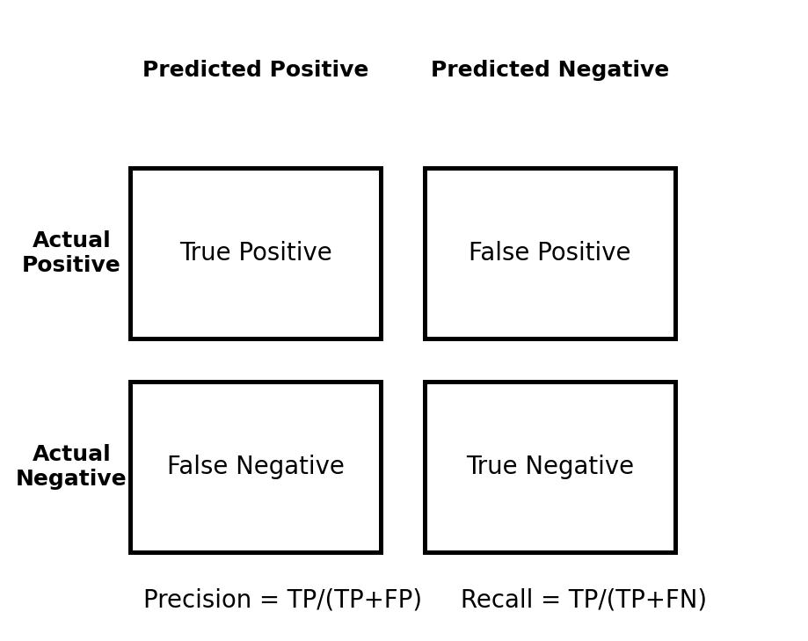
Training example: in a screening system, missing a true positive may be costly, so recall can be especially important. In a workflow where false alarms are very expensive, precision may receive more emphasis. The correct metric follows the business consequence.

12.9 Generative-AI Evaluation
The video introduces several task-specific metrics. BLEU is associated with translation/text overlap; ROUGE is commonly associated with summarization; BERTScore uses contextual embeddings to estimate semantic similarity; Word Error Rate evaluates speech transcription; perplexity measures language-model uncertainty. The training lesson is that there is no single universal AI metric—the evaluation method must match the task.

12.10 Responsible AI and Security
Responsible AI is not a single feature. It combines governance, data protection, bias/fairness considerations, transparency, guardrails, reliability, and human oversight. The video highlights SageMaker Clarify for bias/explainability, Bedrock Guardrails for safeguards, Amazon A2I for human review, Macie for sensitive-data discovery, and Inspector for vulnerability findings.

For generative AI, explicitly explain hallucination and prompt attacks. A hallucination is a confident but false or unsupported output. Jailbreaking attempts to bypass model safeguards. Adversarial or poisoned prompts/context attempt to manipulate behavior. The operational response is layered: trusted data, access controls, grounding, guardrails, testing, monitoring, and human review where consequences warrant it.

12.11 MLOps and Production Operations
MLOps is the operational discipline around the model lifecycle. The training message should connect model creation to production reality: versioning, deployment, monitoring, rollback, governance, and continuous improvement. Real-time endpoints are appropriate when interactive latency matters; batch inference is suitable when large volumes can be processed asynchronously. Model monitoring is needed because production data and model behavior can change after deployment.


