DBMS

Nikhil Raju Mohite

PES1UG20CS667

K Section

13.09.2022

create table train(train_no integer, train_name varchar(10) unique not null, train_arrival varchar(10), train_dest varchar(10), train_availability varchar(10) default 'Yes', train_type varchar(10) not null, primary key(train_no));

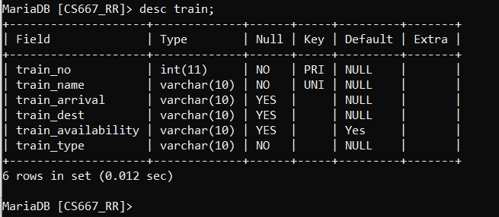

create table compartment(ctype integer, cno varchar(10), ccapacity integer, cavailability varchar(10) default 'Yes', train_no integer, foreign key(train_no) references train(train_no), primary key(cno,train_no));

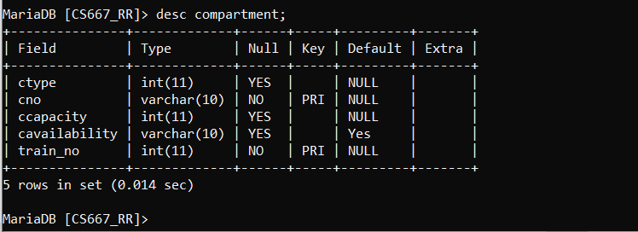

create table route_info(from_station_no integer, from_station_name varchar(10), to_station_no integer, to_station_name varchar(10), distance integer, train_no integer, foreign key(train_no) references train(train_no), primary key(from_station_no,to_station_no,train_no));

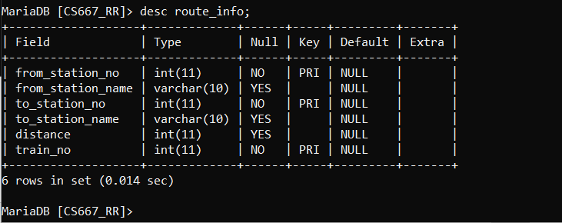

create table user(user_id integer, user_type varchar(10), fname varchar(10), lname varchar(10), age integer, dob integer, pincode integer, street_no integer, primary key(user_id));

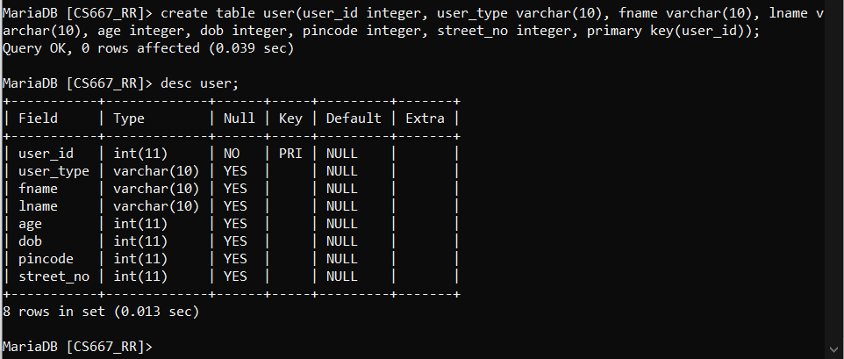

create table user_train(date_time_stamp integer,train_no integer, foreign key(train_no) references train(train_no),user_id integer, foreign key(user_id) references user(user_id), primary key(date_time_stamp,user_id,train_no));

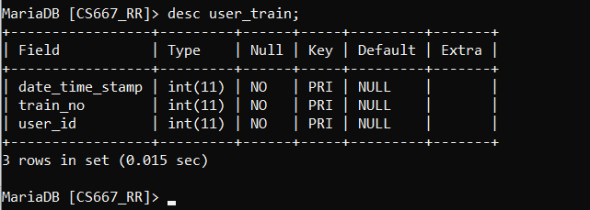

create table ticket(pnr integer, train_number integer, travel_date varchar(10), departure varchar(10), arrival varchar(10), dep_time varchar(10), arr_time varchar(10), train_type varchar(10), compartment_type varchar(10), compartment_no integer,user_id integer, foreign key(user_id) references user(user_id));

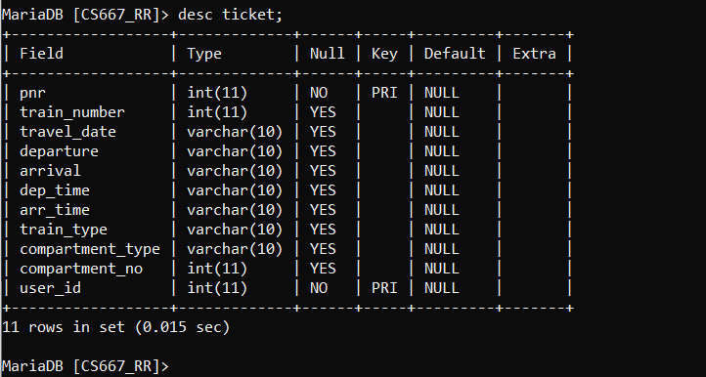

create table user_phone(user_id integer, phone_no integer, primary key(user_id,phone_no), foreign key(user_id) references user(user_id));

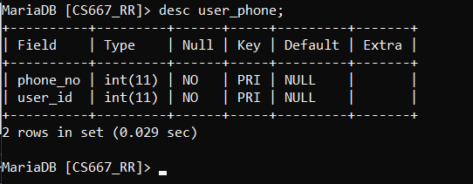

create table payment_info(transaction_id integer, bank varchar(10), card_no integer, price integer, pnr integer, foreign key(pnr) references ticket(pnr), primary key(transaction_id));

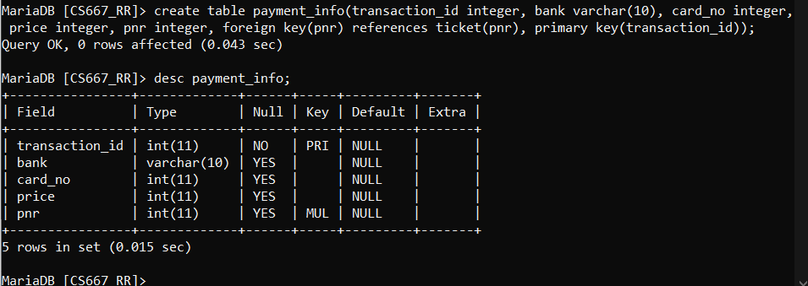

create table ticket_passenger(seat_no integer, pname varchar(10), age integer check (age>5), pnr integer, foreign key(pnr) references ticket(pnr), primary key(seat_no));

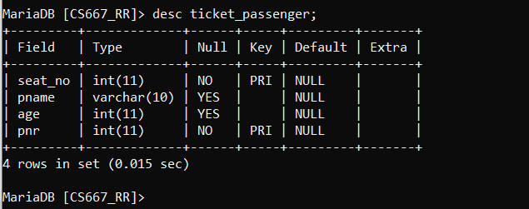

create table fare_table(train_type varchar(10), compartment_type varchar(10), fare_per_km integer,primary key(train_type, compartment_type));

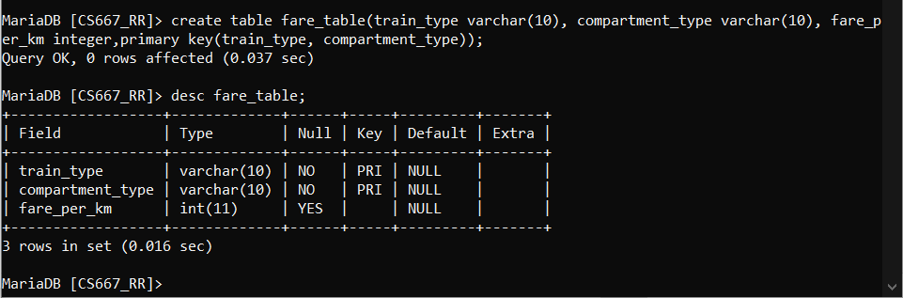

Renaming:

alter table fare_table rename to fare_calculation;

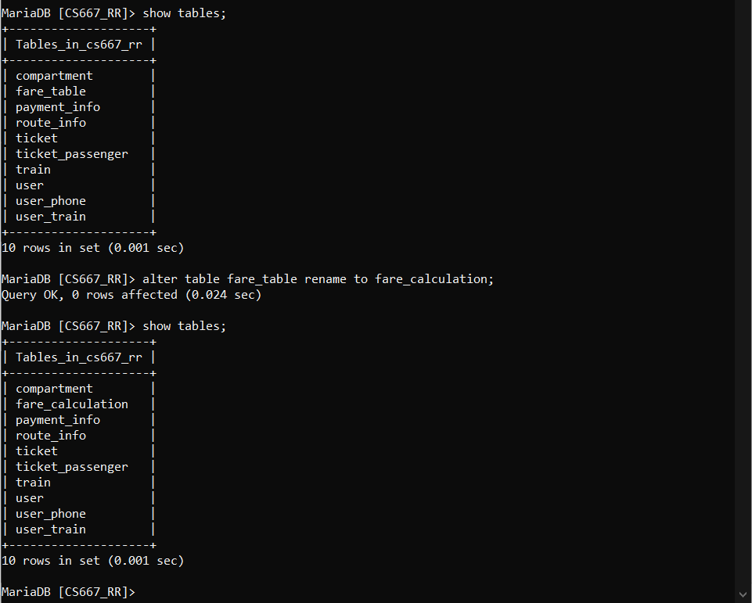

Truncate:

insert into fare_calculation(train_type, compartment_type, fare_per_km) values ("AC", "3 Tier", 10);

truncate table fare_calculation;

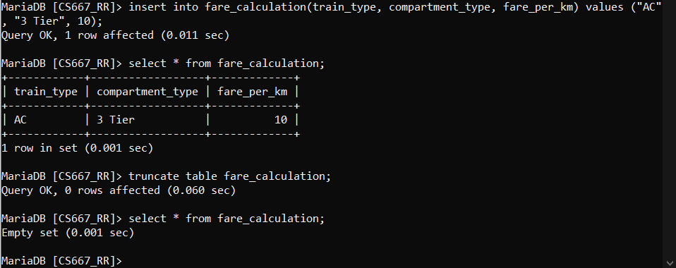

Delete:

drop table fare_calculation;

