DATABASE MANAGEMENT SYSTEM

LAB 4

26.09.2022

NAME: NIKHIL RAJU MOHITE

SRN: PES1UG20CS667

SECTION: K

DEPT: CSE

1. Loading Data into tables

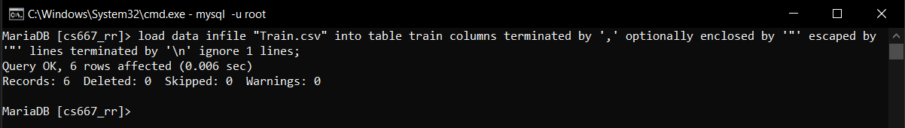

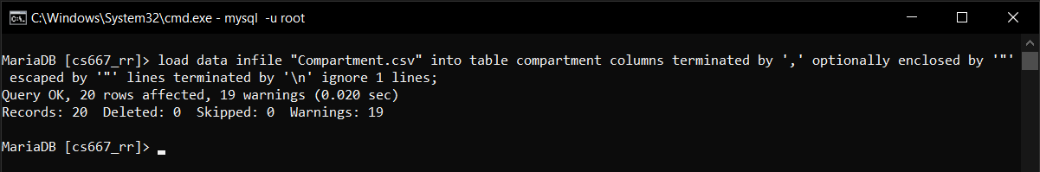

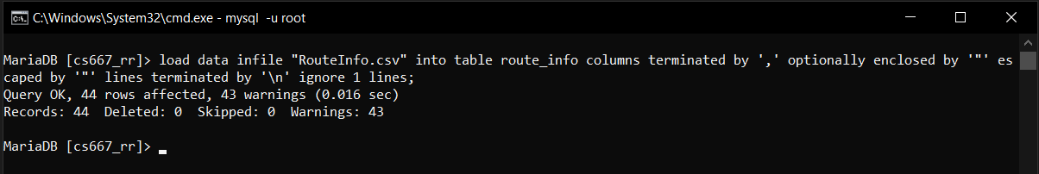

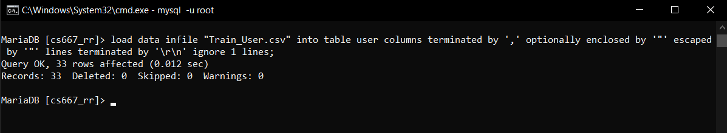

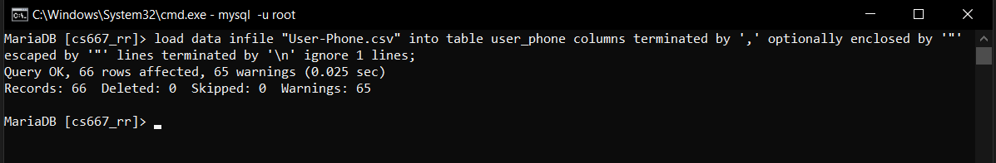

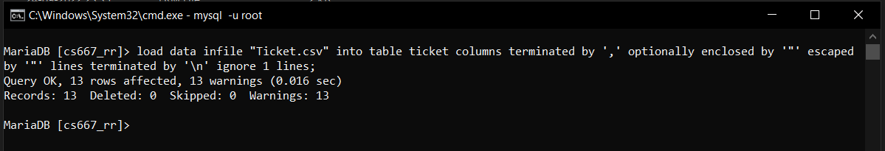

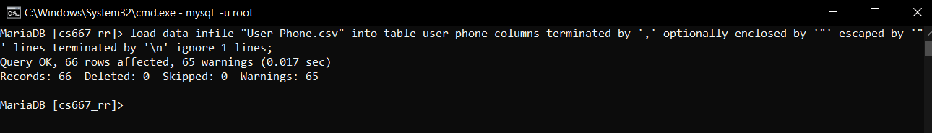

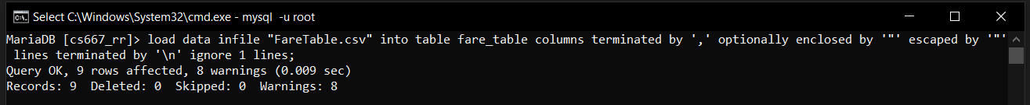

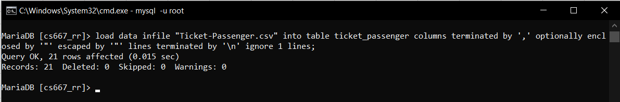

Using insert command:

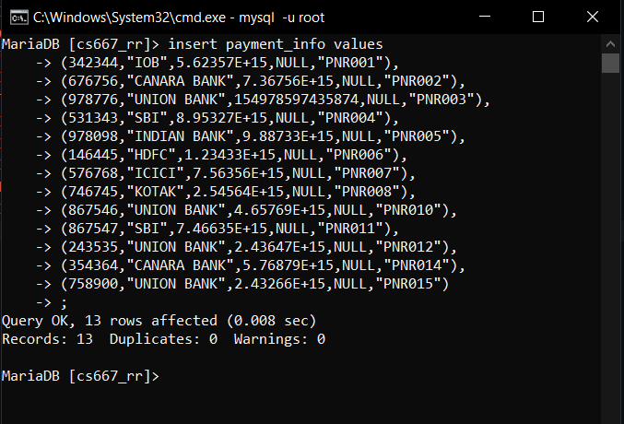

1. Calculate and update age attribute in User Table.

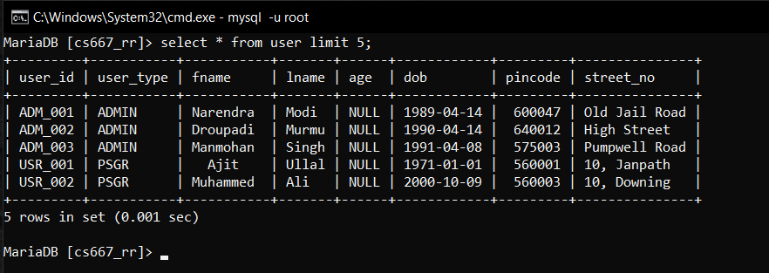

UPDATE user set age =DATE_FORMAT(FROM_DAYS(DATEDIFF(now(),DOB)),”%Y”)+0;

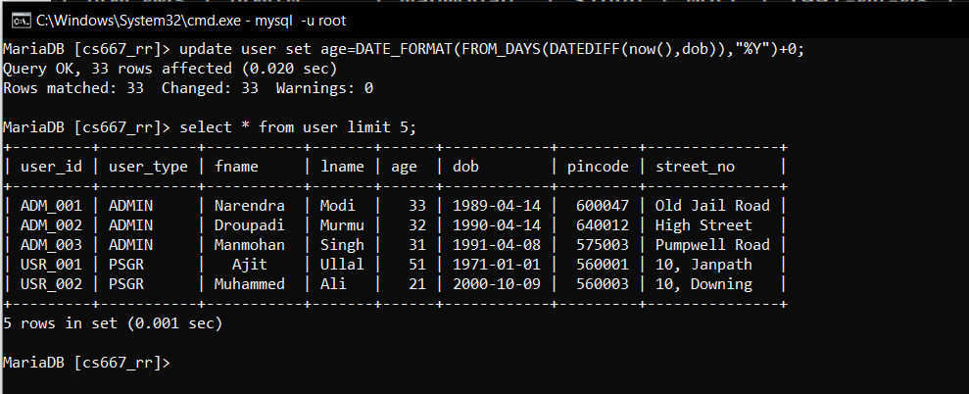

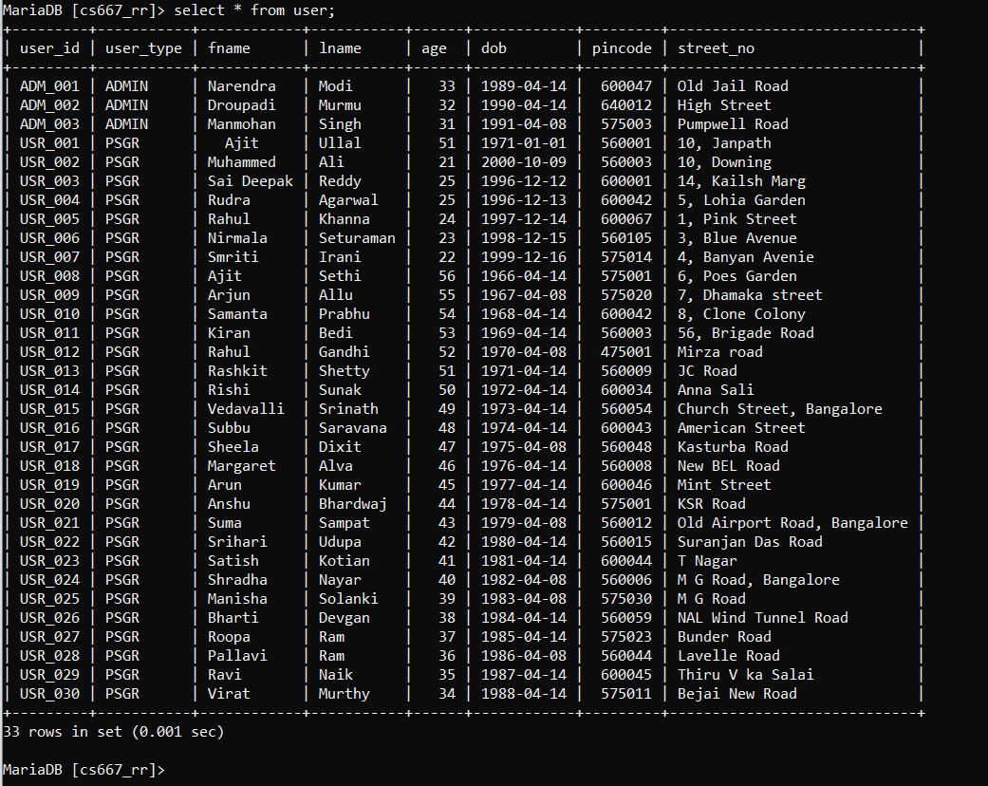

1. Display all the route information whose distance falls in a range from 70 to 150 km

select * from route_info where distance<=150 && distance>=70;

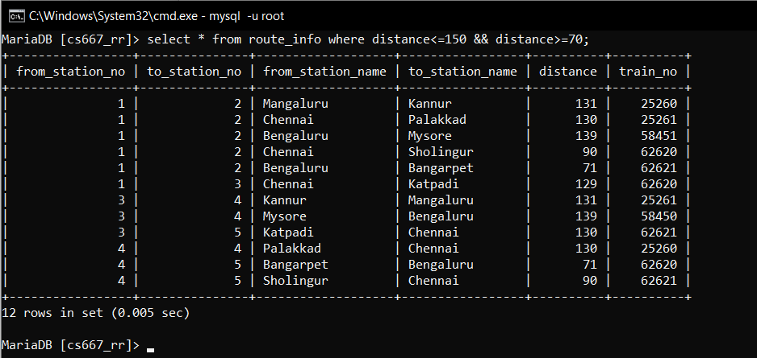

1. Display the train route information which are run between Chennai and Sholingur

select * from route_info where from_station_name="Chennai" && to_station_name="Sholingur";

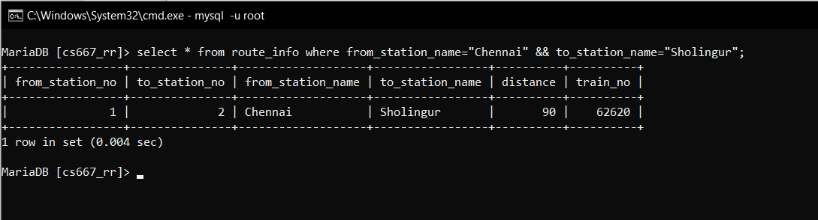

1. Display the train details whose type is not mail.

select * from train where train_type!="mail";

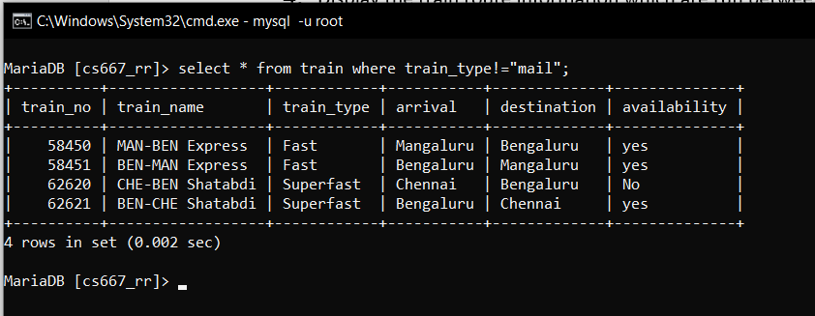

1. Display the train name which goes to Chennai from Sholingur.

select train_name,arrival, destination from train where arrival="Bengaluru" && destination="Chennai";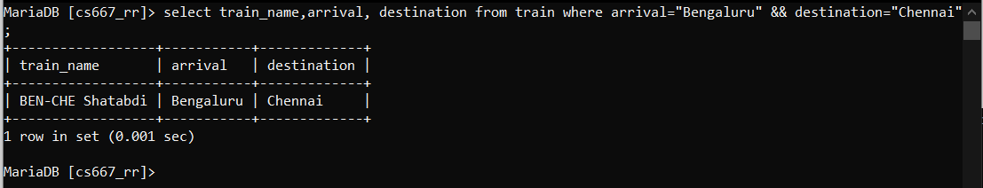

1. Display the list of trains starting from Chennai after 8:00.

select distinct train_no, departure_time from ticket where departure_time>('08:00:00') && departure="Chennai";

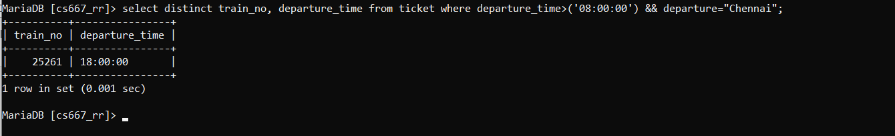

1. Display the list of users who are born between 1980 to 1990

select * from user where dob>=('1980-01-01') && dob<=('1990-01-01');

select * from user where dob between ('1980-01-01') and ('1990-01-01');

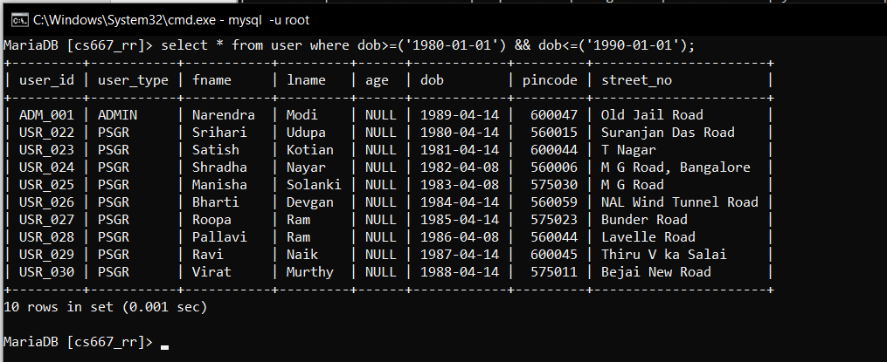

1. Display the train users whose name starts with the letter ‘S’

select * from user where fname like 'S%';

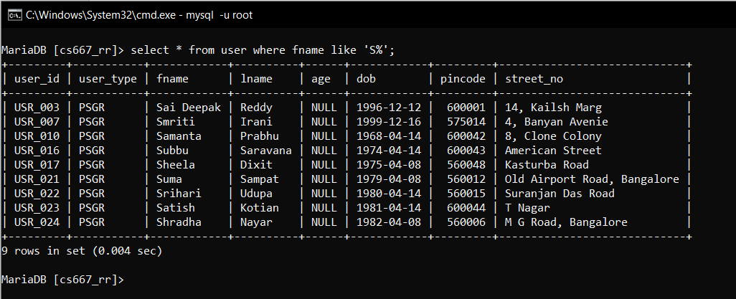

1. Find the availability of I Class compartment of the train number 62621

select availability from compartment where compartment_type="I Class" && train_no=62621;

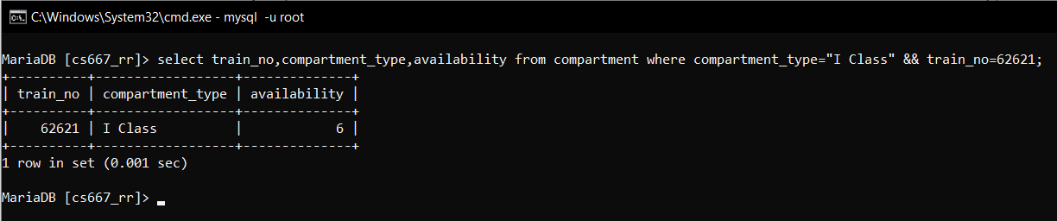

1. Find the PNR and Transaction ID of the users who made payment via Union Bank.

select transaction_id,pnr from payment_info where bank="Union Bank";

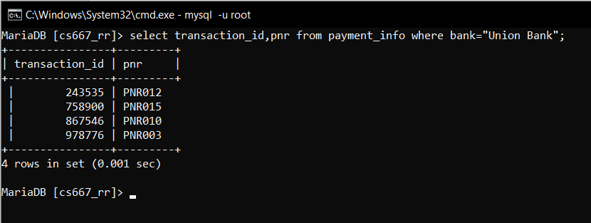

TASK 2:

1. Grant privileges on different tables to users and observe the effect

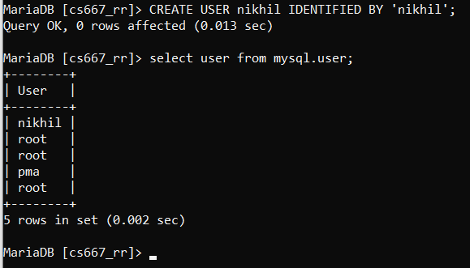

Give only select permission to user ‘nikhil’ on ‘train’ table

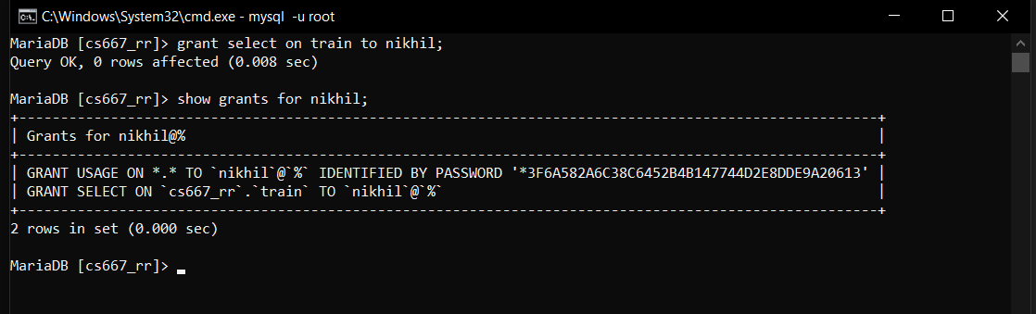

Deleting table where the user has no access

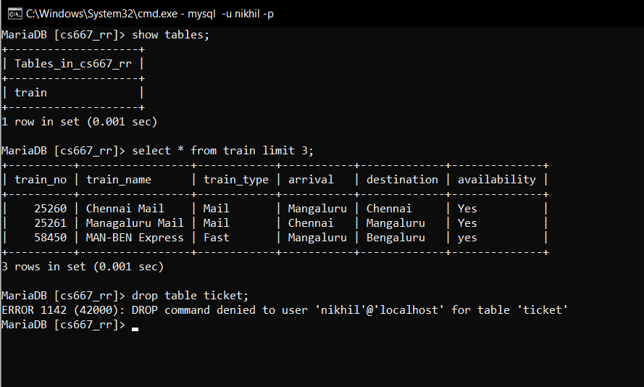

2. Revoke UPDATE & DELETE privileges on any tables and observe the effect if any deletion/updation is performed.

Grant permission to nikhil

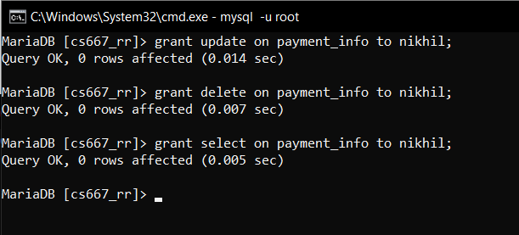

Update operation

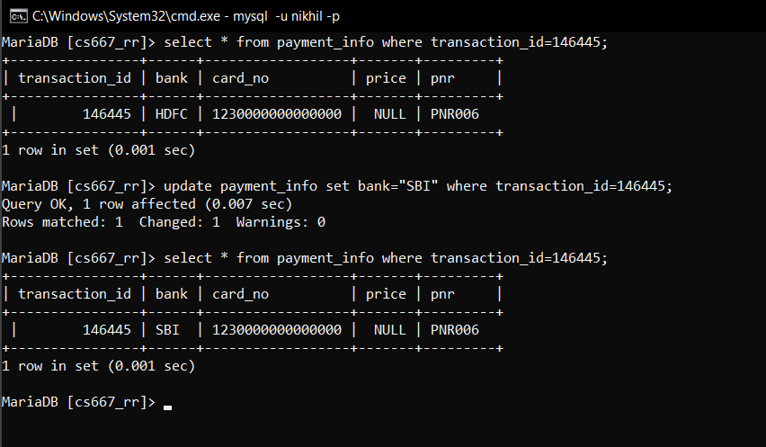

Delete operation

row from payment_info where transaction_id=146445

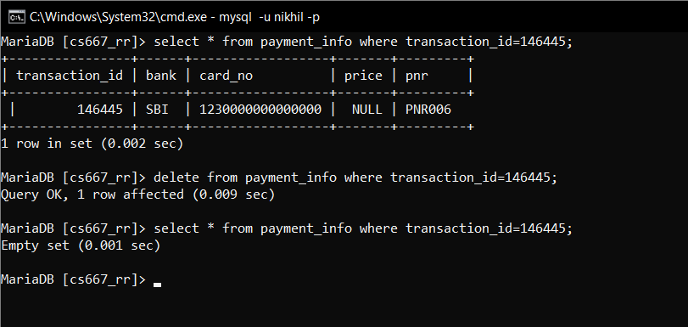

Revoke operation

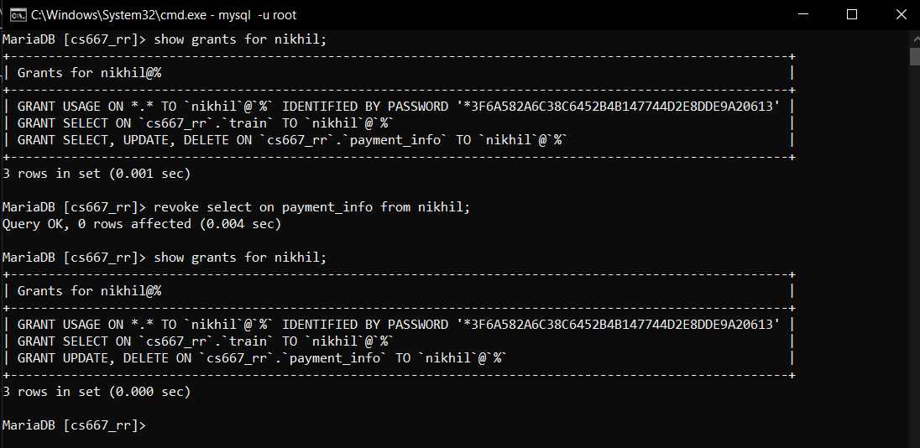

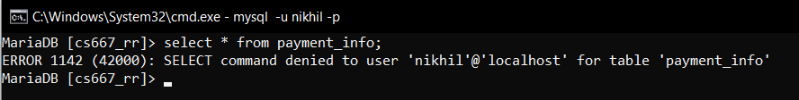

3. Create different save points and perform some insert/update/delete operations. Observe the effect of commit & rollback operations and release any created savepoints.

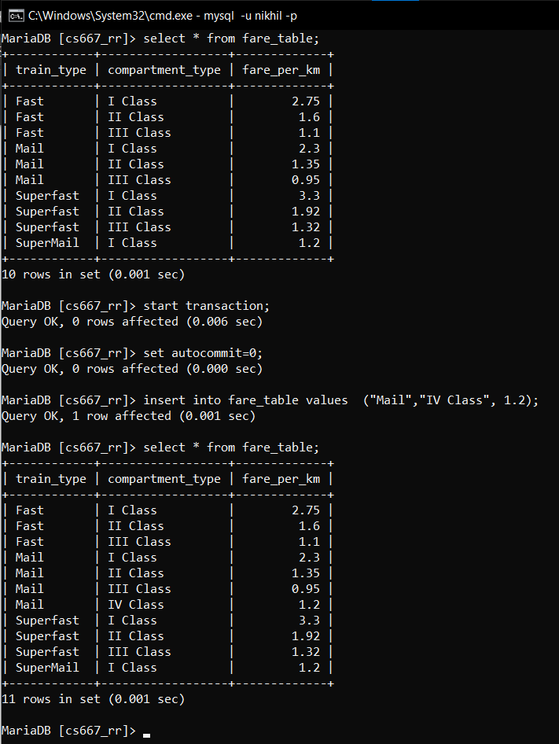

Savepoint

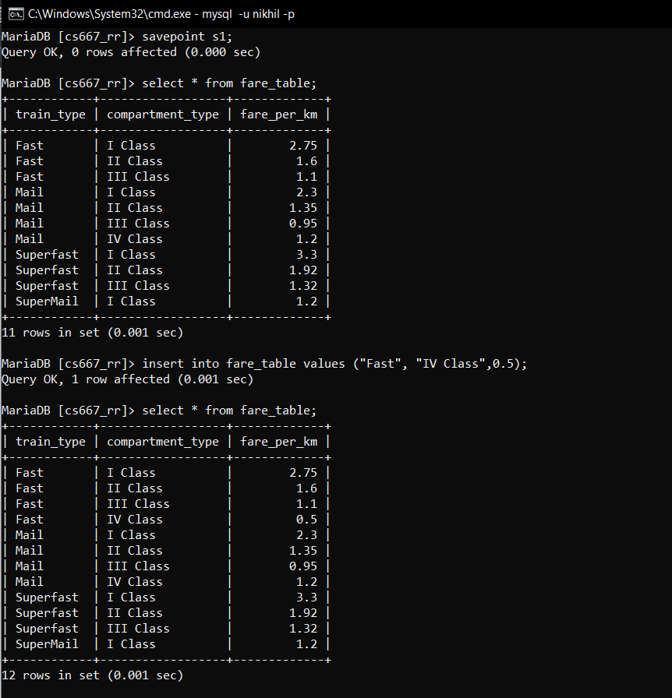

Rollback

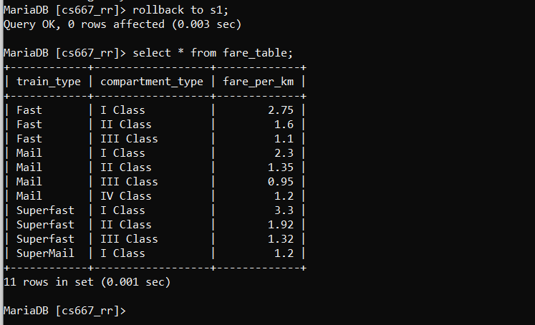

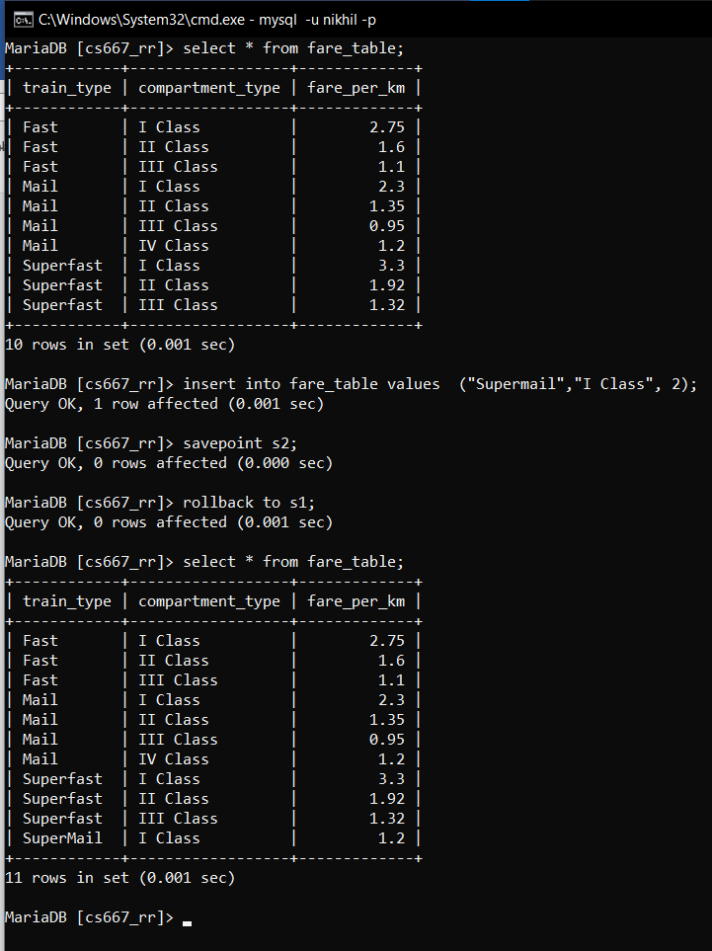

Release and commit

