DBMS LAB 8

NAME: NIKHIL RAJU MOHITE

SRN: PES1UG20CS667

SECTION: K

1. Write a function to find the number of tickets booked by a customer. If no of tickets is more than 3 for the current month then display error message as “cannot purchase tickets current limit is over”

SQL Code:

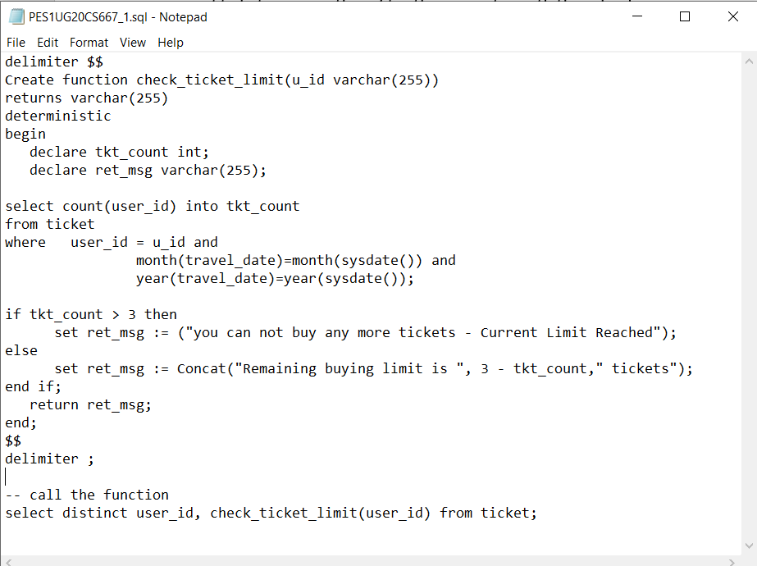

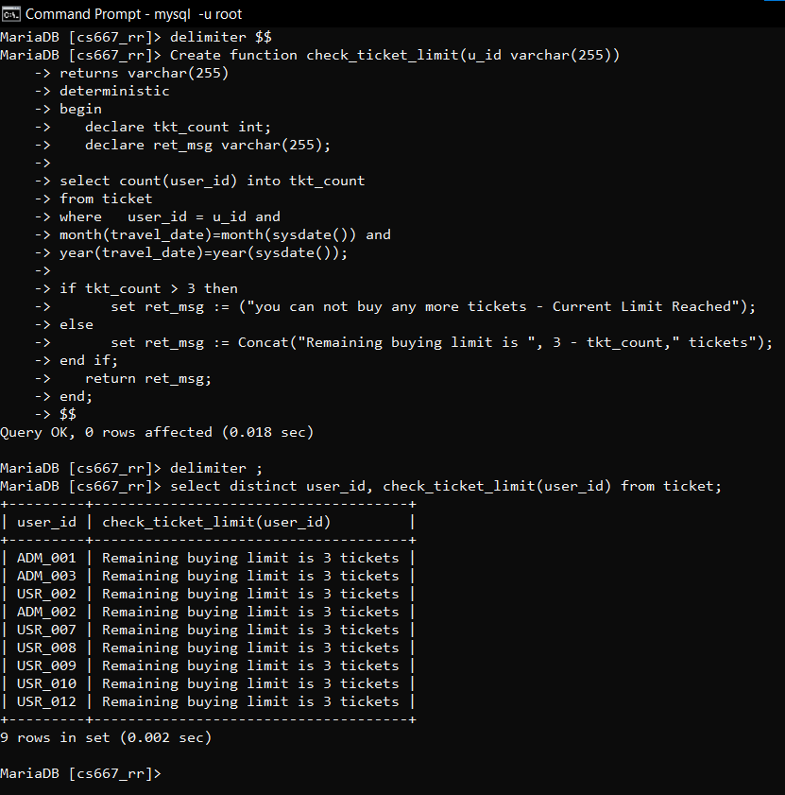

1. Write a stored procedure to calculate the age of the customer when the date of birth is given. Update the column named age in the customer table.

SQL Code

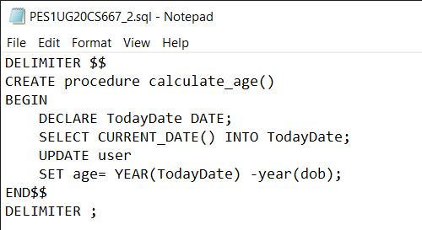

Before

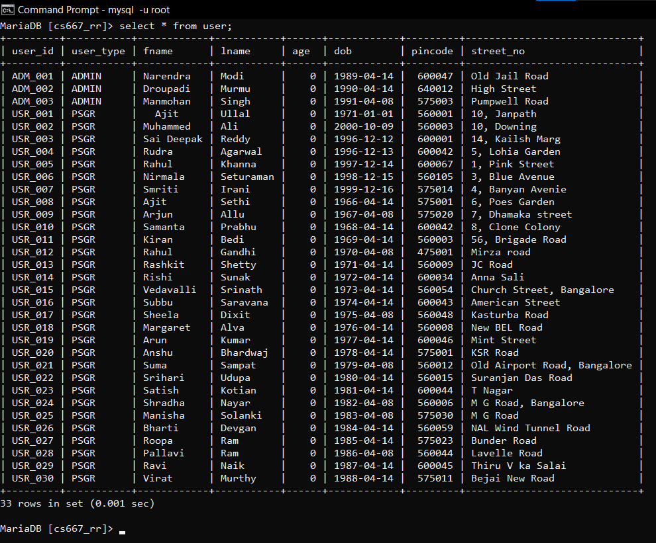

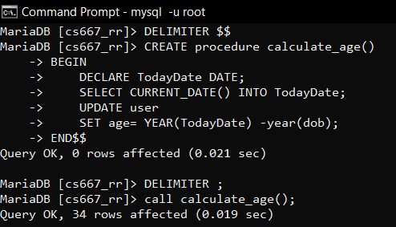

After procedure call

