DBMS LAB-09

NAME: NIKHIL RAJU MOHITE

SRN: PES1UG20CS667

SECTION: ‘5K’

1. Write a trigger on insert to compartment table when a new compartment gets

added to a train and make sure that total number of compartments available in

the train does not exceed more than 4.

DELIMITER $$

CREATE TRIGGER check_compartment_count

BEFORE INSERT

ON compartment FOR EACH ROW

BEGIN

DECLARE error_msg VARCHAR(255);

declare count int;

SET error_msg = ("Can't have more than 4 compartments");

IF (select count(compartment_no) from compartment where train_no=new.train_no) > 4 THEN

SIGNAL SQLSTATE '45000'

SET MESSAGE_TEXT = error_msg;

END IF;

END $$

DELIMITER ;

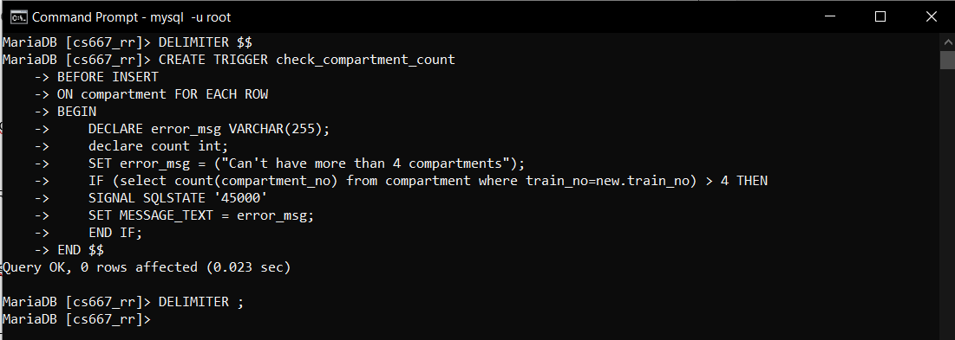

Example 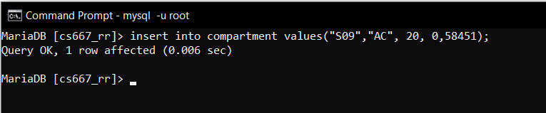

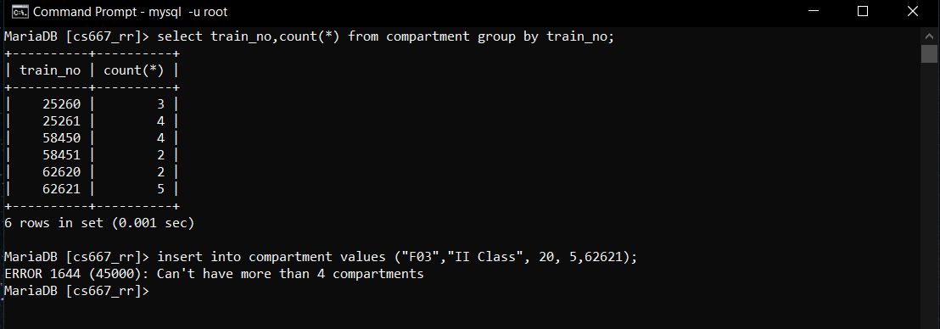

1. create a trigger to add payment information to the backup table when we try to

delete some information from ticket table.

CREATE TABLE payment_ ( transaction_id bigint(20),bank varchar(15),card_no bigint(20),price float ,pnr varchar(15) NOT NULL, primary key(transaction_id, pnr));

DELIMITER $$

CREATE OR REPLACE TRIGGER store_payment_info before delete on ticket for each row

begin

INSERT INTO payment_info_backup (SELECT * FROM payment_info WHERE pnr=old.pnr);

DELETE FROM payment_info where pnr=old.pnr;

DELETE FROM ticket_passenger where pnr=old.pnr;

END;

$$

DELIMITER ;

