NETB101 Introduction to Programming

(Nikolay Kirov, lecturer)

Chapter 7: Advanced Control Flow I

Chapter Goals
- To recognize the correct ordering of decisions in multiple branches
- To program conditions using Boolean operators and variables
- To understand nested branches and loops
- To be able to program loops with the for statement

Multiple Alternatives
- By using collections of if/else statements, a program can distinguish between multiple alternatives.
- Example: The user enters the name of a coin, and the program returns the value.
- This program has five alternatives to choose from:
  - "penny"
  - "nickel"
  - "dime"
  - "quarter"
  - erroneous input
- The order that the alternatives are checked is unimportant.

Multiple Alternatives (Coins Flowchart)
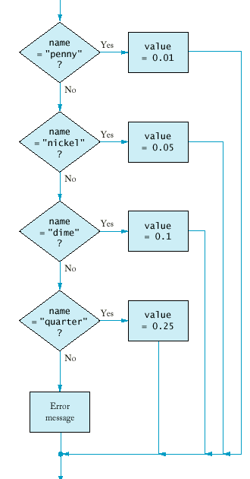

Multiple Alternatives (coins5.cpp)
#include <iostream>
#include <string>
using namespace std;

int main()
{ cout << "Enter coin name: ";
string name;
cin >> name;
double value = 0;

if (name == "penny") value = 0.01;
else if (name == "nickel") value = 0.05;
else if (name == "dime") value = 0.10;
else if (name == "quarter") value = 0.25;
else
cout << name << " is not a valid coin name\n";
cout << "Value = " << value << "\n";
return 0;
}

In some cases, the order of the tests is important.
- Example: A program that displays a description of the likely impact of an earthquake based on its magnitude on the Richter scale.

Multiple Alternatives (richter.cpp)
#include <iostream>
#include <string>
using namespace std;

int main()
{ cout << "Enter a magnitude on the Richter scale: ";
double richter;
cin >> richter;

if (richter >= 8.0)
cout << "Most structures fall\n";
else if (richter >= 7.0)
cout << "Many buildings destroyed\n";
else if (richter >= 6.0)
cout << "Many buildings considerably damaged, "
<< "some collapse\n";
else if (richter >= 4.5)
cout << "Damage to poorly constructed buildings\n";
else if (richter >= 3.5)
cout << "Felt by many people, no destruction\n";
else if (richter >= 0)
cout << "Generally not felt by people\n";
else
cout << "Negative numbers are not valid\n";
return 0;
}

Note that the order of the tests ensures that the right results are printed (reverse the order of tests).
- Note that the if/else structure ensure the alternatives are exclusive. Independent if statements may cause a single input to print several messages ().

Nested Branches
- Nested if/else statements can be used when there are two (or more) levels of decision making.
- Example: Taxes
  - There is a different table for each marital status (decision 1).
  - Once you have found the right table, your are taxed differently according to your income (decision 2).
If your status is Single and  if the taxable income is over | but not over | the tax is | of the amount over
$0 | $21,450 | 15% | $0
$21,450 | $51,900 | $3,217.50 + 28% | $21,450
$51,900 |  | $11,743 + 31% | $51,900

If your status is Married and  if the taxable income is over | but not over | the tax is | of the amount over
$0 | $35,800 | 15% | $0
$35,800 | $86,500 | $5,370.00 + 28% | $35,800
$86,500 |  | $19,566.00+ 31% | $86,500
- The two-level decision process is reflected in two levels of if statements.
- We say the income test is nested inside the test for filing status.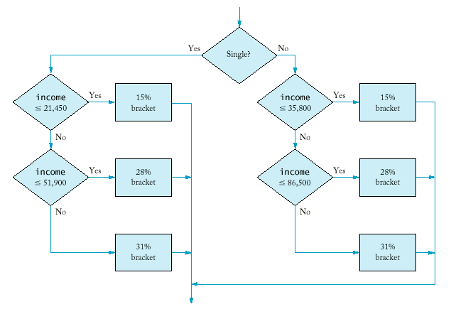
- More complicated decisions may require deeper levels of nesting.

Nested Branches (tax.cpp)
#include <iostream>
#include <string>
using namespace std;
int main()
{ const double SINGLE_LEVEL1 = 21450.00;
const double SINGLE_LEVEL2 = 51900.00;
const double SINGLE_TAX1 = 3217.50;
const double SINGLE_TAX2 = 11743.50;
const double MARRIED_LEVEL1 = 35800.00;
const double MARRIED_LEVEL2 = 86500.00;
const double MARRIED_TAX1 = 5370.00;
const double MARRIED_TAX2 = 19566.00;
const double RATE1 = 0.15;
const double RATE2 = 0.28;
const double RATE3 = 0.31;
double income;
cout << "Please enter your income: ";
cin >> income;
cout << "Please enter s for single, m for married: ";
string marital_status;
cin >> marital_status;
double tax;
if (marital_status == "s")
{ if (income <= SINGLE_LEVEL1)
tax = RATE1 * income;
else if (income <= SINGLE_LEVEL2)
tax = SINGLE_TAX1 + RATE2*(income - SINGLE_LEVEL1);
else
tax = SINGLE_TAX2 + RATE3*(income - SINGLE_LEVEL2);
}
else
{ if (income <= MARRIED_LEVEL1)
tax = RATE1 * income;
else if (income <= MARRIED_LEVEL2)
tax = MARRIED_TAX1 + RATE2*(income - MARRIED_LEVEL1);
else
tax = MARRIED_TAX2 + RATE3*(income - MARRIED_LEVEL2);
}
cout << "The tax is $" << tax << "\n";
return 0;
}

Boolean Operations
- An operator that combines test conditions is called a logical operator.
- The && (and) operator combines several tests into a new test that passes only when all the conditions are true.
- Example: Suppose you want to test whether your homework is due right now. The test passes only if both fields match.
if (now.get_hours() == homework.get_hours() &&
now.get_minutes() == homework.get_minutes())
cout << "The homework is due right now!\n";
- hwdue1.cpp
- The || (or) operator combines two or more conditions and succeeds if at least one of the conditions is true.
- Example: A test whether an order is shipped to Alaska or Hawaii.
if (state == "HI" || state == "AK")
shipping_charge = 10.00;
- hwdue2.cpp
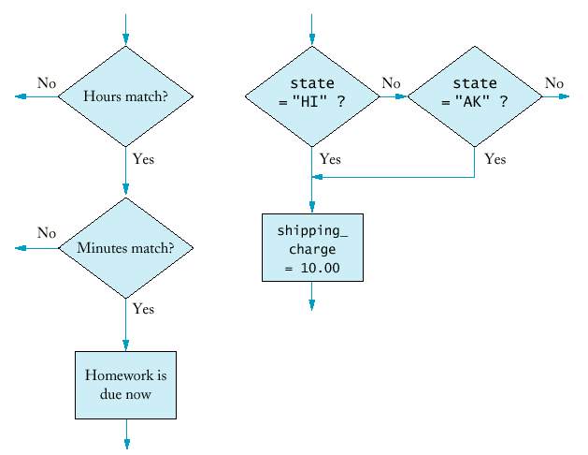
- The && and || operators are computed using lazy evaluation: the expressions are evaluated from left to right, and evaluation stops as soon as the truth value (true or false) is determined.
if (cin.fail() || area < 0) cout << "Input error.\n";
if (r >= 0 && -b / 2 + sqrt(r) >= 0) ...
- The ! (not) operator takes a single condition and evaluates to true if that condition is false and to false if that condition is true.
if (!cin.fail()) quarters = quarters + n;
- Summary:
A
  B | A && B
  true | true | true
  true | false | false
  false | Any | false
  A | B | A ||B
  true | Any | true
  true | false | true
  false | false | false
A | !A
true | false
false | true

DeMorgan's Law
- Humans generally have a hard time comprehending logical conditions with not operators applied to and/or expressions.
- Example: Suppose we want to charge a higher shipping rate if we don't ship within the continental United States.
if (!(country == "USA" && state != "AK" && state != "HI"))
shipping_charge = 20.00;
- Is it not true that some people won't be confused by this code?
- DeMorgan's Law can be used to simplify these Boolean expressions.
- DeMorgan's Law has two forms:
not (A and B) | is the same as | not A or not B
not (A or B) | is the same as | not A and not B
- Pay particular attention to the fact that the and and or operators are reversed by moving the not inwards.
- Example:
state != "AK" && state != "HI"
means
!(state == "AK") && !(state == "HI")
Applying DeMorgan's Law to the original expression yields
!(state == "AK" || state == "HI")
Finally we have (lazy evaluation!)
if (country != "USA" || state == AK" || state == "HI") ...

The for Loop
- The most common loop has the form
i = start;
while (i <= end)
{ . . .
i++;
}
- Because this loop is so common, there is a special form for it.
for (i = start; i <= end; i++)
- Example: Let us compute the function factorial, n! = 1.2.3.4...n.
int product = 1;
for (int i = 1; i <= n; i++) product = product * i;
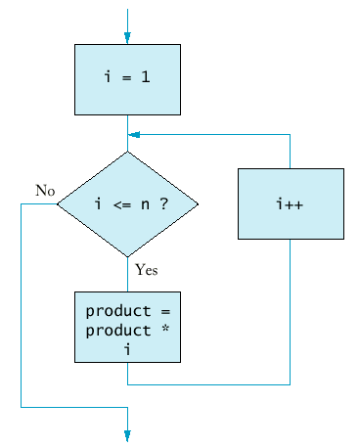

Syntax 7.1: for Statement
Syntax 7.1 : for Statement
for (initialization_expression; condition; update_expression) statement
Example: | for (int i = 1; i <= 10; i++) sum = sum + i;
Purpose: | Execute the initialization statement. While the condition remains true, execute the statement and update the expression.

The for Loop (forfac.cpp)
#include <iostream>
using namespace std;
long forfac(int n)
{ long product = 1;
for (int i = 1; i <= n; i++) product = product * i;
return product;
}
int main()
{ cout << "Please enter a number: ";
int n;
cin >> n;
cout << n << "! = " << forfac(n) << "\n";
return 0;
}
- We can count down instead of up:
for (int n = 10; n >= 0; n--) ...
- The increment or decrement need not be in step 1:
for (x = -10; x <= 10; x = x + 0.5) ...
- It is possible to put unrelated conditions into the loop (bad taste):
for (rate = 6; month--; cout << balance) ...

Chapter 7: Advanced Control Flow II

Chapter Goals
- To be able to program loops with the do/while statement
- To learn how to process character, word, and line input
- To learn how to read input from a file through redirection
- To implement approximations and simulations

The do Loop
- Sometimes you want to execute the body of a loop at least once and perform the loop test after the body was executed.
- The do/while loop serves that purpose.
do
{ statements
}
while (condition);
- Example: A simple approximation algorithm computes square root (ancient Greeks): the sequence
x₀ = a, x_{n+1} = ( x_{n} + a/x_{n} ) / 2
converges and has a limit square root of a.
do
{ xold = xnew;
xnew = (xold + a / xold) / 2;
}
while (fabs(xnew - xold) > EPSILON);
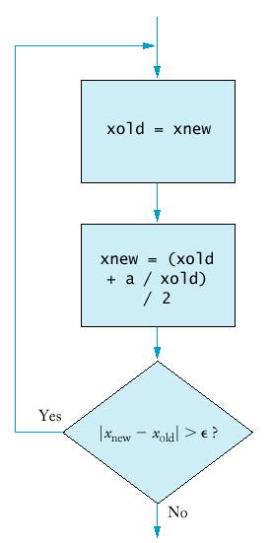

The do Loop (sqroot.cpp)
#include <iostream>
#include <cmath>
using namespace std;

int main()
{ cout << "Please enter a number: ";
double a;
cin >> a;

const double EPSILON = 1E-14;
double xnew = a;
double xold;

do
{ xold = xnew;
xnew = (xold + a / xold) / 2;
}
while (fabs(xnew - xold) > EPSILON);

cout << "The square root is " << xnew << "\n";
return 0;
}

Syntax 7.2: do/while Statement
do statement while (condition);
Example: | do x = sqrt(x); while (x >= 10);
Purpose: | Execute the statement, then test the condition, and repeat the statement while the condition remains true.

Nested Loops
- How can we print a table of values?
- For example, this table tells you the fate of $10000 invested under various interest rates for a different number of years.
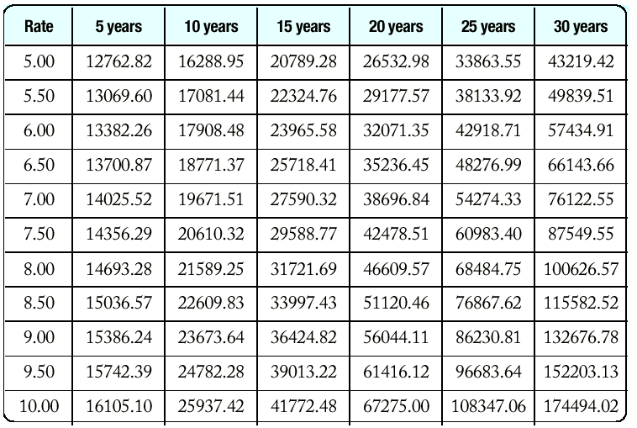
- Here is the pseudocode:
print table header
double rate;
for (rate = RATE_MIN; rate <= RATE_MAX;
rate = rate + RATE_INCR)
{ print table row
}
- How do we print a table row? You need to program another loop.
int year;
for (year = YEAR_MIN; year <= YEAR_MAX;
year = year + YEAR_INCR)
{ balance = future_value(initial_balance, rate, year);
cout << setw(10) << balance;
}
- It's a good idea to print the table header as a loop as well.
cout << "Rate ";
int year;
for (year = YEAR_MIN; year <= YEAR_MAX;
year = year + YEAR_INCR)
{ cout << setw(2) << year << " years";
}
- Once everything is put together, you have the loop printing a single row nested in the loop that traverses the interest rates.

Nested Loops (table.cpp)
#include <iostream>
#include <iomanip>
#include <cmath>
using namespace std;

int main()
{ const double RATE_MIN = 5;
const double RATE_MAX = 10;
const double RATE_INCR = 0.5;
const int YEAR_MIN = 5;
const int YEAR_MAX = 30;
const int YEAR_INCR = 5;

/* print table header */

cout << " Rate ";
int year;
for (year = YEAR_MIN; year <= YEAR_MAX;
year = year + YEAR_INCR)
cout << setw(2) << year << " years ";
cout << "\n";
cout << fixed << setprecision(2);

double rate;
double initial_balance = 10000;
for (rate = RATE_MIN; rate <= RATE_MAX;
rate = rate + RATE_INCR)
{
/* print table row */
int year;
cout << setw(5) << rate;
for (year = YEAR_MIN; year <= YEAR_MAX;
year = year + YEAR_INCR)
{ double balance =
initial_balance * pow(1 + rate/100, year);
cout << setw(10) << balance;
}
cout << "\n";
}
return 0;
}

Sometimes the iteration count of the inner loop depends on the outer loop.
- Example: printing a triangle shape.
[]
[][]
[][][]
[][][][]
- To print n rows, use the loop.
for (int i = 1; i <= n; i++)
{ print triangle row
}
- Each row contains i boxes.
for (int j = 1; j <= i; j++) cout << "[]";
cout << "\n";
- Putting the two loops together yields
for (int i = 1; i <= n; i++)
{ for (int j = 1; j <= i; j++) cout << "[]";
cout << "\n";
}
- triangle.cpp

Processing Text Input
- When processing text input, is the input structured as a sequence of characters, words, or lines?
- To input a sequence of words, use the loop
string word;
while (cin >> word)
{ process word
}
- cin >> word has the same value as cin - it is the same test as !cin.fail().

Processing Text Input (words.cpp)
#include <iostream>
#include <string>
using namespace std;

int main()
{ int count = 0;
string word;
while (cin >> word) count++;

cout << count << " words.\n";
return 0;
}

You would type text in, and at the end of the input the program would tell you how many words you typed. (You would never want to use such a program!)
- The program makes a lot of sense if input is read from a file.
- To link a file to the input of a program you type:
words < article.txt
on a command line. The input instructions no longer expect input from the keyboard but from the file article.txt.
- Input redirection on the command line.
- If you can redirect also output of this program you type
words < article.txt > output.txt
- To process input one line at a time, use the getline function.
string line;
while (getline(cin, line))
{ process line
}
- As above, the getline function returns cin, so you can test that cin hasn't yet failed.
- lines.cpp
- To process input character by character, use the loop
char ch;
while (cin.get(ch))
{ process ch
}
- chars.cpp

Simulations
- In a simulation we generate random events and evaluate their outcomes.
- The C++ library has a random number generator, which produces numbers that appear to be random.
- Calling rand() yields a random number between 0 and RAND_MAX (usually 32767, but implementation dependent).
- These numbers actual come from a a very long sequence of numbers computed from fairly simple formulas; they just behave like random numbers.
- For that reason they are often called pseudorandom numbers.
- The following program produces the exact same output every time the program is run (because the numbers are generated with formulas).
int main()
{ int i;
for (i = 1; i <= 10; i++)
{ int r = rand();
cout << r << "\n";
}
return 0;
}
- random.cpp
- When you specify a new seed for the random number sequence, the generator generates a new (different) sequence.
- The seed is set with the srand function.
- By setting the seed based on the time, the random numbers will be different every time you run the program.
Time now;
int seed = now.seconds_from(Time(0,0,0));
srand(seed);
- In actual applications you want to generate random numbers in different ranges, say between a and b.
- For example, to simulate a die roll, you need numbers between a = 1 and b = 6.
- First compute rand() % (b - a + 1) to obtain a random value between 0 and b - a.
- Add that to a to yield a random value between a and b.
int rand_int(int a, int b)
{ return a + rand() % (b - a + 1);
}

Simulations (dice.cpp)
#include <iostream>
#include <string>
#include <cstdlib>
#include <ctime>
using namespace std;

/**
Sets the seed of the random number generator.
*/
void rand_seed()
{ int seed = static_cast<int>(time(0));
srand(seed);
}
/**
Compute a random integer in a range
@param a the bottom of the range
@param b the top of the range
@return a random integer x, a <= x and x <= b
*/
int rand_int(int a, int b)
{ return a + rand() % (b - a + 1);
}

int main()
{ rand_seed();
int i;
for (i = 1; i <= 10; i++)
{ int d1 = rand_int(1, 6);
int d2 = rand_int(1, 6);
cout << d1 << " " << d2 << "\n";
}
cout << "\n";
return 0;
}
- To generate a random floating-point number, note that the quantity rand() * 1.0 / RAND_MAX is a random floating-point value between 0 and 1.
- The 1.0 ensures that the divisor is a floating-point number.
double rand_double(double a, double b)
{ return a + (b - a) * rand() * (1.0 / RAND_MAX);
}

Simulations (Buffon Needle Experiment)
- Devised by Comte George-Louis Leclerc de Buffon (1707-1788), a French naturalist.
- A needle of length 1 inch is dropped onto paper that is ruled with parallel lines 2 inches apart.
- If the needle drops onto a line, we count it as a hit.
- The quotient tries / hits approximates pi.
- Our program randomly generates the lower point of the needle and an angle.
- The upper point of the needle is given by y_{high} = y_{low} + sin(alpha).
- If y_{high} >= 2, we count the needle as a hit.
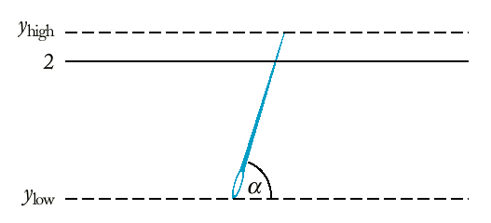

Simulations (buffon.cpp)
#include <iostream>
#include <cstdlib>
#include <cmath>
#include <ctime>
using namespace std;
/**
Sets the seed of the random number generator.
*/
void rand_seed()
{ int seed = static_cast<int>(time(0));
srand(seed);
}
/**
Compute a random floating point number in a range
@param a the bottom of the range
@param b the top of the range
@return a random floating point number x,
a <= x and x <= b
*/
double rand_double(double a, double b)
{ return a + (b - a) * rand() * (1.0 / RAND_MAX);
}
/**
Converts an angle from degree to radian.
@param alpha the angle in degrees
@return the angle in radian
*/
double deg2rad(double alpha)
{ const double PI = 3.141592653589793;
return alpha * PI / 180;
}
int main()
{ const int NTRIES = 10000;
int hits = 0;
rand_seed();
for (int i = 1; i <= NTRIES; i++)
{ double ylow = rand_double(0, 2);
double angle = rand_double(0, 180);
double yhigh = ylow + sin(deg2rad(angle));
if (yhigh >= 2) hits++;
}
cout << "Tries / Hits = "
<< NTRIES * (1.0 / hits) << "\n";
return 0;
}
- The point of this program is not to compute pi (after all, we needed the value of pi in the deg2rad function). Rather, the point is to show how to a physical experiment can be simulated on the computer.

Chapter 8: Testing and Debugging

Chapter Goals
- To learn how to design test harnesses for testing components of your programs in isolation
- To understand the principles of test case selection and evaluation
- To be able to use assertions to document program assumptions
- To become familiar with the debugger

Unit Tests
- In a unit test, a function or procedure is compiled outside the program in which it will be used, together with a test harness that feeds arguments to it.
- Once you have confidence that the function is working correctly, you can plug it into your program.
- Test data can be
  - entered manually (sqrtest1.cpp),
  - in a loop (sqrtest2.cpp), or
  - using random number generation (sqrtest3.cpp).

Unit Tests (sqrtest1.cpp)
#include <iostream>
#include <cmath>
using namespace std;
/**
Tests whether two floating-point numbers are
approximately equal.
@param x a floating-point number
@param y another floating-point number
@return true if x and y are approximately equal
*/
bool approx_equal(double x, double y)
{ const double EPSILON = 1E-14;
if (x == 0) return fabs(y) <= EPSILON;
if (y == 0) return fabs(x) <= EPSILON;
return fabs(x - y) / max(fabs(x), fabs(y)) <= EPSILON;
}
/* Function to be tested */
/**
Computes the square root using Heron's formula
@param a an integer >= 0
@return the square root of a
*/
double squareroot(double a)
{ if (a == 0) return 0;
double xnew = a;
double xold;
do
{ xold = xnew;
xnew = (xold + a / xold) / 2;
}
while (!approx_equal(xnew, xold));
return xnew;
}
/* Test harness */
int main()
{ double x;
while (cin >> x)
{ double y = squareroot(x);
cout << "squareroot of " << x << " = " << y << "\n";
}
return 0;
}
- You need to enter inputs and to force an end of input when you are done, by typing a key such as Ctrl+Z or Ctrl+D.
- For each test case, the harness code calls the squareroot function and prints the result.
- You can then manually check the computations.

Unit Tests (sqrtest2.cpp)
#include <iostream>
#include <cmath>
using namespace std;
/**
Tests whether two floating-point numbers are
approximately equal.
@param x a floating-point number
@param y another floating-point number
@return true if x and y are approximately equal
*/
bool approx_equal(double x, double y)
{ const double EPSILON = 1E-14;
if (x == 0) return fabs(y) <= EPSILON;
if (y == 0) return fabs(x) <= EPSILON;
return fabs(x - y) / max(fabs(x), fabs(y)) <= EPSILON;
}
/* Function to be tested */
/**
Computes the square root using Heron's formula
@param a an integer >= 0
@return the square root of a
*/
double squareroot(double a)
{ if (a == 0) return 0;
double xnew = a;
double xold;
do
{ xold = xnew;
xnew = (xold + a / xold) / 2;
}
while (!approx_equal(xnew, xold));
return xnew;
}
/* Test harness */
int main()
{ double x;
for (x = 0; x <= 10; x = x + 0.5)
{ double y = squareroot(x);
cout << "squareroot of " << x << " = " << y << "\n";
}
return 0;
}
- We generate test cases automatically and check the results manually.

Unit Tests (sqrtest3.cpp)
#include <iostream>
#include <cstdlib>
#include <cmath>
#include <ctime>
using namespace std;
/**
Sets the seed of the random number generator.
*/
void rand_seed()
{ int seed = static_cast<int>(time(0));
srand(seed);
}
/**
Compute a random floating point number in a range
@param a the bottom of the range
@param b the top of the range
@return a random floating point number x,
a <= x and x <= b
*/
double rand_double(double a, double b)
{ return a + (b - a) * rand() * (1.0 / RAND_MAX);
}
/**
Tests whether two floating-point numbers are
approximately equal.
@param x a floating-point number
@param y another floating-point number
@return true if x and y are approximately equal
*/
bool approx_equal(double x, double y)
{ const double EPSILON = 1E-14;
if (x == 0) return fabs(y) <= EPSILON;
if (y == 0) return fabs(x) <= EPSILON;
return fabs(x - y) / max(fabs(x), fabs(y)) <= EPSILON;
}
/* Function to be tested */
/**
Computes the square root using Heron's formula
@param a an integer >= 0
@return the square root of a
*/
double squareroot(double a)
{ if (a == 0) return 0;
double xnew = a;
double xold;
do
{ xold = xnew;
xnew = (xold + a / xold) / 2;
}
while (!approx_equal(xnew, xold));
return xnew;
}
/* Test harness */
int main()
{ rand_seed();
int i;
for (i = 1; i <= 100; i++)
{ double x = rand_double(0, 1E6);
double y = squareroot(x);
cout << "squareroot of " << x << " = " << y << "\n";
}
return 0;
}
- Random generation of test cases is useful for testing.

Selecting Test Cases
- Test cases:
  - Positive tests consist of legitimate inputs that you expect the program handles correctly.
For example: 4, 2, 1.5, 1e10, 1.111111111, ...
  - Boundary cases are also legitimate inputs that you expect the program to handle in a trivial way.
For example: 0
  - Other boundary cases are also legitimate inputs.
For example: 1e200, 1e-200, 2.222222222222, ...
  - Negative cases are inputs that you expect the program to fail on.
For example: -1
- Keeping test data in a file is smart because you can use it to review every version of the program.
>sqrtest1 < test.in > test.out
- When you find a bug, you should record the data that caused the bug, and retest your program with that data after you have tried to fix the bug.
- The phenomenon of fixing a bug, only to have it reappear after further program modifications is called cycling. The process of testing against a set of past failures is called regression testing.
- Testing the functionality of the program without consideration of its internal structure is called black-box testing.
- Testing strategies that look inside a program are called white-box testing.

Test Case Evaluations
- Once you have determined what inputs are needed to test the program, you need to decide if the outputs are correct.
  - Sometimes you can verify output by calculating the correct values by hand.
  - Sometimes a computation does a lot of work, and it is not practical to do the computation manually.
- We could write a test program that verifies that the output values fulfill certain properties.
- Here we test the squareroot() function by comparing the square of the returned number with the original input.

Test Case Evaluations (sqrtest4.cpp)
#include <iostream>
#include <cstdlib>
#include <cmath>
#include <ctime>
using namespace std;
/**
Sets the seed of the random number generator.
*/
void rand_seed()
{ int seed = static_cast<int>(time(0));
srand(seed);
}
/**
Compute a random floating point number in a range
@param a the bottom of the range
@param b the top of the range
@return a random floating point number x,
a <= x and x <= b
*/
double rand_double(double a, double b)
{ return a + (b - a) * rand() * (1.0 / RAND_MAX);
}
/**
Tests whether two floating-point numbers are
approximately equal.
@param x a floating-point number
@param y another floating-point number
@return true if x and y are approximately equal
*/
bool approx_equal(double x, double y)
{ const double EPSILON = 1E-14;
if (x == 0) return fabs(y) <= EPSILON;
if (y == 0) return fabs(x) <= EPSILON;
return fabs(x - y) / max(fabs(x), fabs(y)) <= EPSILON;
}
/* Function to be tested */
/**
Computes the square root using Heron's formula
@param a an integer >= 0
@return the square root of a
*/
double squareroot(double a)
{ if (a == 0) return 0;
double xnew = a;
double xold;
do
{ xold = xnew;
xnew = (xold + a / xold) / 2;
}
while (!approx_equal(xnew, xold));
return xnew;
}
/* Test harness */
int main()
{ int i;
for (i = 1; i <= 100; i++)
{ double x = rand_double(0, 1E6);
double y = squareroot(x);
if (not_equal(y * y, x))
cout << "Test failed. ";
else
cout << "Test passed. ";
cout << "squareroot of " << x << " = " << y << "\n";
}
return 0;
}
- Another method is to use a slower but reliable procedure (called an oracle) to verify the results. In this case, we will use pow() as an oracle. (See sqrtest5.cpp)

Test Case Evaluations (sqrtest5.cpp)
#include <iostream>
#include <cstdlib>
#include <cmath>
#include <ctime>
using namespace std;
/**
Sets the seed of the random number generator.
*/
void rand_seed()
{ int seed = static_cast<int>(time(0));
srand(seed);
}
/**
Compute a random floating point number in a range
@param a the bottom of the range
@param b the top of the range
@return a random floating point number x,
a <= x and x <= b
*/
double rand_double(double a, double b)
{ return a + (b - a) * rand() * (1.0 / RAND_MAX);
}
/**
Tests whether two floating-point numbers are
approximately equal.
@param x a floating-point number
@param y another floating-point number
@return true if x and y are approximately equal
*/
bool approx_equal(double x, double y)
{ const double EPSILON = 1E-14;
if (x == 0) return fabs(y) <= EPSILON;
if (y == 0) return fabs(x) <= EPSILON;
return fabs(x - y) / max(fabs(x), fabs(y)) <= EPSILON;
}
/* Function to be tested */
/**
Computes the square root using Heron's formula
@param a an integer >= 0
@return the square root of a
*/
double squareroot(double a)
{ if (a == 0) return 0;
double xnew = a;
double xold;
do
{ xold = xnew;
xnew = (xold + a / xold) / 2;
}
while (!approx_equal(xnew, xold));
return xnew;
}
/* Test harness */
int main()
{ rand_seed();
int i;
for (i = 1; i <= 100; i++)
{ double x = rand_double(0, 1E6);
double y = squareroot(x);
if (!approx_equal(y, pow(x, 0.5)))
cout << "Test failed. ";
else
cout << "Test passed. ";
cout << "squareroot of " << x << " = " << y << "\n";
}
return 0;
}

Assertions (reminder)
- Functions often contain implicit assumptions (denominators should be nonzero, salaries should not be negative).
- Such illegal values can creep into a program due to an input or processing error - with distressing regularity!
- Assertions provide a valuable sanity check.
void raise_salary(Employee& e, double by)
{ assert(e.get_salary() >= 0 );
assert(by >= -100);
double new_salary = e.get_salary() * (1 + by / 100);
e.set_salary(new_salary);
}
- If an assertion is not satisfied, the program terminates with a useful error message showing the line number and the code of the failed assertion:
assertion failed in file finclac.cpp line 61: by >= -100
- That is a powerful signal that something went wrong elsewhere and that the program needs further testing.
- [futval0.cpp]

Program Traces
- To get a printout of the program flow, you can insert trace messages into the beginning and end of every procedure.
- It is also useful to print the input parameters when a procedure is entered and to print return values when a function is exited.
string int_name(int n)
{ cout << "Entering digit_name. n = " << n << "\n";
...
cout << "Exiting digit name. Return value = "
<< s << "\n";
return s;
}
- trace.cpp
- To get a proper trace, you must locate each function exit point.
- Sample output for n = 12305.
Inside int_name. Thousands.
Entering int_name. n = 12
Inside int_name. Teens.
Entering teen_name. n = 12
Exiting teen_name. Return value = twelve
Exiting digit_name. Return value = twelve
Inside int_name. Hundreds.
Entering digit_name. n = 3
Exiting digit_name. Return value = three
Inside int_name. Ones.
Entering digit_name. n = 5
Exiting digit_name. Return value = five
Exiting int_name. Return value = twelve thousand three hundred five

Program Traces (Problems with Trace Messages)
- Program traces can be time-consuming to find out which trace message to insert.
- If you insert too many messages, you produce a flurry of output that is hard to analyze.
- If you insert to few, you may not have enough information to spot the cause of the error.
- When you are done with the program, you need to remove all the trace messages.
- When you find a new error, you need to stick the print statement back in.
- Many profession programmers use a debugger, not trace messages, to locate errors in their code.

The Debugger
- Modern development environments contain special programs, called debuggers, that help you locate bugs by letting you follow the execution of a program.
- You can stop and restart your program and see the contents of variables whenever your program is temporarily stopped.
- Using a debugger is not cost free - it takes time to set up and carry out an effective debugging session.
- Larger programs are harder to debug without using a debugger, so learn how to use one is time well spent.
- Debuggers vary wildly from one system to another.
- If you use an integrated development environment, which contains an editor, compiler, and a debugger, finding and starting the debugger is usually very easy.
- On a UNIX system, you must manually build a debug version of your program and invoke the debugger.
- You can go a long way with just three commands:
  - Run until this line.
  - Step to next line.
  - Inspect variable.
- The exact names for these commands will vary from debugger to debugger, but all debuggers support them.
- [prime.cpp]

Chapter 9: Vectors and Arrays I

Chapter Goals
- To become familiar with using vectors to collect objects
- To be able to access vector elements and resize vectors
- To be able to pass vectors to functions
- To learn about common vector algorithms

Using Vectors to Collect Data Items
- Example: Suppose you write a program that read in a list of salary figures and prints out the list, marking the highest value, like this:
32000
54000
67500
29000
35000
80000
highest value => 115000
44500
100000
65000
- All the values need to be read to find the highest one.
- If you know there are 10 inputs, you could use 10 variables salary1, salary2, ... , salary10. But you would have to write a lot of code 10 times to handle each variable.
- This technique becomes prohibitive as the list gets larger (100 salaries).
- A vector is a collection (a sequence) of data items of the same type.
vector<double> salaries(10);
- This vector holds 10 successive values of double type.
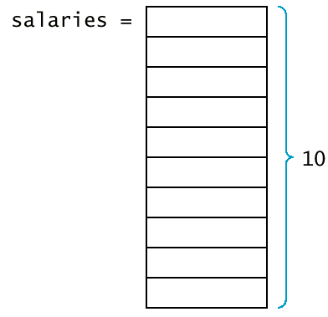
Syntax 9.1: Vector Variable Definition
vector<type_name> variable_name;
vector<type_name> variable_name(initial_size);
Example: | vector<int> scores;  vector<Employee> staff(20);
Purpose: | Define a new variable of vector type, and optionally supply an initial size.

- You must specify which slot (memory location) you want to use with the [] (subscript) operator.
salaries[4] = 35000;
- The number inside the brackets is called an index.
- Because salaries is a vector of double values, a slot such as salaries[4] can be used just like any variable of type double.
cout << salaries[4] << "\n";
- In C++, the slots (elements) of vectors are numbered starting at 0.
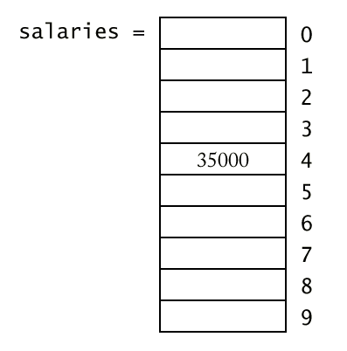

Vector Subscripts
Syntax 9.2: Vector Subscripts
vector_expression[integer_expression]
Example: | salaries[i + 1]
Purpose: | Access and element in a vector.

- Trying to access a slot that does not exist in the vector is an error.
vector<double> salaries(10);
cout << salaries[10];
/* ERROR ! Legal subscripts are 0 until 9 */
- The C++ standard implementation of vector generates no error message.
- If you make an index error, you silently read or overwrite another memory location.
- When a vector is defined without a size parameter, it is empty and can hold no elements.
vector<double> salaries; /* no size given */
salaries[0] = 35000; /* ERROR ! */
- You can find the size vector by calling the size()member function.
for(i = 0; i < v.size(); i++)
do something with v[i];
- Using size is actually better than using a constant (so called magic number).
- The function push_back allows you to start out with an empty vector and grow the vector whenever another element is added.
vector<double> salaries;
. . .
double s;
cin >> s;
. . .
salaries.push_back(s);
- The push_back member function resizes the vector by adding one element to its end.
- If you already know how many elements you need in a vector, you should specify that size when you define it.
- Another member function, pop_back, removes the last element of a vector, shrinking its size by one.
salaries.pop_back(); /* Now salaries has size 9 */
- The C++ standard (STL) defines many more useful functions for vectors, but we will use only size, push_back and pop_back.

Vector Subscripts (salvect.cpp)
#include <iostream>
#include <vector>
using namespace std;
int main()
{ vector<double> salaries;
bool more = true;
while (more)
{ double s;
cout << "Please enter a salary, 0 to quit: ";
cin >> s;
if (s == 0) more = false;
else salaries.push_back(s);
}
double highest = salaries[0];
int i;
for (i = 1; i < salaries.size(); i++)
if (salaries[i] > highest)
highest = salaries[i];
for (i = 0; i < salaries.size(); i++)
{ if (salaries[i] == highest)
cout << "highest value => ";
cout << salaries[i] << "\n";
}
return 0;
}

Vector Parameters and Return Values
- Functions and procedures often have vector parameters.
- Example: This function computes the average of a vector of floating-point numbers.
double average(vector<double> v)
{ if (v.size() == 0) return 0;
double sum = 0;
for (int i = 0; i < v.size(); i++) sum = sum + v[i];
return sum / v.size();
}
- average.cpp
- A vector can be passed by value or by reference.
- Pass by reference is used for modifying individual elements of the vector.
- Example: The function raises all values in the vector by the given percentage.
void raise_by_percent(vector<double>& v, double p)
{ for (int i = 0; i < v.size(); i++)
v[i] = v[i] * (1 + p / 100);
}
- raisesal.cpp
- A function can return a vector.
- Example: Here is a function that collects all values that fall within a certain range.
vector<double> between(vector<double> v, double low, double high)
{ vector<double> result;
for (int i = 0; i < v.size(); i++)
if (low <= v[i] && v[i] <= high) result.push_back(v[i]);
return result;
}
- between.cpp
- Example: Here is a function that collects the positions of all matching values in a vector of integers.
vector<int> find_all_between(vector<double> v, double low, double high)
{ vector<int> pos;
for (int i = 0; i < v.size(); i++)
if (low <= v[i] && v[i] <= high) pos.push_back(i);
return pos;
}

Vector Parameters and Return Values (matches.cpp)
#include <iostream>
#include <vector>
using namespace std;
/**
Returns the positions of all values within a range
@param v a vector of floating-point numbers
@param low the low end of the range
@param high the high end of the range
@return a vector of positions of values in the given range
*/
vector<int> find_all_between(vector<double> v,
double low, double high)
{ vector<int> pos;
for (int i = 0; i < v.size(); i++)
if (low <= v[i] && v[i] <= high)
pos.push_back(i);
return pos;
}
int main()
{ vector<double> salaries(5);
salaries[0] = 35000.0;
salaries[1] = 63000.0;
salaries[2] = 48000.0;
salaries[3] = 78000.0;
salaries[4] = 51500.0;
vector<int> matches
= find_all_between(salaries, 45000.0, 65000.0);
for (int j = 0; j < matches.size(); j++)
cout << salaries[matches[j]] << "\n";
return 0;
}

Removing and Inserting Elements
- How do you remove an element from a vector?
- If the order is not important, overwrite the element to be removed with the last element of the vector, then shrink the size of the vector.
void erase(vector<string>& v, int pos)
{ int last_pos = v.size() - 1;
v[pos] = v[last_pos];
v.pop_back();
}
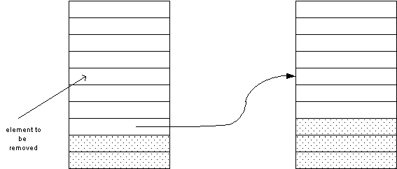
- erase1.cpp
- If the order matters, you must move all elements down by one slot (to the index 0), then shrink the size of the vector.
void erase(vector<string>& v, int pos)
{ for (int i = pos; i < v.size() - 1; i++) v[i] = v[i + 1];
v.pop_back();
}
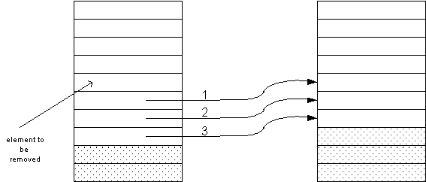

Removing and Inserting Elements (erase2.cpp)
#include <iostream>
#include <string>
#include <vector>
using namespace std;
/**
Removes an element from an ordered vector.
@param v a vector
@param pos the position of the element to erase
*/
void erase(vector<string>& v, int pos)
{ for (int i = pos; i < v.size() - 1; i++)
v[i] = v[i + 1];
v.pop_back();
}
/**
Prints all elements in a vector.
@param v the vector to print
*/
void print(vector<string> v)
{ for (int i = 0; i < v.size(); i++)
cout << "[" << i << "] " << v[i] << "\n";
}
int main()
{ vector<string> staff(5);
staff[0] = "Cracker, Carl";
staff[1] = "Hacker, Harry";
staff[2] = "Lam, Larry";
staff[3] = "Reindeer, Rudolf";
staff[4] = "Sandman, Susan";
print(staff);
int pos;
cout << "Remove which element? ";
cin >> pos;
erase(staff, pos);
print(staff);
return 0;
}
- To insert an element in the middle of a vector, you must add a new element at the end of the vector and move all elements above (to the end of the vector) the insertion location up by one slot.
void insert(vector<string>& v, int pos, string s)
{ int last = v.size() - 1;
v.push_back(v[last]);
for (int i = last; i > pos; i--) v[i] = v[i - 1];
v[pos] = s;
}
- Note that when you insert an element you start at the end of the vector, move that element up, then go to the one before that.
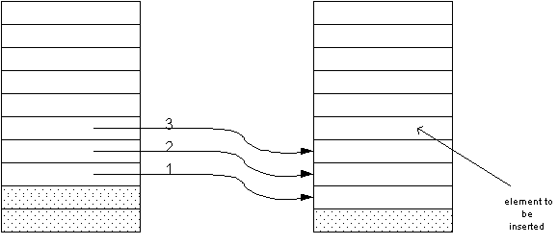

Removing and Inserting Elements (insert.cpp)
#include <iostream>
#include <string>
#include <vector>
using namespace std;
/**
Inserts an element into a vector.
@param v a vector
@param pos the position before which to insert the element
@param s the element to insert
*/
void insert(vector<string>& v, int pos, string s)
{ int last = v.size() - 1;
v.push_back(v[last]);
for (int i = last; i > pos; i--)
v[i] = v[i - 1];
v[pos] = s;
}
/**
Prints all elements in a vector.
@param v the vector to print
*/
void print(vector<string> v)
{ for (int i = 0; i < v.size(); i++)
cout << "[" << i << "] " << v[i] << "\n";
}
int main()
{ vector<string> staff(5);
staff[0] = "Cracker, Carl";
staff[1] = "Hacker, Harry";
staff[2] = "Lam, Larry";
staff[3] = "Reindeer, Rudolf";
staff[4] = "Sandman, Susan";
print(staff);
int pos;
cout << "Insert before which element? ";
cin >> pos;
insert(staff, pos, "New, Nina");
print(staff);
return 0;
}

Parallel Vectors
- Example: Suppose you want to process a series of product data, and the display the product information, making the best value (with the best price/score ratio).
ACMA P600 Price: 995 Score75
ALaris Nx686 Price 798 Score 57
AMAX Powerstation 600 Price: 999 Score 75
AMS Infogold P600 Price: 795 Score: 69
AST PRemmia Price: 2080 Score: 80
Austin 600 Price: 1499 Score: 95
best value => Blackship NX-600 Price 598 Score: 60
Kompac 690 Price: 695 Score: 60
- One possibility is to create three vectors (names, price, scores) of the same length.
- These vectors are called parallel vectors because they must be processed together.
- Each slice - names[i], prices[i], scores[i] - contains data that needs to be processed together.
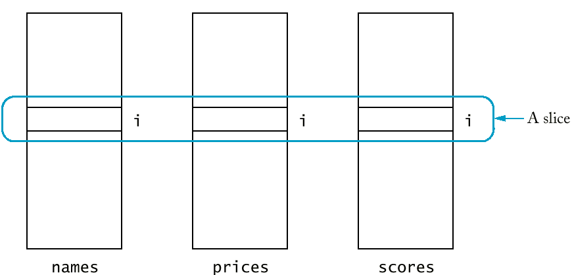

Parallel Vectors (bestval1.cpp)
#include <iostream>
#include <string>
#include <vector>
using namespace std;
int main()
{ vector<string> names;
vector<double> prices;
vector<int> scores;
double best_price = 1;
int best_score = 0;
int best_index = -1;
bool more = true;
while (more)
{ string next_name;
cout << "Please enter the model name: ";
getline(cin, next_name);
names.push_back(next_name);
double next_price;
cout << "Please enter the price: ";
cin >> next_price;
prices.push_back(next_price);
int next_score;
cout << "Please enter the score: ";
cin >> next_score;
scores.push_back(next_score);
string remainder; /* read remainder of line */
getline(cin, remainder);
if (next_score / next_price > best_score / best_price)
{ best_index = names.size() - 1;
best_score = next_score;
best_price = next_price;
}
cout << "More data? (y/n) ";
string answer;
getline(cin, answer);
if (answer != "y") more = false;
}
for (int i = 0; i < names.size(); i++)
{ if (i == best_index) cout << "best value => ";
cout << names[i]
<< " Price: " << prices[i]
<< " Score: " << scores[i] << "\n";
}
return 0;
}
- Parallel vectors become a headache in larger programs.
  - Each vector must be the same length.
  - Each slice is filled with values that belong together.
  - Any function that operates on a slice must get several vectors as parameters.
- To remove parallel vectors, look at the slice and find the concept it represents. Make the concept into a class.
- Eliminate parallel vectors and replace them with a single vector of objects.
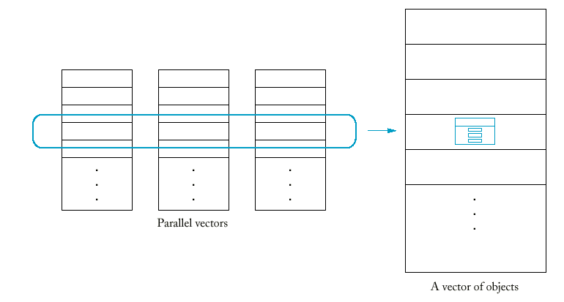

Parallel Vectors (bestval2.cpp)
#include <iostream>
#include <string>
#include <vector>
using namespace std;
class Product {
public:
Product();
void read();
bool is_better_than(Product b) const;
void print() const;
private:
string name;
double price;
int score;
};
Product::Product()
{ price = 0;
score = 0;
}
void Product::read()
{ cout << "Please enter the model name: ";
getline(cin, name);
cout << "Please enter the price: ";
cin >> price;
cout << "Please enter the score: ";
cin >> score;
string remainder; /* read remainder of line */
getline(cin, remainder);
}
bool Product::is_better_than(Product b) const
{ if (price == 0) return false;
if (b.price == 0) return true;
return score / price > b.score / b.price;
}
void Product::print() const
{ cout << name
<< " Price: " << price
<< " Score: " << score << "\n";
}
int main()
{ vector<Product> products;
Product best_product;
int best_index = -1;
bool more = true;
while (more)
{ Product next_product;
next_product.read();
products.push_back(next_product);
if (next_product.is_better_than(best_product))
{ best_index = products.size() - 1;
best_product = next_product;
}
cout << "More data? (y/n) ";
string answer;
getline(cin, answer);
if (answer != "y") more = false;
}
for (int i = 0; i < products.size(); i++)
{ if (i == best_index) cout << "best value => ";
products[i].print();
}
return 0;
}

