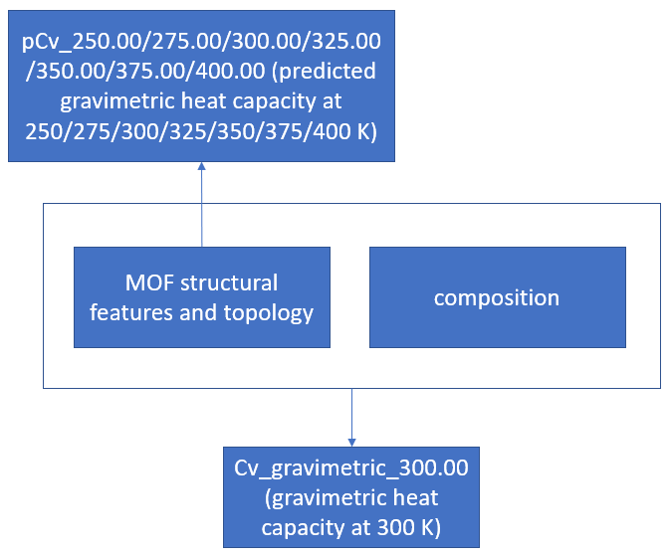

A -> B

* What is the predicted gravimetric heat capacity at 250/275/300/325/350/375/400 K for MOF with MOF structural features and topology

A + B -> C

* What is the gravimetric heat capacity at 300 K for MOF with MOF structural features and topology and composition

Unable to answer

* What is the gravimetric heat capacity at 300 K for MOF with MOF structural features and topology
* What is the gravimetric heat capacity at 300 K for MOF with composition