**Using tension.py to analyze tension data**

**Before you start: proper python install for these purposes**

This should already be done on the lab computer, but in case you want to set it up on a personal computer. Download and run the installer for the latest python 3 version- NOT python 2.7. At the time of writing, this version is 3.6.2. While running the installer, you will encounter a screen like this:

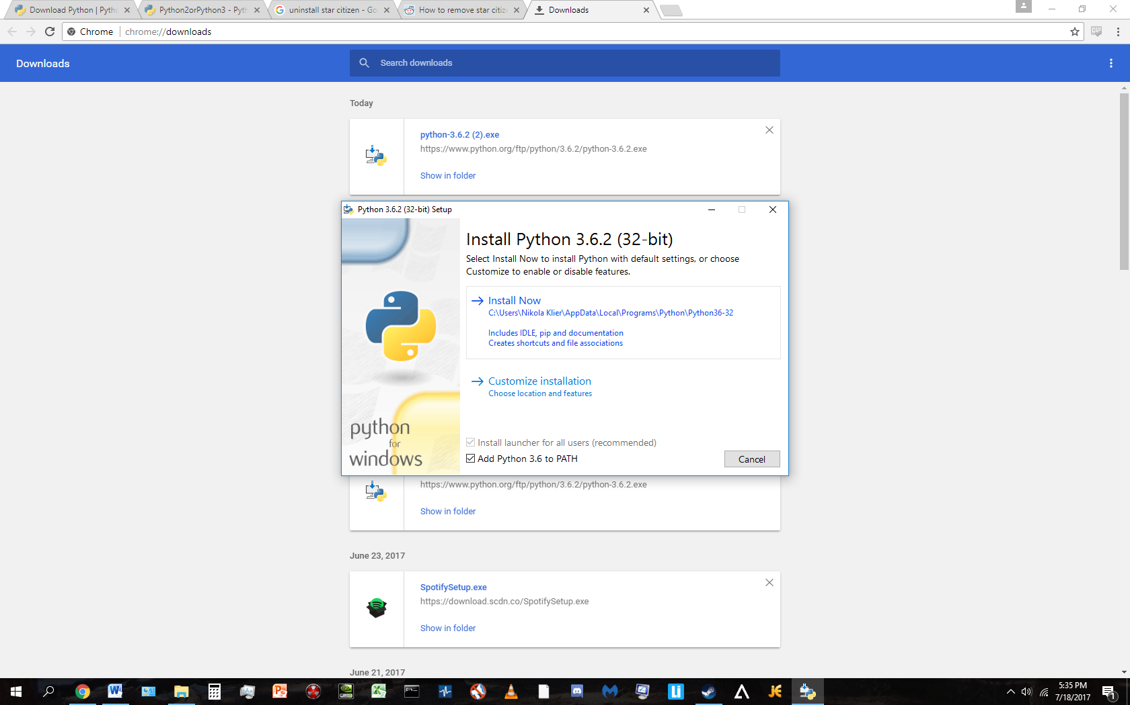

Make sure that you check the box circled in red above- it will allow you to run python programs from command prompt. Otherwise, the “install now” option should be fine.

**File arrangement**

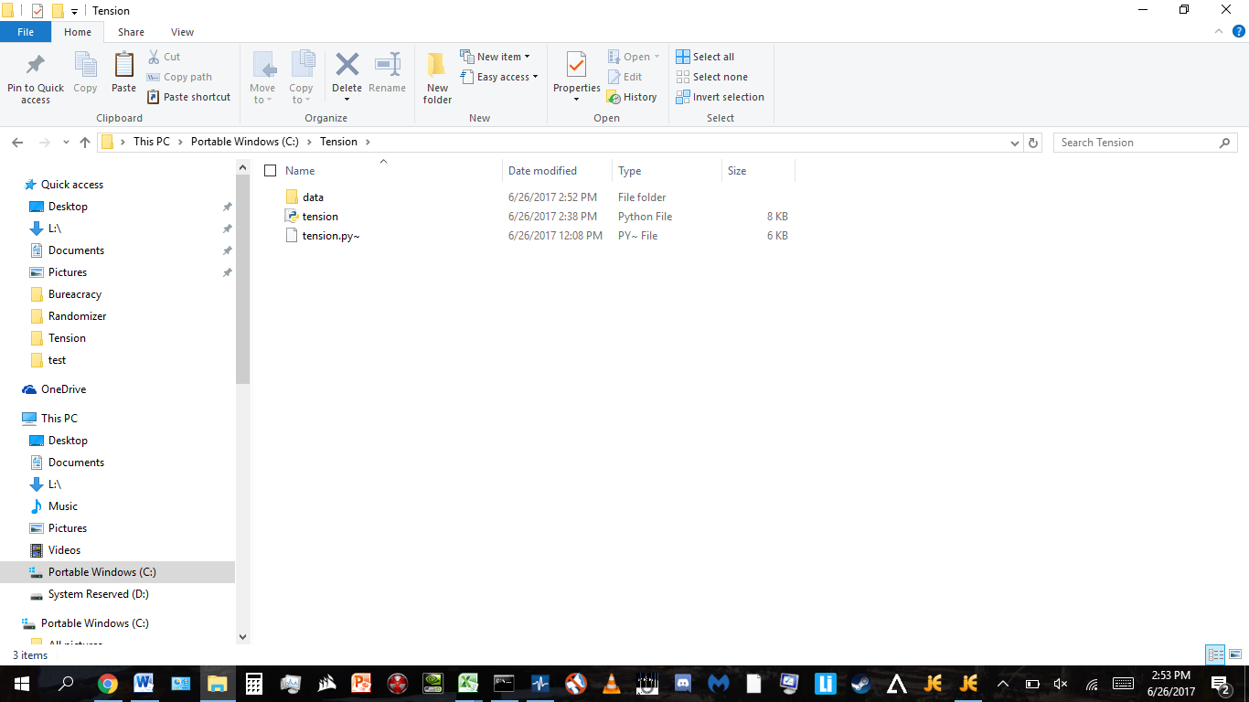The folder with the code should look like this:

With this document being the only other thing saved in it.

**Getting the data**

Open the file that is to be analyzed in labchart. In datapad, set up the following columns:

'time', 'tension: mean, 'tension: time at maximum', 'tension: maximum value’, 'tension: min value ', 'tension: value at selection', 'length: maximum value', 'length: time at maximum'

Hit multiple add to dataPad. Set it up looping through the entire document, with a step time of 0.05, then hit add. THIS MAY TAKE A WHILE. Usually 10-20 minutes or more. This is normal.

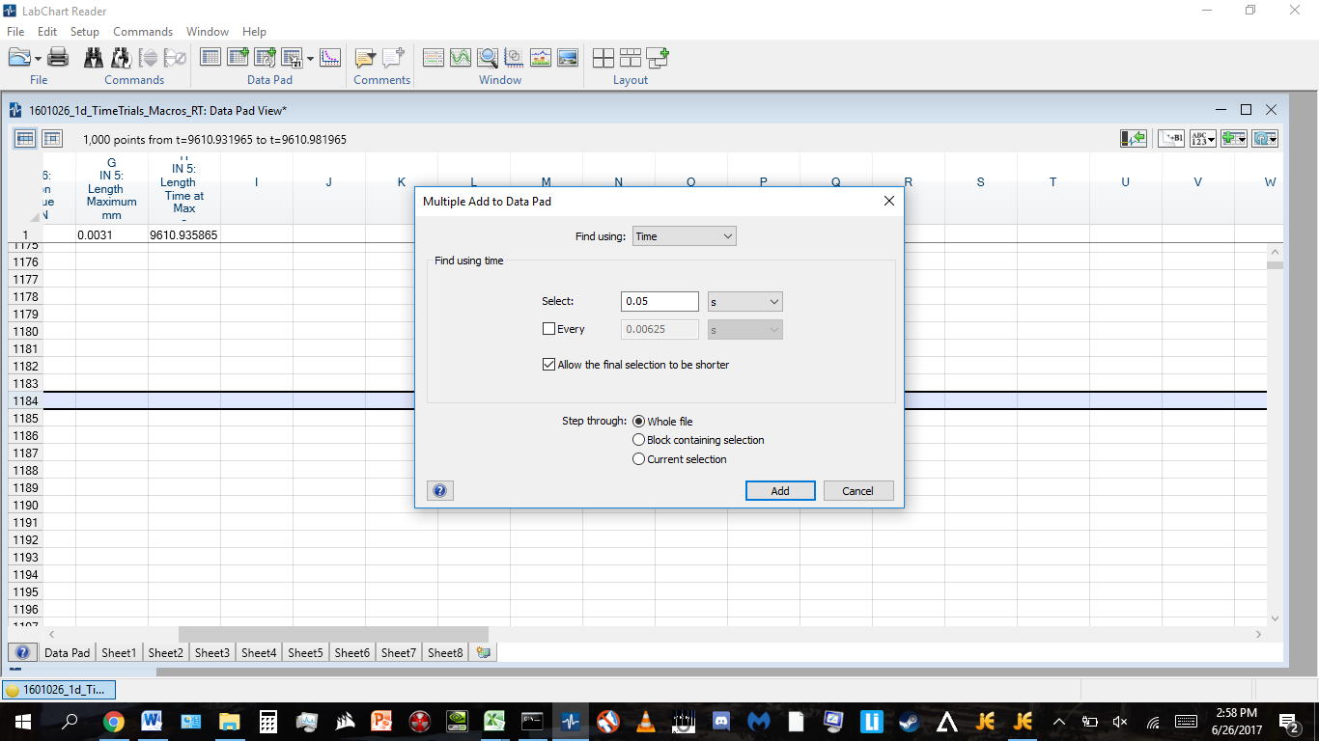

After the data is in the datapad, hit the grey square with the inset triangle in the top left (circled in red) to highlight the whole datapad. Copy the data over to an excel spreadsheet- including the headers for the columns is okay, they will be ignored by the program. It should look something like this:

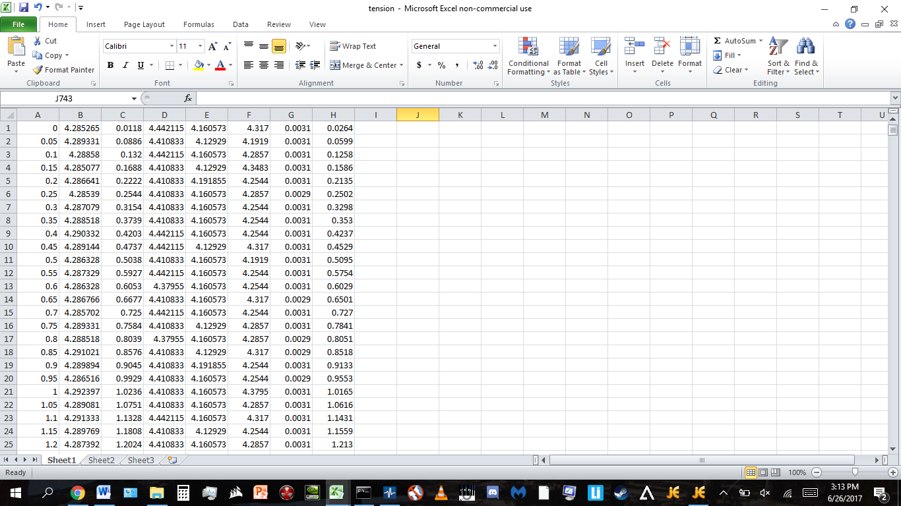

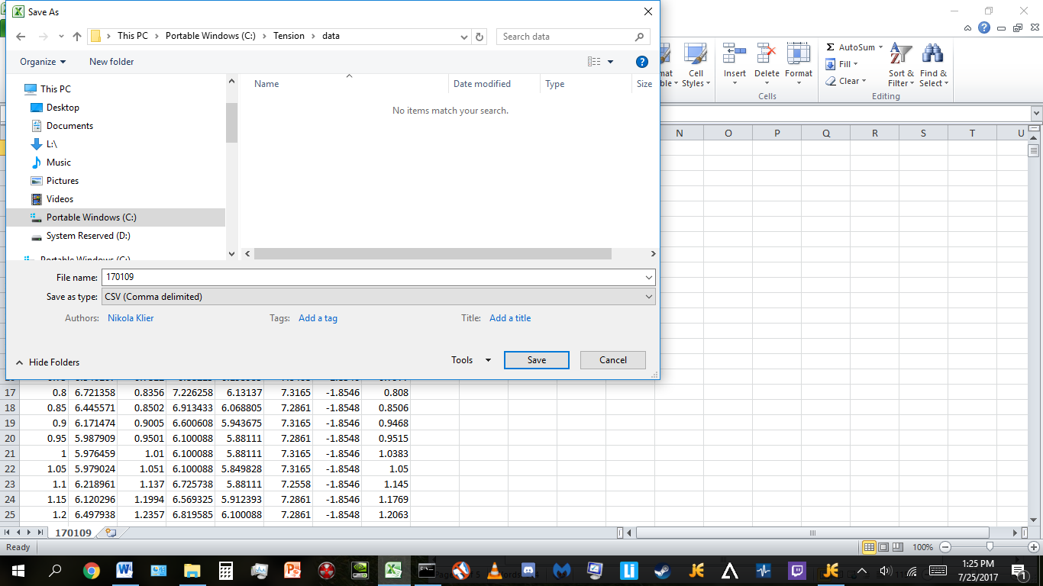Save the file under any name, preferably something that identifies what day/rig it is from, of file type “CSV (MS-DOS)”. Save it in the subfolder of the folder with the code, called data here:

Note: if you want more accuracy on the means, or don’t need as much accuracy and want adding things to the datapad to run faster, you can adjust the step time- 0.05 is just a nice standard.

Put as many .csv data files into the data folder as you want- the program will analyze them all at once.

**Running the file**

Open up command prompt. You may have to use the windows search bar to find it. A black window with white text telling you an active directory will pop up. Navigate to the directory with the python file in it.

Relevant commands: CD will change your directory. CD .. will change your directory to the folder one layer above your current active directory. CD (folder name) will take you to the directory with that name. Use enter to execute commands. Command prompt will likely start in your current user folder, so in our current example, we must navigate to the top level and then navigate to the tension folder, like this:

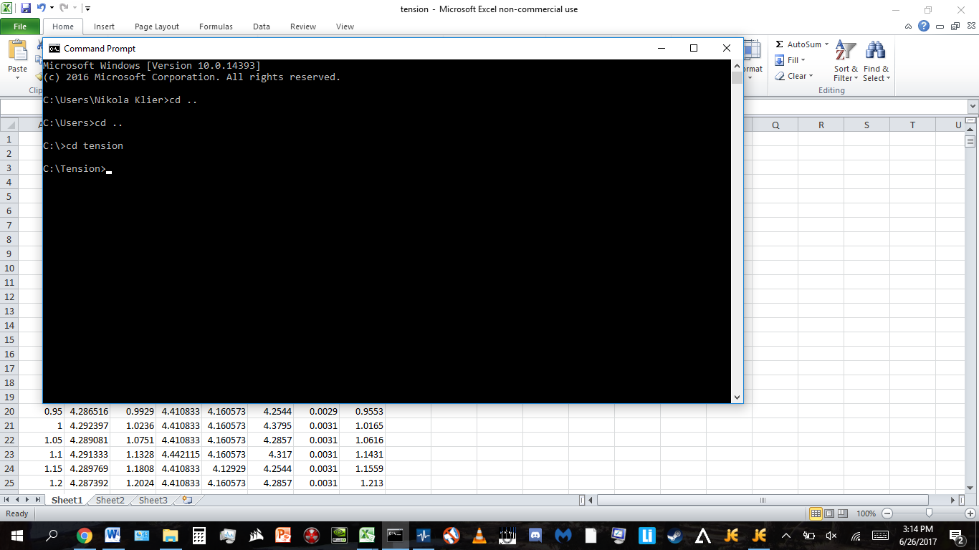

To run the file, run the following command: **python tension.py data**

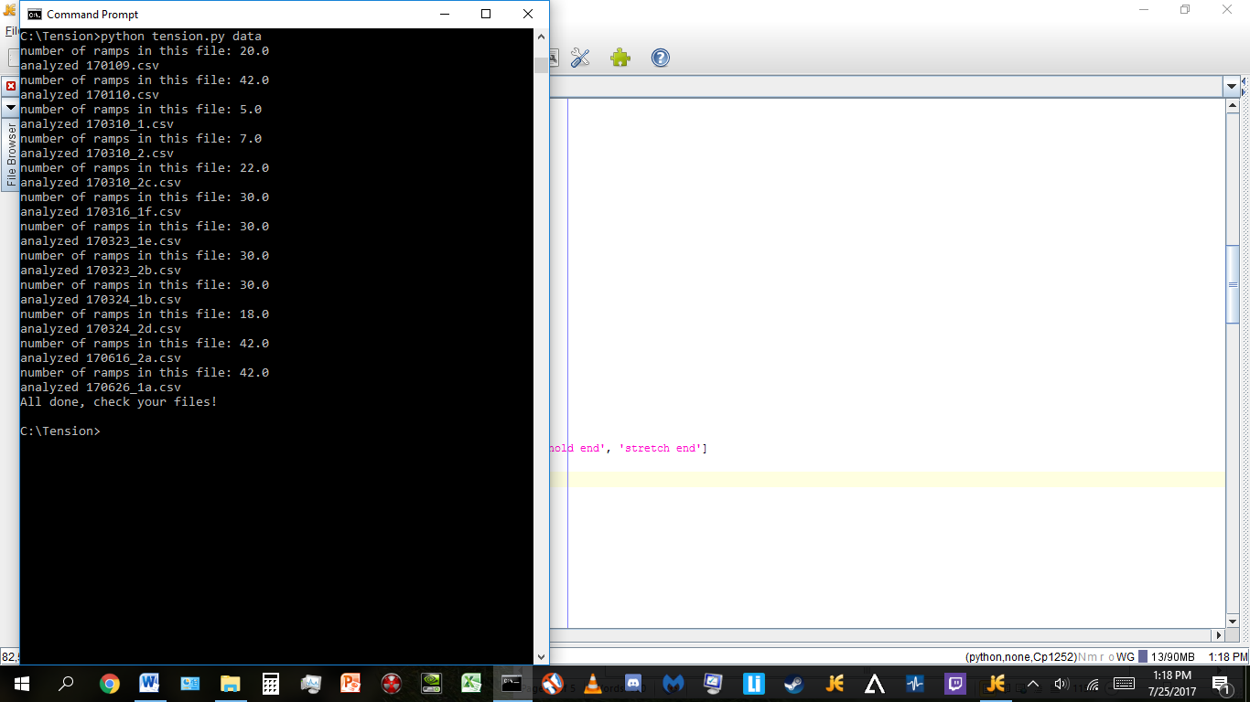It’ll think for a few seconds, saying which files it has analyzed and how many ramps it found in that file, and then say all done.

**Getting your data**

The analyzed files will be saved in the same folder you dropped your input data into, with the names being “analyzed” plus the corresponding raw data file. So it should look like this:

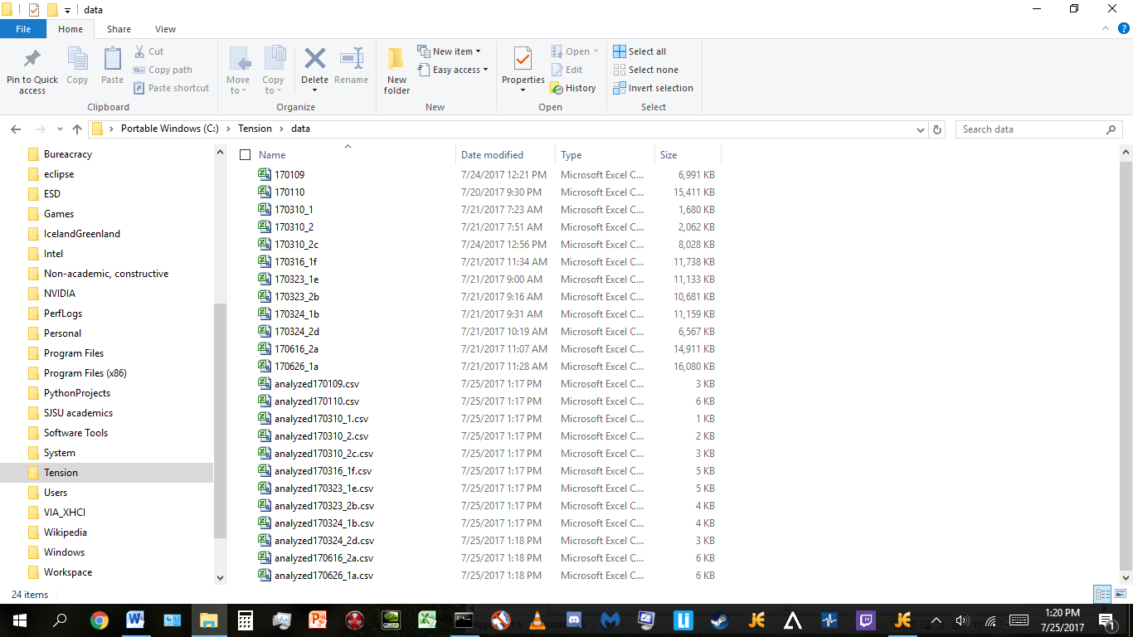

Then, copy paste to where it needs to be in Arthur’s master excel file.

**Some notes:**

There are weird formatting things with counting the ramps and macros in the output file (for example, ramp 6 of a macro is shown as ramp 0)- they shouldn’t influence the readability of the file as a whole, however.

Before you analyze another file, make sure to move or delete the previous “analyzed” files. The program will analyze the already analyzed files, outputting meaningless numbers or blank documents.