Project Overview S1-Vis

This document provides project related management tables to document the project structure and progress. It is subject to regular updates.

# Document version

Table 1: Document version

|  |  |  |  |  |  |
| --- | --- | --- | --- | --- | --- |
| Nr. | Date | Version | Altered chapters | Type of altering | Author |
| 1 | 15.03.2022 | 1.0 | all | Creation | Niklas Jaggy |
| 2 |  |  |  |  |  |
| 3 |  |  |  |  |  |
| 4 |  |  |  |  |  |
| 5 |  |  |  |  |  |

# Project information

*Please provide important facts for your project, e.g. acronym, title, proposed period, principal investigator and contractor.*

Table 2: Overall project information

|  |  |  |  |  |
| --- | --- | --- | --- | --- |
| Project |  | | | |
| Acronym | S1-Vis | | | |
| Title | A Google Earth Engine App for a Sentinel-1 based visual interpretation tool | | | |
| Period | Start: | 01.03.2022 | End: | 30.06.2022 |
| Principal investigator | Dr. Herrmann Klug, | | | |
| Contractor | University of Salzburg, Department of Geoinformatics (Z_GIS) | | | |

# Project Content and Project Goals

*Please provide an overview of your project with its main activities. Additionally give some information on the purpose, benefits and target groups as well as the proposed goals of your project. Please also provide explicit information on those aspects of the overall challenges, which you will not tackle with your project.*

Table 3: Project Content and Project Goals

|  |
| --- |
| Content & Goals |
| Project description *(~100-150 words)* |
| This project aims at creating an interactive Google Earth Engine that allows to intuitively access radar imagery and visualizes it instantly. The user thereby selects an area and time-period of interest for which the data is collected and presented using RGB composites and split-panel views. The focus of the application is set on dwelling detection in crisis areas but can be extended towards other topics such as flood detection. Extended functionality such as thresholding images for retrieving classification masks or basic classification tasks are in planning. |
| Project purpose, benefits and target group description *(~100 words)* |
| The main purpose is to provide easy and intuitive access for non-radar experts to radar data and using it for information visualization and retrieval in humanitarian contexts. It aims at directly supporting humanitarian applications through data and information provision. Direct benefits are the exploitation of a complementary satellite data source for humanitarian actors in interactive application form and the generation of geospatial datasets. |
| Project objectives (please also include a listing of the sub-goals) *(~100 words)* |
| * Working Google Earth Engine App * User friendly and intuitive app interface   + Interactive   + Meaningful buttons, labels and descriptions |
| Non-Goals |
| * Implementation of complex image classification routines * Accuracy assessment of results |

# Frame of the project

*Please provide a description of the existing situation. Therefore, please describe the actual state and the identified challenges. As a second part, please also provide the most important information with regard to the proposed project period and the most important dates (Kick-off, interim/mid-term report/presentation, final report, paper submission etc.).*

Table 4: Frame of the project – Part 1

|  |
| --- |
| Context |
| Up-to-date status *(~50-100 words)* |
| There is a lack of freely available applications that allow to utilize radar data in humanitarian contexts. This GEE app hope to contribute to filling this gap of software solutions. Major challenges will be on the coding side, meaning the development of the code logic that should result in a working app. It is assumed that the GEE platform is and remains available for now. |
| Project setting *(~50 Wörter)* |
| The official project kick-off is on 01.03.2022 with the first course session. Within the first 2-3 weeks, the project concept and its framework is developed before starting the app development phase. Important dates are the delivery of the final project product on 20.06.2022 and mid-term presentations on the project status in end of April. |

Table 5: Frame of the project – Part 2

|  |  |  |  |  |  |
| --- | --- | --- | --- | --- | --- |
| Time frame of the project | | | | | |
| Start: | | 01.03.2022 | | **End:** | 30.06.2022 |
| Important Dates | | | | | |
| 1 | 01.03.2022 | | Kick-Off, First Session | | |
| 2 | 22.03.2022 | | Project Idea/Abstract presentation | | |
| 3 | 26.04.2022 | | Mid-Term Pecha Kucha presentation | | |
| 4 | 21.06.2022 | | Final Poster Presentation | | |
| 5 | 30.06.2022 | | Delivering of final product, Project closing | | |

# Resources & Budget

*Please provide information on the project lead and the project team. Please include information on name, role and qualification. Additionally provide information about the planned resources with regard to personal costs and other costs.*

Table 6: Resources and Budget – Part 1

|  |
| --- |
| Project Team |
| Project Lead |
| Niklas Jaggy |
| Project Team |
| Niklas Jaggy |

Table 7: Resources and Budget – Part 2

|  |
| --- |
| Resources |
| Personal costs |
| 300 working hours |
| Project costs |
| 300 working hours |
| Other Costs |
| - |

# Project structure, description and risk matrix

*Please provide a description about your work plan (work breakdown structure) your work packages in tabular and graphical form.*

## Work packages overview

Table 8: Work packages overview

|  |  |  |
| --- | --- | --- |
| WP | Name of the Work Package | Time Frame [to – from] |
| 1 | Project Management | 01.03.2022 – 30.06.2022 |
| 2 | Program logic | 20.03.2022 – 30.04.2022 |
| 3 | App Design/UI design | 20.03.2022 – 15.06.2022 |
| 4 | App creation | 01.06.2022 – 25.06.2022 |

## Work Breakdown Structure (WBS)

Create a work breakdown structure for your work packages including the important tasks.

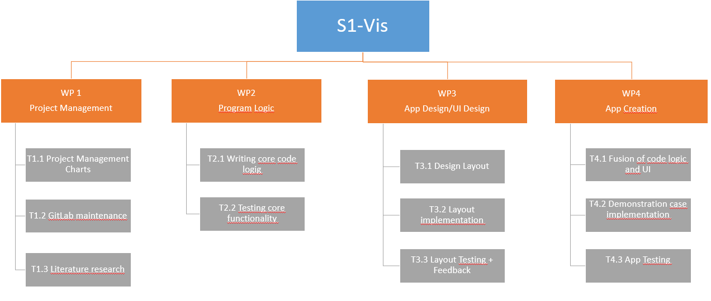

Figure 1 Work breakdown Structure

## Detailed work plan

*Please document the goals, content and expected results for each work package. Provide information on the planned approach and methods you want to apply as well as the expected results (including the planned milestones and deliverables). As a first work package please use ‘project management‘.*

Table 9: Detailled Work Plan – WP1

|  |  |  |  |
| --- | --- | --- | --- |
| WP 1 | Project management | Duration | 01.03.2022 – 30.06.2022 |
| Project Lead | **Project team** | | |
| Niklas Jaggy | Niklas Jaggy | | |
| Objectives | | | |
| Continuous project management for successful completing the project | | | |
| Content & Tasks | | | |
| * Creating and updating essential project management charts * Set up and maintaining GitLab project | | | |
| Expected results | | | |
| * Supporting charts and overviews on project status and progress * GitLab repository for documentation and results | | | |
| Milestones & Deliverables | | | |
| M1 Kick-Off  M2 Project Concept Presentation  D1 Projectmanagement Charts (Gantt Chart, PERT Chart, Risk Matrix, Time Sheet)  D2 GitLab project | | | |

Table 10: Detailled Work Plan – WP2

|  |  |  |  |  |
| --- | --- | --- | --- | --- |
| WP 2 | Program Logic | Duration | | 20.03.2022 – 30.04.2022 |
| Project Lead | | | **Project team** | |
| Niklas Jaggy | | | Niklas Jaggy | |
| Objectives | | | | |
| Writing the core functionality of the app | | | | |
| Content & Tasks | | | | |
| * Implement the core routines necessary for making the app work * Testing each part | | | | |
| Expected results | | | | |
| * Java Script code that implements the app functionality | | | | |
| Milestones & Deliverables | | | | |
| M3 Code delivery  D3 Ready-to-implement code | | | | |

Table 11: Detailled Work Plan – WP*3*

|  |  |  |  |  |
| --- | --- | --- | --- | --- |
| WP 3 | App Design/UI Design | Duration | | 20.03.2022 – 15.06.2022 |
| Project Lead | | | **Project team** | |
| Niklas Jaggy | | | Niklas Jaggy | |
| Objectives | | | | |
| To design an user interface that is intuitive and easy to navigate but allows to exploit the entire code functionality | | | | |
| Content & Tasks | | | | |
| * Making Design concepts * Translating design concepts into script | | | | |
| Expected results | | | | |
| * App design code ready for integration with the core code | | | | |
| Milestones & Deliverables | | | | |
| M4 Design delivery  D4 Working layout code | | | | |

Table 12: Detailled Work Plan – WP*4*

|  |  |  |  |  |
| --- | --- | --- | --- | --- |
| WP 4 | App creation | Duration | | 01.06.2022 – 25.06.2022 |
| Project Lead | | | **Project team** | |
| Niklas Jaggy | | | Niklas Jaggy | |
| Objectives | | | | |
| Merge code logic and UI design into a working app | | | | |
| Content & Tasks | | | | |
| * Integrating the previously created core code logic and UI code into a single script * Deploy app | | | | |
| Expected results | | | | |
| * Working GEE app ready for use | | | | |
| Milestones & Deliverables | | | | |
| M5 Product delivery  D5 Final working app | | | | |

## Milestone plan

*Please provide a summary of the planned milestones and provide an according overview graphic.*

Table 12: Milestone plan

|  |  |  |
| --- | --- | --- |
| MS | Name | Date Completion |
| M1 | Kick-Off | 01.03.2022 |
| M2 | Project Concept Presentation | 22.03.2022 |
| M3 | Code delivery | 30.04.2022 |
| M4 | Design delivery | 31.05.2022 |
| M5 | Product delivery | 30.06.2022 |

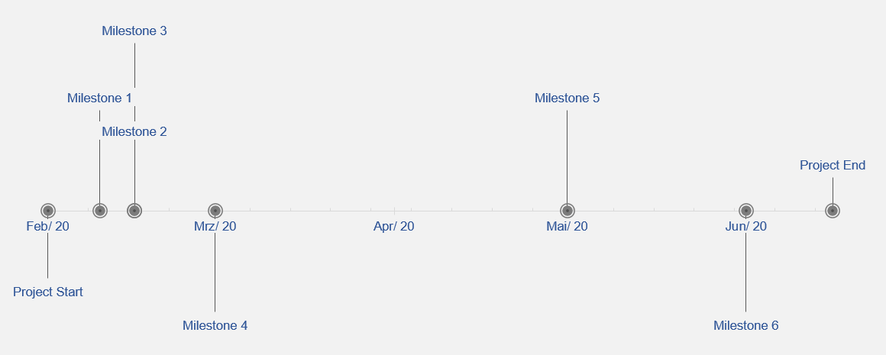

Figure 2 Milestones (from Excel template)

## Gantt Chart

*Please provide an image of your Gantt chart as overview graphics. Please attach the Gantt chart and its monthly updates in addition to this document.*

Table 13: Milestone plan

*[place the table here]*

## Risk Matrix

*In this table, please provide the important risk information. Please categorize the risks accordingly. ([****L****]ow, [****M****]edium, [****H****]igh], [****C****]leared) as well as your mitigation strategy. Please update this list accordingly during your project execution time frame.*

Table 14: Risk matrix

|  |  |  |  |  |  |
| --- | --- | --- | --- | --- | --- |
| No | Risk | Potential adverse impact | Risk level* | Risk management strategy | Responsibility |
|  |  |  |  |  |  |
|  |  |  |  |  |  |
|  |  |  |  |  |  |
|  |  |  |  |  |  |
|  |  |  |  |  |  |

# Additional comments

*Add additional comments if necessary.*

Table 15: Additional comments

|  |
| --- |
| Comments |
|  |

# Approval

*Please provide further information if necessary.*

Table 16: Approval

|  |  |  |  |
| --- | --- | --- | --- |
| Freigabe | | | |
| Date: | dd.mm.yyyy | **Date**: | dd.mm.yyyy |
|  | |  | |
| Signature principal investigator | | Signature project lead/contractor | |

# Attachments

*Attachment 1: Gantt chart (biweekly updated).*