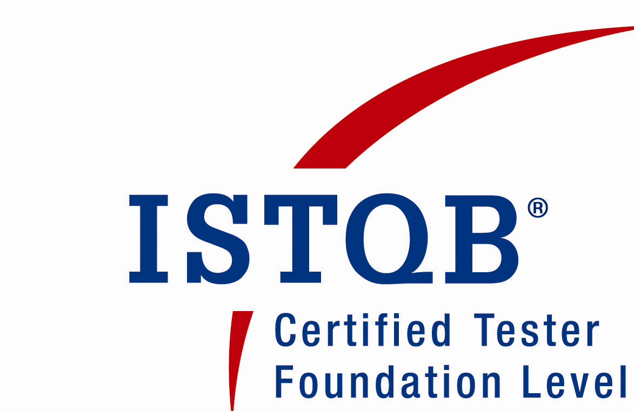 M.S. Vijay kumar

E-Mail: nklvijay@gmail.com

Ph: +91 9965743093

Career Span

Experience in the IT Industry as a Software Architect / Systems Analyst / Project Lead, and experience in Software Application Development of Website/Portal Development, Hosting and Web Application Development.
Have been a Software Consultant and Corporate Trainer.

Profile Summary
- Experience in corporate training in .NET, JAVA, PYTHON with Machine Learning, PHP, Web development, Scripts and Testing with Automation tools.
- Certified Tester by ISTQB ( International Software Testing Qualification Board )
- Experience in Web application development of PHP and Python Technologies.
- Experience in Systems Analysis, Design, Development and Implementation of various applications including Web and Client/Server Application development using Microsoft .NET Framework, C#. NET, VB.NET, ASP.NET
- Experience in database programming using SQL Server and Mysql,
- Exposure in manual and automated testing tools like WinRunner, QTP, Load Runner and Test Director.
- Experience in Architecting, Designing, Development and Deployment of High-Performance, Scalable, Distributed, ASP.NET Applications and SQL Server 2000.
- Experience in Software Development Life Cycle and Implementation of Client/Server applications using C#, VB.NET and SQL Server 2000 with N-tier development environment.
- Experience in Win-Forms and Web-Forms using .Net Technologies.
- Experience in the entire Software Development Life Cycle (SDLC).
- Experience in Requirements Analysis and Documentation.
- Excellent understanding of Software Quality Assurance Techniques and complete knowledge of the Software Development Life Cycle (SDLC) and Software Testing Life cycle (STLC).
- Since 2015, regular speaker at some of the major events like seminar, workshop, and international conference at various colleges in India and abroad.

Specialization in

- Windows and web application development in Microsoft .NET and web applications with Python and PHP.
- Microsoft .NET up to Version 4.7.2, which includes: C# 7.0, VB.NET, Tasks, Async & Parallel Programming,ADO.Net.
- Front-End Web UX development technologies like HTML5, CSS3, Bootstrap, JavaScript, XML, DTD, XSL/T, XPATH, XQUERY, XSD, WSDL, SOAP, XHTML, etc.
- Server-Side programming using ASP , PHP , Python. Internet and Intranet development architectures targeted for n-Tier, distributed and disconnected Application Development models, Design Patterns & Practices, Security, Configuring, Optimization & Deployment models, Team Testing
- Microsoft Office (2003/2007/2010/2013/2015/2016) in terms of:
  - Usage (Beginner - Intermediate - Advanced - Expert)
  - Programming: VBA for Word/Excel/Outlook
  - Visual Studio Tools for Office (VSTO) for Word/Excel/Outlook

Working Experience

Organization | Designation
Accenture, Bangalore. | QA Engineer
Forus Technologies, Chennai, Coimbatore | Team Leader

Academic profile

- M.Tech( Information Technology ) from at Anna University of Technology, Coimbatore with 86% First class With Distinction
- B.E( Computer Science and Engineering )from Periyar University with 80.3 % First class With Distinction

S

IT Exposure

• .NET Development Technologies
  - Frameworks .NET 1.0, 1.1, 2.0, 3.0, 3.5, 4.0, 4.5.x, 4.6.x, 4.7.x,
  - Languages C#, VB.NET,
  - Technologies ASP.NET, ADO.NET, Entity Framework,
  - Web Development HTML5, CSS3, Javascript, BootStrap 3/4,

- Languages: C#.NET, VB.NET, J#, VB 6.0, Turbo C++, Turbo C, PHP , PYTHON
- Databases: RDBMS - SQL Server , MYsql
- Application Architectures: COM, COM+, DCOM, Client/Server and n-Tier, ASP.NET MVC, MVVM,
- Web Server Technologies: IIS 4 / 5.1 / 5.5 / 6 / 7 / 7.5 / 8.0, Personal Web Server
- Web Server
Configurations: HTTP, HTTPS, FTP, SFTP, Setting up SSL and Payment Gateways using VeriSign & PayPal
- Web Technologies & Tools: HTML 5/4.01, DOM, DHTML, JavaScript , CSS 3.0
- Report Writers: Crystal Reports, Adobe Acrobat (PDF) Writer.
- Testing: Manual Testing, Winrunner, QTP, LoadRunner, Selenium.

Corporate Trainer Assignments:

TATA Consultancy Services, Chennai

- Python 3.8
- Python Installation-Windows, Configuration.
- Environment variables setup.
- Python Variables, Lists, Tuples
- Conditional and Loop iterative statements
- Dictionaries
- Map functions
- Database with Mysql
- Scipy, Numpy, Pandas
- Machine Learning Algorithms
- Data Analytics with Juypter, R Tool
- Python with Google Colab
- Python with Spyder

Earn2Clicks, Coimbatore.

- Python 3.6.4
- Python Installation-Windows, Configuration.
- Environment variables setup.
- Python Variables, Lists, Tuples
- Conditional and Loop iterative statements
- Dictionaries
- Tuples
- Class and object
- Database Integration.
- Manual Testing and Automation Procedures with Selenium IDE.

RIT Info Tech, Chennai
• Introduction to JavaScript
• XML, DTD, XSL and XSLT
• SOAP
• Microsoft .NET Framework
• XML Web Services
• ASP.NET, ADO.NET and Visual C#.NET
• Advanced Visual C#.NET (Customized)
• .NET Patterns and Best Practices
• Localizing .NET Applications using C#.NET

Gateway Software Solution, Coimbatore
• HTML 4.0
• CSS
• Introduction to JavaScript
• XML, DTD, XSL and XSLT
• SOAP
• Microsoft .NET Framework
• XML Web Services
• ASP.NET, ADO.NET and Visual C#.NET (Customized)
• Advanced Visual C#.NET (Customized)
• Advanced ASP.NET and XML Web Services (Customized)
• .NET Patterns and Best Practices
• Localizing .NET Applications using C#.NET

4S Software Solution, Coimbatore
• HTML 4.0
• CSS
• Bootstrap
• PHP
- Manual Testing and Automation Procedures with Selenium IDE.

JiSoft, Madurai
• HTML 4.0
• CSS
• Introduction to JavaScript
• XML, DTD, XSL and XSLT
• SOAP
• Microsoft .NET Framework
• XML Web Services
• ASP.NET, ADO.NET and Visual C#.NET (Customized)
• Advanced Visual C#.NET (Customized)
• Advanced ASP.NET and XML Web Services (Customized)
• .NET Patterns and Best Practices

Legend Info Tech, Coimbatore
- Python 3.6.4
- Python Installation-Windows, Configuration.
- Environment variables setup.
- Python Variables, Lists, Tuples
- Conditional and Loop iterative statements
- Dictionaries, Tuples, Sets.
- Class and object.
- Database Integration.

Manual Testing and Automation Procedures with Selenium IDE

Recent Samples:

TCS Corporate Training

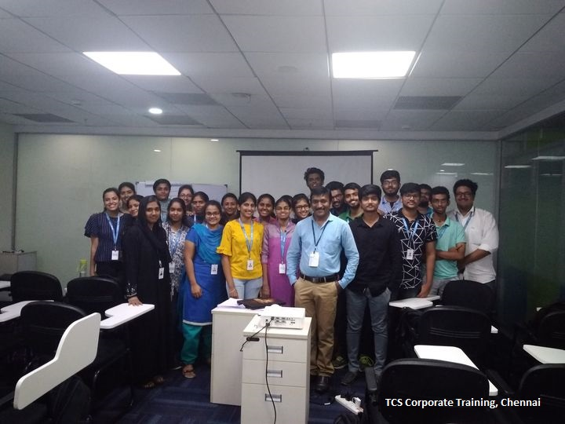

Accenture Corporate Training

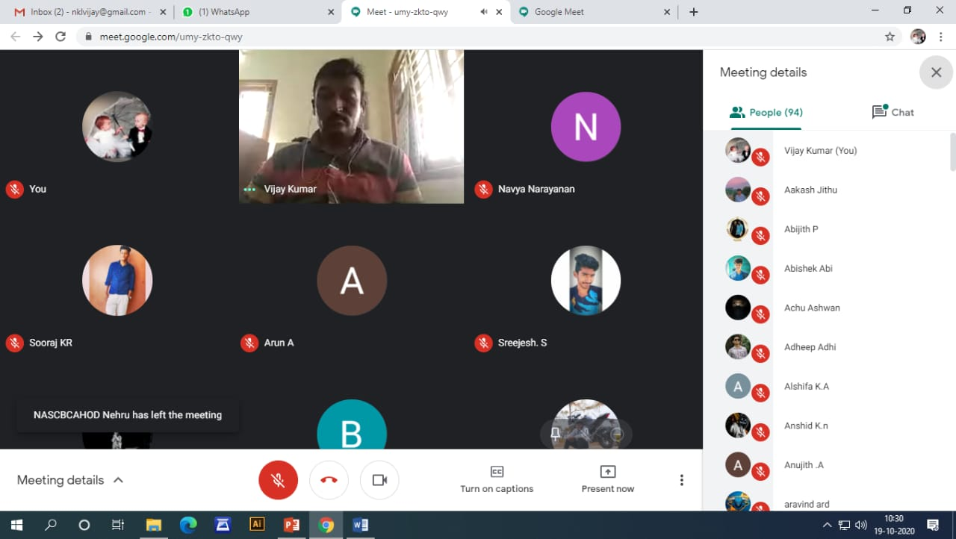

IGDATA WITH HADOOP online workshop in PSG 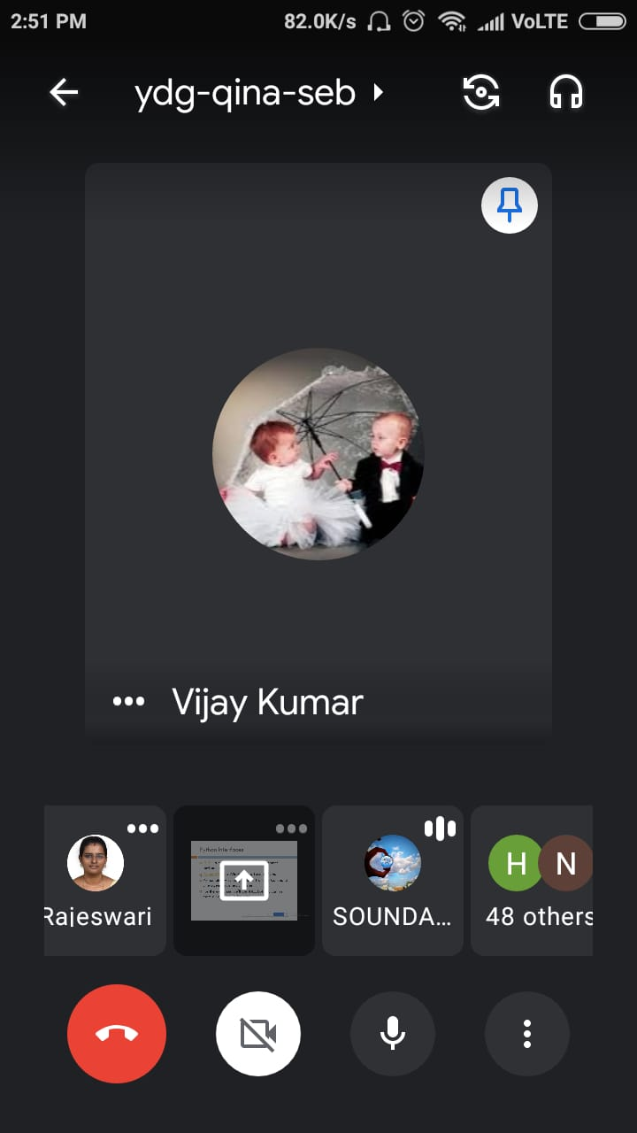

Online Corporate Training with Mphasis Techologies
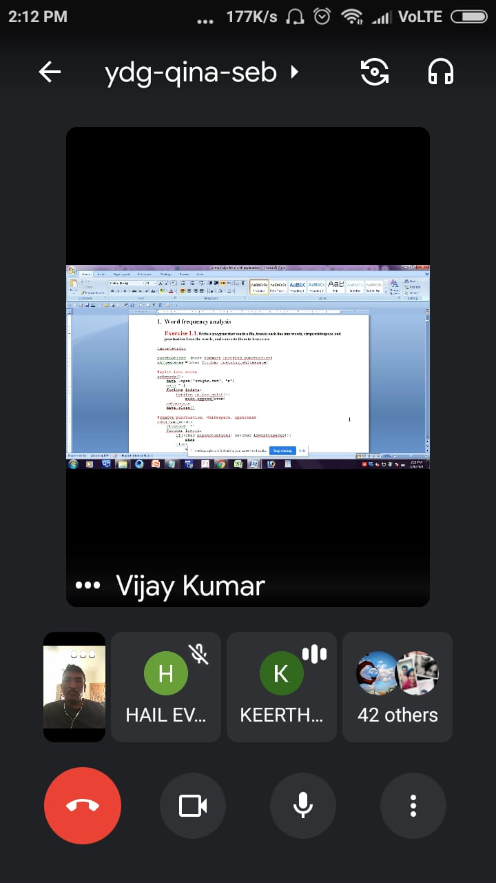

Training Awards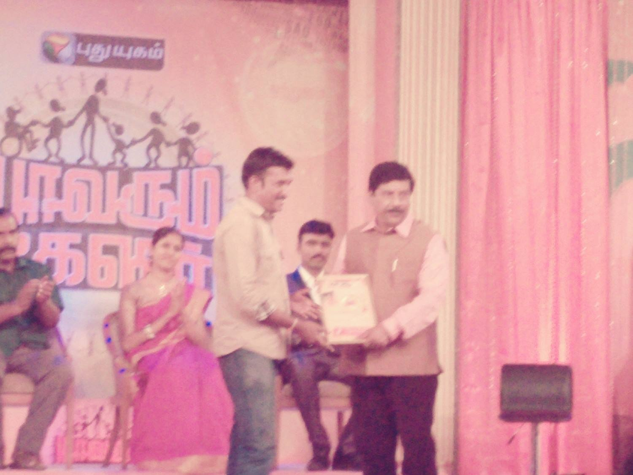

Workshops
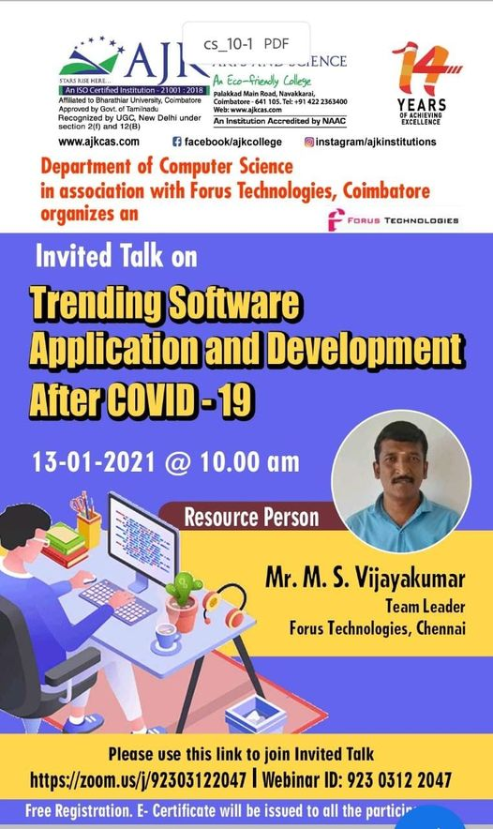
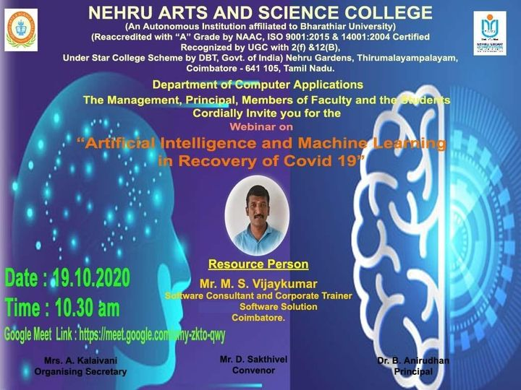

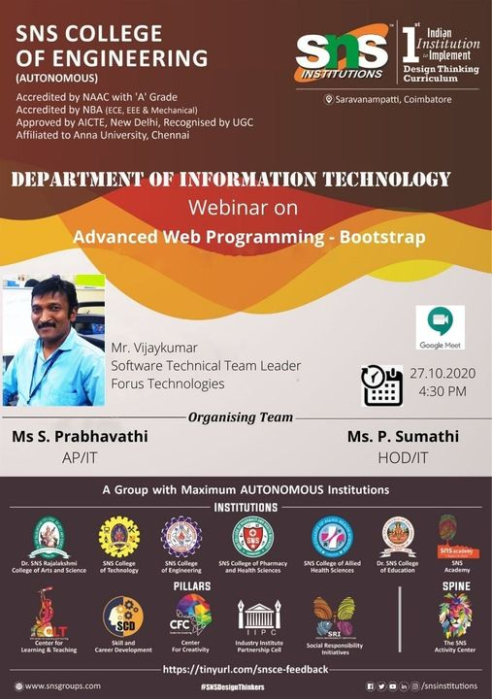

Workshop in PSG Institutions, Coimbatore
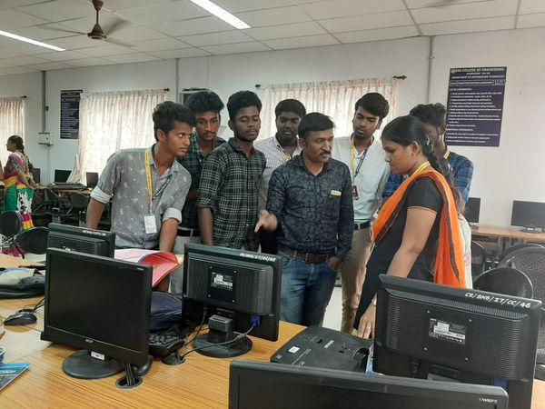

Workshop in Hindustan Groups of Institutions ,Coimbatore