1. Git repository: <https://github.com/nkminh/Udacity-Image-Filter.git>
2. EB dashboard:

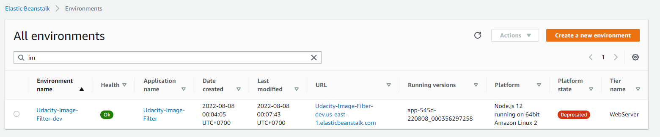

1. URL EB deployment: <http://udacity-image-filter-dev.us-east-1.elasticbeanstalk.com/>

In file README:

