**API:** Open POSTMAN application, then import file: “**iCommerce/DOC/1.Postman/NAB.postman_collection.json**”

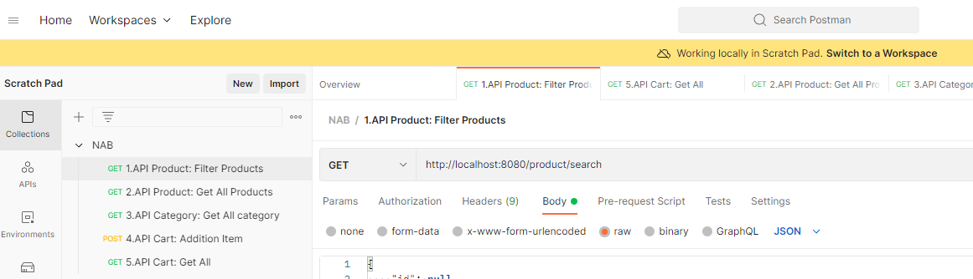

1. **API Product: Filter Products**
2. API Product: Get All Products
3. API Category: Get All category
4. **API Cart: Addition Item**
5. API Cart: Get All carts