Link APP: <http://ae379a68e26c943699c660a9d35d8a36-1616005923.us-east-1.elb.amazonaws.com/>

Currently, I can’t using my acc to auto deploy via Travis

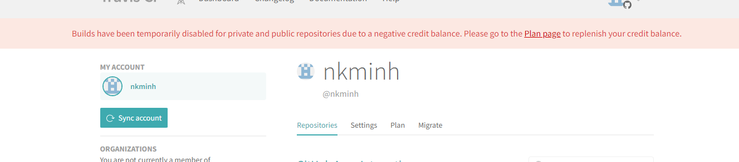

but I build docker Image local then push to Docker HUB by step: (You can check in Readme file):

1. clone src from git: https://github.com/nkminh/udacity-pj5-severless-microservices
2. cd udacity-pj5-severless-microservices
3. docker build -t minhnk/udagram-frontend-pj5:v2 .
4. docker push minhnk/udagram-frontend-pj5:v2
5. kubectl apply -f aws-secret.yaml
6. kubectl apply -f client/deployment.yaml
7. kubectl apply -f client/service.yaml