
Green University of Bangladesh
Department of Computer Science and Engineering (CSE)
Faculty of Sciences and Engineering
Semester: (spring, Year:2026), B.Sc. in CSE (Day)

Design Document

Course Title: Design Project 2 Lab
Course Code: CSE-320 Section: 231-D4

Project Title :
Smart Waste Management System

Student Details

Name |  | ID
1. | Nilandu Kumar Das Vapon | 231902031
2. | Asfiqul Alam Emran | 231902049
3. | Saiful Islam | 231902065
4. | Rahat Perves Rahi | 231002043

Submission Date : 06/04/2026
Course Teacher’s Name : Jannathul Moawa Hasi

Report Status
Marks: ………………………………… Signature:.....................
Comments:.............................................. Date:..............................

1. Introduction
Smart Waste Management System is a technology-assisted waste monitoring and collection platform designed to reduce overflow, improve collection efficiency, and support cleaner urban areas. The system combines smart bins equipped with sensors, a backend server, a database, and user-facing web interfaces for administrators, citizens, and collectors.

2. Problem Statement
Traditional waste collection often follows fixed schedules without considering real-time fill levels. This causes overflowing bins in busy areas, unnecessary collection trips to half-empty bins, and delayed complaint resolution. The proposed system addresses these gaps by using live status data and a coordinated digital workflow.

3. Objectives
- Monitor the fill level and operational status of waste bins in real time.
- Notify administrators when a bin approaches full capacity or requires urgent attention.
- Support route planning and collection scheduling for waste collectors.
- Allow citizens to submit complaints or report unmanaged waste from the interface.
- Maintain structured historical data for analytics and future decision-making.

4. High-Level Architecture
The high-level architecture of the Smart Waste Management System is designed using a layered approach to ensure better organization and efficient system operation.
The User Interface Layer enables administrators, citizens, and collection staff to access the system through dashboards and web or mobile interfaces.
The Application Management Layer is responsible for authentication, user control, bin management, and notification handling.
The Core Business Logic Layer manages the major functional operations such as bin monitoring, collection scheduling, and complaint processing.
The Infrastructure and Support Layer connects the software system with smart bins, sensors, backend servers, databases, and external service platforms.
This layered architecture improves scalability, maintainability, and the overall effectiveness of the system.
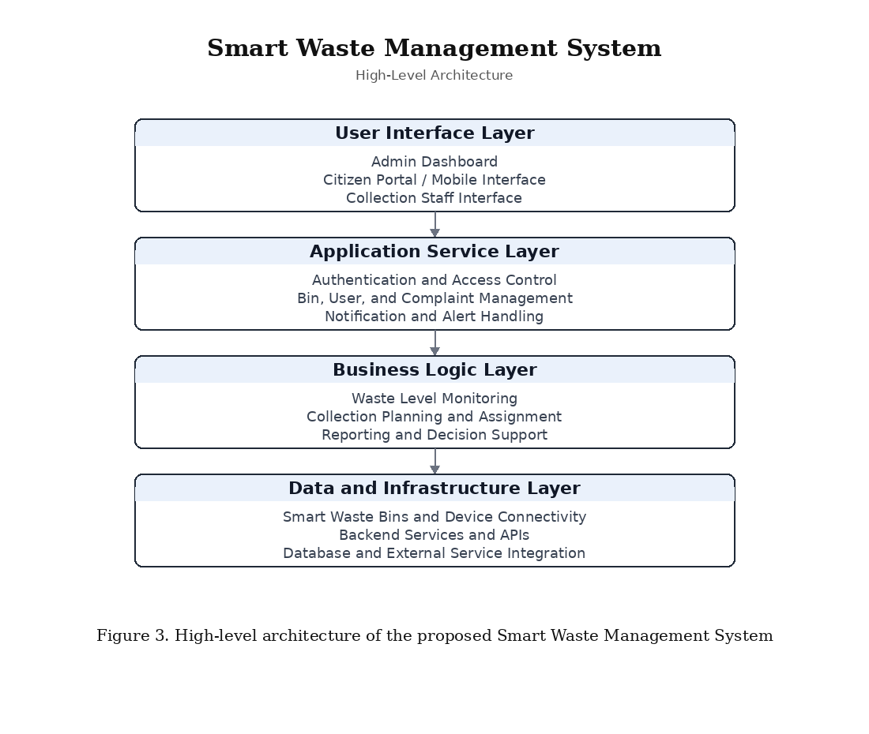
Figure 1. High-level architecture of the Smart Waste Management System.

4.1 Component Interaction Flow
- Each smart bin measures its current fill level through the installed sensing unit.
- The collected reading is sent to the backend server via the internet.
- The backend validates the incoming data, applies system rules, and processes the bin status.
- The latest processed status is stored in the database for future use.
- The database preserves records related to bins, users, complaints, collection schedules, and notifications.
- The admin dashboard accesses processed data for monitoring, supervision, and decision-making.
- The collector panel receives route assignments and updates collection status after each service visit.
- The citizen interface enables users to view relevant information and submit complaints when required.

5. Low-Level Architecture
This section describes the internal design of each subsystem, including the proposed technologies and implementation responsibilities.

5.1 SD — Smart Waste Operation System Diagram
This diagram presents the overall low-level structure of the Smart Waste Management System. It shows how the main operational modules interact with users, smart bins, and the central database to support waste monitoring, complaint handling, and collection activities.
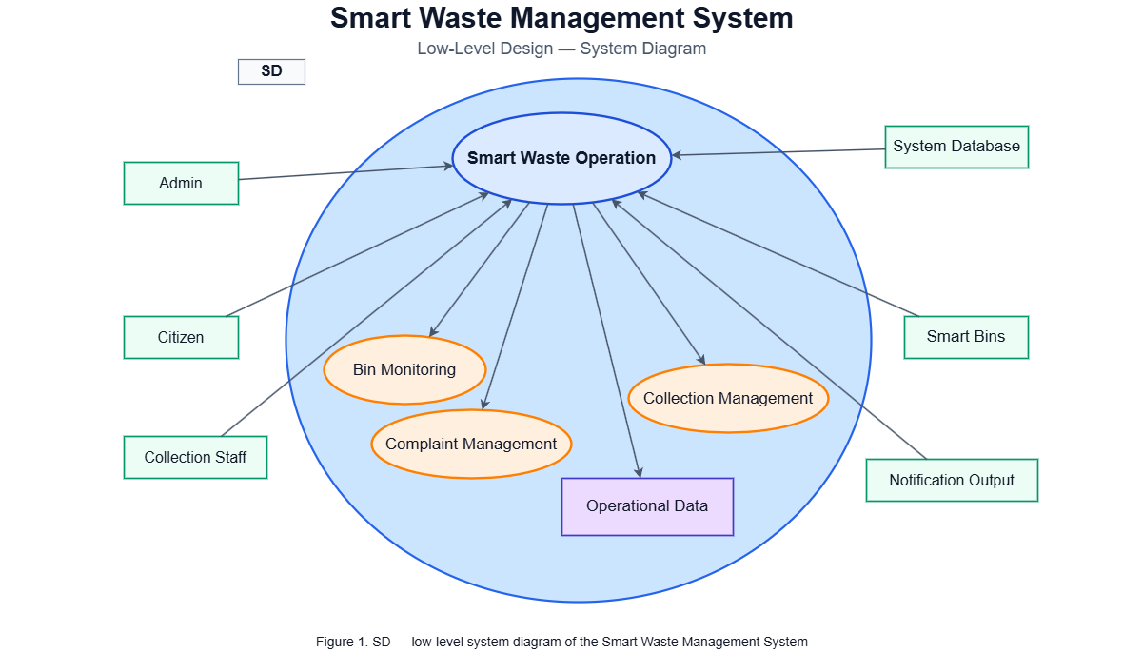

5.2 SD1 — Bin Monitoring Module
This module monitors the waste level and condition of each smart bin. It evaluates bin status, checks threshold levels, and updates the system to support timely collection decisions.
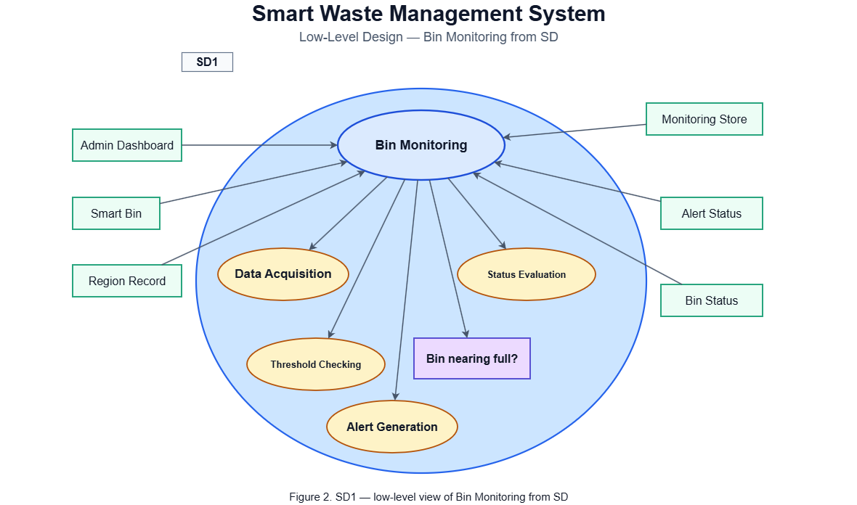

5.3 SD1.1 — Data Acquisition and Validation Module
This module collects bin status data and verifies its accuracy before further processing. Valid data is forwarded to analysis, while invalid or incomplete data is recorded for error handling.
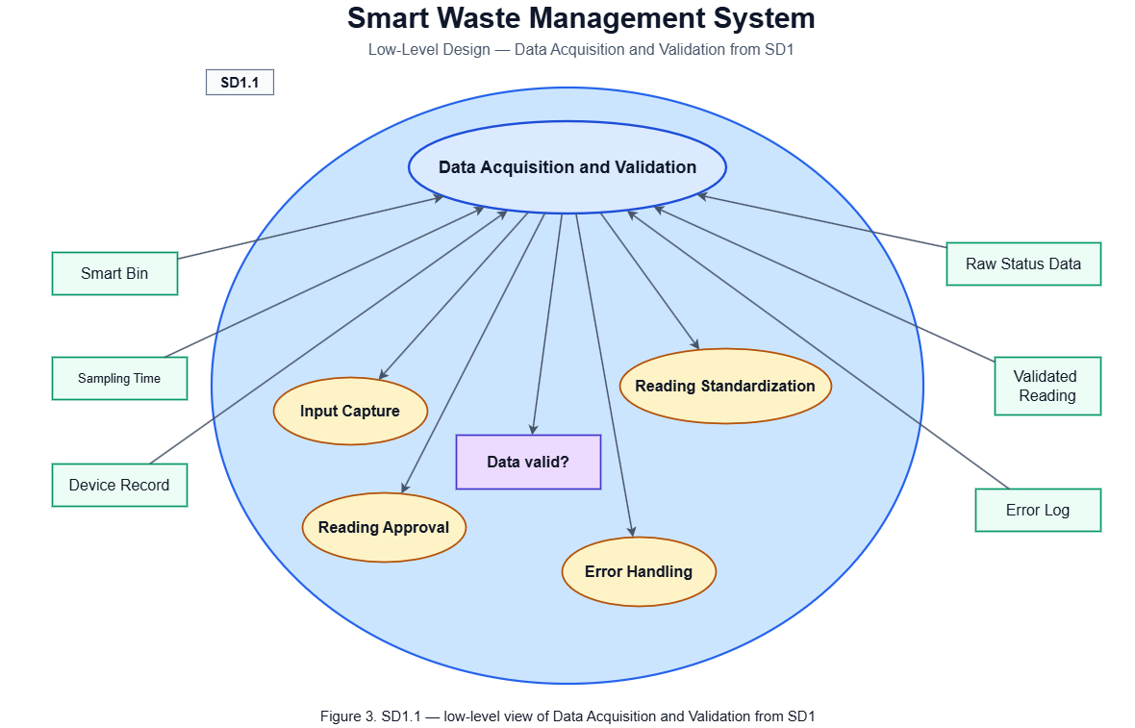

5.4 SD1.2 — Fill-Level Analysis Module
This module analyzes validated bin data to determine the current waste condition. It classifies the bin status and helps the system identify whether service is required.
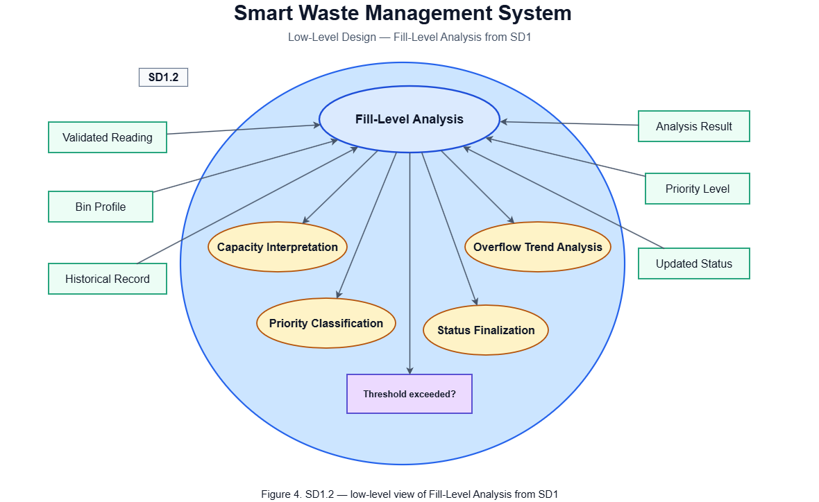

5.5 SD1.2.1 — Threshold Decision Module
This module applies threshold rules to decide whether a bin requires immediate collection or normal scheduling. It supports priority-based waste management decisions.
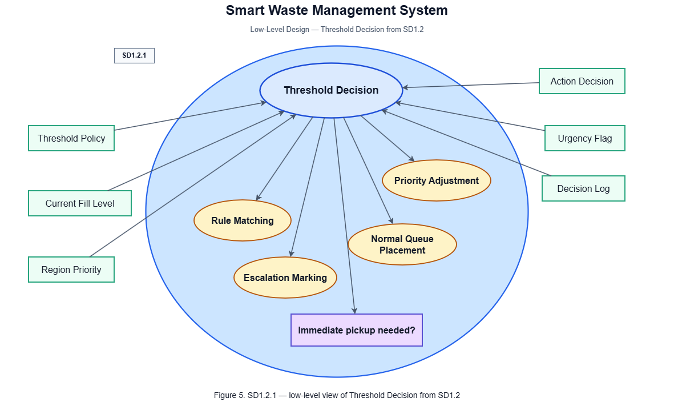

5.6 SD2 — Collection Management Module
This module manages waste collection activities, including task assignment, schedule preparation, and pickup confirmation. It helps ensure efficient service execution.
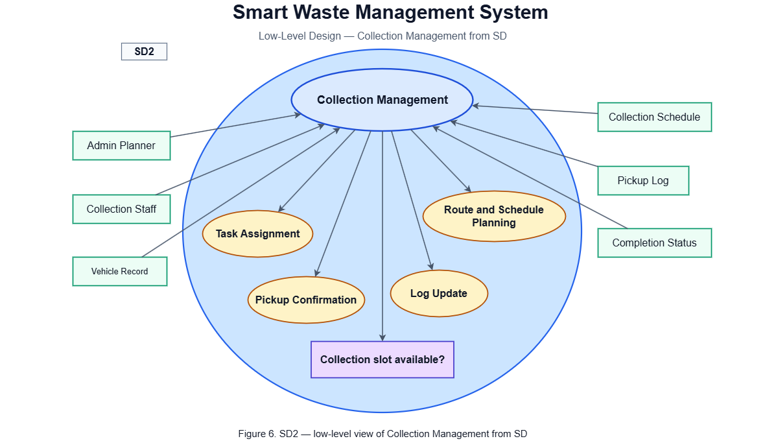

5.7 SD2.1 — Route and Schedule Planning Module
This module prepares collection routes and assigns time slots based on bin priority and available resources. It improves operational efficiency and reduces service delays.
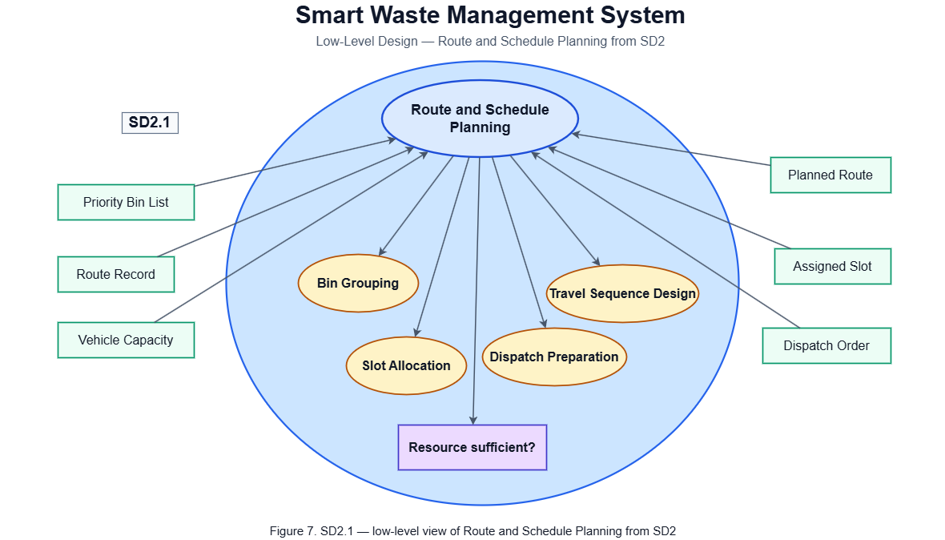

5.8 SD3 — Complaint and Notification Management Module
This module handles citizen complaints and system notifications. It supports issue reporting, verification, escalation, and response tracking to improve service quality.
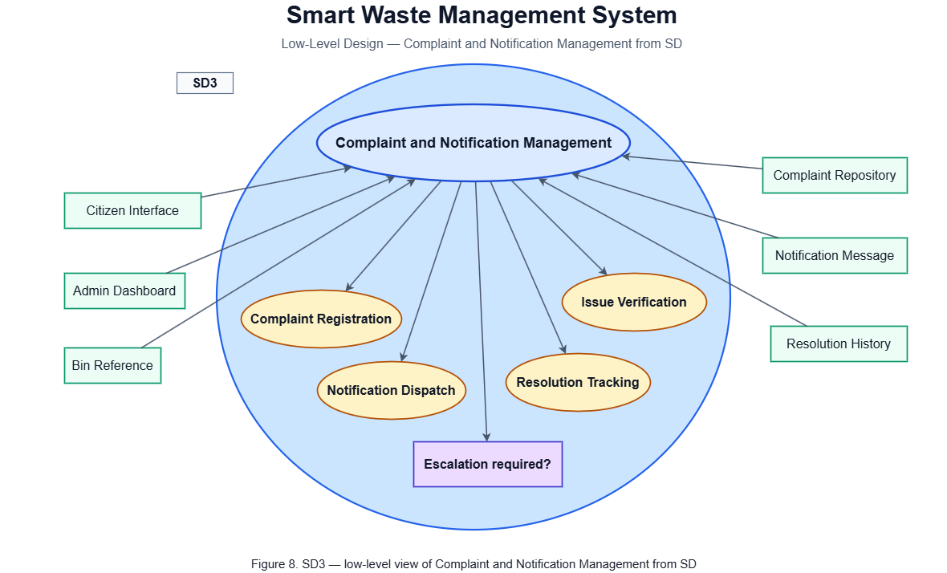

6. Updated UML Diagram

6.1 Use Case Diagram
The use case diagram illustrates the interaction between the main users and the Smart Waste Management System. It shows how the admin, citizen, and collection staff perform key activities such as monitoring bin status, managing smart bins, submitting complaints, generating collection schedules, updating collection status, and receiving notifications.
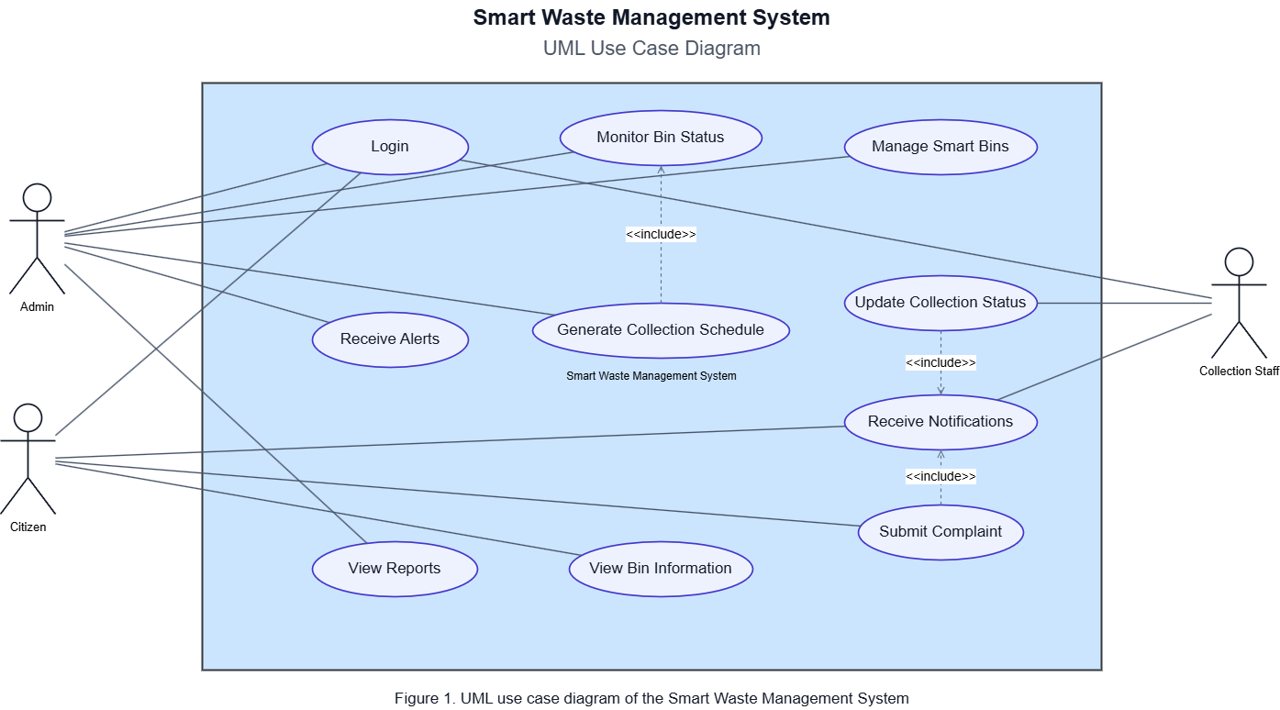

6.2 Class Diagram
The class diagram represents the structural design of the Smart Waste Management System. It presents the major classes, their attributes, methods, and relationships, including user, admin, collection staff, smart bin, sensor reading, collection schedule, complaint, notification, and report.
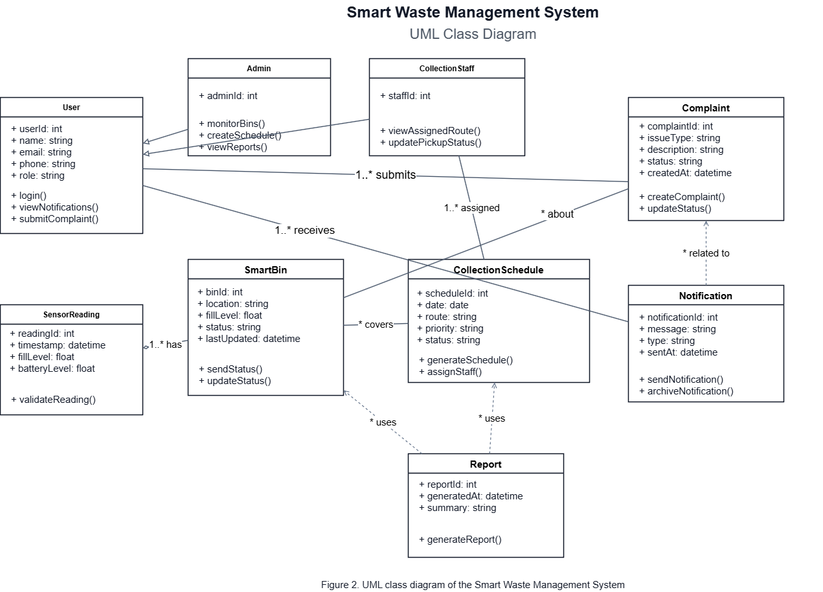

6.3 Sequence Diagram
The sequence diagram explains the time-ordered interaction among system components during complaint handling and notification flow. It shows how a complaint is submitted by a citizen, processed by the backend, stored in the database, reviewed by the admin, and then returned to the user as an updated complaint status.
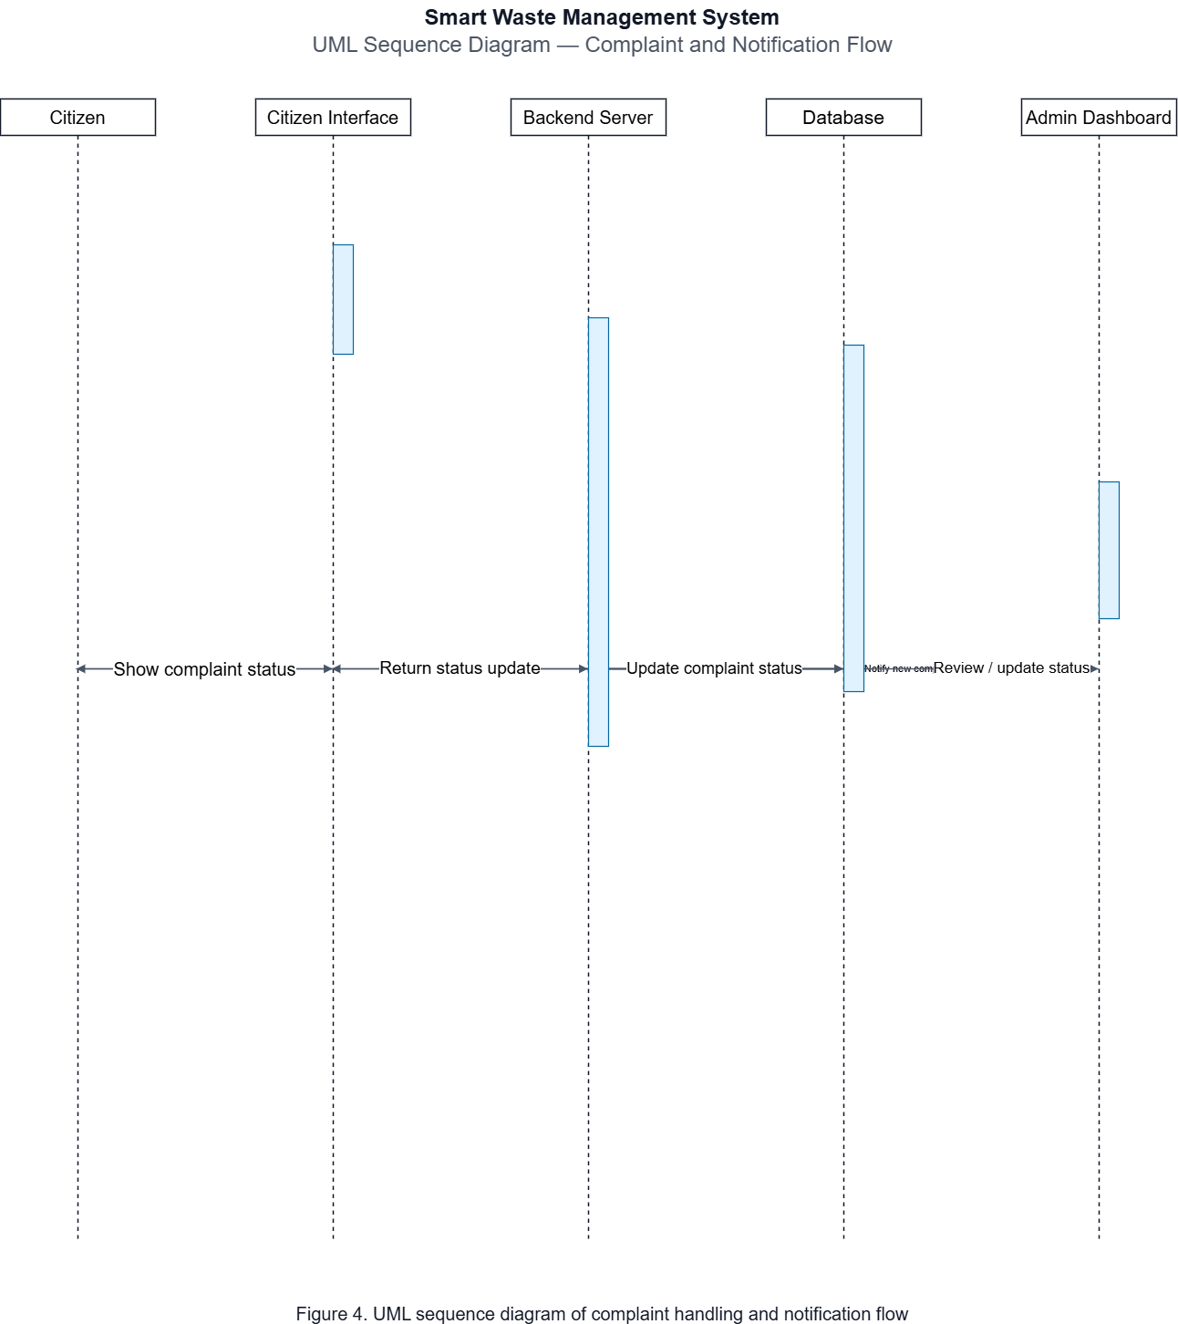

7. Entity-Relationship (ER) Diagram
The ER diagram models the data entities and the cardinality between them. It reflects a relational database design for implementation.
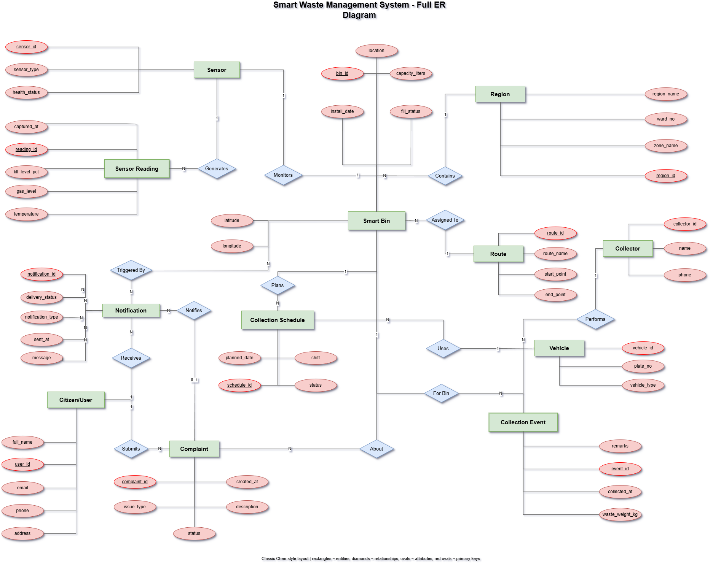
Figure 4. ER diagram for the core project
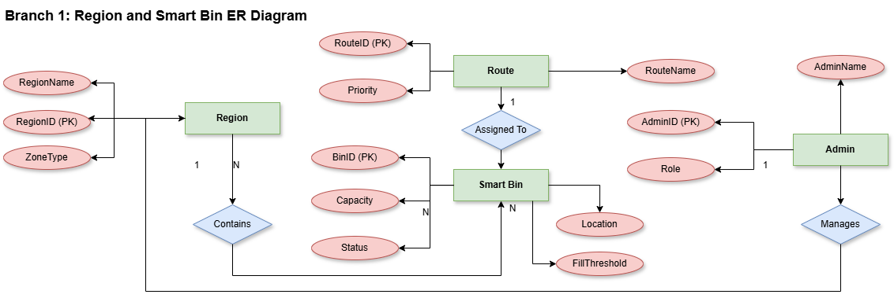
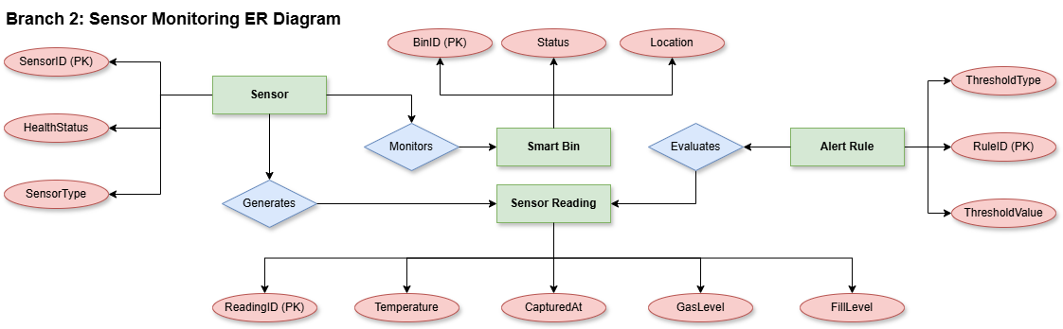

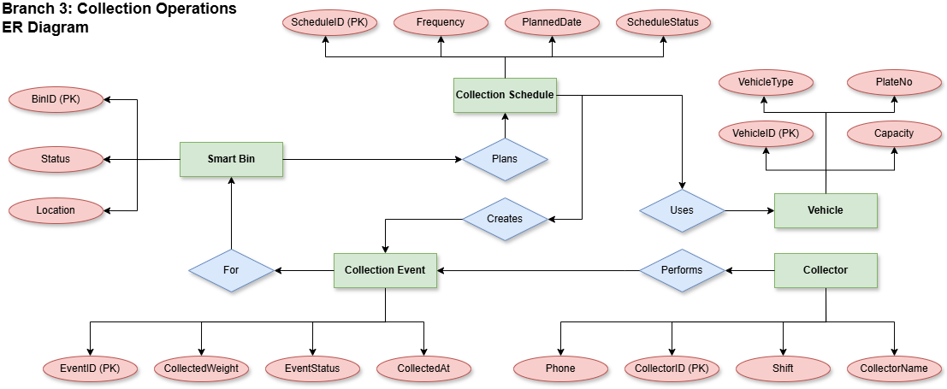

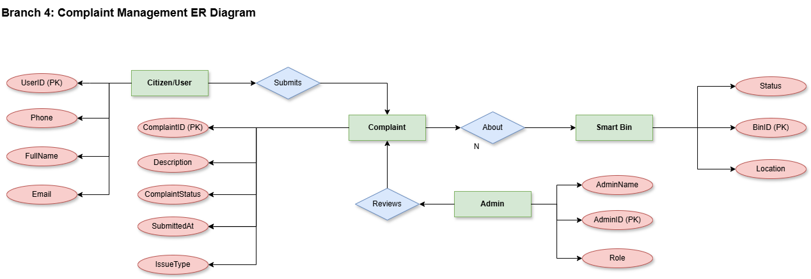

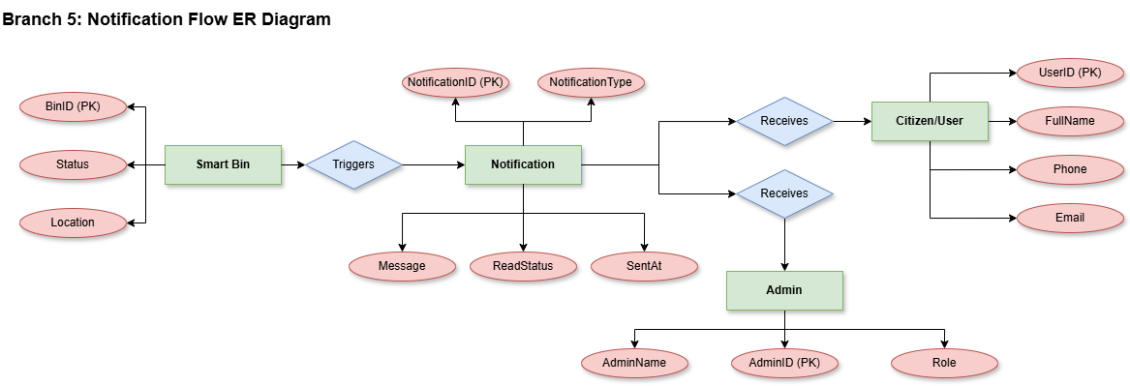

8. Database Entity Summary
Entity | Primary Attributes | Description
Users | user_id, name, email, role | Stores administrator, citizen, and collector information.
Bins | bin_id, location, fill_level, status | Maintains the live operational state of each smart bin.
CollectionSchedule | schedule_id, bin_id, pickup_time | Records collection planning and execution.
Complaints | complaint_id, user_id, bin_id, details | Tracks public complaints or overflow reports.
Notifications | notification_id, user_id, bin_id, message | Stores alerts generated by the system.

9. Non-Functional Considerations
- Scalability: The architecture should support additional bins, zones, and users without redesigning the platform.
- Reliability: Sensor data transmission should tolerate temporary network failure and retry when connection is restored.
- Security: User authentication and role-based authorization should be applied in the dashboard and APIs.
- Usability: Interfaces should remain simple enough for municipal staff and citizens with minimal training.
- Maintainability: The modular structure allows future upgrades such as route optimization, analytics, and predictive alerts.

10. Conclusion
The Smart Waste Management System provides a practical and scalable solution to modern waste collection challenges. By combining sensor-enabled bins, a structured backend, digital interfaces, and a relational database, the system improves monitoring, response time, and operational efficiency. This design document offers a clear implementation roadmap and satisfies the required architectural, diagrammatic, and prototype-focused deliverables for the assignment.

The End

