**Project (Learning management system (LMS) with the integration of Facebook)**

**Objective of project**

* To implement Facebook APIs for the facilitation of a LMS framework to aid students in their studies.

I have attached the API of blackboard too as I think some of it can be used for this website as well (<https://developer.blackboard.com/portal/displayApi>)

**Features of LMS**

1. Registration with Facebook Accounts - Allowing students to register an account with the LMS using their Facebook own accounts
   * Despite using their own Facebook accounts for registration, prompt students for their faculty and Student ID number during registration to make sure that the student is indeed a student with the university. (The university’s student ID number goes by the format UxxxxxxxX, where ‘x’ is any number from 0-9 and ‘X’ is any letters from A-Z.)
2. Login with facebook accounts -Allowing registered students to login to the LMS with their Facebook accounts after registration.
   * Maybe for logins, prompt students for their student ID together with their Facebook account details to verify the login.
   * Allow for the option to reset their password through Facebook as per Facebook’s login (maybe this is included in the API?)
3. Dashboard on the main page of the LMS – Allowing students to view all important information regarding their classes/ about the LMS
   * After logging in, there should preferably be a dashboard in the main page with the classes that the student is registered for (I am not sure if you are able to call the API of the University’s LMS system to record the courses that the students are enrolled in) (after clicking on the courses/ quizzes on this main page, the LMS should bring the students to the respective pages.)
   * The dashboard can also show students reminder of any due dates they have for their assignments/ quizzes
   * The dashboard should also be able to show any announcements posted by the lecturer (maybe can look into showing the announcements that the lecturer can post directly through his/her Facebook account)

*Take reference from the screen shot below for an idea of how the dashboard should be like (it is taken from BlackBoard which schools use as a LMS)

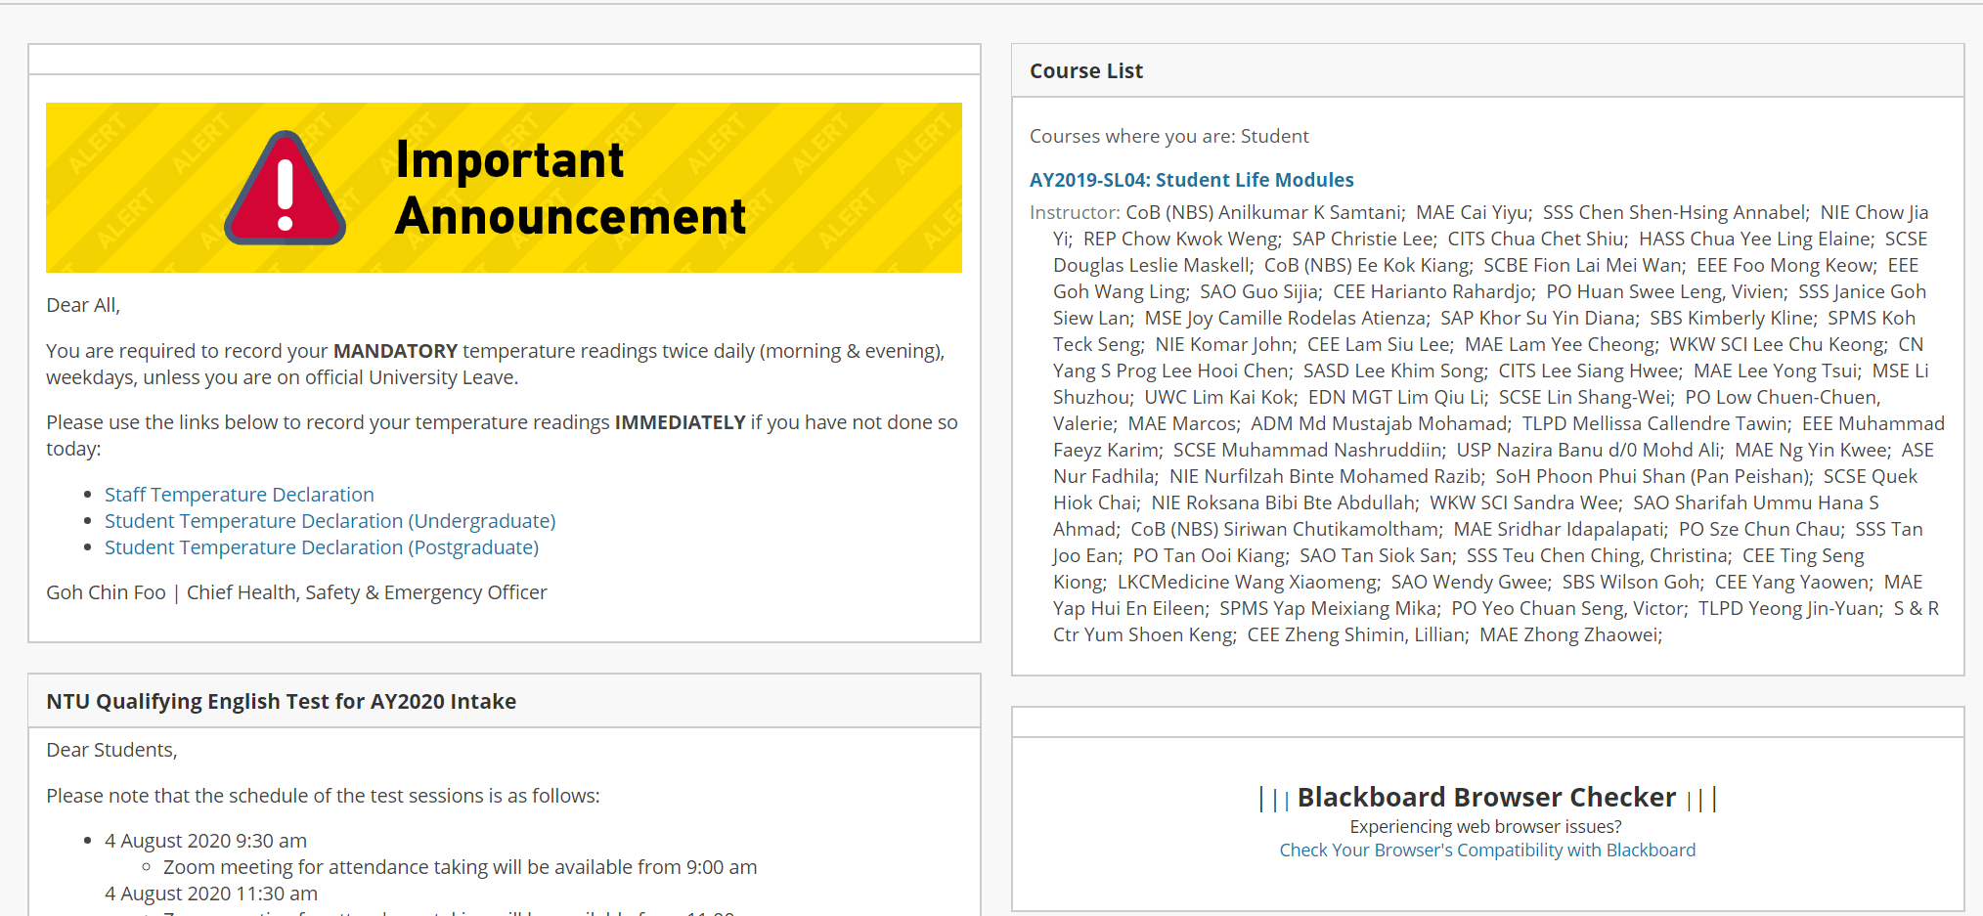

1. Administrator account – the person who is managing the LMS from day to day as of now.
   * Allow the admin to manually add the names of lecturers who want to conduct classes through this LMS (for now I guess we can assume that lecturers will email the Admin directly for requests)
   * Lecturers will also be registered to the LMS through Facebook. They can then be free to set up classes which students can register for in the LMS.
   * Lecturers should be able to post announcements which will appear on the dashboards of students who are registered for that class

*Refer to the screenshot below to see roughly how the course page should look like

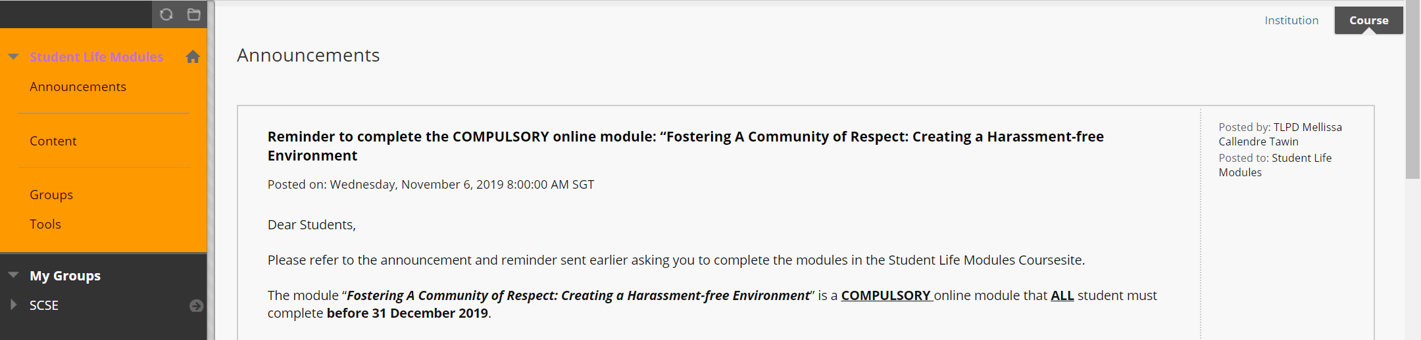

Students will be brought to the respective course page after clicking on a course on the main page. The course page should contain links to bring students to subsequent pages( that are all listed below) that are specific to this course.

1. Quizzes Page – This is the page students go to do their quizzes
   * Lecturers can create a quiz page on the LMS and open the quiz with a deadline for students to attempt within the deadline
   * Students can check the number of attempts they have left and how much they scored on the main page to the quizzes page.
   * System to record the scores of the students for lecturers to collate at the end of a semester

*can refer to APIs like this to integrate quizzes in lms (<https://www.classmarker.com/online-testing/api/developers/>)

1. Assignment Page - Where students can view and submit their assignments
   * Lecturers can upload PDF files of assignment details which students can open to view
   * The website should also allow an option for students to submit their assignments to their lecturers
   * Lecturers can download the submitted files for viewing
   * Lecturers should be able to post a score to the students for their assignment which is recorded and shown in the website as well.
2. Contents Page – Where students can view course materials and access the recorded lectures.
   * There should be an option for lecturers here to upload a video recording of their lectures which students can access
   * Lecturers should be able to upload course materials (slides/ word docs) as materials for the lessons
   * Students should be able to access and download the course materials from this page
   * Students should be able to view the recorded lecture that was uploaded on the page too (there should be a link to access the uploaded recorded lecture)
3. Facebook Messenger
   * It should be an overlay that students can use on any page of the LMS. Else you can create a link that students can use to assess facebook messenger to message their lecturers.
   * I was hoping you could integrate facebook messenger (if possible) on this website as well where students can easily access to message their lecturers for consultation/ queries.

Also, as a requirement, I was hoping that the LMS is able to host a large number of people at any one time. I am looking at about 700-1000 people so do you think it will be feasible?