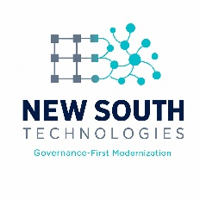
A NEW SOUTH TECHNOLOGIES PUBLICATION | JUNE 2026

THE NEW SOUTH
MODERNIZATION BLUEPRINT

A Governance-First Guide to Legacy Transformation
How to modernize critical systems without stopping the mission.
ZERO DOWNTIME  Continuous Delivery | CONTINUOUS ATO  Always Audit-Ready | STRANGLER FIG  Risk-Free Migration

01 | Introduction — Why Most Modernization Fails

Why Most Modernization Fails (And How to Avoid It)
Modernization is not a technology upgrade — it is a risk management exercise. Too many federal agencies attempt "Big Bang" cutover strategies that promise speed but deliver downtime, budget overruns, and audit findings.

⚠ The Big-Bang Approach  Years of work before any delivery. Everything changes at once. One failure takes down the entire mission. Audit findings discovered only at the end.  Result: Budget overruns, downtime, and failed authorizations. | ✔ The Governed Approach  Value delivered every sprint. Each component migrated individually. Compliance artifacts generated automatically. The mission never stops.  Result: On-time, on-budget, always authorized.

Our Governed Modernization Framework prioritizes:
- Continuity: Zero unplanned downtime — users never experience an interruption.
- Compliance: Audit-ready artifacts generated in real-time at every sprint.
- Incremental Value: Delivering measurable outcomes every 2 weeks, not at year two.

02 | The Framework — Three Pillars of Our Approach

The Three Pillars of Our Approach
Every New South modernization engagement rests on three mutually reinforcing pillars. Together they eliminate the compliance wall, protect mission continuity, and deliver value at speed.

1. STRATEGIC DISCOVERY & SCOPE MAPPING
Data Flow Analysis: Identifying where PII/CUI lives across every legacy component.
Control Mapping: Linking existing NIST 800-53 controls to specific legacy system components.
Risk Profiling: Categorizing components by criticality (High/Medium/Low) to prioritize migration sequence.

2. INCREMENTAL MIGRATION — The Strangler Fig Pattern
Step A: Intercept traffic via an API Gateway — the legacy system keeps running.
Step B: Rebuild one business function (e.g., User Authentication) as a microservice.
Step C: Route traffic to the new service while keeping the legacy monolith operational.
Step D: Repeat until the legacy system is fully strangled and safely decommissioned.

3. GOVERNED AGILITY PIPELINES — Compliance Automated
Policy-as-Code: Security rules enforced via Terraform/Ansible — no manual checklist required.
Automated Evidence: Every build generates a compliance log entry directly into the SSP.
Continuous Monitoring: Real-time dashboards show control status to the ISSO at all times.

03 | Implementation Roadmap — 6-Month Timeline

Our 6-Month Implementation Timeline
Structured into six progressive phases, this roadmap takes your agency from legacy inventory to full Authorization to Operate — without pausing mission operations at any point.

PHASE | DURATION | KEY ACTIVITIES | OUTCOME
1. Assessment | Month 1 | Data mapping, control gap analysis, architecture design | Validated Scope & Risk Profile
2. Foundation | Month 2 | CI/CD pipeline setup, security baseline, DevSecOps tools | Secure Environment Ready
3. Pilot | Month 3 | Move lowest-risk component first. Validate control automation | First Increment Live & Audited
4. Scaling | Months 4–5 | Rapid iteration on remaining components. Continuous ATO updates | 60% of System Modernized
5. Cutover | Month 6 | Final integration, legacy decommission, full ATO sign-off | Full Modernization Complete
6. Optimization | Ongoing | Performance tuning, cost optimization (FinOps) | Sustainable Operations

The Governing Principle
Every phase gate requires documented evidence before proceeding. No phase is marked complete until the compliance artifacts are generated, reviewed, and accepted. This means the ATO is never at risk — it evolves with the project.

04 | Risk Mitigation — Addressing Top Federal Concerns

Addressing the Top Federal Concerns
Every agency CIO asks the same four questions before committing to a modernization program. Here are our answers.

CONCERN | MITIGATION
"What if the old system breaks?" | The legacy system remains active as a live fallback until the new component is proven stable for 30 consecutive days. No data is lost, no mission is interrupted.
"How do we maintain ATO during migration?" | We use Incremental Authorization — each new component receives its own mini-ATO before going live. The overall system authorization is maintained continuously.
"Can we afford the downtime?" | Zero-downtime migrations are our standard. Users experience no service interruption because traffic is routed dynamically between old and new components.
"Is the new system actually secure?" | Security is built in from Day 1, not added at the end. Automated scans run on every commit. If a vulnerability is found, the build fails and is blocked from deployment.

“Modernization without governance is just technical debt with a new label.”
— New South Technologies Engineering Principle

05 | Next Steps — Ready to Transform Your Mission?

Ready to Transform Your Mission?
Modernization doesn't have to be a gamble. With a governed, incremental approach, you can achieve speed, security, and sustainability simultaneously — and keep the mission running the entire time.

Contact Us for a Free Gap Analysis
Let us map your legacy system against our Governed Modernization Framework — at no cost.

✉ Email: info@newsouthtechnologies.com
🌐 Web: www.newsouthtechnologies.com
✆ Phone: [Insert Phone Number]

“We don’t just move code. We build the future of your agency’s operations.”
— New South Technologies
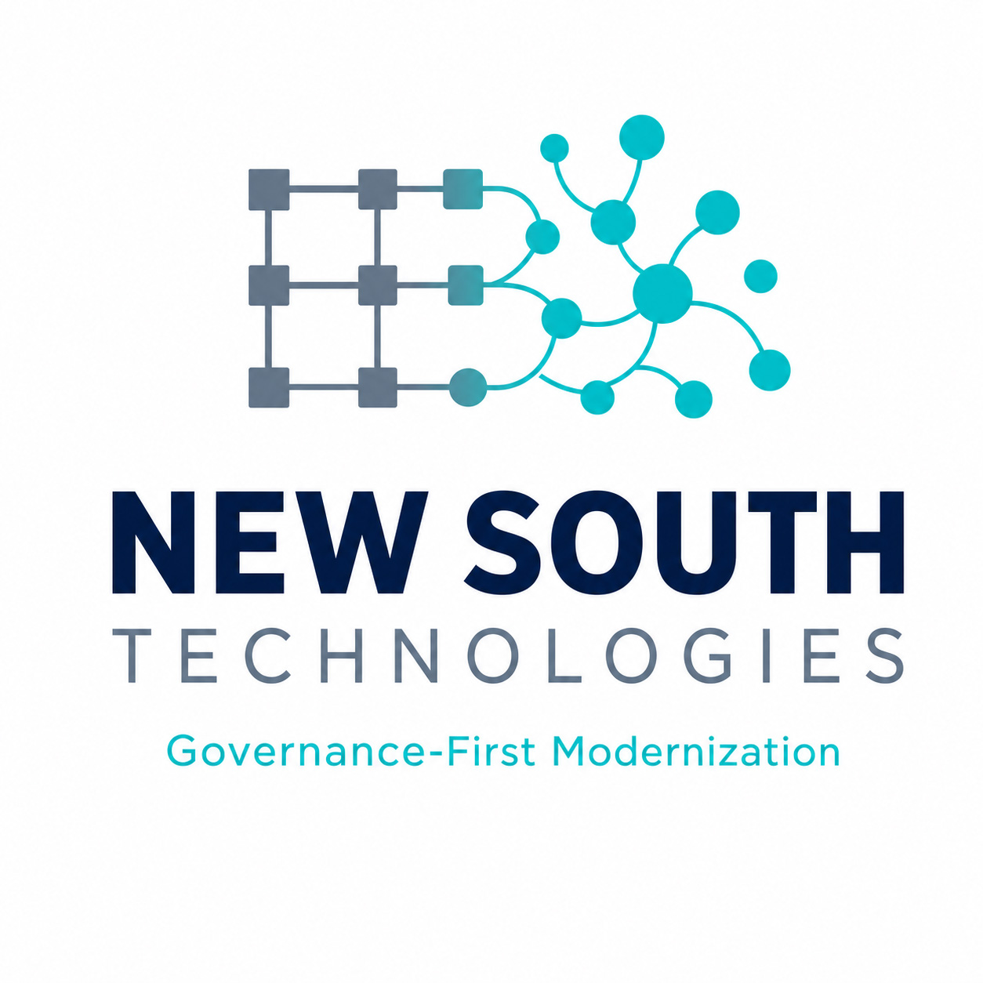
NEW SOUTH TECHNOLOGIES
Governance-First Modernization

© 2026 New South Technologies. All Rights Reserved.
This document is proprietary and confidential. For executive distribution only.

