Moderated Learning Management System (LMS)

- Introduction
  - Purpose
The document is a description of how the Moderated LMS will be built for it to satisfy the Software Requirements Specification (SRS). It covers the architecture, class design and patterns, the database system and the behavioural models. The implementation will only start after the design passes Gate 2 (G2).

  - Design principles
- Simplicity: The design is sized for one developer in a 2 week implementation window. One process, one local database file and a console interface.
- Testability: here the tie and password hashing are included, this helps with the late penalty boundaries so they can be tested with no database and a fixed clock.
- Separation of concerns: we have four layers (presentation, application, domain, and infrastructure) and each only uses the layer under it.
- Security by inversion: the application and domain layers depend on interfaces and not on SQLite or directly on the password library.
- Security: only the repositories contain SQL, the audit lo cannot be edited and authorization is checked in the services.

  - Where is each task covered?
- Architecture: style, component diagram, rationale and a rejected alternative. Covered in section 2
- Class diagram: visibility, types, multiplicities, inheritance, interfaces, two or more patterns, SOLID. Covered in section 3
- Behavioural models: state machine, swimlane activity diagram, two sequence diagrams. Covered in section 4.
- Database design: ERD to 3NF, data dictionary, SQL schema, mapping to classes. Covered on section 5.
  - Conventions
Diagrams use UML 2 notation. Visibility is shown as - (private) and + (public). Times are stored in UTC as ISO 8601 text and marks as whole numbers of hundredths of a mark (decision DD-2). Requirement identifiers (FR-nn, NFR-nn), use case identifiers (UC-nn) and conflict identifiers (C-nn, D1, D2, R-1).
- Architecture
  - Chosen style
The system is organised in four layers. The presentation layer is the console interface. The application layer has one service class per group of use cases. The domain layer holds the entities, the business rules (late penalty, lateness, and state transitions) and the interfaces ("ports") that the lower layer must implement. The infrastructure layer implements those interfaces with SQLite, the system clock and a password-hashing library, and stores submitted files on the local disk (Figure 1).
This is the Layered Architecture pattern in Sommerville (2016, section 6.3, PDF p. 233): each layer relies only on the layer beneath it, a layer can be replaced if its interface is kept, and the pattern suits systems with multilevel security. Its listed disadvantages are that a clean separation is hard to keep and that requests pass through several layers. Here all layers run in one process, so the cost of passing through layers is small.
  - Why use this style?
- Security: NFR-03, NFR-04, NFR-05, NFR-10. The architecture responds by a layered structure where security matters, with critical assets in the innermost layers. Password hashes and marks are reachable only through the repositories and the hasher, authorisation is checked in the services, not only in the console menus, only repository classes contain SQL. This is supported by Sommerville (2016, section 6.1).
- Performance: NFR-01, NFR-02. The architecture responds by in-process calls between layers, and indexes on the foreign keys and lookup columns used by the services. Sommerville recommends few, larger components when performance is critical.
- Testability: NFR-12 and the boundary tests of FR-14. The architecture responds to this by domain rules that depend only on interfaces. A FixedClock and in-memory fakes allow unit tests with no database, so the deadline +1 second and +72 hours cases are exact.
- Offline, single machine: NFR-09. The architecture responds to this by one process and one local SQLite file. There are no network components to install or secure.
- Change: the late-penalty rule is a stakeholder policy (HoD) that may change. The rule sits behind the IPenaltyPolicy interface (Strategy pattern, Section 3.3). Replacing it does not touch MarkingService.
- Maintainability: NFR-11. Source folders follow the layers, so a reviewer can find every class from the component diagram.

  - Alternatives that were considered and rejected
- Client-server: Services delivered by servers that clients access, often from different locations (section 6.3.3, PDF p. 236). This was rejected because the version 1.0 runs on one computer, offline. A server process adds installation, ports and failure modes that school technicians must manage (see decision C12 and risk R7), and SQLite is not a network database server.
- Model-View-Controller (MVC): it separates presentation and interaction from the data, suited to systems with several ways to view and interact with the same data (section 6.3, PDF p. 231). Rejected because the LMS has one console interface, so the view/controller split would add code for little gain, which is the disadvantage the book lists for simple interactions. The presentation layer still keeps input handling apart from the services.
- Repository architecture (shared data store): here all components share data only through a central repository (section 6.3.2, PDF p. 235). This was rejected because of the use case logic (penalty, state transitions). It (logic) needs direct calls and rules, not data-triggered components.

  - Component diagram
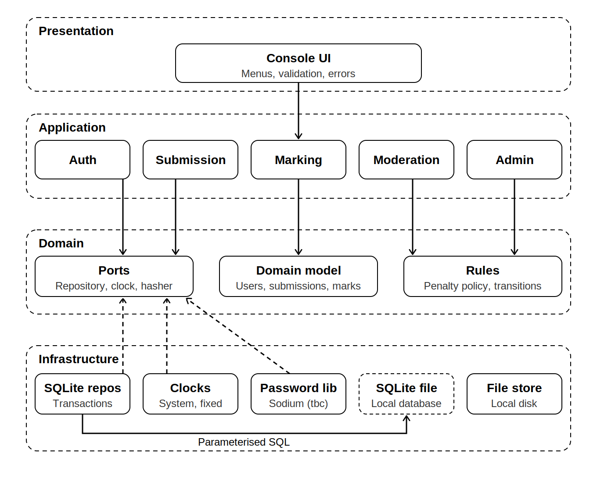

  - Component responsibilities
- Console UI (ConsoleApp). It shows a menu for the logged-in role, reads and validates input, displays results and error messages, and handles every exception at the top level so the program never crashes. It depends on application services.
- Application services. Its responsibility is a one service per use case group: AuthService (UC-01), SubmissionService (UC-02, UC-10, and UC-11), MarkingService (UC-08, UC-14), ModerationService (UC-09, UC-12, and UC-16), AdminService and similar services (UC-03 to UC-07). Each checks authorisation, runs one transaction per operation, and records audit entries. This depends on domain model, rules, ports
- SQLite repositories. Its responsibilities are to implement the repository interfaces with parameterised statements, SqliteDatabase and TransactionScope manage the connection and transactions. This is dependent on SQLite.
- Clocks, password library, file store. Its responsibilities are SystemClock and FixedClock, SodiumPasswordHasher (library to be confirmed, risk R5), copies of submitted files on the local disk. Dependent on the OS.
- Domain model and rules. Entities, the User hierarchy, lateness calculation, the IPenaltyPolicy strategy and the state transitions of a submission. Only depends on ports.
- Ports (interfaces). IUserRepository and the other repository interfaces, IClock, IPasswordHasher.

  - Key design decisions
ID | Decision | Alternative and reason
DD-1 | Time comes from IClock and is stored as UTC ISO 8601 text. Days late are computed in the domain layer from timestamps. | Calling the system clock directly would make the boundary tests (deadline, +24 h, +72 h) impossible to run exactly.
DD-2 | Marks, maximum marks and deductions are integers in hundredths of a mark. A deduction is 10% of the maximum mark per day, rounded half up to a hundredth. | Floating-point numbers can give 4.999999 instead of 5.0 in comparisons. Whole numbers make unit tests exact.
DD-3 | Every version of a submission is a row; the current version is the highest version_no. | A "current version" column would duplicate information that can be derived and could disagree with the version rows.
DD-4 | Submitted files are stored on the local disk under a name built from the submission and version ids, the database stores the path. | Storing files as BLOBs would grow the database file and slow backups. Id-based names also prevent path-traversal attacks from user-supplied file names.
DD-5 | Authorisation is checked in the services using User::canPerform(Action) plus ownership checks (the lecturer teaches the course, the HoD heads the department, the student owns the submission). | Checking only in the menus would leave the rules unprotected if a new interface is added.
DD-6 | Each service operation runs inside one TransactionScope. If an exception is thrown the scope rolls back. | Separate commits per statement could leave a mark without its audit entry (NFR-07).
DD-7 | The User hierarchy is a class hierarchy in C++ and a single table with a role column in the database. UserFactory builds the right subclass from a row. | One table per subclass would add joins and empty tables because the subclasses add no columns.
DD-8 | The audit entry is written directly by the service in the same transaction as the mark change. | An Observer that listens for mark changes would decouple auditing, but it would run outside the transaction, so a failure could leave a change without its audit entry.
DD-9 | The penalty is calculated when the lecturer marks, from the current version's timestamp, and the deduction is stored. | Recalculating at read time would change old marks if the rule or an extension changed later.
DD-10 | An extension is a separate row; the latest extension for the student and assignment sets the effective deadline, and it must be later than the assignment deadline. | Editing the deadline on the assignment would extend it for everyone, and the extension history (who, when, why) would be lost.

- Class Design
  - Class diagrams

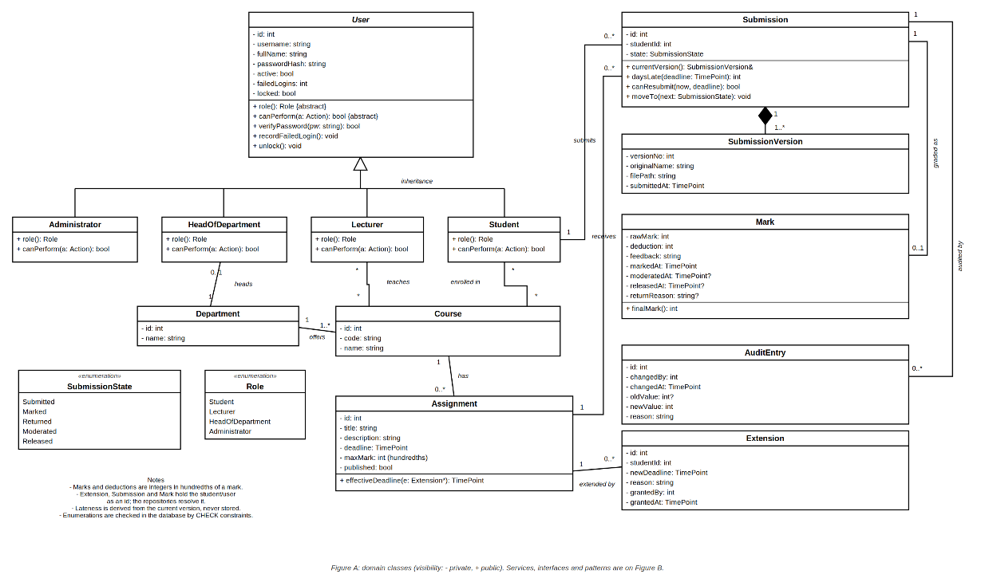

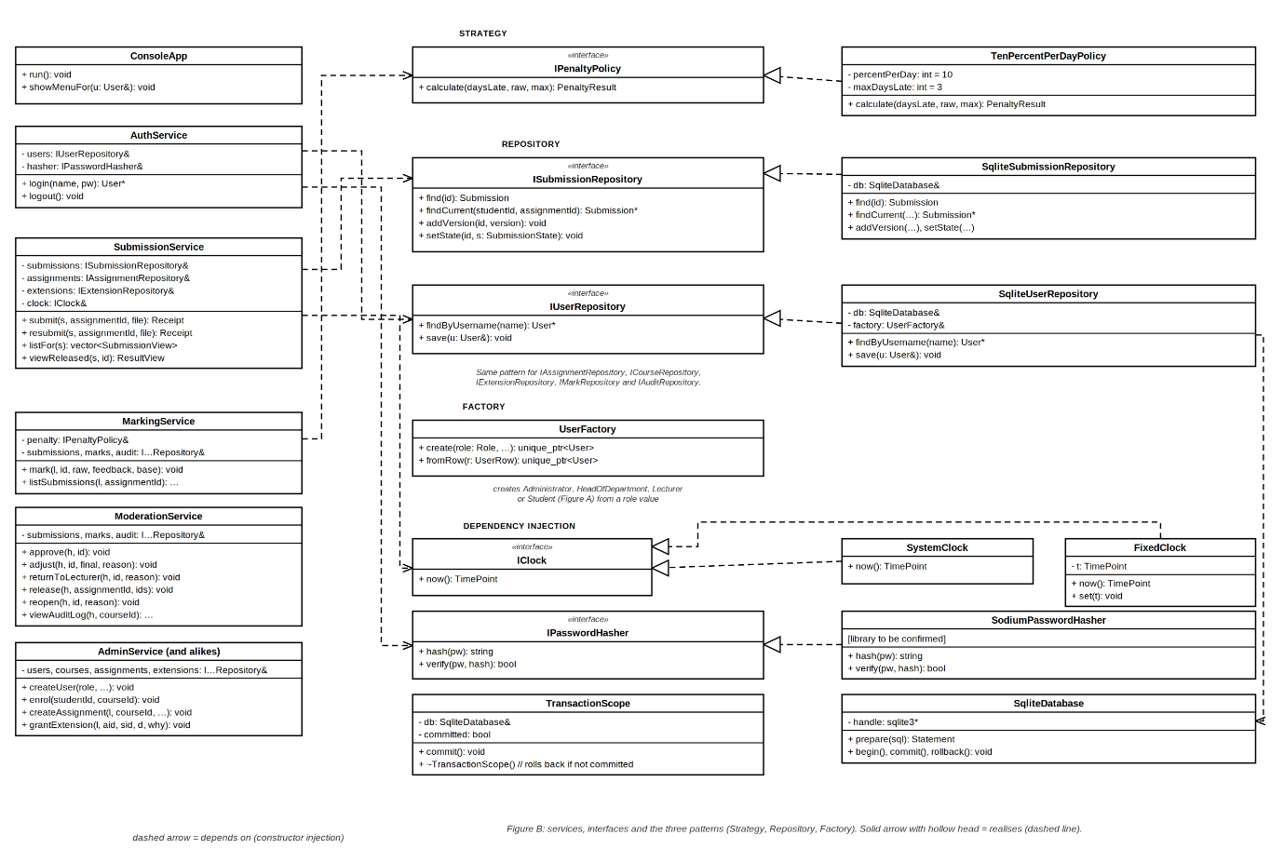

  - Main classes and responsibilities
- User (abstract) and its four subclasses. Its responsibility is identity, status and password verification. role () and canPerform(Action) are abstract and implemented by Student, Lecturer, HeadOfDepartment and Administrator (polymorphism). The key collaborators are UserFactory, IPasswordHasher.
- Assignment. It has the title, deadline and maximum mark, it works out the effective deadline for a student from that student's extension, if any. Key collaborators are extension and SubmissionService.
- Extension. It has one extension granted to one student which is a new deadline, reason, grantor and time. The key collaboration is an assignment.
- Department and Course. It has academic structure. A department owns courses and has at most one head. The key collaboration is AdminService.
- SubmissionVersion. This is one version of the work: number, stored file path and timestamp. It is also composed in Submission. Key collaborator is Submission.
- Submission. Here we have one student's work for one assignment and its life-cycle state. Works out days late whether a resubmission is allowed, and moves to the next state only through a legal transition. The key collaborators are SubmissionVersion and Mark.
- Mark. There is raw mark, deduction, feedback, and who marked, moderated and released it. finalMark() = raw mark - deduction. Submission is they key collaborator.
- MarkingService. The responsibility is to mark with feedback (UC-08), validate the mark, ask, IPenaltyPolicy for the deduction, and store the mark and the audit entry in one transaction. This includes IPenaltyPolicy and repositories as key collaborators.
- SubmissionService. Here we submit and resubmit (UC-02), list assignments and view released marks (UC-10, UC-11). Repositories and IClock are our key collaborators.
- ModerationService. The responsibility is to approve, adjust, return, release and reopen marks, and view the audit log (UC-09, UC-12, and UC-16) where repositories and IClock are the key collaborators.
- AuditEntry. This is an immutable record of one creation or change of a mark with IAuditRepository as the key collaborator.
- AuthService. We have the log-in, lock-out and log-out. IUserRepository and IPasswordHasher are our key collaborators.
- IPenaltyPolicy and TenPercentPerDayPolicy. Uses the late-penalty rule as a replaceable strategy. MarkingService is the key collaborator.
- UserFactory. Creates the right User subclass from a role value or a database row. SqliteUserRepository and AdminService as key collaborators.
- IClock, IPasswordHasher, SqliteDatabase and TransactionScope. Time source, password hashing, database connection and RAII transaction are used here with services and repositories as key collaborators.
- I...Repository, SQLite...Repository. Persistence ports and their SQLite implementations are the responsibilities. SqliteDatabase is used as the key collaborators.

  - Design Patterns

- Strategy : The problem posed in this project with this is The HoD's late-penalty rule (10% of the maximum per day, up to three days, then zero) is stakeholder policy that may change, and it must be testable on its own (FR-14). The solution as classes is IPenaltyPolicy with calculate (daysLate, raw, max). TenPercentPerDayPolicy implements it. MarkingService receives the policy through its constructor. The consequence(s) and/or trade-offs could be that a new rule is a new class with no change to MarkingService. This costs one more interface and class, and the policy must be passed in at start-up.
- Factory : The problem here is that a user row must become the right subclass (Student, Lecturer, HeadOfDepartment or Administrator) in several places (log-in, account management). The solution in terms of classes is UserFactory::create (role, ...) and fromRow(row) return unique_ptr<User>. The consequence(s) and trade-off(s) are that the construction rules live in one place and a new role needs one change there. The cost is that the factory must be aware of every subclass.
- Repository (data access). The problem is that services must not contain SQL, and tests must run without a database (NFR-04, NFR-12). The solution is to have one interface per aggregate (IUserRepository, ISubmissionRepository, ...) and a SQLite implementation of each. Only these classes use SQL, always with parameterised statements. The trade-off(s) and consequence(s) are that persistence can be replaced or faked. The cost is that there are many small classes and a mapping step between rows and objects.

  - SOLD principles

Principle | How the design follows it | Where
Single responsibility | Each service handles one group of use cases; each repository one aggregate; the penalty rule, the clock and the hasher are separate classes. | Services, repositories, IPenaltyPolicy, IClock
Open/closed | A new penalty rule or a new Role is added by a new class, not by changing the services. | TenPercentPerDayPolicy, User subclasses
Liskov substitution | Any User subclass can be used where a User is expected: subclasses implement role() and canPerform() with the same meaning and do not add stricter preconditions. | User hierarchy
Interface segregation | Small, focused interfaces (IClock, IPasswordHasher, one repository per aggregate) instead of one large data-access interface. | Ports
Dependency inversion | Services depend on interfaces. Concrete SQLite, clock and hasher objects are created in main() and passed in through constructors. | Services, Figure B

- Behavioural Models
  - State machine: Submission life cycle
The brief's life cycle (submitted, late, marked, moderated, and released) is refined in two ways. First, lateness is not a state: it is a property of the current version (days late) that runs alongside the life cycle (conflict C16). Second, a state Returned is added so that a mark the HoD sends back cannot be changed by the student, which keeps decision D2 consistent (Section 8 lists the matching changes to the SRS).

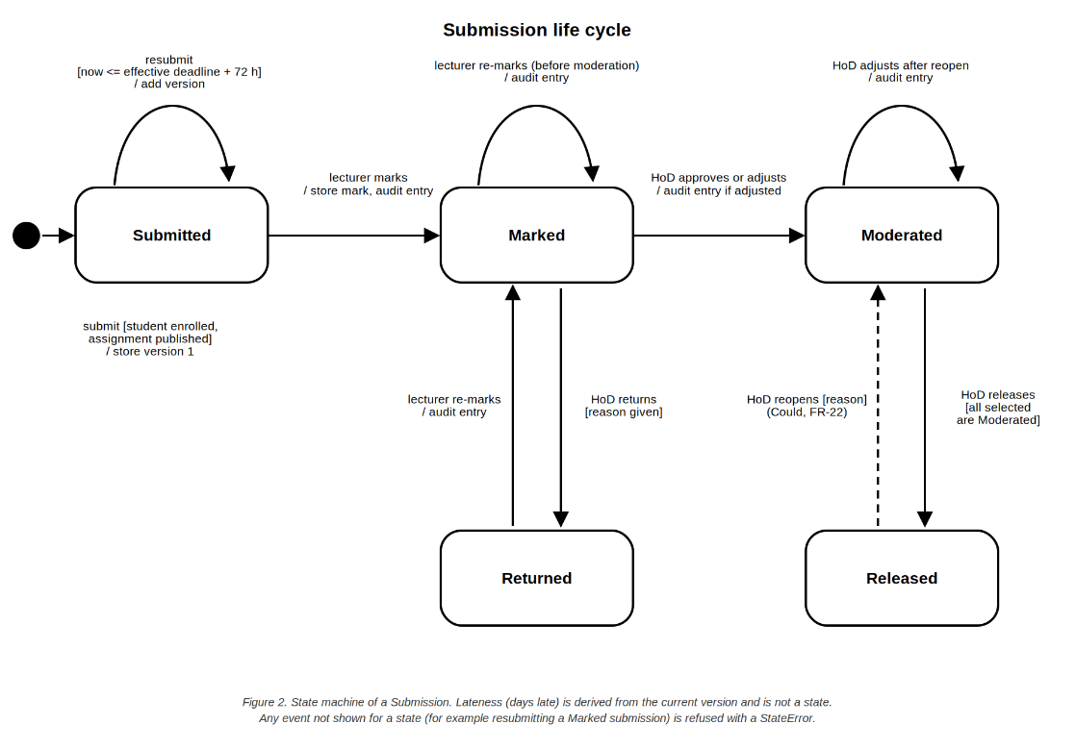

From | Event | Guard | Action | To | Req.
(start) | Student submits | Enrolled; assignment published | Store version 1 | Submitted | FR-10, FR-13
Submitted | Student resubmits | Now <= effective deadline + 72 h | Add version; warn if late | Submitted | FR-11, FR-12
Submitted | Lecturer marks | Raw mark in range; feedback given | Store mark; audit entry | Marked | FR-16, FR-23
Marked | Lecturer re-marks | Reason given | Update mark; audit entry | Marked | FR-16, FR-23
Marked | HoD approves or adjusts | Reason given if adjusted | Store; audit entry if adjusted | Moderated | FR-20, FR-23
Marked | HoD returns | Reason given | Store return reason | Returned | FR-20
Returned | Lecturer re-marks | Reason given | Update mark; audit entry | Marked | FR-16, FR-23
Moderated | HoD releases | All selected are Moderated | Set released time and HoD | Released | FR-21
Released | HoD reopens | Reason given (“Could”) | Set state; audit entry | Moderated | FR-22
Moderated | HoD adjusts after reopen | Reason given | Update mark; audit entry | Moderated | FR-22, FR-23

Note: any event that is not in this table is refused with a StateError and the submission is unchanged. Submission::moveTo (next) enforces the table, so no service can make an illegal transition.
  - Activity diagram(including swimlanes)
The diagram follows one submission from the student's work to the released mark. The lanes show who does each step which is the student, the system (the services), the lecturer and the Head of Department. The loop at the decision "Improve work and still within the late window?" is the resubmission rule (R-1, D1). The HoD's return path leads back to the lecturer (state Returned). Sommerville uses activity diagrams for data-driven models (section 5.4.1, PDF p. 202).

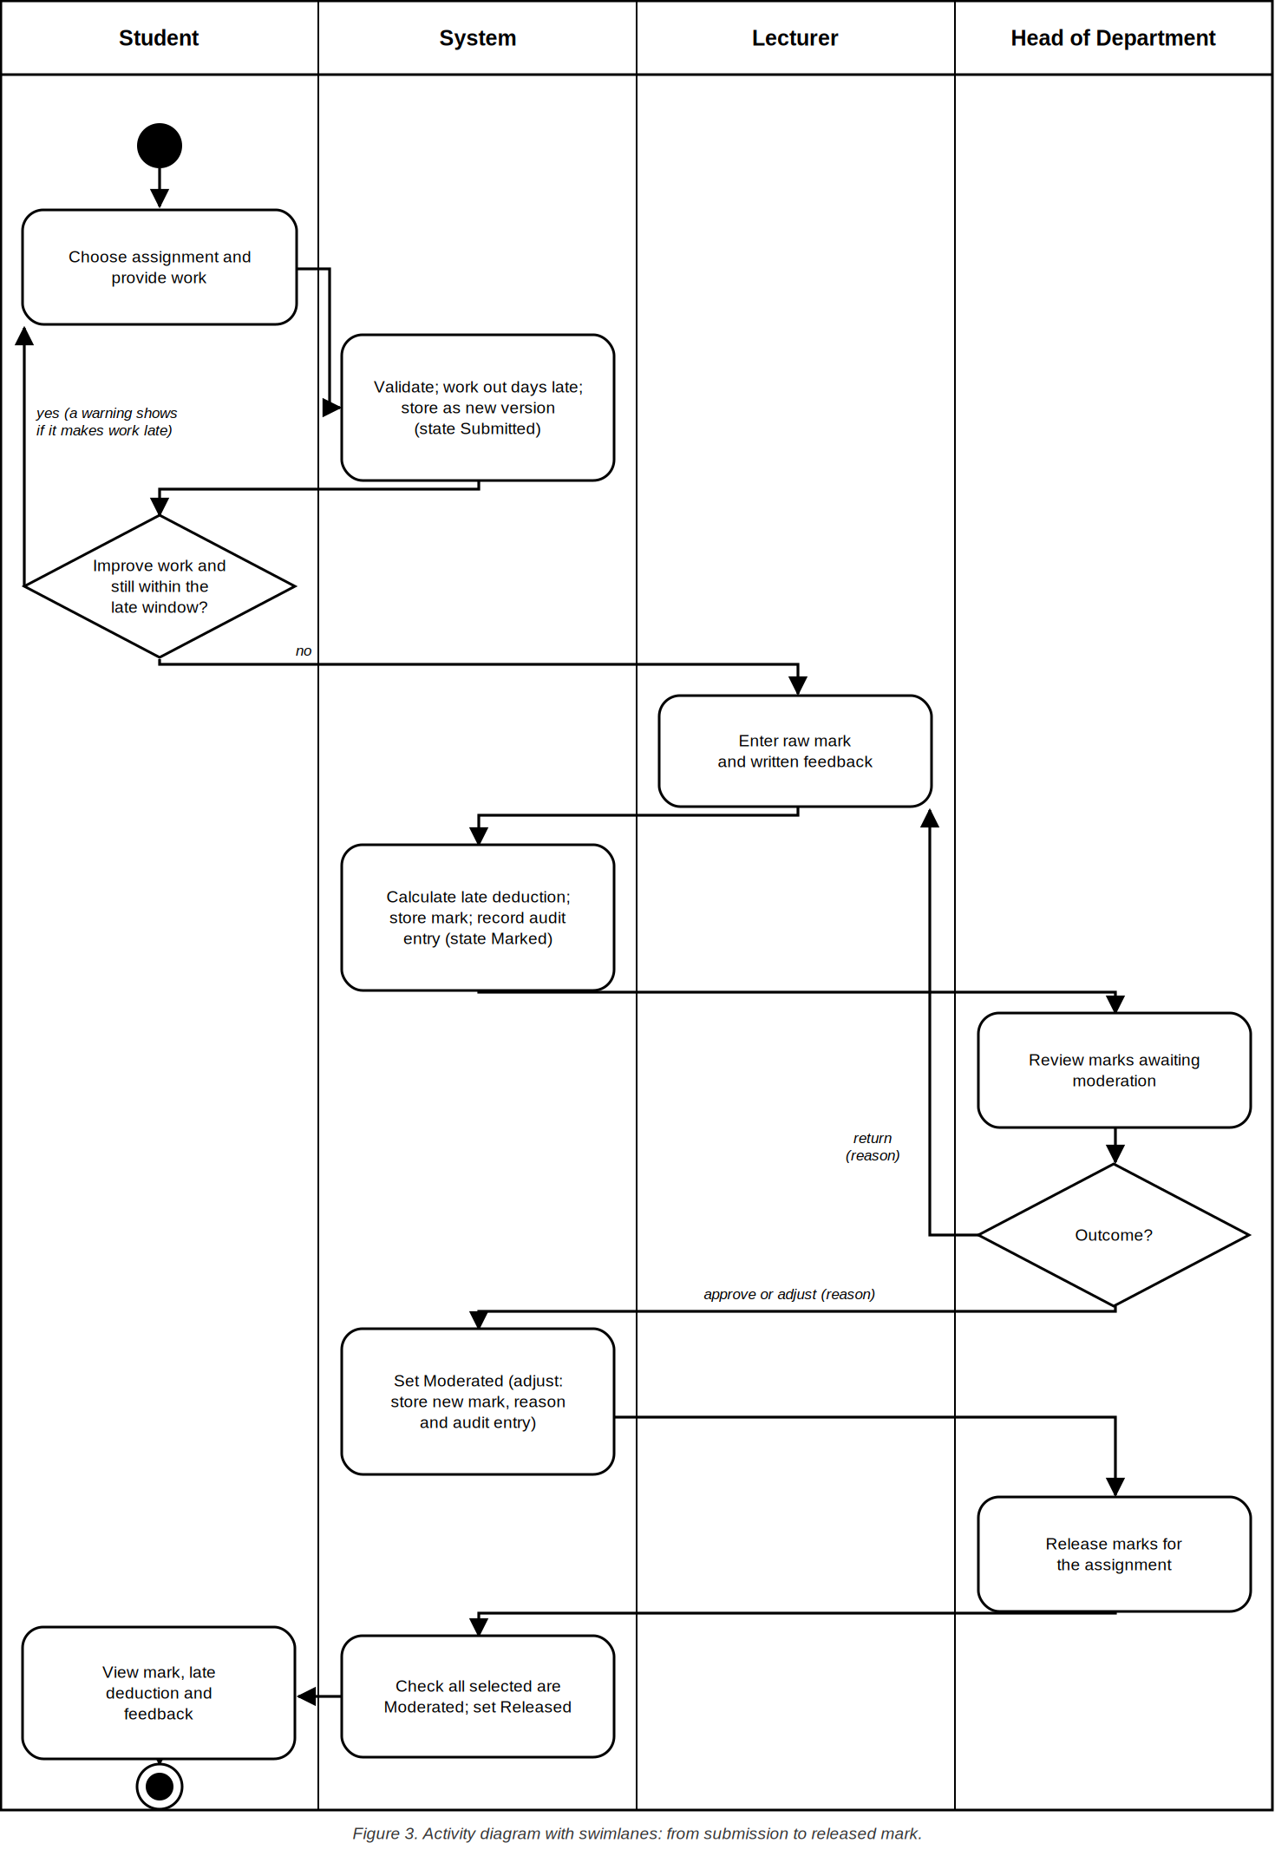
  - Sequence Diagrams
Submit assignment (UC-02)
The service reads the assignment, the student's latest extension and the clock, then works out the effective deadline and the days late. If the student has no submission, the first submission is stored whether it is on time or late. If a submission exists, a resubmission is allowed only while its state is “Submitted” and it is no more than three days late; when it is after the deadline the student must confirm the warning first. Otherwise the service refuses with a StateError (exception flow E4).
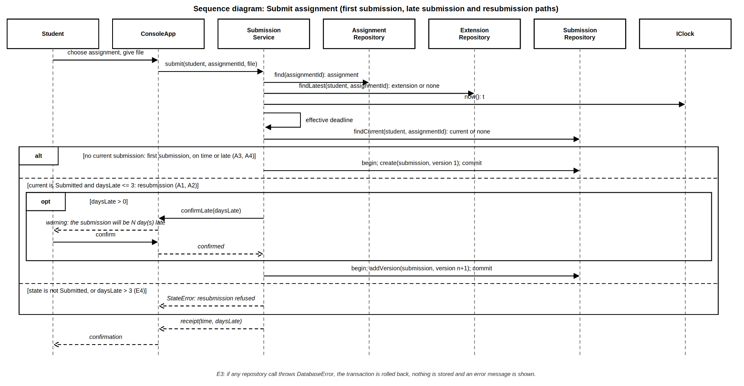

Moderate and release marks (UC-09)
The HoD sees the marked submissions of the department and chooses an outcome for each: approve, adjust with a reason, or return with a reason. An adjustment writes the new mark and its audit entry in one transaction. Release is allowed only when every selected submission is “Moderated”, otherwise nothing is released (exception flow E1).
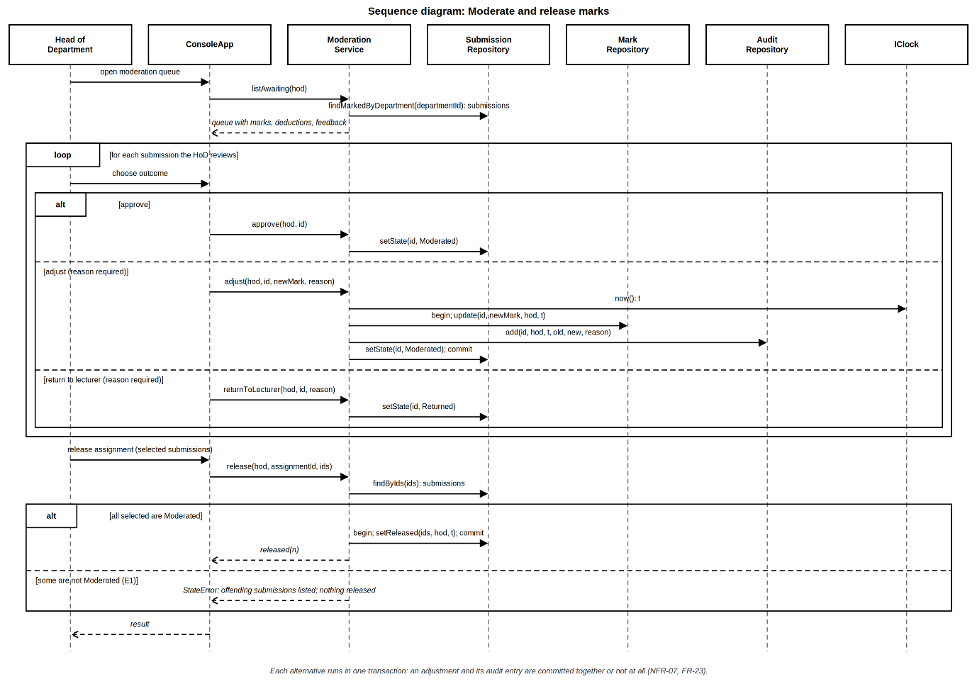
- Database Design
  - Entity-relationship Diagram(ERD)

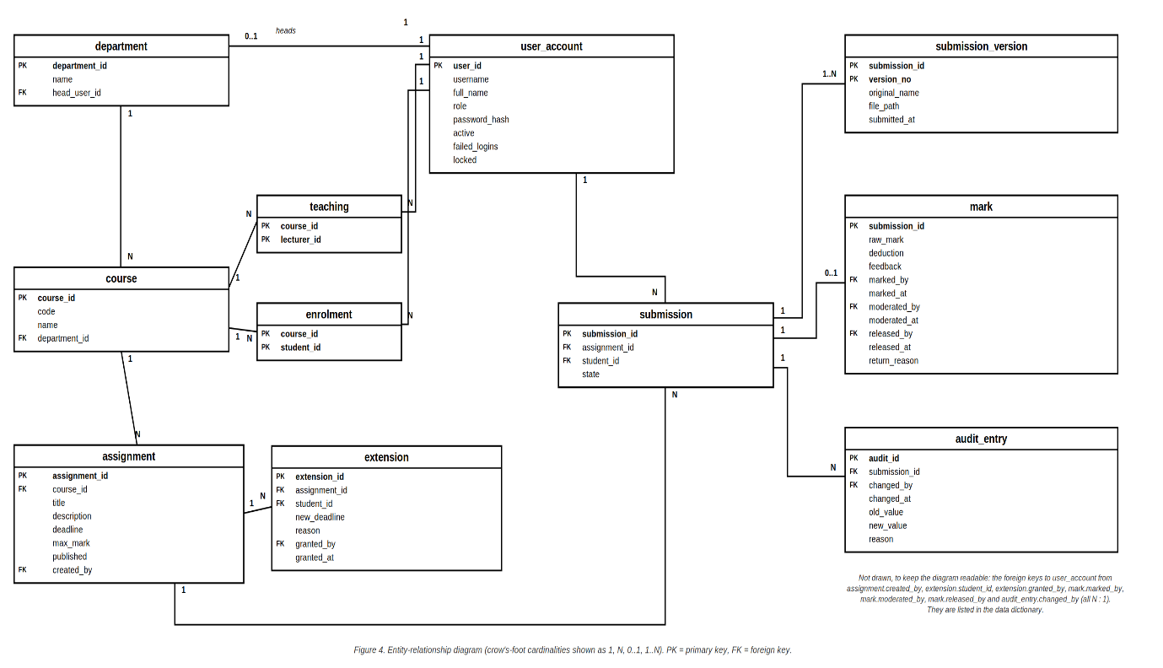
  - Normalisation to 3NF

1NF: this tests if every column holds one atomic value and there are no repeating group. The versions are rows of submission_version, and enrolments and teaching are junction tables, so no list is stored in a column.
2NF: tests in tables with a composite key, every other column depends on the whole key. The result(s) are that teaching and enrolment have no other columns. In submission_version, original_name, file_path and submitted_at depend on (submission_id, version_no) together.
3NF: this tests that no non-key column depends on another non-key column. Department data is reached through department_id, not repeated in course. The final mark is not stored (it is raw_mark - deduction). The current version number is not stored (it is the highest version_no).

  - Data Dictionary
department - A department of the school, it may have one head.

Column | Type | Constraints | Description
department_id | INTEGER | PRIMARY KEY | Surrogate key.
name | TEXT | NOT NULL UNIQUE | Department name.
head_user_id | INTEGER | UNIQUE, FK user_account | The Head of Department; NULL until one is appointed.

user_account - One row per person who can log in (single-table mapping of the User hierarchy).
Column | Type | Constraints | Description
user_id | INTEGER | PRIMARY KEY | Surrogate key.
username | TEXT | NOT NULL UNIQUE | Log-in name.
full_name | TEXT | NOT NULL | Name shown in the application.
role | TEXT | NOT NULL, CHECK in 4 roles | Student, Lecturer, HeadOfDepartment or Administrator (discriminator).
password_hash | TEXT | NOT NULL | Salted hash string produced by the password library; never a plain password.
active | INTEGER | NOT NULL DEFAULT 1, CHECK 0/1 | 0 = account deactivated.
failed_logins | INTEGER | NOT NULL DEFAULT 0, CHECK >= 0 | Consecutive failed log-ins (FR-03).
locked | INTEGER | NOT NULL DEFAULT 0, CHECK 0/1 | 1 = locked until an administrator unlocks it.

course - A course offered by one department.
Column | Type | Constraints | Description
course_id | INTEGER | PRIMARY KEY | Surrogate key.
code | TEXT | NOT NULL UNIQUE | Course code.
name | TEXT | NOT NULL | Course name.
department_id | INTEGER | NOT NULL, FK department | Owning department.

teaching - Which lecturers teach which courses (many-to-many).
Column | Type | Constraints | Description
course_id | INTEGER | FK course, part of PK | Course.
lecturer_id | INTEGER | FK user_account, part of PK | Lecturer (role is checked by a trigger).

enrolment - Which students are enrolled in which courses (many-to-many).
Column | Type | Constraints | Description
course_id | INTEGER | FK course, part of PK | Course.
student_id | INTEGER | FK user_account, part of PK | Student (role is checked by a trigger).
assignment - Work set by a lecturer for a course.
Column | Type | Constraints | Description
assignment_id | INTEGER | PRIMARY KEY | Surrogate key.
course_id | INTEGER | NOT NULL, FK course | Course the work belongs to.
title | TEXT | NOT NULL | Title.
description | TEXT | NOT NULL DEFAULT '' | Instructions.
deadline | TEXT | NOT NULL | Deadline, ISO 8601 UTC text.
max_mark | INTEGER | NOT NULL, CHECK > 0 | Maximum mark in hundredths of a mark.
published | INTEGER | NOT NULL DEFAULT 0, CHECK 0/1 | 1 = visible to students.
created_by | INTEGER | NOT NULL, FK user_account | Lecturer who created it.
extension - An individual extension granted to one student (history is kept).
Column | Type | Constraints | Description
extension_id | INTEGER | PRIMARY KEY | Surrogate key.
assignment_id | INTEGER | NOT NULL, FK assignment | Assignment extended.
student_id | INTEGER | NOT NULL, FK user_account | Student who received it.
new_deadline | TEXT | NOT NULL | New deadline, ISO 8601 UTC text.
reason | TEXT | NOT NULL, CHECK length > 0 | Reason given (FR-08).
granted_by | INTEGER | NOT NULL, FK user_account | Lecturer who granted it.
granted_at | TEXT | NOT NULL | When it was granted.
submission - One row per student per assignment, holds the life-cycle state.
Column | Type | Constraints | Description
submission_id | INTEGER | PRIMARY KEY | Surrogate key.
assignment_id | INTEGER | NOT NULL, FK assignment | Assignment.
student_id | INTEGER | NOT NULL, FK user_account | Student.
state | TEXT | NOT NULL, CHECK in 5 states | Submitted, Marked, Returned, Moderated or Released.
Table constraint: UNIQUE (assignment_id, student_id)
submission_version - Each version of a submission, the highest version_no is the current one.
Column | Type | Constraints | Description
submission_id | INTEGER | FK submission, part of PK | Owning submission.
version_no | INTEGER | CHECK >= 1, part of PK | 1, 2, 3 ...
original_name | TEXT | NOT NULL | File name as the student supplied it.
file_path | TEXT | NOT NULL | Location of the stored copy on the local disk.
submitted_at | TEXT | NOT NULL | Timestamp of this version, ISO 8601 UTC text.
mark - The mark awarded to a submission (0 or 1 per submission).
Column | Type | Constraints | Description
submission_id | INTEGER | PRIMARY KEY, FK submission | Submission marked.
raw_mark | INTEGER | NOT NULL, CHECK >= 0 | Lecturer's mark before penalty, hundredths.
deduction | INTEGER | NOT NULL, CHECK 0..raw_mark | Late deduction applied at marking, hundredths. Final mark = raw_mark - deduction (derived, not stored).
feedback | TEXT | NOT NULL | Written feedback (FR-16).
marked_by | INTEGER | NOT NULL, FK user_account | Lecturer.
marked_at | TEXT | NOT NULL | When marked.
moderated_by | INTEGER | FK user_account | HoD who approved or adjusted; NULL until then.
moderated_at | TEXT | - | When moderated.
released_by | INTEGER | FK user_account | HoD who released; NULL until then.
released_at | TEXT | - | When released.
return_reason | TEXT | - | Reason given when the HoD returned it; cleared on re-mark.
audit_entry - Append-only record of every creation or change of a mark (FR-23).
Column | Type | Constraints | Description
audit_id | INTEGER | PRIMARY KEY | Surrogate key.
submission_id | INTEGER | NOT NULL, FK submission | Submission whose mark changed.
changed_by | INTEGER | NOT NULL, FK user_account | Who made the change.
changed_at | TEXT | NOT NULL | When.
old_value | INTEGER | - | Final mark before the change; NULL for the first mark.
new_value | INTEGER | NOT NULL | Final mark after the change.
reason | TEXT | NOT NULL, CHECK length > 0 | Reason for the change.

  - SQL schema
PRAGMA foreign_keys = ON;

CREATE TABLE user_account (
user_id INTEGER PRIMARY KEY,
username TEXT NOT NULL UNIQUE,
full_name TEXT NOT NULL,
role TEXT NOT NULL
CHECK (role IN ('Student','Lecturer','HeadOfDepartment','Administrator')),
password_hash TEXT NOT NULL,
active INTEGER NOT NULL DEFAULT 1 CHECK (active IN (0,1)),
failed_logins INTEGER NOT NULL DEFAULT 0 CHECK (failed_logins >= 0),
locked INTEGER NOT NULL DEFAULT 0 CHECK (locked IN (0,1))
);

CREATE TABLE department (
department_id INTEGER PRIMARY KEY,
name TEXT NOT NULL UNIQUE,
head_user_id INTEGER UNIQUE REFERENCES user_account(user_id)
);

CREATE TABLE course (
course_id INTEGER PRIMARY KEY,
code TEXT NOT NULL UNIQUE,
name TEXT NOT NULL,
department_id INTEGER NOT NULL REFERENCES department(department_id)
);

CREATE TABLE teaching (
course_id INTEGER NOT NULL REFERENCES course(course_id),
lecturer_id INTEGER NOT NULL REFERENCES user_account(user_id),
PRIMARY KEY (course_id, lecturer_id)
);

CREATE TABLE enrolment (
course_id INTEGER NOT NULL REFERENCES course(course_id),
student_id INTEGER NOT NULL REFERENCES user_account(user_id),
PRIMARY KEY (course_id, student_id)
);

CREATE TABLE assignment (
assignment_id INTEGER PRIMARY KEY,
course_id INTEGER NOT NULL REFERENCES course(course_id),
title TEXT NOT NULL,
description TEXT NOT NULL DEFAULT '',
deadline TEXT NOT NULL,
max_mark INTEGER NOT NULL CHECK (max_mark > 0),
published INTEGER NOT NULL DEFAULT 0 CHECK (published IN (0,1)),
created_by INTEGER NOT NULL REFERENCES user_account(user_id)
);

CREATE TABLE extension (
extension_id INTEGER PRIMARY KEY,
assignment_id INTEGER NOT NULL REFERENCES assignment(assignment_id),
student_id INTEGER NOT NULL REFERENCES user_account(user_id),
new_deadline TEXT NOT NULL,
reason TEXT NOT NULL CHECK (length(reason) > 0),
granted_by INTEGER NOT NULL REFERENCES user_account(user_id),
granted_at TEXT NOT NULL
);

CREATE TABLE submission (
submission_id INTEGER PRIMARY KEY,
assignment_id INTEGER NOT NULL REFERENCES assignment(assignment_id),
student_id INTEGER NOT NULL REFERENCES user_account(user_id),
state TEXT NOT NULL
CHECK (state IN ('Submitted','Marked','Returned','Moderated','Released')),
UNIQUE (assignment_id, student_id)
);

CREATE TABLE submission_version (
submission_id INTEGER NOT NULL REFERENCES submission(submission_id),
version_no INTEGER NOT NULL CHECK (version_no >= 1),
original_name TEXT NOT NULL,
file_path TEXT NOT NULL,
submitted_at TEXT NOT NULL,
PRIMARY KEY (submission_id, version_no)
);

CREATE TABLE mark (
submission_id INTEGER PRIMARY KEY REFERENCES submission(submission_id),
raw_mark INTEGER NOT NULL CHECK (raw_mark >= 0),
deduction INTEGER NOT NULL CHECK (deduction >= 0),
feedback TEXT NOT NULL,
marked_by INTEGER NOT NULL REFERENCES user_account(user_id),
marked_at TEXT NOT NULL,
moderated_by INTEGER REFERENCES user_account(user_id),
moderated_at TEXT,
released_by INTEGER REFERENCES user_account(user_id),
released_at TEXT,
return_reason TEXT,
CHECK (deduction <= raw_mark)
);

CREATE TABLE audit_entry (
audit_id INTEGER PRIMARY KEY,
submission_id INTEGER NOT NULL REFERENCES submission(submission_id),
changed_by INTEGER NOT NULL REFERENCES user_account(user_id),
changed_at TEXT NOT NULL,
old_value INTEGER,
new_value INTEGER NOT NULL,
reason TEXT NOT NULL CHECK (length(reason) > 0)
);

CREATE INDEX idx_course_department ON course(department_id);
CREATE INDEX idx_assignment_course ON assignment(course_id);
CREATE INDEX idx_extension_lookup ON extension(assignment_id, student_id, granted_at);
CREATE INDEX idx_submission_student ON submission(student_id);
CREATE INDEX idx_submission_state ON submission(assignment_id, state);
CREATE INDEX idx_audit_submission ON audit_entry(submission_id, changed_at);

CREATE TRIGGER audit_no_update BEFORE UPDATE ON audit_entry
BEGIN SELECT RAISE(ABORT, 'audit entries are append-only'); END;

CREATE TRIGGER audit_no_delete BEFORE DELETE ON audit_entry
BEGIN SELECT RAISE(ABORT, 'audit entries are append-only'); END;

CREATE TRIGGER department_head_is_hod BEFORE INSERT ON department
WHEN NEW.head_user_id IS NOT NULL AND
(SELECT role FROM user_account WHERE user_id = NEW.head_user_id) <> 'HeadOfDepartment'
BEGIN SELECT RAISE(ABORT, 'head must have role HeadOfDepartment'); END;

CREATE TRIGGER department_head_is_hod_upd BEFORE UPDATE OF head_user_id ON department
WHEN NEW.head_user_id IS NOT NULL AND
(SELECT role FROM user_account WHERE user_id = NEW.head_user_id) <> 'HeadOfDepartment'
BEGIN SELECT RAISE(ABORT, 'head must have role HeadOfDepartment'); END;

CREATE TRIGGER teaching_is_lecturer BEFORE INSERT ON teaching
WHEN (SELECT role FROM user_account WHERE user_id = NEW.lecturer_id) <> 'Lecturer'
BEGIN SELECT RAISE(ABORT, 'only a Lecturer can teach a course'); END;

CREATE TRIGGER enrolment_is_student BEFORE INSERT ON enrolment
WHEN (SELECT role FROM user_account WHERE user_id = NEW.student_id) <> 'Student'
BEGIN SELECT RAISE(ABORT, 'only a Student can be enrolled'); END;

  - Mapping from classes to tables

Class (Figure A) | Table | Difference and justification
User, Student, Lecturer, HeadOfDepartment, Administrator | user_account | Single-table mapping with a role column (DD-7): the subclasses add no columns, so separate tables would only add joins. The head of a department is stored on department.head_user_id.
Department | department | Direct. The 0..1 head association becomes a unique foreign key.
Course | course | Direct.
Lecturer-Course and Student-Course associations | teaching, enrolment | Many-to-many associations become junction tables. They are not classes in the domain model.
Assignment | assignment | Direct. maxMark and deadline map to max_mark and deadline text.
Extension | extension | Direct; history is kept, and the latest row sets the effective deadline.
Submission | submission | Direct. The current version is not stored (DD-3).
SubmissionVersion (composed in Submission) | submission_version | Composition becomes a child table with a composite key.
Mark | mark | One row per marked submission. finalMark() is derived and has no column. returnReason is stored here.
AuditEntry | audit_entry | Direct. Triggers make it append-only.
SubmissionState, Role (enumerations) | CHECK constraints | Enumerations are checked in the database and are not tables.
Services, repositories, IPenaltyPolicy, IClock, IPasswordHasher, SqliteDatabase | (none) | Behaviour and infrastructure; they hold no persistent data.
Session (the logged-in user) | (none) | Kept in memory only for the length of one log-in.

- Security and Error-handling design
  - Security
Concern | Design | Req.
Authentication | AuthService finds the user, refuses an inactive or locked account, verifies the password through IPasswordHasher, and on failure calls recordFailedLogin(), the account locks after 5 consecutive failures. The error message is the same for an unknown user and a wrong password. | FR-01, FR-03
Authorisation | User::canPerform(Action) for the role, plus ownership checks in the services (teaches the course, heads the department, owns the submission). A failed check throws AuthorisationError. | FR-02, NFR-05
Password storage | IPasswordHasher returns a salted hash string stored in password_hash. Plain passwords are never stored or logged. | NFR-03
SQL injection | Only repository classes contain SQL. SqliteDatabase::prepare binds every value as a parameter, no SQL is built by joining strings. Static analysis and code review check this. | NFR-04
Audit integrity | audit_entry has triggers that abort any update or delete, and IAuditRepository has no update or delete operation. | NFR-10, FR-23
File handling | The stored file name is built from ids, the original name is kept as text only, and type and size are validated before storage. | FR-10
Privacy | Only the personal data in the data dictionary is held, and each role sees only what its use cases need. | NFR-13

  - Error Handling
All application errors derive from one base class, AppError. Services throw them, TransactionScope rolls back on any exception, and ConsoleApp catches them at the top of the menu loop, shows a message and returns to the menu. Any other std::exception is caught in the same place, logged, and shown as a general error, so the program does not terminate (NFR-06, NFR-07).

Exception | Thrown when | Handling
ValidationError | Input is missing, malformed or out of range (for example a mark above the maximum, an empty reason, a bad file type). | Message; the user re-enters the value.
AuthorisationError | The role or ownership check fails. | Message; no change is made.
NotFoundError | A requested record does not exist. | Message; return to menu.
StateError | An illegal state transition or an operation not allowed in the current state (for example a resubmission after marking has started). | Message naming the current state; no change is made.
DatabaseError | SQLite reports an error. | Transaction rolled back; general error message; details logged.

- Traceability (requirements to design)
This fills the "Design elements" column of the traceability matrix in the SRS. The source-file and test-case columns are completed in Phases 4 and 5.
Req. | Design elements (classes, operations, diagrams) | Tables and columns
FR-01 | AuthService.login: User; IPasswordHasher; ConsoleApp | user_account
FR-02 | User::canPerform and the role subclasses; checks in every service | user_account.role
FR-03 | User::recordFailedLogin, unlock; AuthService | user_account.failed_logins, locked
FR-04 | AdminService.createUser, UserFactory; IUserRepository | user_account
FR-05 | AdminService; Department, Course | department, course
FR-06 | AdminService (assign, enrol) | teaching, enrolment
FR-07 | Assignment; assignment service | assignment
FR-08 | Extension, IExtensionRepository and extension service | extension
FR-09 | Assignment::effectiveDeadline, SubmissionService and Submit sequence diagram | extension, assignment.deadline
FR-10 | SubmissionService.submit; Submission, SubmissionVersion, and Submit sequence diagram | submission, submission_version
FR-11 | SubmissionService.resubmit; Submission::canResubmit, state machine, Submit sequence diagram | submission_version
FR-12 | SubmissionService and ConsoleApp confirmLate, Submit sequence diagram | -
FR-13 | SubmissionService (first-submission path), Submit sequence diagram | submission_version.submitted_at
FR-14 | IPenaltyPolicy, TenPercentPerDayPolicy; Submission::daysLate; MarkingService | mark.deduction
FR-15 | Mark::finalMark; MarkingService; SubmissionService.viewReleased | mark
FR-16 | MarkingService.mark; Mark | mark
FR-17 | SubmissionState, Submission::moveTo, state machine | submission.state (CHECK)
FR-18 | SubmissionService.listFor and viewReleased (mark hidden unless Released) | submission.state, mark.released_at
FR-19 | ModerationService.listAwaiting, Moderate sequence diagram | submission, course.department_id
FR-20 | ModerationService.approve, adjust, returnToLecturer: Moderate sequence and activity diagrams | mark, submission.state, audit_entry
FR-21 | ModerationService.release; Moderate sequence diagram | mark.released_*, submission.state
FR-22 | ModerationService.reopen; state machine (Released to Moderated) | submission.state, audit_entry
FR-23 | IAuditRepository; MarkingService and ModerationService in one transaction | audit_entry and its triggers
FR-24 | ModerationService.viewAuditLog | audit_entry, course
FR-25 | SubmissionService.listFor | enrolment, assignment, submission
FR-26 | SubmissionService.viewReleased | mark, submission
FR-27 | MarkingService.listSubmissions | submission, submission_version
NFR-01 | Indexed username lookup, hash cost setting in SodiumPasswordHasher | user_account.username (unique)
NFR-02 | Repository queries using the indexes | idx_* indexes
NFR-03 | IPasswordHasher, SodiumPasswordHasher | user_account.password_hash
NFR-04 | SqliteDatabase::prepare with bound parameters, SQL only in repositories | all tables
NFR-05 | User::canPerform; ownership checks in services | -
NFR-06 | Exception hierarchy, ConsoleApp top-level catch, input validation | -
NFR-07 | TransactionScope (RAII rollback) | all tables
NFR-08 | Shallow role-specific console menus | -
NFR-09 | One process,, local SQLite file, no network components | -
NFR-10 | No update or delete in IAuditRepository | triggers audit_no_update and audit_no_delete
NFR-11 | Source folders by layer, CMake targets per layer | -
NFR-12 | Interfaces, FixedClock and fakes allow tests without a database | -
NFR-13 | Only the columns in the data dictionary, role-based views | user_account

- Changes that are necessary on the earlier documents(submitted)

We need to update these before Gate 2 so that all artefacts describe the same system (brief, Section 6).
Document | Item | Change | Reason
SRS (Week 2) | FR-17 | List the states as Submitted, Marked, Returned, Moderated and Released. | The state machine adds Returned (Section 4.1).
SRS (Week 2) | UC-09, alternative flow A2 | A returned submission goes to state Returned, not Submitted. | Keeps D2 true: a student cannot resubmit after marking has started.
SRS (Week 2) | UC-08, precondition | The submission is in state Submitted, Marked (not yet moderated) or Returned. | A returned mark is re-marked by the lecturer.
SRS (Week 2) | Assumptions (Section 2.5) | Add: marks have at most two decimal places; the deduction is rounded half up to a hundredth. | Design decision DD-2.
Week 1 plan | Risk register | Update at Gate 2 (Section 10). | The brief requires an update at each gate.

- Decisions that are needed for confirmation at G2
Ref | Decision needed | Proposed default | Affects
DD-2 | Mark precision and rounding rule. | Two decimal places; deduction rounded half up. | FR-14, Mark, tests
R5 | Password-hashing library and algorithm. | a recognised library such as libsodium with Argon2id to be confirmed after a trial build | NFR-03, SodiumPasswordHasher
DD-4 | Where submitted files are stored, and the maximum file size and types. | A folder next to the database file: [10 MB; PDF, DOCX, TXT]. | FR-10, UC-02 E2
FR-03 | Lock-out threshold. | 5 failed log-ins. | AuthService
DD-10 | Must an extension be later than the assignment deadline? | Yes. | FR-08, extension service
D2 | Confirm that resubmission is locked once marking starts. | Locked: a returned mark is not open to resubmission. | State machine, FR-11
NFR-01 | Reference machine and hashing cost. | Obtain the hardware specification from the IT officer if possible; set the cost so that log-in takes under 2 s. | NFR-01, SodiumPasswordHasher

- Risk register update for G2
ID | Risk | L | I | Exp. | Gate 2 update and response
R1 | Implementation window too short for the Must requirements | 4 | 4 | 16 | Open. The design has 16 service and infrastructure classes plus 10 domain classes; implement in the order of Section 8's traceability so the Must use cases come first.
R2 | Conflicts resolved wrongly, causing rework | 2 | 4 | 8 | Reduced: the Gate 1 decisions are reflected in the design. Re-score again when Section 9 is confirmed.
R5 | Password-hashing library will not build with CMake | 3 | 3 | 9 | Open. Library choice is still pending; do the trial build before implementation starts.
R7 | SQLite problems if shared over a network | 2 | 3 | 6 | Reduced: single-machine deployment is designed in (Section 2.1), and transactions are used throughout.
R11 (new) | The design is larger than the implementation window allows | 3 | 4 | 12 | Minimise: Should and Could items (FR-03, FR-22, NFR-02, NFR-08, NFR-13) are cut-ready; services share TransactionScope, the audit mechanism and the penalty policy.
R12 (new) | The code drifts from the design, so the diagrams no longer match (marks are reduced for this) | 3 | 3 | 9 | Avoid: use the traceability table in Section 7; update the diagrams in the same commit as any structural change; check the class diagram at Gate 3.

- References
- Sommerville, I. (2016) Software Engineering. 10th edn, Global Edition. Harlow: Pearson.
- National University of Lesotho, Department of Mathematics and Computer Science (2026) CS4433 Software Engineering - Individual Assignment (assignment brief).
- Gamma, E., Helm, R., Johnson, R. and Vlissides, J. (1995) Design Patterns: Elements of Reusable Object-Oriented Software. Addison-Wesley.
- Fowler, M. (2002) Patterns of Enterprise Application Architecture. Addison-Wesley (Repository pattern).
- Martin, R. C. - the SOLID principles

