**K-means clustering for Image Compression**

Image compression ratios for different values of K:

1. **Penguins.jpg**

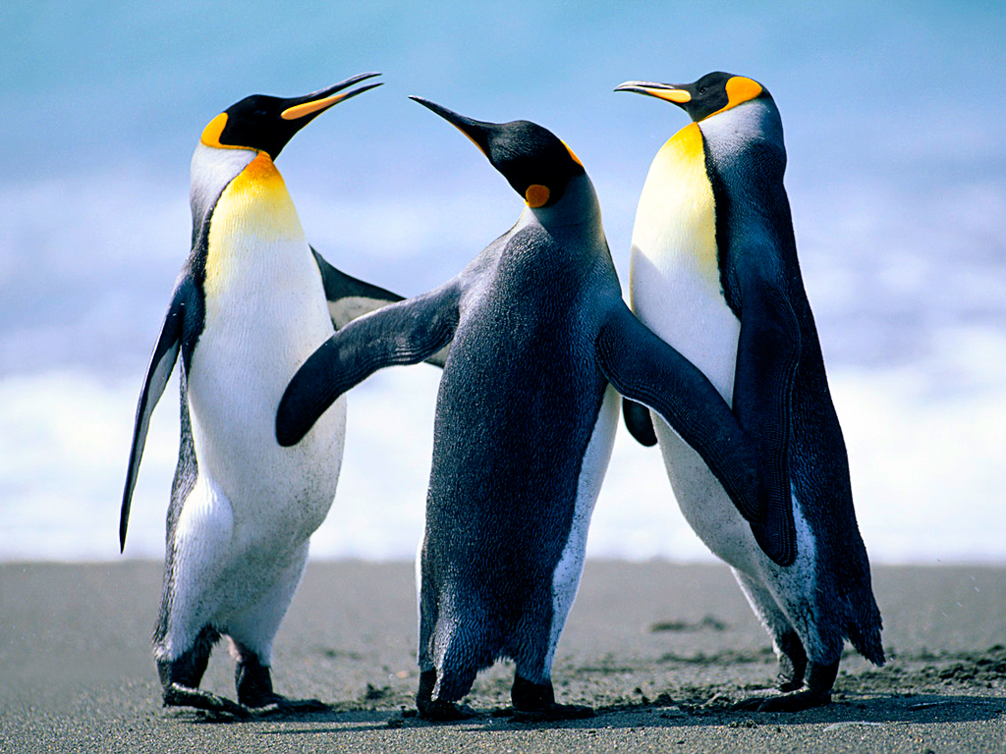 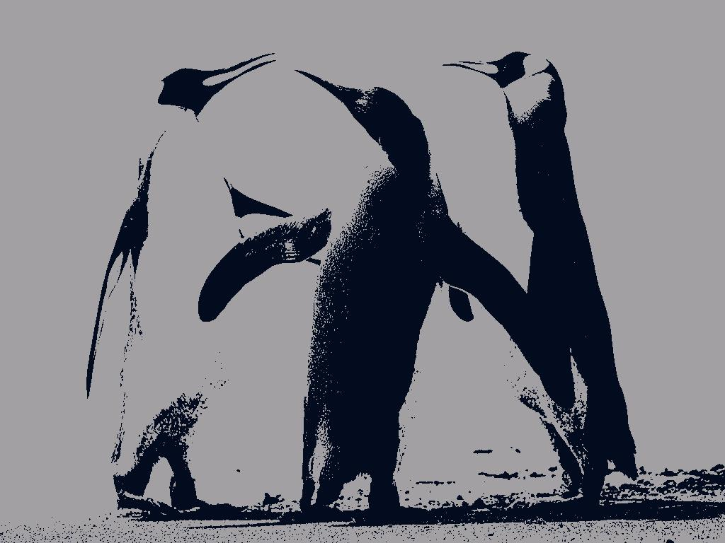

Original Image

Height x Width: 768 x 1024

Image Size: 777.835 KB

Image with K = 2

Height x Width: 768 x 1024

Input Image Size: 777.835 KB

Output Image size: 83.093 KB

Compression Ratio: 9.361017

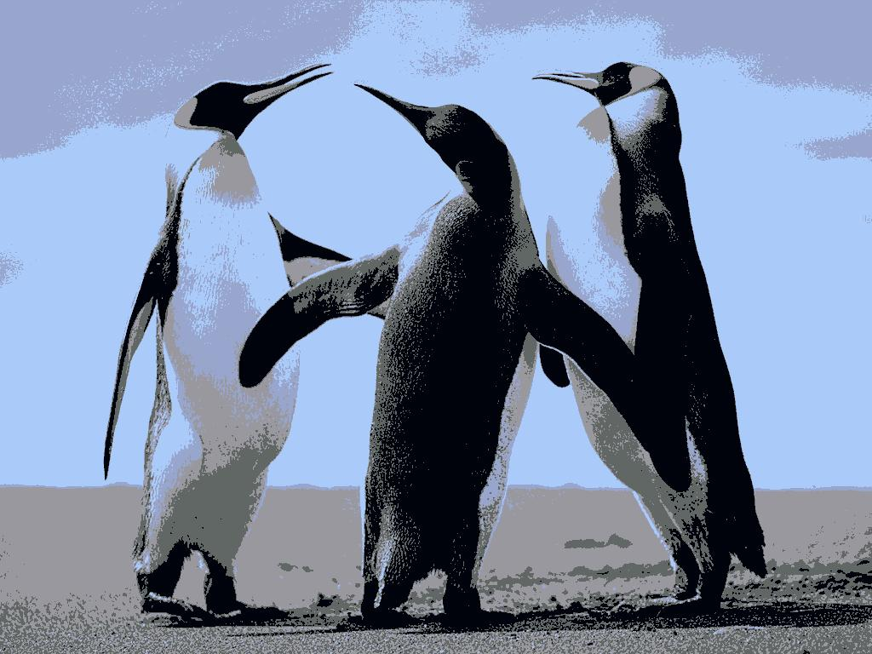 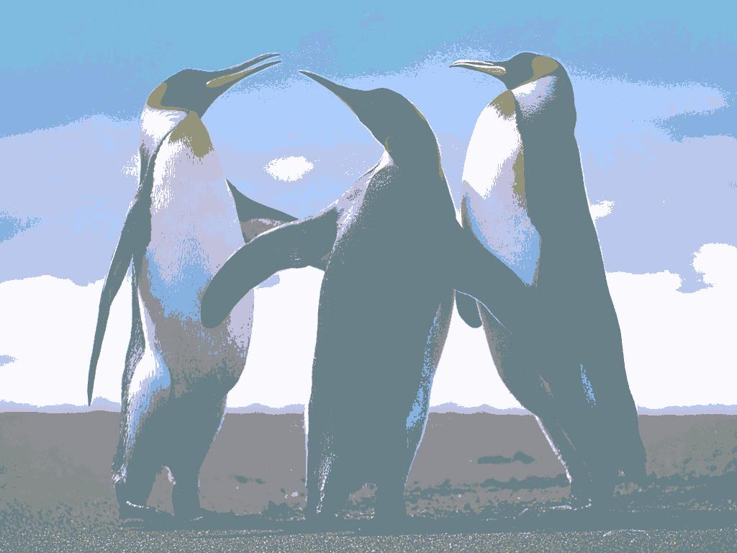

Image with K = 5

Height x Width: 768 x 1024

Input Image Size: 777.835 KB

Output Image size: 111.138 KB

Compression Ratio: 6.998821

Image with K = 10

Height x Width: 768 x 1024

Input Image Size: 777.835 KB

Output Image size: 68.269 KB

Compression Ratio: 11.393677

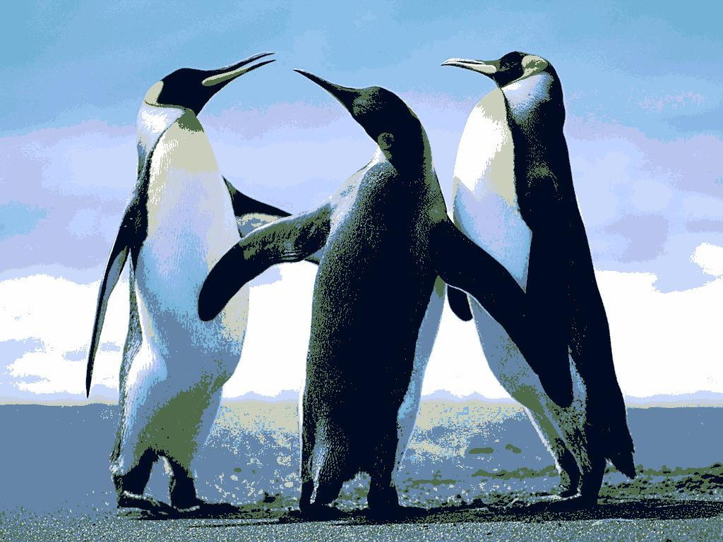 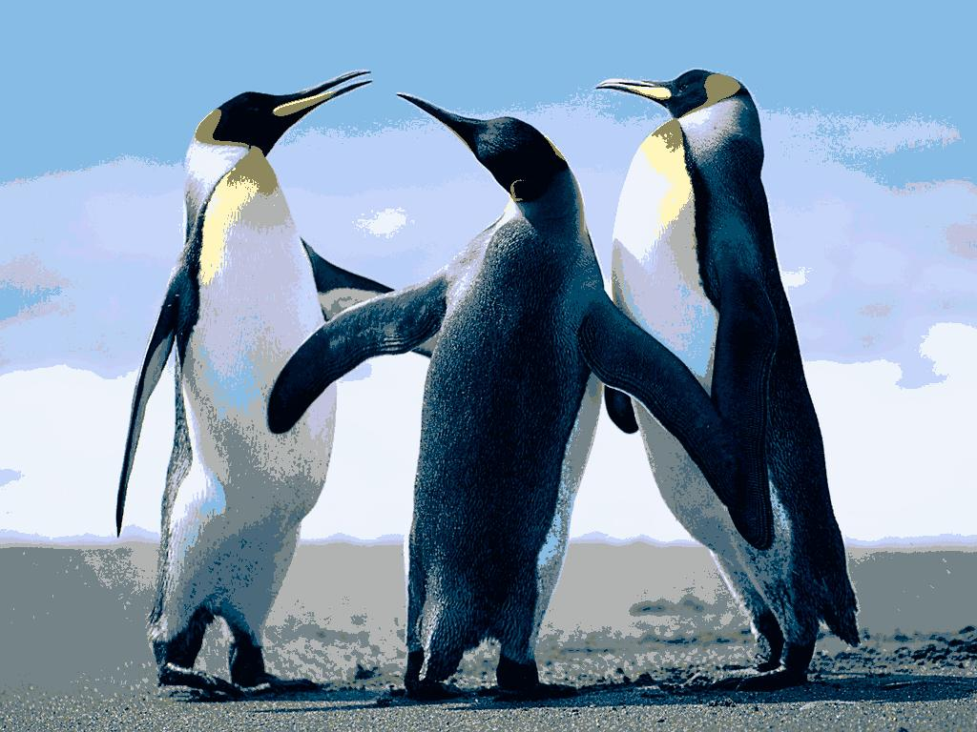

Image with K = 20

Height x Width: 768 x 1024

Input Image Size: 777.835 KB

Output Image size: 117.681 KB

Compression Ratio: 6.609690

Image with K = 15

Height x Width: 768 x 1024

Input Image Size: 777.835 KB

Output Image size: 123.615 KB

Compression Ratio: 6.292399

1. **Koala.jpg:**

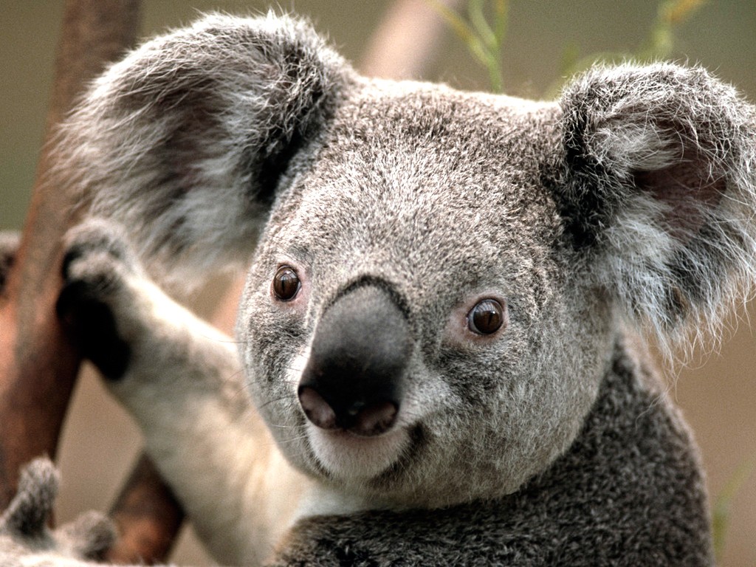 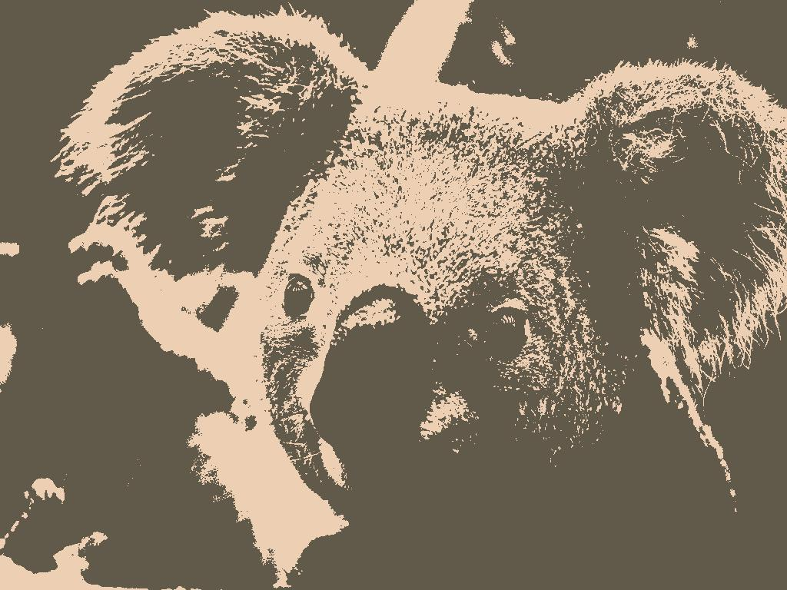

Original Image

Height x Width: 768 x 1024

Image Size: 780.831 KB

Image with K = 2

Height x Width: 768 x 1024

Input Image Size: 780.831 KB

Output Image size: 132.608 KB

Compression Ratio: 5.888265

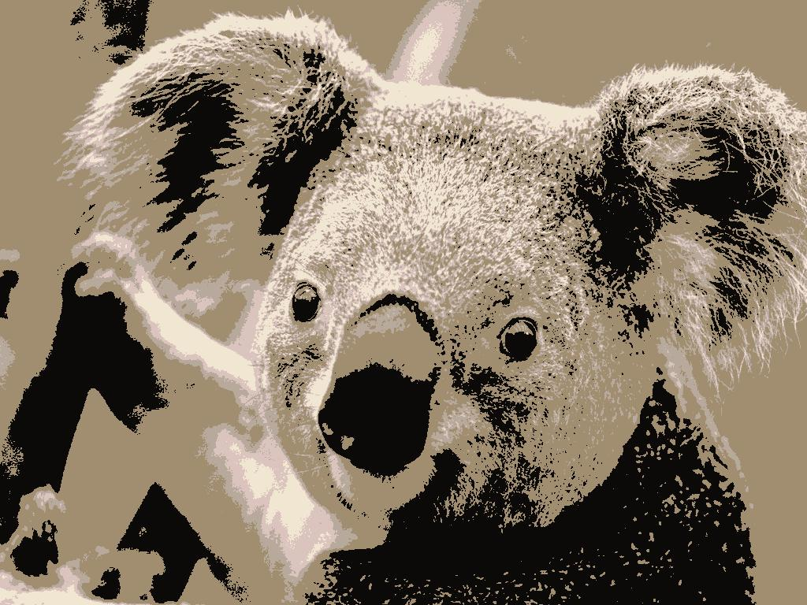 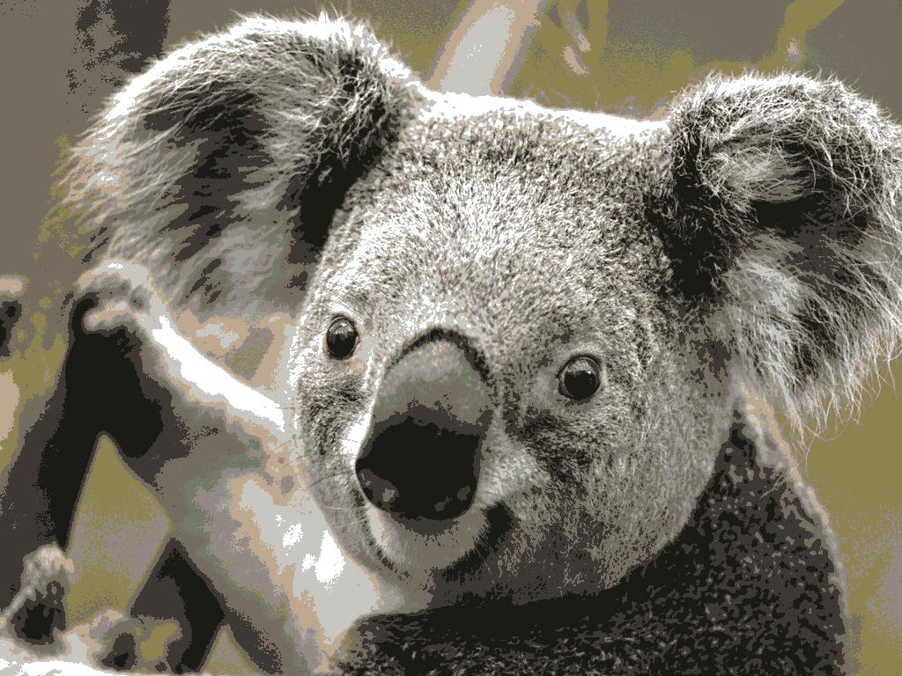

Image with K = 10

Height x Width: 768 x 1024

Input Image Size: 780.831 KB

Output Image size: 168.692 KB

Compression Ratio: 4.628737

Image with K = 5

Height x Width: 768 x 1024

Input Image Size: 780.831 KB

Output Image size: 170.457 KB

Compression Ratio: 4.580809

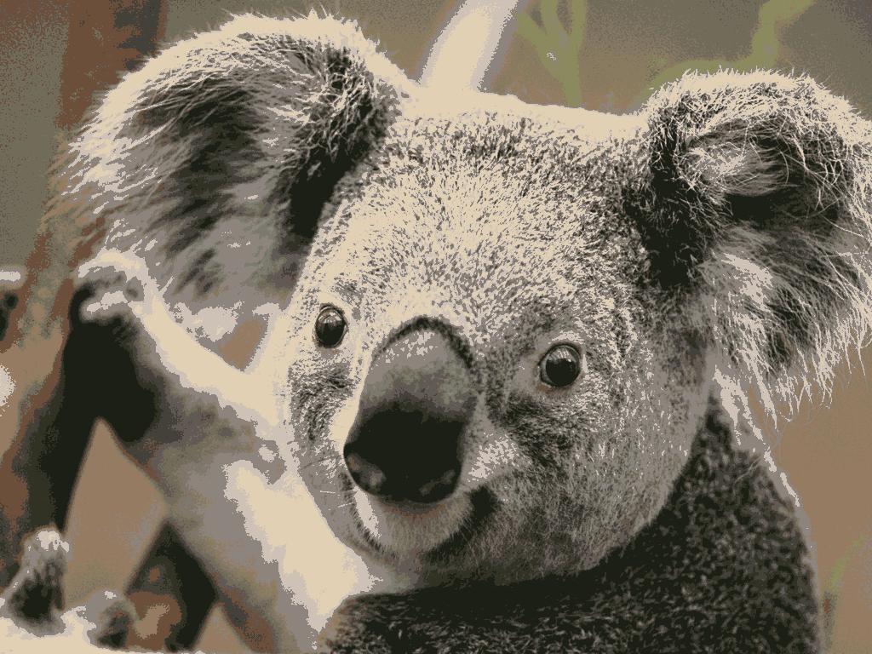 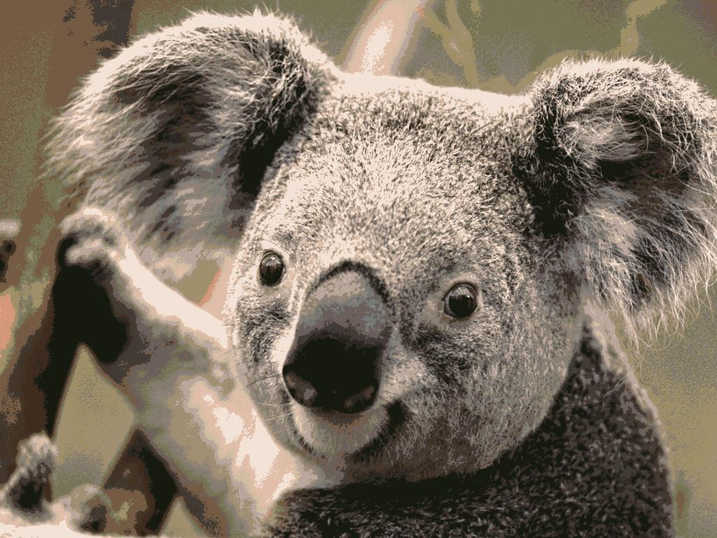

Image with K = 15

Height x Width: 768 x 1024

Input Image Size: 780.831 KB

Output Image size: 156.292 KB

Compression Ratio: 4.995975

Image with K = 20

Height x Width: 768 x 1024

Input Image Size: 780.831 KB

Output Image size: 162.697 KB

Compression Ratio: 4.799296

**Analysis:**

There is a trade-off between quality of the image and the compression ratio.

For lower K values, the quality of the image is low as the number of colours representing the image is low and hence a lot of details in the image are compromised. Whereas higher K values produce a better image quality but takes longer time to run.

The goal here is to reconstruct the original image from the compressed representation without any loss of details rather than higher compression. Hence, for both the images the good values of K lie between 15 and 20.

For Penguins.jpg, 15 would be a good choice of K with compression ratio 6.292399 which is close to that of K=20. For Koala.jpg, 10 would be a good choice of K with compression ratio 4.628737 which is close to that of K=15 and K=20.