PicChat
CS1530 Sprint 3-Deliverable
Due Date: July 8th 2015

Team Members:
Blaise Clair (blaiseclair)- Product Owner
Andrew Harper (graphitezeppelin) – Software Developer
Neel Kowdley (nkowdley) - Software Developer
Dom Grigore (domgrigore) - Quality Assurance Manager

Project Description
Client: Nate Thompson

Name of Project: PicChat

Description: The client for this project wants us to create a map-centric social media platform. A user will log in, and be able to create posts and content by providing a location and the content itself. The content will then be place on a map, so that other users can view activities and posts at a specific location and be able to find activities to do at certain locations.

This project will be created as a website that will eventually be compatible with mobile browsers.

Project Github Page: https://github.com/nkowdley/CS1530-Team9

Design Mock-up:
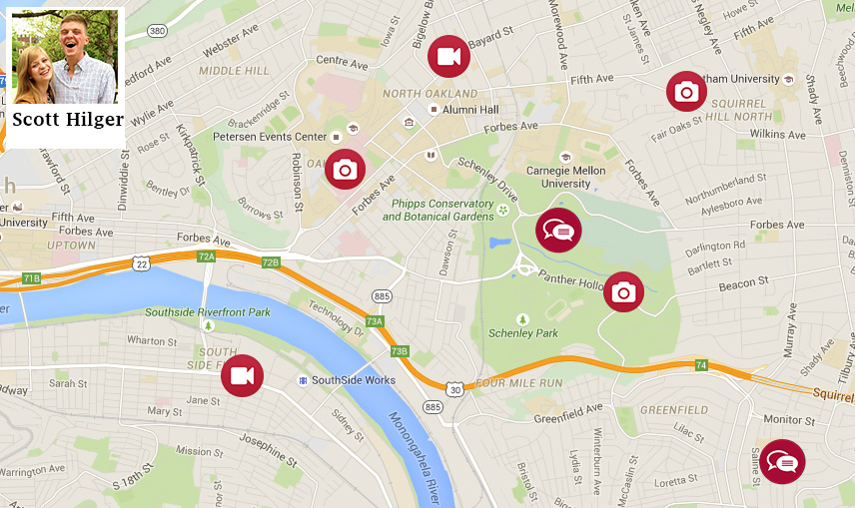

User Stories and Backlog:

Sprint 3 Backlog:

How User Stories Were Chosen for this Sprint:
User Stories were selected to be worked on from our Product Backlog for this Sprint. The process by which we selected items for this Sprint were based on a number of characteristics:

1) How important the User Story is to the client. If the client really wants to see a particular feature completed, it is given a slightly higher priority.
2) How important the user story is to the final product. If the user story contains a feature integral to the functionality of the product, it is given a higher priority.
3) If the backlog item is a defect, how critical is the defect and how important the defect is to the overall function of the product.
4) How many user stories or features are “blocked” by other user stories. A user story is considered blocking if another user story cannot be completed without first completing the “blocking” user story.

These characteristics were used to determine the original priorities of items in our Product Backlog, and played a role in helping us determine which items we would attack on this sprint. However, items were chosen for this Sprint in a slightly different manner than they were for Sprint 2. The selection process for items in the backlog was heavily influenced by how important the feature was to the client, and how severe a defect found during Sprint 2 was.

The backlog items worked on this sprint are provided in the table below.

The columns of the table are defined as follows:
Priority: How valuable the user story is to the overall product.
User Story Number: Our internal numbering scheme in order to keep track of User Stories.
Backlog Item: The contents of the User Story or the Defect
Points: How long we anticipate this user story will take to complete.
Assigned To: The person responsible for completing the user story.

Priority | Number | Item | Assigned to: | Points
1 | US20 | As a User, I want to be able to share my interests and information, so that others can share things that I would find interesting with me. | Neel | 8
2 | D1 | Uploading pictures needs to be done through JS and needs to work as intended on the front end. | Andrew | 16
3 | D2 | The CSS and overall UI of the site needs to be overhauled | Dom | 4
4 | D3 | PHP Unit Tests need to be cleaned up and a better workflow needs to be added for them | Blaise | 8
5 | US21 | As a User, I want personal information and interests to be saved somewhere so that my information will be consistent to all users who want to view it. | Dom | 4

Testing:
While coding, a number of defects emerged. Simple ones, usually caught by unit tests, were fixed. There were a few defects that were found through code reviews and testing functionality manually. Some of these defects have been left in the code at the end of the iteration because of time constraints and they were low priority. Other require more research as to why they are occurring, such as those dealing with DB queries.

Text Upload
To reproduce this defect, log in to a user and upload a text update. The expected behavior is that the text update will be posted and a text icon will appear at the chosen location, allowing the user to view the text update. Currently the observed behavior is that the text is not shown on the page. This was found through unit testing and is caused by text updates not being implemented on the front-end.

Photo Upload with Location
To reproduce this defect, log in to a user and upload a photo. The expected behavior is that the photo chosen will be uploaded to the server along with the location where the photo was taken. Currently the observed behavior is that the photo is uploaded to the server but the location is not. This was found through unit testing and is caused by an error with DB querying.

Get Query Sanitation
There were some defects found with the current database implementation. There is no query sanitation implemented. With this defect there is no sanitation with get requests from the DB. The expected behavior of this is that attempting something like SQL injection through a query is not blocked. The observed behavior is that any input can be queried without any validation.

User Interface
The UI that is currently in place in the website is not on the same level as the UI specification. There are various areas that are not implemented exactly as specified and does not conform to the defined standard. This was found through manual testing from the customer as well as internal manual testing. This has been left in since there are higher priority user stories to work on.

Database Primary Keys
This defect was found through a code review. Looking at how our MySQL databases were set up, it was determined that a primary key was not set, which meant that our Databases could have had collisions between user names. This was fixed prior to the end of the Sprint.
Sprint Notes:

Work Accomplished this Sprint:
While we only completed a few user stories this sprint, these user stories played a pivot role in giving our client what they wanted. A walking skeleton for a profile page was added, and the database schema for holding this information was also added. There was a lot of work done on getting PHPUnit tests working and in a state where we felt that we could use them effectively to test our code. We also added a lot of functionality to the picture upload feature of our site, and tested it extensively. Finally, there was some UI cleanup done.
Client Interactions:
This sprint, we had more interactions with the client than the previous sprint, consisting of two major meetings with the client.

During the first meeting, we discussed the progress we had made on the project: The client was shown the project in its current state, and we noted the clients reaction to what was currently done. On the whole, they were pleased with how much work we had done and had a few issues with UI that we had planned for Sprint 4. After this, we talked the client through what our teams current priorities were and did some minor reprioritizing with them. These adjustments became part of the Product Backlog. One important note about this is that we found that the client had wanted an additional feature that we did not plan for: profile pages. As a result of this, we added an item to the backlog, and made sure that it was a priority during the current sprint.

After the first meeting with the client, our team had our sprint planning meeting and we decided that we needed to refine some of our backlog items and gather a better understanding of the client’s needs. To get these requirements from the client, our team came up with a list of questions, and we held a second meeting with the client to get those questions answered. This meeting was vital in clearing up some of the finer points of items in our backlog and gave us some additional requirements to meet.

Coding Reviews:
During this sprint, we instituted Coding Reviews. Instead of merging directly to master, we merged to a different branch and reviewed each other’s code before merging to master. To do this, we met as a group and added in line comments on Github about questions we had. We then discussed the issues and oddities we found in each other’s code.

Our team felt that code reviewing definitely helped improve the overall quality of code submitted to the project. A great example of this is the fact that all of our Databases did not have a primary key, which could have caused many issues down the road if multiple users had the same name. This issue was resolved during the code review phase and helped prevent a defect later on.
Integrating Work:
In the first two sprints, our team had worked largely independent of each other, as we each worked on a distinctly different piece of code. This sprint, however we had some collisions. The UI and Picture Upload code had elements on the same main page, and the Database Initialization, PHPUnit Tests and Profiles were all tightly integrated. One thing that helped to integrate this work together was working on separate branches. This allowed us to verify that our individual components worked on the known good version of product created in Sprint 2. After we had developed these pieces, we had a meeting where we did our code review and began merging our work into the main branch. After everything was merged into the main branch, we ran our tests again to verify the product still worked as intended.

Disagreements:
Our team had a number of disagreements during this sprint. One disagreement we had was how to prioritize profiles and database schemas. One side thought we should give them a lower priority due to the fact that we had to add them right before this sprint started, and that we had very loose requirements surrounding them. Another side to this disagreement was that the client had specifically wanted this feature done before the end of the last sprint and that we could move other lower priority items down the chain. We ended up doing this, and soliciting more requirements from the client before adding the relevant user story to our backlog and working on it.

Challenges while Coding and Testing:
We faced a number of challenges during this Sprint while writing code and testing. The biggest hurdle we faced as a team was writing testable code. This was one of our main focuses this sprint, so we spent a large amount of time planning out our code in order to make it easier to use PHPUnit and Qunit. We also worked on making our tests more exhaustive and flexible which was incredibly difficult as we still faced a large amount of technical debt related to PHPUnit and Qunit.

Changes in process since last sprint:
Our process for attacking this sprint was much different than our process for the previous sprint. One of the main differences in this sprint was that we had to do much more backlog maintenance than in previous sprints, due to the addition of new user stories and defects. Reevaluating the backlog is one of the most important ideas behind agile software development, and our team benefited from it greatly, as it ensures that our time is being spent on the most important features and issues of our product.
During this sprint, we were also more organized and structured. Our team held more technical meetings and we had a much better stand-up process over text messages. Our stand-ups were extremely concise and informative and allowed us to understand the progress each team member had made.
We also placed a greater emphasis on unit testing, and added a much higher number of tests this sprint. This turned out to be a great help, as when we merged in each branch created for this sprint, we were able to quickly run our tests and verify that each method worked as intended.

