PicChat
CS1530 Sprint 2-Deliverable
Due Date: June 24th 2015

Team Members:
Blaise Clair - Product Owner
Andrew Harper – Software Developer
Neel Kowdley - Software Developer
Dom Grigore - Quality Assurance Manager

Project Description
Client: Nate Thompson

Name of Project: PicChat

Description: The client for this project wants us to create a map-centric social media platform. A user will log in, and be able to create posts and content by providing a location and the content itself. The content will then be place on a map, so that other users can view activities and posts at a specific location and be able to find activities to do at certain locations.

This project will be created as a website that will eventually be compatible with mobile browsers.

Project Github Page: https://github.com/nkowdley/CS1530-Team9

Design Mock-up:
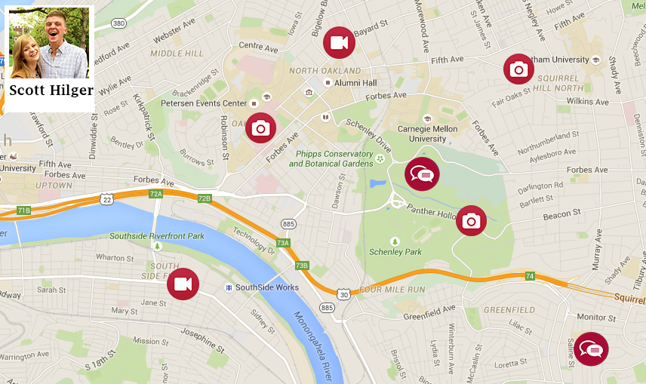

User Stories and Backlog:

Sprint 2 Backlog:

How User Stories Were Chosen for this Sprint:
User Stories were selected to be worked on from our Product Backlog for this Sprint. The process by which we selected items for this Sprint were based on a number of characteristics:

1) How important the User Story is to the client. If the client really wants to see a particular feature completed, it is given a slightly higher priority.
2) How important the user story is to the final product. If the user story contains a feature integral to the functionality of the product, it is given a higher priority.
3) How many user stories or features are “blocked” by other user stories. A user story is considered blocking if another user story cannot be completed without first completing the “blocking” user story.

These characteristics were integral in determining our original priority values in the first sprint. This sprint, however, we attacked the backlog in a slightly different manner. Of these 3 characteristics, the one that was given the highest priority this sprint was #3, or if the user story was “blocking” additional user stories. This was given a particularly high value this sprint to allow us to access more of the backlog in Sprints 3 and 4. This meant, that we would be attacking some lower priority user story items, such as UI Specs.

The User Stories worked on this sprint are provided in the table below.

The columns of the table are defined as follows:
Priority: How valuable the the user story is to the overall product.
User Story Number: Our internal numbering scheme in order to keep track of User Stories.
User Story: The contents of the User Story, in the Connextra format.
Points: How long we anticipate this user story will take to complete.
Assigned To: The person responsible for completing the user story.

Priority | User Story Number | User Story | Assigned To | Points
8 | 2 | As a user, I want to be able to create posts and view posts, so that I can share experiences with other users. | Neel | 8
3 | 16 | As a user, I want to be able to make text posts with the location of the post, so that I can create content for people to see. | Blaise | 8
4 | 3 | As a user, I want the ability to upload photos, so that I can share cool pictures with their locations for my friends to see. | Blaise | 8
10 | 11 | As a user, I want a clean and easy to understand User Interface, so that I can easily use this site, without needing help. | Dom | 8
6 | 5 | As a user, I want to be able to search by location and by user name, in order to filter the amount of posts visible on my screen. | Andrew | 8
5 | 4 | As a user, I want to be able to log onto the site with a profile, in order to save my settings and preferences. | Andrew | 2

Testing:

Defects:
While coding, a number of defects emerged. Simple ones, usually caught by unit tests, were fixed. There were a few defects that were found through code reviews and testing functionality manually. Some of these defects have been left in the code at the end of the iteration because of time constraints and they were low priority. Other require more research as to why they are occurring, such as those dealing with the Google Maps API.

Search Zoom
To reproduce this defect, search for a named location on the map such as Cathedral of Learning. When the map zooms in closer to your location, it will zoom in too far. The expected behavior of the search function is to find a location and adjust the map to show this location on the map with enough area around the location to see potential picture icons. The observed behavior is that the map will readjust and zoom in too far on the location, and this will not allow picture icons to show.

DB-Query Sanitation
There were some defects found with the current database implementation. There is no query sanitation implemented. With this defect there is a lack of input validation and potential security risks. The expected behavior of this is that attempting something
like SQL injection through a query is not blocked. The observed behavior is that any input can be queried without any validation.

NavBar
The Navbar that is currently in place in the website is not on the same level as the UI specification. The expected form of the Navbar is a tool bar at the top of the screen with various buttons and tools such as upload photo. The current observable form of the Navbar is not as specified from the UI Specification document. Buttons are placed on
top of each other and the style needs to be changed.

Generic Location Zoom
To reproduce this defect, search for a generic location with multiple possible addresses, such as Starbucks or Dunkin Donuts. The expected behavior is that the map will find the closest match to your current location. The observed behavior is that the map will zoom out and find all of the addresses in a general area, such as the Pittsburgh
metropolitan area. This is not ideal as the user will only want to see one location, not multiple in a large area such as the city of Pittsburgh.

Upload
To reproduce this defect, log in to a user and upload a photo. The expected behavior is that the photo chosen will be uploaded to the server and a picture icon will appear at the chosen location, allowing users to view the photo. Currently the observed behavior is that the photo is not uploaded to the server. This was found through unit testing and is caused by an error with permissions.

Sprint Notes:

Client Interactions:
During this sprint, We presented the product of the initial sprint to the customer, and informed them of what we planned to complete this sprint. The client was pleased with our progress so far and had few criticisms or suggestions to offer. This was primarily due to the fact that all we had to show him was the walking skeleton of our program. Afterward showing the client our current progress, we reviewed some of the important requirements we had gathered in Sprint 1 to confirm that we were on the same page with our development plan and priorities.

Design Patterns and Procedures:
For this project, our team is using a number of methodologies. Our process is based on Agile, as we have user stories and are attacking them in sprints. We have also added a form of kanban, on our Github which lists the user stories for the sprint, who is assigned to them, and a column for them to enter their progress on the user story.

Beyond this, our approach to completing this project is a bottom up approach. We are completing each individual user story independently, and designing it to the requirements we have for each section. This strategy suits us quite well as it ensures that anything that gets added to the main project and implemented into it is 100% functional.
We also allowed for the use of spikes in our sprint, by allowing time in sprints to be used to resolve technical debt.

Challenges Writing Code and Testing:
We faced a number of challenges during this Sprint while writing code and testing. The biggest hurdle we faced as a team was writing high quality and testable code, as we faced quite a large amount of technical debt by using PHP, JavaScript and MySQL. This meant that while some of our User Stories were given a lower number of points, there was extra time spent in paying back this technical debt by learning about the proper way of designing code. We faced a similar issue with writing unit tests, as our unit tests were to be written using PHPUnit and Qunit, which required some time to set up and learn.

Changes in Process since Sprint 1:
Our team had many process improvements during this Sprint, which made our team more efficient. We implemented a kanban-like page on Github to notify others of our progress on this project, and we worked on implementing time for spikes into our sprint schedule. We also placed a greater emphasis on TDD, by creating unit tests that were more applicable to code being written, instead of testing a walking skeleton. We added a number of unit tests to ensure the functionality of the Maps API and tests to verify database calls which resulted in higher quality code and a much better understanding of our code.

We also implemented a post-sprint run down where we went over what was completed this sprint and what still needs to be worked on from this sprint. This was vital as information learned during this sprint can help with planning for future sprints.

Future Process Improvements:
While in many ways, our process improved since Sprint 1 there is still room for improvement. Team communication is one of our biggest areas for improvement. While we did have meetings to decide what backlog items to work on, and an end of sprint rundown, we did not implement scrum as effectively as needed. In order to do this, we proposed making meetings after class to discuss progress on sprints and potential issues, as well as using text messages or email to convey this information if meetings are not possible, or a member is unable to attend.

Another area for improvement is sprint planning. While this sprint was more highly structured than Sprint 1, we agreed that we did not provide enough specific requirements to complete each user story. For our next sprint planning sections, we will take each backlog item and decide if the user story needs to be split up in order to provide enough detail to thoroughly complete each user story. Another useful tool for sprint planning is burn-down charts, which were planned for sprint 2, but never set up. This is something we would like to implement for sprint 3, in order to better track our progress on this project.
Team Communication:
Our team communicated in many ways during this sprint. Here is an overview of some of the communications we had and the methods of communication we used:
1) Meetings-We held three meetings over the course of this sprint: A sprint planning meeting, and a sprint burn-down meeting, and a meeting in the middle to discuss progress on User Stories.
2) Email-We used Email to communicate informal changes or documentation that we wanted the other group members to know about. These communications were primarily for notes we felt were not ready for Github, but were important for other team members to know
3) Text Messages- We used text messages to communicate short messages on progress of backlog items, and to schedule meetings. This was used only for informal information about the project.
Disagreements:
Our team also had a number of disagreements this sprint. One disagreement we had was regarding which user stories we should focus on this sprint. This disagreement came about largely because of User Story 10, which was focused on UI specifications. This was given quite a low priority during the creation of our backlog, because of the lack of functionality being added to product. This position stuck with some of our group members, while the other side of this argument was that this was important to do now in order to make the product feel more cohesive, and would provide some context while developing the functional aspects of this website. It would also provide the client with a much better understanding of how the end product will look and feel, and give us a chance to verify with them. We decided on including in this sprint based on the above ideas.

Another disagreement we encountered was on how to best divide up work. By convention, each user story is assigned a number of points based on how long we believe it will take to implement and test the features associated with it. When we originally selected the number of points per user story in the first sprint, we did not account for the amount of time it would take us to overcome the amount of learning and research we would have to do to implement each feature. When we assigned each team member user stories, a disagreement arose about how many points to assign to each user. The original intent was to assign each person 16 points, but the other idea brought up was to assign each member about 8-10 points, and allow each member to use the 'extra' time as an unofficial spike in order to resolve this. We ended up selecting this measure in order to help ensure a high level of quality of the final product.

How Problems Were Resolved:
As this sprint required much more than sprint 1, there were many issues that came up throughout this sprint. We had many initial set up issues when attempting to set up MySQL databases locally, as well as some basic coding issues. These issues were resolved by collaboration, via explaining the code to another team member. This proved to be useful to step through the code, or procedures to set up an environment

We also resolved a large number of coding issues by stepping through known good examples of code that did similar functions. This was really helpful for items that we were unfamiliar with before this project, such as database queries, and Google Map API functions. This provided us with a good idea of how to interact with services outside of the programs we wrote.

