PicChat
CS1530 Sprint 4-Deliverable
Due Date: July 22nd 2015

Team Members:
Blaise Clair (blaiseclair)- Product Owner
Andrew Harper (graphitezeppelin) – Software Developer
Neel Kowdley (nkowdley) - Software Developer
Dom Grigore (domgrigore) - Quality Assurance Manager

Project Description
Client: Nate Thompson

Name of Project: PicChat

Description: The client for this project wants us to create a map-centric social media platform. A user will log in, and be able to create posts and content by providing a location and the content itself. The content will then be place on a map, so that other users can view activities and posts at a specific location and be able to find activities to do at certain locations.

This project will be created as a website that will eventually be compatible with mobile browsers.

Project Github Page: https://github.com/nkowdley/CS1530-Team9

Design Mock-up:
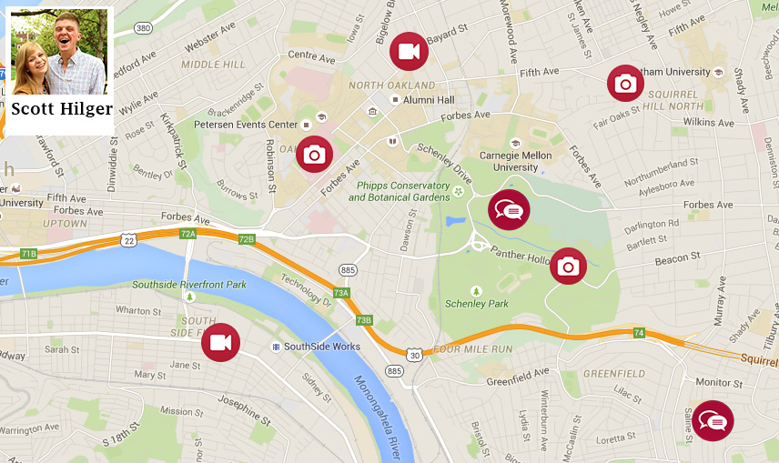

User Stories and Backlog:

Sprint 4 Backlog:

How User Stories Were Chosen for this Sprint:
User Stories were selected to be worked on from our Product Backlog for this Sprint. The process by which we selected items for this Sprint were based on a number of characteristics:

1) How important the User Story is to the client. If the client really wants to see a particular feature completed, it is given a slightly higher priority.
2) How important the user story is to the final product. If the user story contains a feature integral to the functionality of the product, it is given a higher priority.
3) If the backlog item is a defect, how critical is the defect and how important the defect is to the overall function of the product.
4) How many user stories or features are “blocked” by other user stories. A user story is considered blocking if another user story cannot be completed without first completing the “blocking” user story.

The backlog items worked on this sprint are provided in the table below.

The columns of the table are defined as follows:
Priority: How valuable the user story is to the overall product.
User Story Number: Our internal numbering scheme in order to keep track of User Stories.
Backlog Item: The contents of the User Story or the Defect
Points: How long we anticipate this user story will take to complete.
Assigned To: The person responsible for completing the user story.

Priority | Number | Item | Assigned to: | Points
2 | US22 | As a user, I want posts clearly marked on the map so that I can view posts by location. | Andrew | 8
3 | D2 | Since we have been doing bottom up development, some pages need to be connected together | Dom | 8
4 | D3 | The profile page needs to be revamped to be more modular and more testable | Neel | 8
5 | US23 | As a User I want to see a map on a profile page so that I can see a users posts on their profile page | Blaise | 8

Testing:

Text Upload

Photo Upload with Location

Get Query Sanitation

User Interface

Database Primary Keys

Sprint Notes:

Work Accomplished this Sprint:

Client Interactions:

Coding Reviews:

Integrating Work:

Disagreements:

Challenges while Coding and Testing:

Changes in process since last sprint:

