CS 1632
Deliverable 2: Unit Testing and Code Coverage
Project: Coffee Maker Quest
Github Page: https://github.com/nkowdley/CS1632-Deliverable2




Team Members:
Neel Kowdley
Therese Dachille
Introduction/Testing Issues:

The goal of this deliverable was to recreate the game from Deliverable 1, Coffee Maker Quest, and to write unit tests based on the code we wrote.

The first step our team took was to read through the requirements and understand them thoroughly. We then whiteboarded out our architecture for this project and divided up the tasks into pseudo-User Stories, which allowed us to ensure that we followed a good design and that we fulfilled the requirements of Coffee Maker Quest.

After we had designed the game, we worked on coding the game and finishing the game. We encountered our first problem while coding the game: We were both a little rusty on Java and Object Oriented Programming. We ended up refactoring a lot of our code as we became more and more familiar with Java, and more confident in our coding abilities.

Once we had written our code, we began the process of unit testing. Since neither of us use IDEs, we encountered another issue when trying to integrate JUnit into our project. We had to download and setup Eclipse in order to begin unit testing, and spent quite a bit of time trying to integrate Eclipse into our workflow. Even more time was spent to trying to add JUnit to Eclipse, but once we finally figured it out, we (thankfully) found it was rather simple and easy to use.

After Eclipse was properly set up, we began planning unit tests for our code. We focused on writing unit tests that would accurately cover any of our public methods that had were non-void and thus had a return value. Any methods that depended on checking a result of a method from a separate class were mocked using Mockito, which also took some setup to get working in eclipse. Since the codebase was quite small, we were able to test a lot of branches that we would not normally unit test, for example, checking that each of the rooms was initialized properly, or that each of the possible win or lose scenarios for drink worked properly. Before actually writing any tests, however, we made two quick hello worlds to verify that Mockito and Junit were properly installed. In order to do this, we mocked a fake class, with a stub that returned true and asserted that the stub was true.

While writing unit tests, we ran into a few problems. We found that a lot of our code was based on void methods, particularly in the Game and Player class. In order to produce higher quality code, we refactored a lot of those methods to return values. For those classes that remained void, we determined that the methods we unit tested implicitly tested most of our void methods that were used inside each of the tests. While refactoring, we made our code cleaner and more robust. This came at a few costs however, and one example of this is that we needed to have more rigorous boundary checking when trying the move into a different room, because we manage our current room in a global variable, and had the potential to move out of bounds while testing. Although we did not intend on implementing Test Driven Development, we did find that while modifying methods for the purpose of better testing and more coverage, our code instantly improved in thoroughness, which is not always a standard coding classes emphasize; we are used to coding almost exclusively for the correct output in select situations. We found the idea of code coverage the most helpful indicator of how well our tests were designed, as it is one of the only quantitative measurements that can be used as a point of reference for the quality of our tests. Even once our overall code coverage reached 80%, we were still determined to see just how much we could improve this percentage. We did this by analyzing the code coverage of each individual class, and trying to get that number as close to 100% as possible (which we were able to achieve for half of our classes, as two out of our four classes had no void methods).
Unit Test Example Code
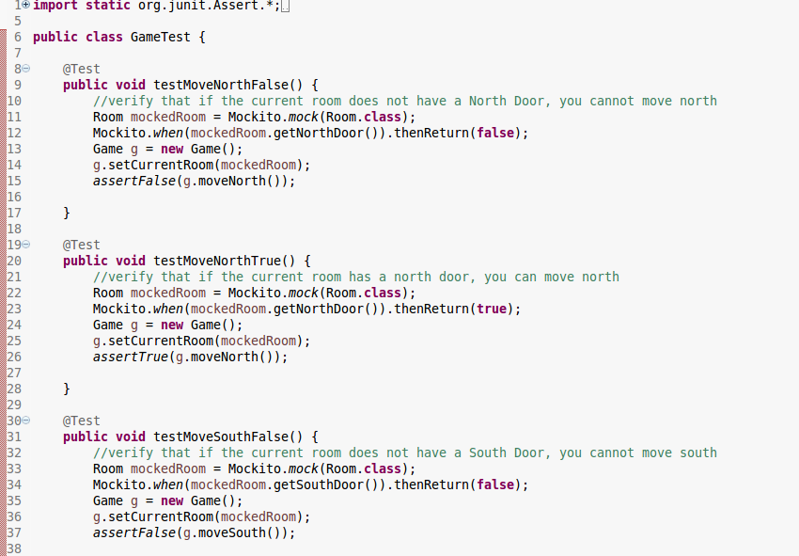

Test Coverage

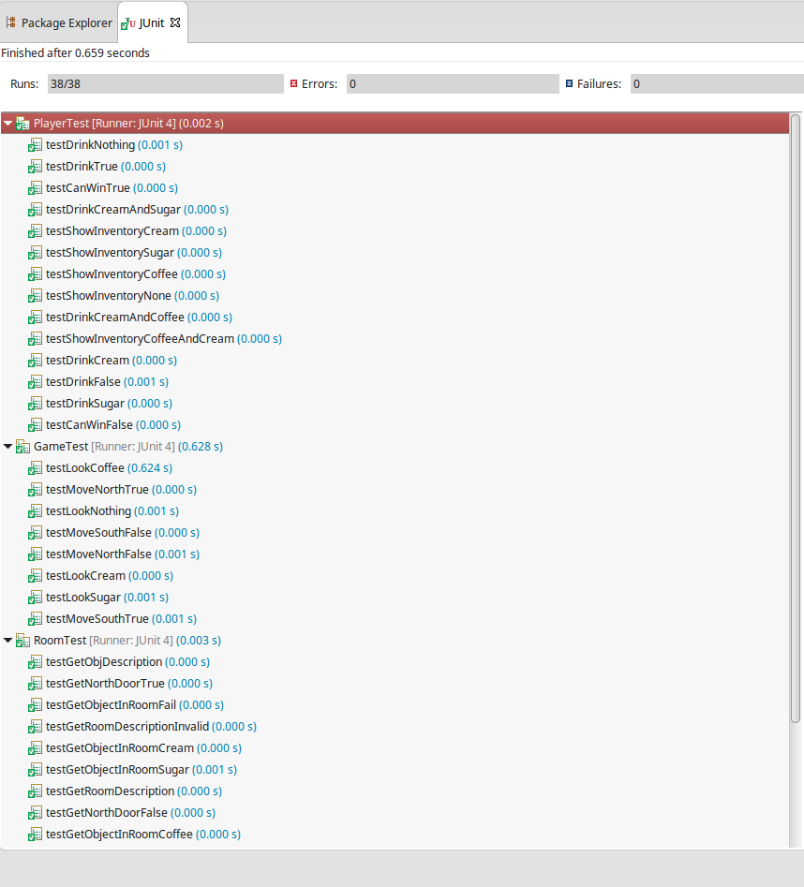

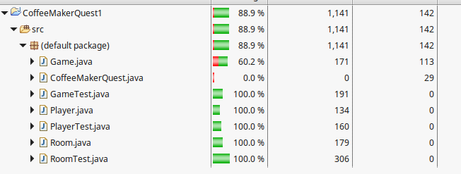
Overview of Test Coverage from EclEmma

Test Coverage broken up by Method
