CS 1632
Deliverable 6: Final Deliverable
Project: Coffee Maker Quest written in Rust with TDD
Github Page: https://github.com/nkowdley/rusty_coffee_maker_quest





Team Members:
Neel Kowdley
David Sweeney
Introduction and Summary:
For this project, we decided to rewrite the game Coffee Maker Quest from the 1st and 2nd deliverables in this class. We, however did add two twists to this:

1) We would write Coffee Maker Quest in Rust
2) We would write Coffee Maker Quest using TDD

This turned out to be quite a challenge for us, as neither of us had ever written in Rust before. We chose to program in Rust for a few reasons:

1) Rust is a brand new systems level language like C.
2) Rust is being actively sponsored by Mozilla, who is including Rust components in Firefox
3) Rust prevents a lot of memory unsafe operations, which removes much of our frustration when using C.
4) Rust uses a much different and more interesting syntax than languages such as C or Java

Choosing to use TDD to develop our project which ended up being very helpful. Reading through the Rust Docs gave us some idea of how to configure our project and start coding in Rust, but it did not help us too much with writing Rust. Writing test functions first allowed us to think ahead about problems we might encounter and what to learn or look up in order to make our project work the way we intended.

Even with TDD, we ran into issues with the Rust language.

One of these items was ownership of objects. This ended up being quite a pain when starting out, but thanks partially due to the in class talk by Carol Nichols, we were able to figure out how ownership should work in out project, and we were able to make our project code even better, by changing mutable borrows to immutable borrows, which improved memory safety.

We also “fought” with the rust compiler quite a bit, as the rust compiler does much more error checking than gcc. We ultimately found the compiler quite useful, as it contained documentation about errors, as was very clearly formatted. Here is an example of the compiler explaining how to get the documentation for E308:
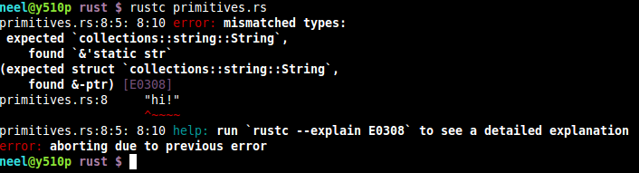
These two issues were the main issues we had using rust for this project, but overall, we enjoyed the opportunity to learn a new language we were interested in.

Testing:
For this project we primarily used the red-green-refactor loop. This can be seen in these two screenshots, where a failing test is written and run, then the code is written to make the test case pass.

Here is the “red” failing test case for test_drink_sugar:
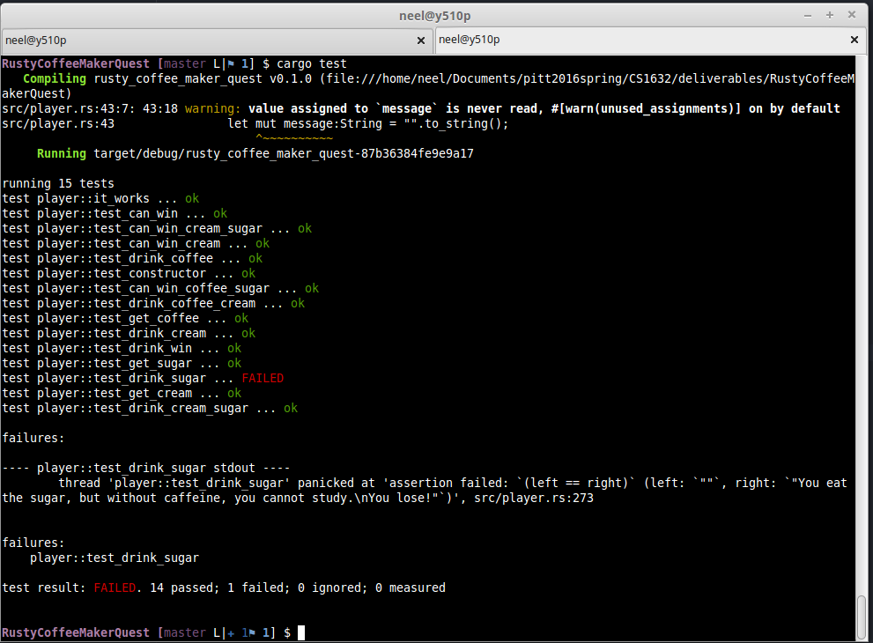
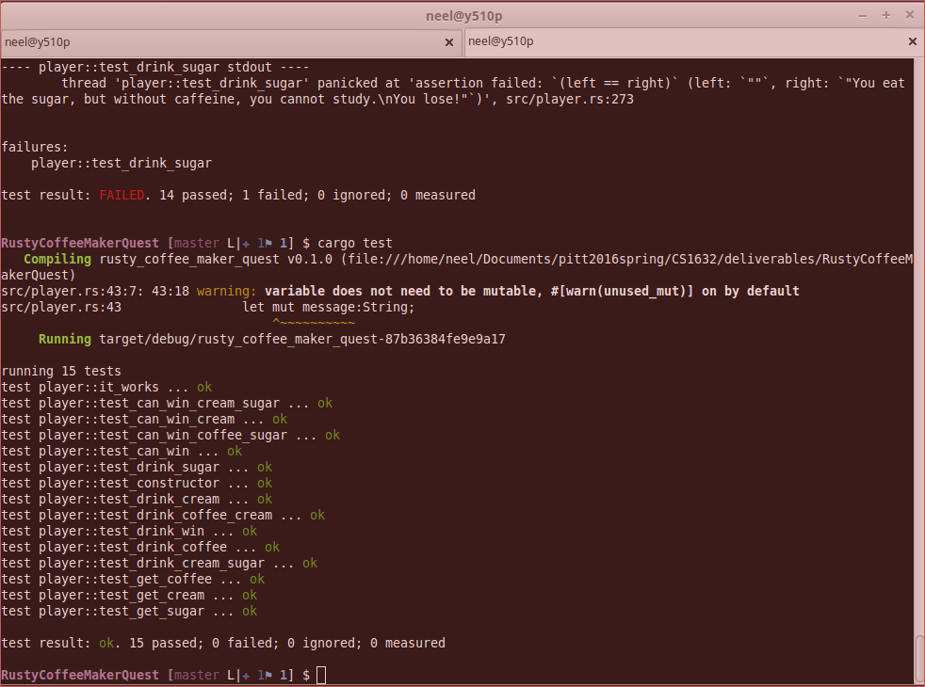
Here is the “green” passing test case for test_drink_sugar():

We also used this opportunity to try out different ways of using assertions in rust. For example, to test if a value is false, we used 3 different methods:
1) We used the assert! Macro to test whether or not boolean values are true such as:
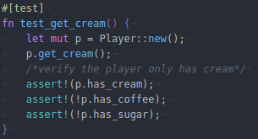

2) We used the assert_eq! Macro to test whether values were equal. For example:

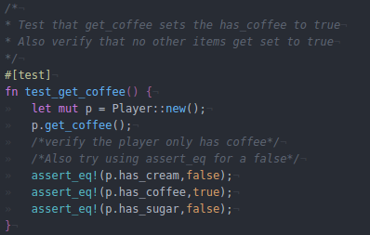

3) This method, involves marking that the test case should fail, as the assertion will be false. We set the expected failure to the fact that assertion should fail.
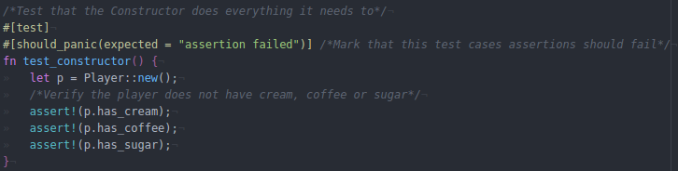

Quality:
I feel as though we thoroughly tested this project. Any problem areas we have would likely be in the main.rs file, as we extensively tested every function in our two structs: player and room, including the constructors. Also, each function returned something, so we were able to extensively test that they were returning the right output in our unit tests.

We were also able to test this project much more efficiently than we were for Deliverable 2, as in Deliverable 2 we had private variables that our tester classes could not reach. In rust, unit test cases are put in the same file as the code, which allows them to access the private variables of the structs.

