Manual Pinning Tests

Test Name: Run-Continuous-1

Description: Test to see if the run continuous function in main panel is equivalent to the old version of run continuous

Test Setup:
1) Start the Game of Life with an argument of 10
2) Verify the window that pops up has a button that says “Run Continuous”
3) Verify the window has a 10x10 grid of gray cells

Test Case:
1) Go 5 rows from the top, and 4 cols from the left.
2)Click the 4th, 5th and 6th cell from the left in the 5th row from the top.
3)Verify your window matches the picture below:
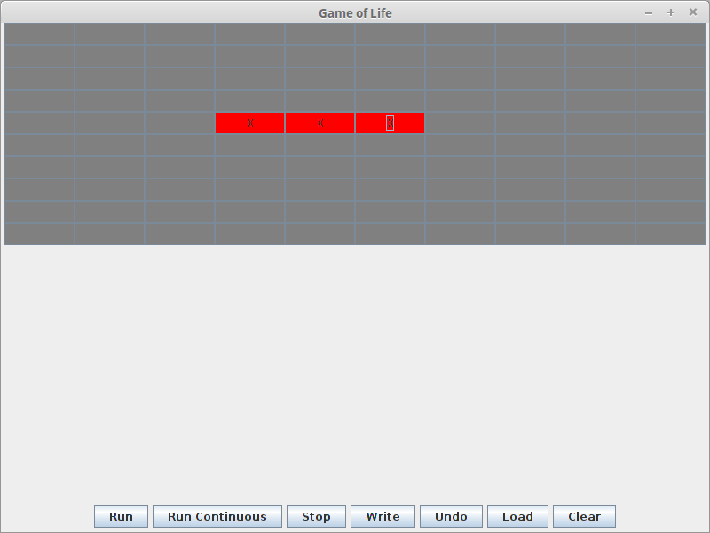

4) Press the run continuous button
Results/Validation
1) Verify the console output is continuously displaying the following text
“Running
Calculating..
Displaying...”

2)Verify the the 10x10 grid shows a “spinner” that looks like the below window. Note that the Middle Cell should be a red cell with an “X”. Verify the cell on top of the middle cell, the cell on the bottom of the middle cell, and the left and right cell of the middle cell are all alternating between red and green
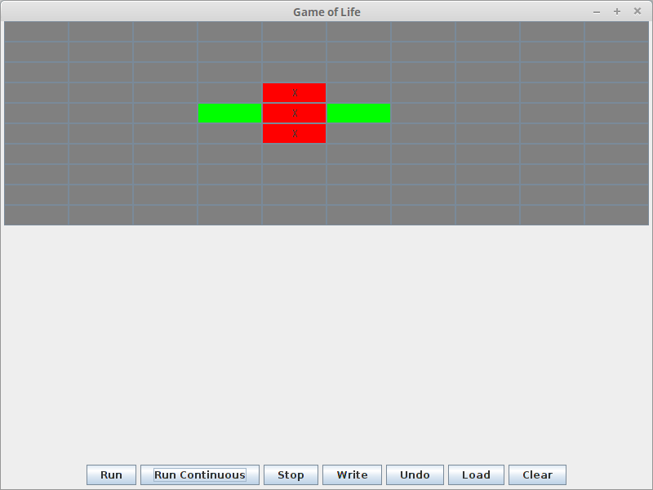

Test Name: Run-Continuous-2

Description: Test to see if the run continuous function in main panel is equivalent to the old version of run continuous, by testing a system that results in a stable configuration after one iteration

Test Setup:
1) Start the Game of Life with an argument of 10
2) Verify the window that pops up has a button that says “Run Continuous”
3) Verify the window has a 10x10 grid of gray cells

Test Case:
1) Click any cell, and verify it is red with an 'X'.
2)Verify that there is only one red cell with an 'X'
4) Press the run continuous button
Results/Validation
1) Verify the console output is continuously displaying the following text
“Running
Calculating..
Displaying...”

2)Verify the cell that was once red is now green, and not changing colors. Verify no other cells are changing colors.

