**Adept.ai**

Gamification and Engagement Quiz Tools for Fostering Intrinsic Motivation and Topic Mastery

Nathan Kozyra

Georgia Institute of Technology, nkozyra@gatech.edu

*Abstract*

The advent and emergence of online learning platforms such as Massive Online Open Courses (MOOCs) and graduate level distance learning programs has provided a host of new educational opportunities for traditional and non-traditional students. As these have grown, tools that facilitate an experience that is comparable to in-person / on-campus versions have failed to compensate for the unique challenges of distance learning. Students often find challenges distinct from their on-campus counterparts related to self-driven motivation and a sense of connection to their courses, material, students and instructors.[1]

Despite common assumptions to the contrary, online and distance learners are not appreciably more driven by intrinsic factors than aforementioned counterparts.[2] This can result in students who lose interest in topics or are motivated exclusively by grades and other extrinsic motivators.[3]

To address these issues, this paper will introduce an application that draws on several popular forms of gamification to build a continuous engagement quiz platform. The platform promotes gamification techniques to drive short-term extrinsic motivators like badges, instant feedback and leaderboards to encourage and foster long-term intrinsic motivation in the topic itself. By utilizing extrinsic motivation as a propellant for frequent engagement with course material, such an application can enable greater appreciation of course material and topic mastery as students participate.

Motivation

Modern gamification for the web followed a nearly parallel history with the birth and growth of MOOCs; online gaming writer Bret Terrill discussed it in June of 2008, just a few months before University of Prince Edward Island’s Dave Cormier is widely considered to be the first to use the term “MOOC.”[4]

This concurrent technological adolescence meant that cross-pollination of the concepts was inevitable. Universities began to experiment with gamifying online and physical classes.[5] Meanwhile, gamification expanded to encompass class-like structures, certifications and eventually real undergraduate and graduate degrees from accredited colleges.

Both concepts were separately commoditized and adopted by the start-ups and web-based applications. Gamification became an underlying method for driving engagement and loyalty from users. Sites like Mint.com, Fitbit.com, CreditKarma.com, Todoist, Waze and others used competitive aspects and reward systems to keep their users on their platforms. [6]

Some of these platforms provided gamification as extrinsic motivation for activities that may be widely considered unappealing *or difficult*, such as credit repair, saving money and exercise.



*Waze’s early leaderboard*

In the example of Waze, under normal conditions a person may not feel compelled to spend time reporting traffic incidents. There may be little to intrinsically drive this behavior.

In this sense there is a parallel with education, particularly at the graduate level. Difficult work can sometimes require a boost to augment intrinsic motivation toward topic mastery.

As such, gamification in this manor does carry some risk. For example, extrinsic motivators are known to have much shorter-term appeal than intrinsic motivators.[7] If students are not compelled by the course material in lieu of badges and in-game successes.

Several of the aforementioned sites served as inspirations for Adept, but none more directly as Duolingo, a platform for learning new spoken languages using quizzes. What’s most compelling about Duolingo is its shuffled question support – this allows questions to be re-used and reintroduced, increasing familiarity and retention through repeated exposure.[8]

ADEPT

Adept was designed to be a simple web-based quiz platform that allows students to interact with course material at any time in a manner that progressively moves students up as they master more levels in the course.

A student may spend as little as 5 minutes a day up to hours attempting to engage with course material via randomized quizzes.

User Base & Authentication

Any user can sign up for Adept at the /registration endpoint, which requires just an email address, username and valid password. The initial setting for Adept is to require account confirmation, but this has been disabled for the prototype.

[Img]

Users are tied to a number of datapoints within the system: course registrations and progress through **users_courses**, course activity logs through **users_courses_activity** and achievements/badges through **users_courses_achievements**. Once earned, an achievement cannot be lost or rescinded.

Users can authenticate via the /login endpoint and log out through the /log out endpoint.

Course Catalogs

Once authenticated, a user will find a dashboard showing recent activity, other noteworthy activity like users earning badges in certain classes and popular courses. Users can also see their last quiz score, their leaderboard positions and get a view of badges and achievements.

Upon initial registration and log in, a user will have no available courses and will be prompted to browse the course catalog via the /courses endpoint.

Courses belong to Organizations, and this hierarchy allows an institution to compile their courses together. Adept can handle any number of organizations and sub-organizations, such that an university such as Georgia Tech could also have an OMSCS organization beneath it.

Courses also accept institutional course IDs, like CS 8083. This data structure allows the presentation and filtering of the courses to match that available from a traditional university enrollment application.

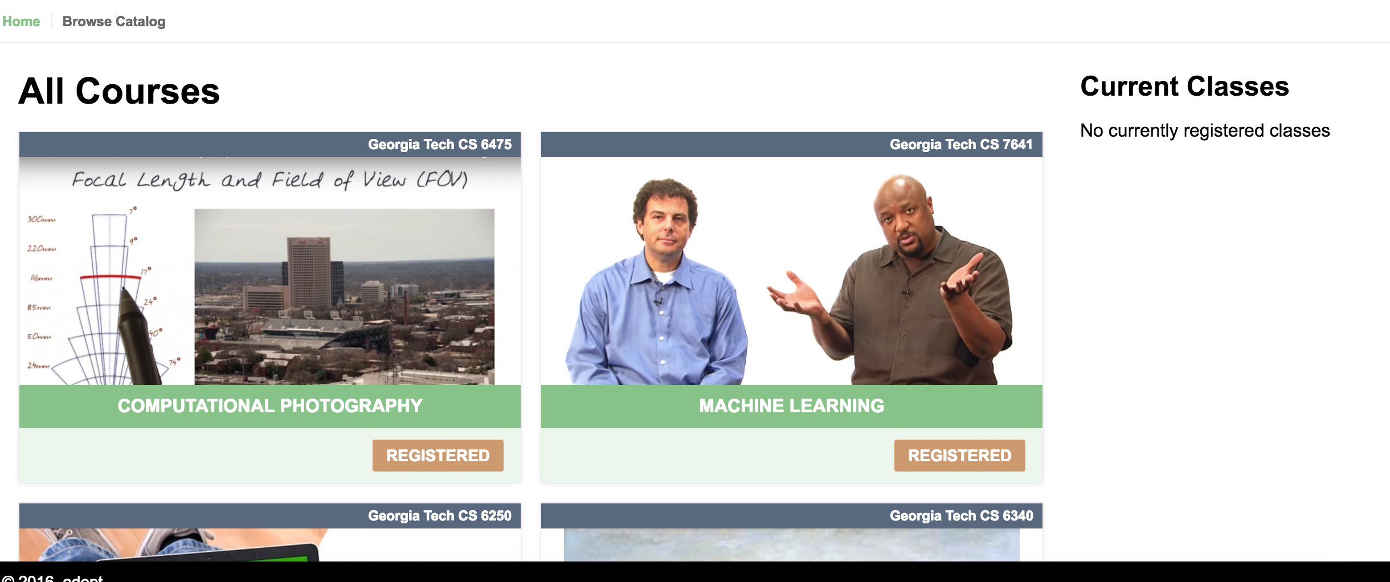*Browsing only Georgia Tech classes on Adept.*

Viewing Details About a Course

Course views include some basic information about a class such as their instructors, a general description and an overview of class levels and available achievements.

Students can register for classes either from the course list itself or from the course details page:

*Registering for a class and seeing existing registrations*

The Mechanics of The Quiz

The quizzes themselves needed to satisfy three basic requirements:

Only be available for valid participants

Be valid for a short period of time

Consist of randomized questions per level

The first requirement prevents users from entering quizzes for levels they do not yet have access. This forces all students to engage in level 1 quizzes no matter their current level.

The next requirement prevents students from attempting to retake quizzes exactly as they were initially presented. While students will see the same questions many times (as with Duolingo, etc.) the question pool and its order will be randomized perquiz, which presents users from anticipating answers.

This approach focuses on the value of repetition for knowledge retention, a well-known and accepted mechanism. As with Duolingo, the concept of spaced repetition is encouraged as a system to prevent knowledge loss and promote topic mastery and retention.

While immediate repetition has negligible effect on memory retention over the long term [XXXXX], frequent, strategically distributed reunions help to mitigate the effect of transience on memory loss[http://www.apa.org/monitor/oct03/sins.aspx].

Extrinsic Motivators

Each course can have any number of quizzes with any number of questions per quiz. Each is extensible but can also share questions. As an example, a level 1 quiz for a class can share questions for a level 2 quiz. This allows some questions to travel forward as a student progresses without duplicating the questions/quiz in each.

Courses can also have course-wide achievements, quiz-specific achievements and/or level-specific achievements.

A few examples of this include

A student participating for the first time (course-wide)

A student taking a quiz for seven straight days (course-wide)

A student getting a perfect score (quiz-specific)

A student reaching level 8 (level-specific)

By mixing and matching requisites, cascading achievements c