1. Regression: Predicting the global land temperature of Earth in 2050 from the past data: Choosing the best model.

(All parts are done together)

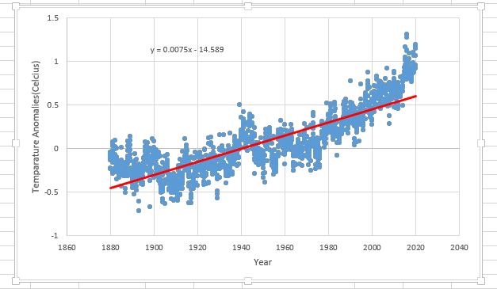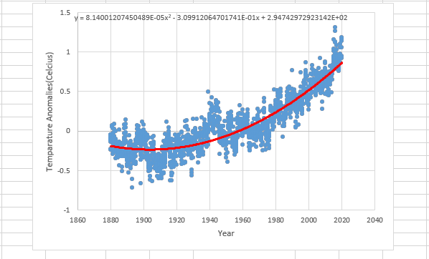

For linear regression, the predicted temperature for 2050 is 0.824190156 degree Celsius.

For quadratic regression, the predicted temperature for 2050 is 1.507248 degree Celcius.

I feel like the quadratic regression mathematical model fits to the data better as it covers more data points. Quadratic regression has more temperature increase in the near future.

1. Visualizing and comparing the temperatures of Honolulu and Duluth via Excel

(All parts are done together)

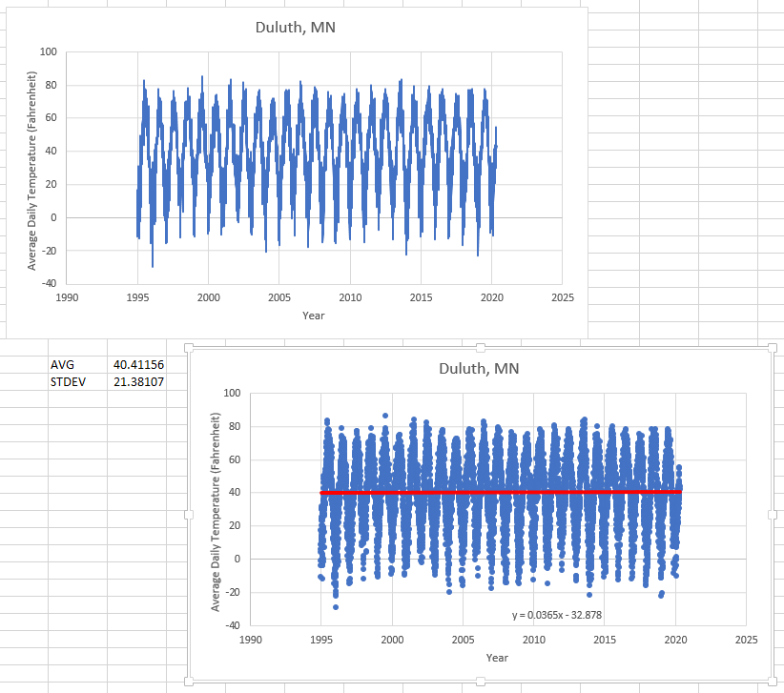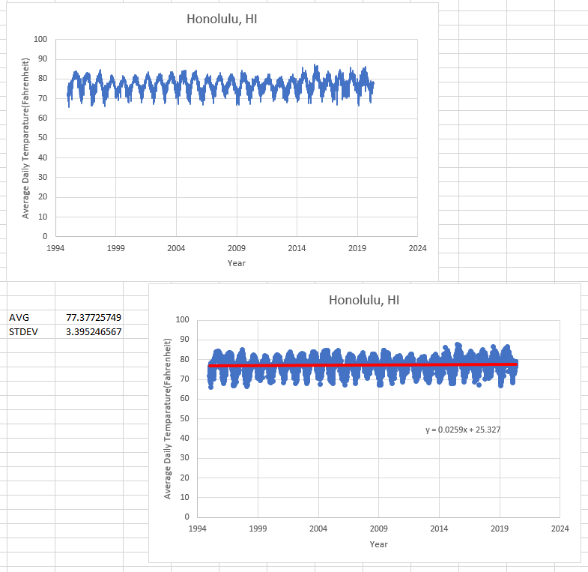

For both the places, the averages and standard deviations are given above.

Honolulu is hotter as compared to Duluth.

Honolulu has less fluctuating temperatures as compared to Duluth.

The slopes are,

For Honolulu, 0.0259

For Duluth, 0.0365

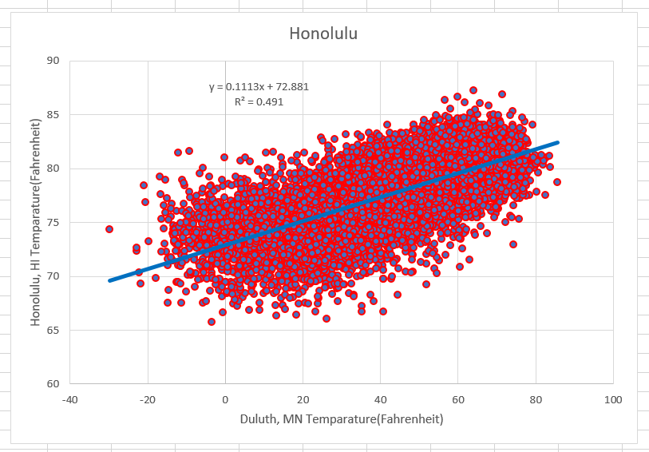

I feel that the temperature of Duluth and Sydney are positively correlated because we can see from the scatter plot that when the temperature in Duluth is low then it is low in Honolulu.

I feel that the temperature of Duluth and Sydney are positively correlated. Because from the equator the Honolulu seems to be approximately as far as Sydney from the equator. And we saw in question fifth that the temperature of Honolulu and Duluth are positively correlated. Hence, the temperature between Duluth, MN and Sydney, Australia is positively correlated.

1. There are two animals. First is frog and horse.
2. We change the stick horizontal in four to become vertical and attached to the shorter side which makes the 4 in to 11, hence, correcting the equation, i.e, 8 + 3 – 11 = 0.