1. First question
   1. Epsilon and midpoints
   2. (Epsilon, Midpoints) – (1.80,1), The set can be – {(1.81,1),(1.82,1),(1.83,1)……}
   3. (Epsilon, Midpoints) – {……,(1.77,1),(1.78,1),(1.79,1)}
2. Final Set of Clusters – 1

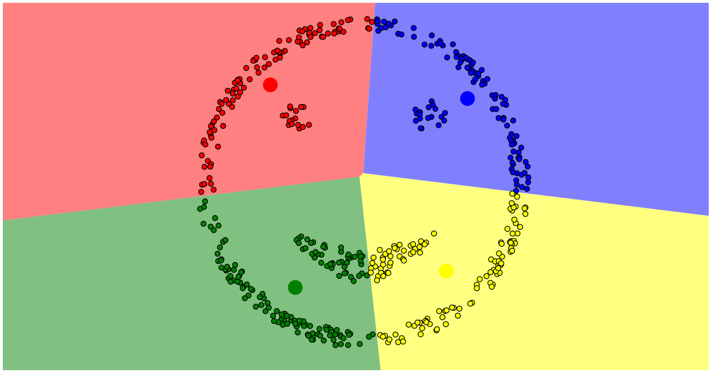

The new set of clusters are different and have different centroids. This is because we have a new set of points and the centroid depends upon the points.

Final Set of Clusters – 2

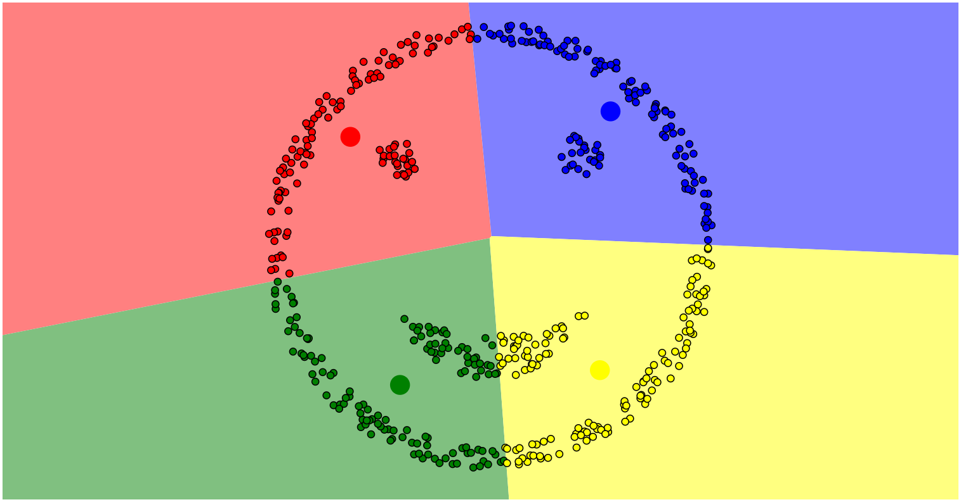

1. This is because as compared to K-means clustering, which focuses on points near to the center, DBSCAN clustering method the clusters are formed based on high-density of points.

