1. First Question:

We know that there are various types of biases that occurs in decision making. This is an example of confirmation bias as the person is only valuing the data that confirm his believes or expectation, ignoring the possibility of misclassification. Confirmation bias clouds the reasoning.

1. Second Question:
   1. Here it is plotted scatter plot:

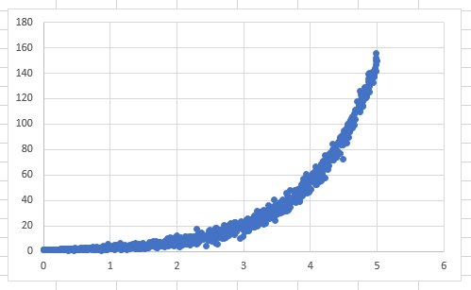

* 1. This relation should fit cubic regression.
  2. Here is the regression.

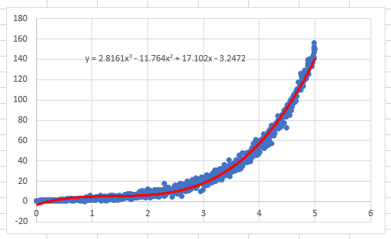

* 1. I think it covers most of the data points so it is mostly correct.
  2. I will be trying to fit exponential regression.

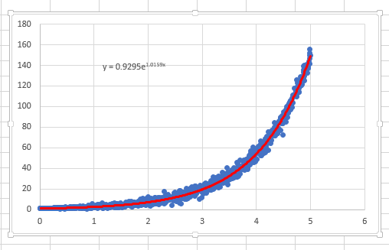

* 1. The alternate hypothesis fits the data perfectly.
  2. The equation is- y = 0.9295e1.0159x
  3. Done.
  4. Done.
  5. Here is the histogram.

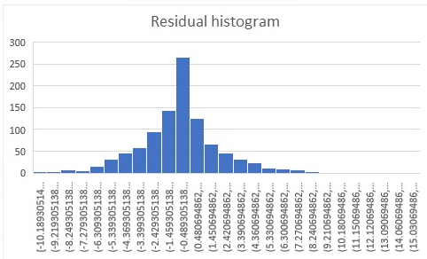

It is symmetric.