Here are the installation instructions

1. Install WAMP Server
2. Modify PHP.INI usually in the Apache bin directory to allow the short open tag (do a phpinfo() to find out where the loaded php.ini is)

short_open_tag = On

3. Use the MySQL Query Browser or phpMyAdmin and run the sql queries contained in the db.sql file in the Altoro install
4. Enable the Apache Rewrite module. You can do so from here:

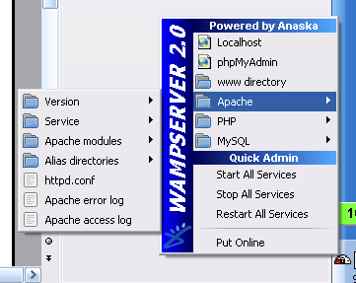

5. Paste Altoro Web2.0 in the www folder in the WAMP directory or whatever your web root is.
6. Edit .htaccess in the Altoro app if Altoro will be in a subfolder of the web root and change the RewriteBase
7. Edit the constants in include/config.php with your corresponding db user and password. Also change the SITE_ROOT to the corresponding URL information.

