Declaration on Plagiarism

Name: | Naveen Garaga Krishnamurthy
Student Number: | 19210263
Programme: | MSc. in Computing (Data Analytics) MCM
Module Code: | CA670
Assignment Title: | Concurrent Programming Assignment 2 – Efficient Large Matrix Multiplication in OpenMP
Submission Date: | 13 Apr 2020
Module Coordinator: | Prof. David Sinclair

I declare that this material, which I now submit for assessment, is entirely my own work and has not been taken from the work of others, save and to the extent that such work has been cited and acknowledged within the text of my work. I understand that plagiarism, collusion, and copying are grave and serious offences in the university and accept the penalties that would be imposed should I engage in plagiarism, collusion or copying. I have read and understood the Assignment Regulations. I have identified and included the source of all facts, ideas, opinions, and viewpoints of others in the assignment references. Direct quotations from books, journal articles, internet sources, module text, or any other source whatsoever are acknowledged, and the source cited are identified in the assignment references. This assignment, or any part of it, has not been previously submitted by me or any other person for assessment on this or any other course of study.

I have read and understood the referencing guidelines found at http://www.dcu.ie/info/regulations/plagiarism.shtml, https://www4.dcu.ie/students/az/plagiarism and/or recommended in the assignment guidelines

Name: Naveen Garaga Krishnamurthy Date: 13/04/2020
Efficient Large Matrix Multiplication in OpenMP

Problem Statement:
The objective of the program is to demonstrate an efficient way for matrix multiplication of large size using C programming language using OpenMP. The efficiency is shown by comparing a naive matrix multiplication implementation and the optimized approach for a square matrix of size N=1024.

Design and Implementation:
Naive Implementation:
The naïve implementation is based on the crud algorithm where we calculate each entry as sum of products.
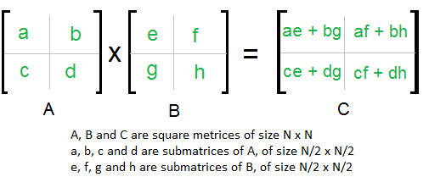

For a square matrix of size 1024, it takes about 7.42 seconds to compute, though the implementation of this is simple there are some disadvantages like the time for calculating the product increases exponentially. The main issue is because of the memory accesses, here it does not exploit data locality. It uses scalars computation and no large arrays are made use of. Elements of B are accessed column-wise, and therefore not in sequential order in memory. While each iteration in j reuses row i of A, that row may have been evicted from the cache by the time the inner-most loop completes. As a result, the algorithm is bandwidth limited and displays poor performance and low efficiency.

Optimized Implementation:
Methods:
- Matrix transpose with OpenMP
- 2D tiling and matrix transpose with OpenMP

Matrix Transpose with OpenMP:
This implementation involves the process of transposing the matrix B first and then multiplying it with the matrix A. This is done with proof that a transposition of either of the matrix before multiplication solves the data locality problem of the naïve approach. Since a matrix multiplication involves operating on an entire row of one matrix and only one value from a column of the other matrix, a transpose would make the matrix either row major or column major. Because of the transpose, the parallelization technique applied can operate simultaneously on different parts of the rows or columns of the matrix being multiplied.

OpenMP parallelization is implemented in this method to make use of the Loop level parallelism concept. Loop level parallelism is something in which multiple threads run parallelly executing the contents of the loop. Each of these threads have their own execution space and executes statements sequentially. All the parallelly running threads are forked after all of them have completed their executions. The main thread then continues its sequential execution further on.

#pragma omp parallel shared (A,B,C,nthread, chunk) private(tid,tmp)
The above line provides the loop level parallelization described above, the contents within the parenthesis after the shared key word specifies that these structures are shared between the various parallel loop running. This is done to avoid the deadlock and cyclic running perils that exist in multithreading in OpenMP.

#pragma omp for schedule(dynamic,block)
This is used to specify how the components of the loop are spread across the threads working on them. It specifies how much work a thread will be involved with; it is of static and dynamic type. A static type is something where in a fixed size block is mentioned before hand and the loop is divided into those many number of chunks and the threads work on them. It is less flexible as compared with the dynamic type in which the blocks are calculated during the execution time and is more flexible. Threads after completion of a block pick up blocks which haven’t been worked on previously. A dynamic implementation is considered here.
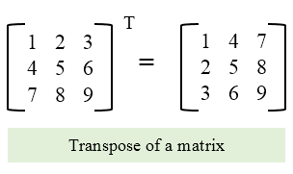
Product of the matrices A × 𝐵T can be calculated using the formula:
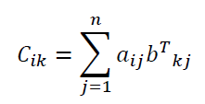

2D tiling and matrix transpose with OpenMP:
This optimization technique where in the large matrix is broken down into a fixed sized number of blocks, this is also called as the blocking technique. This is useful because the large matrix now is broken down into smaller parts and each of these parts can be worked on independently. This is exploited by the parallel running threads and the result is got by forking all of them together. A matrix transpose is also done to exploit the data locality in the storage.
A large matrix M (m X n) is first broken into chunks along the rows m, this forms groups of m sized rows, next these are broken down along columns to form a small row column chunk, this is done for the entire matrix, these chunks can be worked on independently by the OpenMP parallelized loops.
A matrix multiplication has 2 operations, the multiplication and the addition. Each of these take one clock cycle to complete and once done they update a variable in memory. Typically, machines can perform one memory operation for a single multiply-add cycle, because of this, values loaded from memory to the cache must be used before cache flushing. If not, another memory read cycle should be waited for the data to be loaded again and worked on. A naïve approach suffers from this cache flush loss and as the matrix size increases this problem of miss and hit will grow larger and the latency becomes more.
Loop tiling is a mechanism where loop’s working is divided into smaller parts, this enables the advantage that when a thread working on that part of the iteration space has the required data in the cache most of the times. This also ensures that a large sized array is broken down and fit into the cache and enables cache reusability.
Product of matrix A and B with blocking/tiling technique can be given as
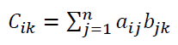
Outputs a matrix of size (m X n) with i row and j column partitions.

Results:
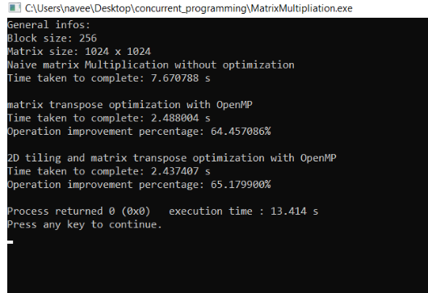

Specifications of the machine:
Processor: Intel(R) Core (TM) i5-8265U CPU @ 2.70GHz, 1800 Mhz, 4 Core(s), 8 Logical Processor(s)
Cache : L1- 256K, L2-1MB, L3-6MB

Type | Run_Time | Efficiency INCREASE (vs naïve)
naïve | 7.67s | -
Transpose | 2.48 | 64.45 %
2d Tiling with Transpose | 2.43 | 65.17 %

References:
[1] Parallel programming in OpenMP, Chandra, R., Dagum, L., Kohr, D., Menon, R., Maydan, D. and McDonald, J., 2001. Parallel programming in OpenMP. Morgan kaufmann.

[2] https://stackoverflow.com/questions/15829223/loop-tiling-blocking-for-large-dense-matrix-multiplication

[3] https://medium.com/tech-vision/parallel-matrix-multiplication-c-parallel-processing-5e3aadb36f27

[4] https://github.com/mperlet/matrix_multiplication/tree/master/src

[5] https://attractivechaos.wordpress.com/2016/08/28/optimizing-matrix-multiplication/

[6] https://bt.nitk.ac.in/c/17b/co332/notes/6-Tiled-MM.pdf

[7] https://stackoverflow.com/questions/10850155/whats-the-difference-between-static-and-dynamic-schedule-in-openmp

